SEII Midterm Presentation

Project Title: Stats Made Easy

Client: Dr. Jornaz

Members: Nick Allee, Robert Becthold, Elizabeth Billings, Justin Folkerts, David Klix, Pappu Sah, Hunter Walters

Risks:

We may not have the project completed in its entirety, if it is completed, it may be difficult to distribute to students, and it could be challenging for students to use.

UML:

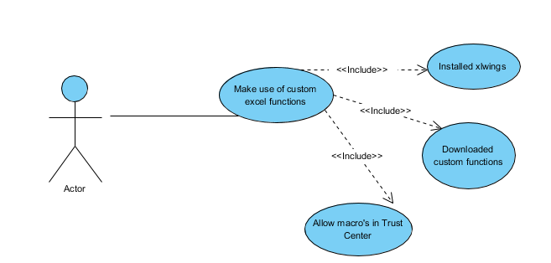

Requirement Chart:

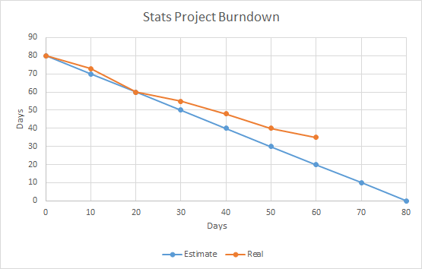

1. Project Management Plan
   1. Schedule
      1. During the first couple weeks, we finished the requirements.
      2. The next two weeks (2/5 through 2/14) we learned how to use Excel and XLWings.
      3. Next, we finished architectural style and design, depending on when assignment is due.
      4. In four to five weeks (3/1) we will have a mid-semester presentation, where we will be able to show a couple functions.
      5. Before the final weeks (before 4/26), we will have our project done and will work on presentation and testing.
   2. Tasks and Deadlines
      1. By the end of the semester our project must be finished and ready for presentation.
      2. By March 14, we must be able to present our requirements and such for midterm presentation.
2. Risk Management Plan
   1. May not finish it.
      1. High
      2. Business Risk
      3. FR1 - FR9
   2. May finish it but it’s hard to distribute to students.
      1. Medium
      2. Technological Risk
      3. FR1 and FR2
   3. May be difficult for students to use.
      1. Medium
      2. Technological Risk
      3. FR3 – FR9
3. Requirements
   1. FR1
      1. TITLE: Download application
      2. DESC: a user should be able to download the application free of charge
      3. RAT: in order for a user to use the software
      4. DEP: none
   2. FR2
      1. Title: install application
      2. Desc: a user should be able to install the applicaion once it is downloaded
      3. Rat: in order for a user to use the software
      4. Dep: Download application
   3. FR3
      1. Title: Frequency table
      2. Desc: a user should be able to create a frequency table by giving inputs
      3. Rat: requested by Dr. Jornaz
      4. Dep: fr1 fr2
   4. FR4
      1. Title: Relative frequency table
      2. Desc: a user should be able to create a relative frequency table by giving inputs
      3. Rat: requested by Dr. Jornaz
      4. Dep: fr1 fr2
   5. FR5
      1. Title: Bar chart (2-d)
      2. Desc: a user should be able to create a bar chart by giving inputs
      3. Rat: requested by Dr. Jornaz
      4. Dep: fr1 fr2
   6. FR6
      1. Title: pie chart
      2. Desc: a user should be able to create a pie chart by giving inputs
      3. Rat: requested by Dr. Jornaz
      4. Dep: fr1 fr2
   7. FR7
      1. Title: contingency table
      2. Desc: a user should be able to create a contingency table by giving inputs
      3. Rat: requested by Dr. Jornaz
      4. Dep: fr1 fr2
   8. FR8
      1. Title: side by side bar chart
      2. Desc: a user should be able to create a side by sied bar chart by giving inputs
      3. Rat: requested by Dr. Jornaz
      4. Dep: fr1 fr2
   9. FR9
      1. Title: segmented bar chart
      2. Desc: a user should be able to create a segmented bar chart by giving inputs
      3. Rat: requested by Dr. Jornaz
      4. Dep: fr1 fr2
4. Software Architecture and UML
   1. 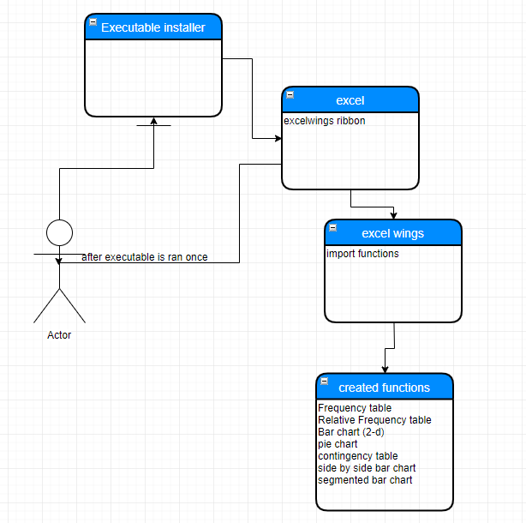
   2. 