Project Title: Stats Made Easy

Client: Dr. Jornaz

Members: Nick Allee, Robert Becthold, Elizabeth Billings, Justin Folkerts, David Klix, Pappu Sah, Hunter Walter.

1. Introduction brief: Our client is Dr. Jornaz, a professor of mathematics that teaches statistics here at Northwest. Our project is called Stats Made Easy. The goal of our project is to make functions in Excel that makes it easier for Dr. Jornaz’s students to manage data they receive. We want our functions to make it easy for students to create contingency tables, pie charts, and much more all in one easy step.
   1. Dr. Jornaz has stated that he often has data he gives to his students and he needs them to do various things with the data such as create a table or do different calculations with. He and his students use Excel and the problem is that creating these tables and doing these calculations is often time consuming and tedious. Dr. Jornaz wants us to streamline this process and make it easier for the students.
   2. Our solution is to create an extension for Excel, using Python code, to automatically do some of the functions for the students. We will use XLWings, an open source option to use Python with Excel.
2. Requirement Gathering
   1. Functional Requirements

FR1

TITLE: Download application

DESC: a user should be able to download the application free of charge

RAT: in order for a user to use the software

DEP: none

FR2

Title: install application

Desc: a user should be able to install the application once it is downloaded

Rat: in order for a user to use the software

Dep: Download application

FR3

Title: Frequency table

Desc: a user should be able to create a frequency table by giving inputs

Rat: requested by Dr. Jornaz

Dep: fr1 fr2

FR4

Title: Relative frequency table

Desc: a user should be able to create a relative frequency table by giving inputs

Rat: requested by Dr. Jornaz

Dep: fr1 fr2

FR5

Title: Bar chart (2-d)

Desc: a user should be able to create a bar chart by giving inputs

Rat: requested by Dr. Jornaz

Dep: fr1 fr2

FR6

Title: pie chart

Desc: a user should be able to create a pie chart by giving inputs

Rat: requested by Dr. Jornaz

Dep: fr1 fr2

FR7

Title: contingency table

Desc: a user should be able to create a contingency table by giving inputs

Rat: requested by Dr. Jornaz

Dep: fr1 fr2

FR8

Title: side by side bar chart

Desc: a user should be able to create a side by sied bar chart by giving inputs

Rat: requested by Dr. Jornaz

Dep: fr1 fr2

FR9

Title: segmented bar chart

Desc: a user should be able to create a segmented bar chart by giving inputs

Rat: requested by Dr. Jornaz

Dep: fr1 fr2

2.2 Non Functional Requirements –

1 Accessibility – Our solution should be easily accessible to students.

2 Usability – Our solution should be easy to use for students.

3 Compatibility – Our solution should be compatible with Excel.

4 Reliability – Our solution should always perform how expected.

5 Quality – Our functions should satisfy the student’s needs.

3. Diagrams

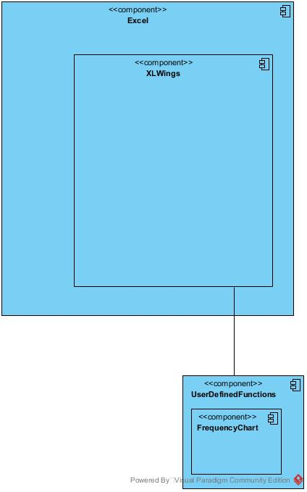

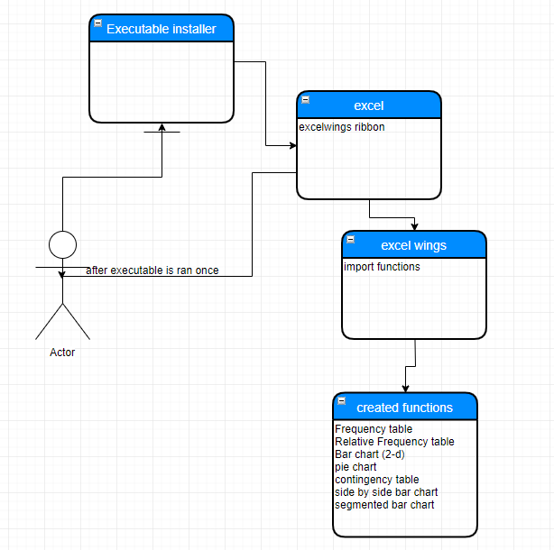

4. Tools and technologies (Developers Manual)

**System specifications**

Anaconda System Requirements

License: Free use and redistribution under the terms of the End User License Agreement

Operating system: Windows 7 or newer, 64-bit macOS 10.10+, or Linux, including Ubuntu, RedHat, CentOS 6+, and others.

System architecture: Windows- 64-bit x86, 32-bit x86; MacOS-64-bit x86; Linux-64-bit x86, 64-bit Power8/Power9

Minimum 5 GB disk space to download and install.

Microsoft Office System Requirements – standalone applications

Computer and processor Windows: 1.6 gigahertz (GHz) or faster, 2-core. 2.0 GHz or greater recommended for Skype for Business.

macOS: Intel processor

Memory Windows: 4 GB RAM; 2 GB RAM (32-bit)

macOS: 4 GB RAM

Hard disk Windows: 4.0 GB of available disk space

macOS: 10 GB of available disk space. HFS+ hard disk format (also known as macOS Extended or APF

Display Windows: 1280 x 768 screen resolution

macOS: 1280 x 800 screen resolution

Graphics Windows: Graphics hardware acceleration requires DirectX 9 or later, with WDDM 2.0 or higher for Windows 10 (or WDDM 1.3 or higher

for Windows 10 Fall Creators Update). Skype for Business requires

DirectX 9 or later, 128 MB graphics memory, and 32 bits per pixel capable format.

macOS: No graphics requirements

**Technologies and tools required to do in the project** – Python, Excel, XLWings, Spyder (optional Spyder is just the IDE we opted to use)

**Installation and Setup** –

1. Download Anaconda - https://www.anaconda.com/distribution/

* Make sure to check the boxes to put it into your path

1. Go to command prompt and type python

3. If it does not recognize the word then you should go back to step 1 or put these addresses in your path (start> path> click environment variables > click the path on top. Add these

C:\Users\s516583\AppData\Local\Continuum\anaconda3

C:\Users\s516583\AppData\Local\Continuum\anaconda3\Library\mingw-w64\bin

C:\Users\s516583\AppData\Local\Continuum\anaconda3\Library\usr\bin

C:\Users\s516583\AppData\Local\Continuum\anaconda3\Library\bin

C:\Users\s516583\AppData\Local\Continuum\anaconda3\Scripts

4. Open anaconda prompt, type pip install xlwings

- Make sure it is downloaded properly look for confirmation

5. Type xlwings addin install

6. Navigate to an empty folder or create one

- In the empty folder make an Excel file and save it as macro enabled

- In the same folder make a .py file with the same name as the Excel file made previously

- You can enter this code to test it.

import xlwings as xw

@xw.func

def hello(name):

return ("hello {0}".format(name))

7. Go to Excel, click file > options > trust center > trust center settings > macro settings

- click enable all macros

- click trust access to the vba project object model

8. Push alt + f11 to open visual basic editor

9. click tools > references

a. check mark xlwings and click ok

**Instructions on how to execute your project for future specification.**

1. Run .py file
2. Open Excel file of the same name
3. Click on the XLWings tab on the tool bar
4. Click the import functions button
5. Now you can use any of the functions that were written in the Python file like you would the default functions already in Excel
6. Just click a cell, type “=” and then the name of the function

**Glossary of all the errors you notice**

- Memory error creating safe array error for statMeasures function

- Side by side bar chart function trouble with output

- Segmented bar chart function trouble with output

- Memory error creating safe array for histogram function

5. Test Cases

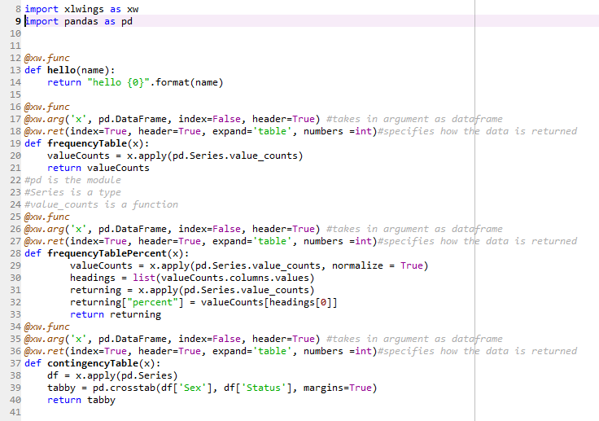

6. Test case execution

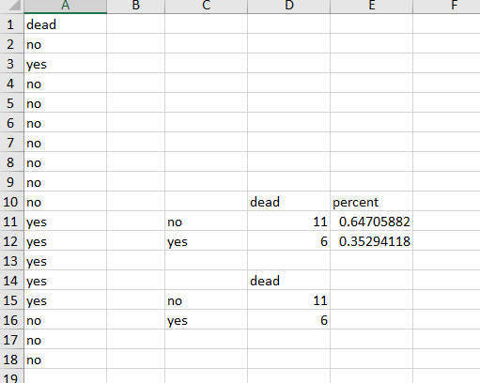

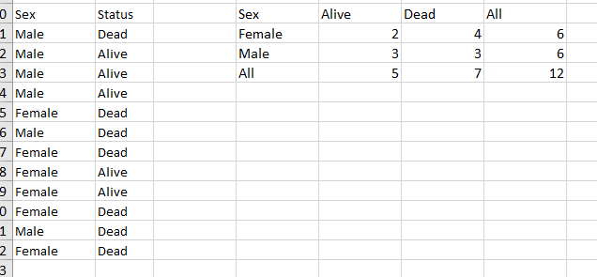

7. List any known errors (incomplete functionality)

**Incomplete Functionality**

* Generating Random Numbers using Data Analysis and Formulas
* Regression using Scatterplot, Data Analysis, Formula
* Scatterplot and Correlation
* Box Plot and Time Plot

8. Deployment Instructions

Open Excel file and find xlwings tab on tool bar

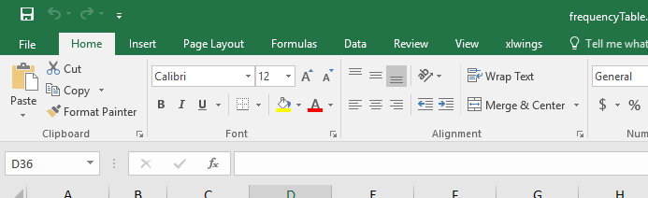

Once you click on the xlwings tab click import functions to import functions from given code

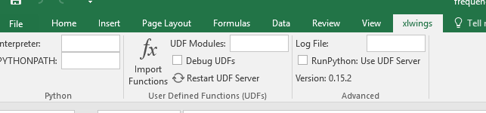

Now you can use the imported functions like any of the default Excel functions

