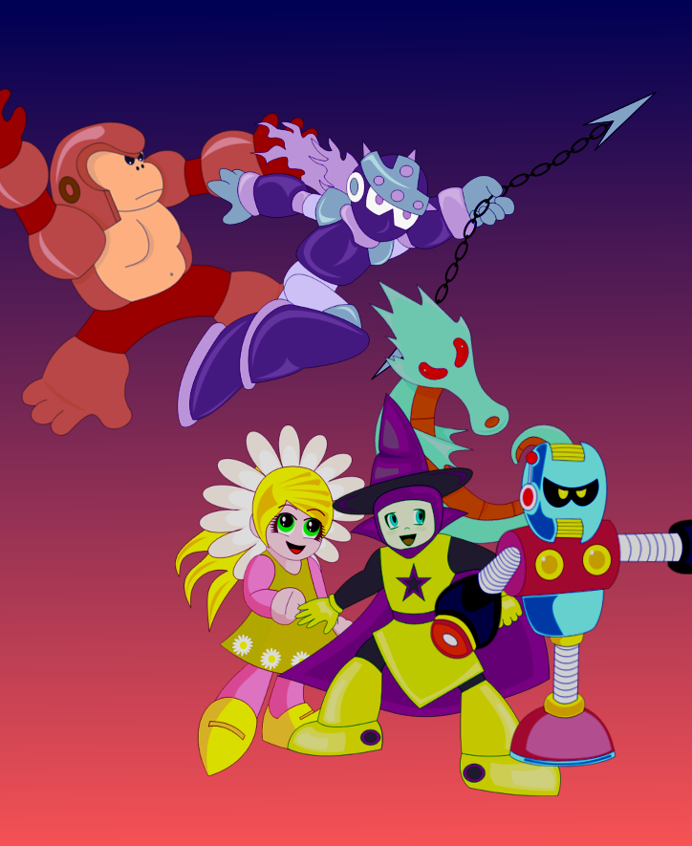





INSTRUCTION MANUAL

A special message from Upperland Studios:

Thank you for experimenting the quick and fun open-source Rockbot® game. This is a game created by Upperland and GreenNeko made for everyone to be able to contribute and enjoy in their favorite system, including Windows, Linux, Mac and Playstation 2.

Rockbot® features old-school colorful low resolution artistic graphics. We are proud to devliver this 1980's like experience to the 21st century.

Iuri Fiedoruk  President  Upperland Studios  Rockbot is not trademark of Upperland or GreenNeko. | This game is not licensed, but plays on the Sony Playstation 2, Dingux (Dingoo), Linux and Windows.  Upperland, Rockbot and Betabot are tm of Upperland Studios. | This game engine is open source licensed under the GPL v2. The art and music data are under other licenses, check the license text file on the package for details.

Table of Contents
Safety Precautions 2
Getting Started 3
Attack in Kyoto City 3
Game Control 4
Player Characteristics 5
Playing the Game 5

Safety Precautions

Getting Started

- Choose your favorite videogame or computer system.
- Turn on your videogame or run Rockbot® executable in your computer system.
- At the title screen, choose if you want to start a new game or continue a previous one.
- Choose one or two player mode and press Start.
- In case of one player mode, select your character and press Start on your joystick.
- In the Stage Select screen, you can choose one of the eight robot masters to start its stage.

Attack in Kyoto City

This is year 20XX, the city is Kyoto in Japan, and unline Tokyo, the city does not have any hero to protect it.
“Calling Dr. Kanotus, plese answer!
“This is the Mayor, we need you to build a robot to defend our city against enemies. Look on what is happening in Tokyo, we need a robot hero to protect the people!

As answer, Dr. Kanotus created one robot, called Betabot, to fight; but is was an early and rushed project, thus he kept constructiong a second one better and smarter and finished him right before a horde of enemy robots started rampaging the city.

“Dr. Kanotus, we are under attack!
“Are your project finished?
“Two? Great! Send them out to help us!

Now it is up to Betabot and Rockbot to fight evil forces and protect the city!

Game Control
PC
- Jump: X
- Attack: A
- Start: Enter
- Quit: Esc

PS2
- Jump: Circle
- Attack: Square

Dingoo
- Jump: A
- Attack: B

Common Controls
- Move left or right: Press the left/right controls in pad or keyboard
- Climb up or down: Press the up/down controls in pad of keyboard
- Jump: Press the jump button. Press the left/right while jumping to move. The longer you hold the jump button, the higher you'll jump.
- Fire weapons: Press the attack button. Press attack and jump altogether to fire while jumping. You can fire anytime, even when climbing.
- Slide left or right (Rockbot only): Press the down with left or right and press jump.
- Charged shot (Rockbot only): Press and hold the attack button until the charge is complete and then release it.

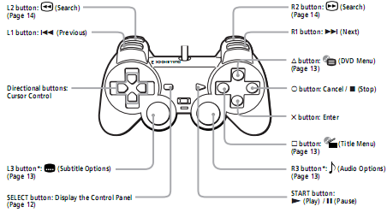

Player Characteristics

Betabot project was rushed, due to the city mayor urgency, thus is was built with harder and heavier materials, limiting his movements a bit. Also, he is very straightforward, and when make a decision, is unable to change his mind and the incomplete vocabulary system makes him talk in a very limited way. He have two cannon arms, enabling him to shot twice at once, being easier to hit a moveable target.

Rockbot, on the other hand, is smarter, faster and have a anti-gravity jump system, allowing him longer and slower jumps. He also have a special cannon arm, that can be charged and shot a more intense energy projectile, but due to this feature, he can't shoot more than 3 regular, or one charged, until his energy unit gets cooled. He also can slide to avoid attacks or enter some areas in the game.

Playing the Game

Your mission is to cross a series of mazes dominated by out-of-control robots and evil machinery. From everywhere they come, you must dodge, shot, run, jump and climb to reach the end of this madness.
At the end of each stage you will have to confront a robot master and if you win, its special weapon will be yours.

You start with three chances to win, and an energy meter in the left of the screen to keep an eye in your robot health. Each time you are hit by a enemy or its shots, you loose a bit of energy, when it reaches zero, you'll loose one chance, and, when no more chances are left, it is the end, the city is doomed without your help!

Luckly some enemies drop items, that can also be found in some parts of the mazes, those items help you. Energy tanks can be used anytime to fully refill your energy, red remedy pills restore some energy and the green ones restore some energy on the special weapon you are equipped with. The robot face gives you one extra chance, up to nine you can store.

Do not give up, fight til the end! The destiny of Kyoto depends on your skills with the joystick, and you must prevail.

Power Up!
Press start during the game to open the weapons menu. Press up, down, left and right to move the selection cursor to a weapon or item, pressing start again to activate it.

Arm Cannon: Pick this to shot regular weapon.
Life: Shows how many chances are left.
Item: Can pick energy or weapons tank.
Bolts: How many bolts you have. Those can be used in the shop to buy extra and special items.
Master Items: Use the special abilities from robot masters.
Coil Item: Go higher by jumping over this item.
Jet item: You can pass abysses by jumping over this item that will fly you over it.

 | 

Robot Masters
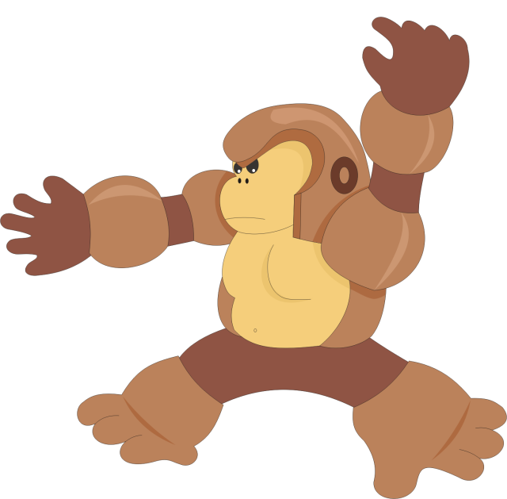  Ape Bot | 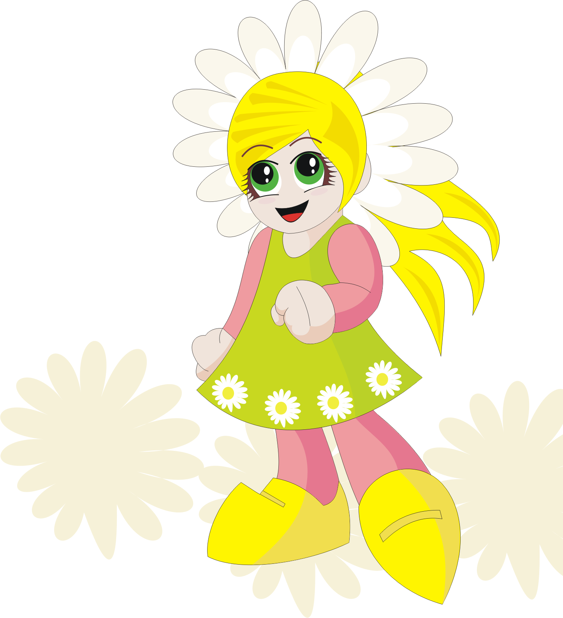  Daisie Bot
  Seahorse Bot | Mummy Bot
  Mage Bot | Dynamite Bot
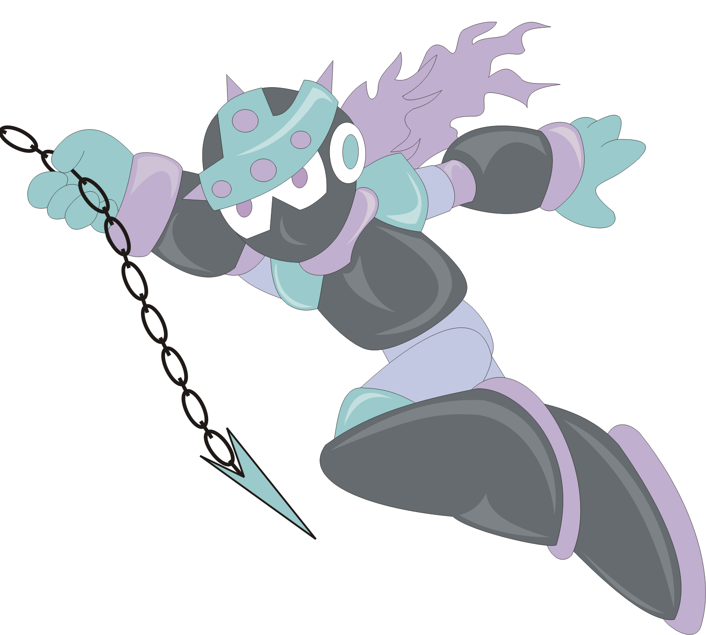  Spike Bot | Techno Bot

Tips for Victory
- Be cautious, try to shot enemy from longe range
- Measure well your jumps, if you miss, try again placing your player more near the edges.
- After being damaged, your players becomes invincible for a short period of time, use this to avoid the enemies and destroy them.
- Test the master robots weapons in each master or stage enemy to find out what are their weaknesses.

LICENSE AND WARRANTY
GNU GENERAL PUBLIC LICENSE
Version 2, June 1991
Copyright (C) 1989, 1991 Free Software Foundation, Inc.
51 Franklin Street, Fifth Floor, Boston, MA 02110-1301, USA

Everyone is permitted to copy and distribute verbatim copies
of this license document, but changing it is not allowed.
Preamble
The licenses for most software are designed to take away your freedom to share and change it. By contrast, the GNU General Public License is intended to guarantee your freedom to share and change free software--to make sure the software is free for all its users. This General Public License applies to most of the Free Software Foundation's software and to any other program whose authors commit to using it. (Some other Free Software Foundation software is covered by the GNU Lesser General Public License instead.) You can apply it to your programs, too.
When we speak of free software, we are referring to freedom, not price. Our General Public Licenses are designed to make sure that you have the freedom to distribute copies of free software (and charge for this service if you wish), that you receive source code or can get it if you want it, that you can change the software or use pieces of it in new free programs; and that you know you can do these things.
To protect your rights, we need to make restrictions that forbid anyone to deny you these rights or to ask you to surrender the rights. These restrictions translate to certain responsibilities for you if you distribute copies of the software, or if you modify it.
For example, if you distribute copies of such a program, whether gratis or for a fee, you must give the recipients all the rights that you have. You must make sure that they, too, receive or can get the source code. And you must show them these terms so they know their rights.
We protect your rights with two steps: (1) copyright the software, and (2) offer you this license which gives you legal permission to copy, distribute and/or modify the software.
Also, for each author's protection and ours, we want to make certain that everyone understands that there is no warranty for this free software. If the software is modified by someone else and passed on, we want its recipients to know that what they have is not the original, so that any problems introduced by others will not reflect on the original authors' reputations.
Finally, any free program is threatened constantly by software patents. We wish to avoid the danger that redistributors of a free program will individually obtain patent licenses, in effect making the program proprietary. To prevent this, we have made it clear that any patent must be licensed for everyone's free use or not licensed at all.
The precise terms and conditions for copying, distribution and modification follow.
TERMS AND CONDITIONS FOR COPYING, DISTRIBUTION AND MODIFICATION

0. This License applies to any program or other work which contains a notice placed by the copyright holder saying it may be distributed under the terms of this General Public License. The "Program", below, refers to any such program or work, and a "work based on the Program" means either the Program or any derivative work under copyright law: that is to say, a work containing the Program or a portion of it, either verbatim or with modifications and/or translated into another language. (Hereinafter, translation is included without limitation in the term "modification".) Each licensee is addressed as "you".
Activities other than copying, distribution and modification are not covered by this License; they are outside its scope. The act of running the Program is not restricted, and the output from the Program is covered only if its contents constitute a work based on the Program (independent of having been made by running the Program). Whether that is true depends on what the Program does.
1. You may copy and distribute verbatim copies of the Program's source code as you receive it, in any medium, provided that you conspicuously and appropriately publish on each copy an appropriate copyright notice and disclaimer of warranty; keep intact all the notices that refer to this License and to the absence of any warranty; and give any other recipients of the Program a copy of this License along with the Program.
You may charge a fee for the physical act of transferring a copy, and you may at your option offer warranty protection in exchange for a fee.
2. You may modify your copy or copies of the Program or any portion of it, thus forming a work based on the Program, and copy and distribute such modifications or work under the terms of Section 1 above, provided that you also meet all of these conditions:
a) You must cause the modified files to carry prominent notices stating that you changed the files and the date of any change.
b) You must cause any work that you distribute or publish, that in whole or in part contains or is derived from the Program or any part thereof, to be licensed as a whole at no charge to all third parties under the terms of this License.
c) If the modified program normally reads commands interactively when run, you must cause it, when started running for such interactive use in the most ordinary way, to print or display an announcement including an appropriate copyright notice and a notice that there is no warranty (or else, saying that you provide a warranty) and that users may redistribute the program under these conditions, and telling the user how to view a copy of this License. (Exception: if the Program itself is interactive but does not normally print such an announcement, your work based on the Program is not required to print an announcement.)
These requirements apply to the modified work as a whole. If identifiable sections of that work are not derived from the Program, and can be reasonably considered independent and separate works in themselves, then this License, and its terms, do not apply to those sections when you distribute them as separate works. But when you distribute the same sections as part of a whole which is a work based on the Program, the distribution of the whole must be on the terms of this License, whose permissions for other licensees extend to the entire whole, and thus to each and every part regardless of who wrote it.
Thus, it is not the intent of this section to claim rights or contest your rights to work written entirely by you; rather, the intent is to exercise the right to control the distribution of derivative or collective works based on the Program.
In addition, mere aggregation of another work not based on the Program with the Program (or with a work based on the Program) on a volume of a storage or distribution medium does not bring the other work under the scope of this License.
3. You may copy and distribute the Program (or a work based on it, under Section 2) in object code or executable form under the terms of Sections 1 and 2 above provided that you also do one of the following:
a) Accompany it with the complete corresponding machine-readable source code, which must be distributed under the terms of Sections 1 and 2 above on a medium customarily used for software interchange; or,
b) Accompany it with a written offer, valid for at least three years, to give any third party, for a charge no more than your cost of physically performing source distribution, a complete machine-readable copy of the corresponding source code, to be distributed under the terms of Sections 1 and 2 above on a medium customarily used for software interchange; or,
c) Accompany it with the information you received as to the offer to distribute corresponding source code. (This alternative is allowed only for noncommercial distribution and only if you received the program in object code or executable form with such an offer, in accord with Subsection b above.)
The source code for a work means the preferred form of the work for making modifications to it. For an executable work, complete source code means all the source code for all modules it contains, plus any associated interface definition files, plus the scripts used to control compilation and installation of the executable. However, as a special exception, the source code distributed need not include anything that is normally distributed (in either source or binary form) with the major components (compiler, kernel, and so on) of the operating system on which the executable runs, unless that component itself accompanies the executable.
If distribution of executable or object code is made by offering access to copy from a designated place, then offering equivalent access to copy the source code from the same place counts as distribution of the source code, even though third parties are not compelled to copy the source along with the object code.
4. You may not copy, modify, sublicense, or distribute the Program except as expressly provided under this License. Any attempt otherwise to copy, modify, sublicense or distribute the Program is void, and will automatically terminate your rights under this License. However, parties who have received copies, or rights, from you under this License will not have their licenses terminated so long as such parties remain in full compliance.
5. You are not required to accept this License, since you have not signed it. However, nothing else grants you permission to modify or distribute the Program or its derivative works. These actions are prohibited by law if you do not accept this License. Therefore, by modifying or distributing the Program (or any work based on the Program), you indicate your acceptance of this License to do so, and all its terms and conditions for copying, distributing or modifying the Program or works based on it.
6. Each time you redistribute the Program (or any work based on the Program), the recipient automatically receives a license from the original licensor to copy, distribute or modify the Program subject to these terms and conditions. You may not impose any further restrictions on the recipients' exercise of the rights granted herein. You are not responsible for enforcing compliance by third parties to this License.
7. If, as a consequence of a court judgment or allegation of patent infringement or for any other reason (not limited to patent issues), conditions are imposed on you (whether by court order, agreement or otherwise) that contradict the conditions of this License, they do not excuse you from the conditions of this License. If you cannot distribute so as to satisfy simultaneously your obligations under this License and any other pertinent obligations, then as a consequence you may not distribute the Program at all. For example, if a patent license would not permit royalty-free redistribution of the Program by all those who receive copies directly or indirectly through you, then the only way you could satisfy both it and this License would be to refrain entirely from distribution of the Program.
If any portion of this section is held invalid or unenforceable under any particular circumstance, the balance of the section is intended to apply and the section as a whole is intended to apply in other circumstances.
It is not the purpose of this section to induce you to infringe any patents or other property right claims or to contest validity of any such claims; this section has the sole purpose of protecting the integrity of the free software distribution system, which is implemented by public license practices. Many people have made generous contributions to the wide range of software distributed through that system in reliance on consistent application of that system; it is up to the author/donor to decide if he or she is willing to distribute software through any other system and a licensee cannot impose that choice.
This section is intended to make thoroughly clear what is believed to be a consequence of the rest of this License.
8. If the distribution and/or use of the Program is restricted in certain countries either by patents or by copyrighted interfaces, the original copyright holder who places the Program under this License may add an explicit geographical distribution limitation excluding those countries, so that distribution is permitted only in or among countries not thus excluded. In such case, this License incorporates the limitation as if written in the body of this License.
9. The Free Software Foundation may publish revised and/or new versions of the General Public License from time to time. Such new versions will be similar in spirit to the present version, but may differ in detail to address new problems or concerns.
Each version is given a distinguishing version number. If the Program specifies a version number of this License which applies to it and "any later version", you have the option of following the terms and conditions either of that version or of any later version published by the Free Software Foundation. If the Program does not specify a version number of this License, you may choose any version ever published by the Free Software Foundation.
10. If you wish to incorporate parts of the Program into other free programs whose distribution conditions are different, write to the author to ask for permission. For software which is copyrighted by the Free Software Foundation, write to the Free Software Foundation; we sometimes make exceptions for this. Our decision will be guided by the two goals of preserving the free status of all derivatives of our free software and of promoting the sharing and reuse of software generally.
NO WARRANTY
11. BECAUSE THE PROGRAM IS LICENSED FREE OF CHARGE, THERE IS NO WARRANTY FOR THE PROGRAM, TO THE EXTENT PERMITTED BY APPLICABLE LAW. EXCEPT WHEN OTHERWISE STATED IN WRITING THE COPYRIGHT HOLDERS AND/OR OTHER PARTIES PROVIDE THE PROGRAM "AS IS" WITHOUT WARRANTY OF ANY KIND, EITHER EXPRESSED OR IMPLIED, INCLUDING, BUT NOT LIMITED TO, THE IMPLIED WARRANTIES OF MERCHANTABILITY AND FITNESS FOR A PARTICULAR PURPOSE. THE ENTIRE RISK AS TO THE QUALITY AND PERFORMANCE OF THE PROGRAM IS WITH YOU. SHOULD THE PROGRAM PROVE DEFECTIVE, YOU ASSUME THE COST OF ALL NECESSARY SERVICING, REPAIR OR CORRECTION.
12. IN NO EVENT UNLESS REQUIRED BY APPLICABLE LAW OR AGREED TO IN WRITING WILL ANY COPYRIGHT HOLDER, OR ANY OTHER PARTY WHO MAY MODIFY AND/OR REDISTRIBUTE THE PROGRAM AS PERMITTED ABOVE, BE LIABLE TO YOU FOR DAMAGES, INCLUDING ANY GENERAL, SPECIAL, INCIDENTAL OR CONSEQUENTIAL DAMAGES ARISING OUT OF THE USE OR INABILITY TO USE THE PROGRAM (INCLUDING BUT NOT LIMITED TO LOSS OF DATA OR DATA BEING RENDERED INACCURATE OR LOSSES SUSTAINED BY YOU OR THIRD PARTIES OR A FAILURE OF THE PROGRAM TO OPERATE WITH ANY OTHER PROGRAMS), EVEN IF SUCH HOLDER OR OTHER PARTY HAS BEEN ADVISED OF THE POSSIBILITY OF SUCH DAMAGES.

WARNING
Do not use play this game for more than a couple of hours. Make regular pauses to rest your eyes. Best playable in a LCD TV or computer monitor.
In portable systems such as Dingoo, check your battery level before playing. This game uses auto-save feature, but if battery dies in the middle of a level, you'll loose all data from the game.

http://rockbot.upperland.net
Porto Alegre, Rio Grande do Sul, Brazil

made in Rio Grande do Sul, Brazil

