Randall Reynolds

Thursday, June 18, 2020

1. Download Picotech [SDK](https://www.picotech.com/downloads) (64 bit)

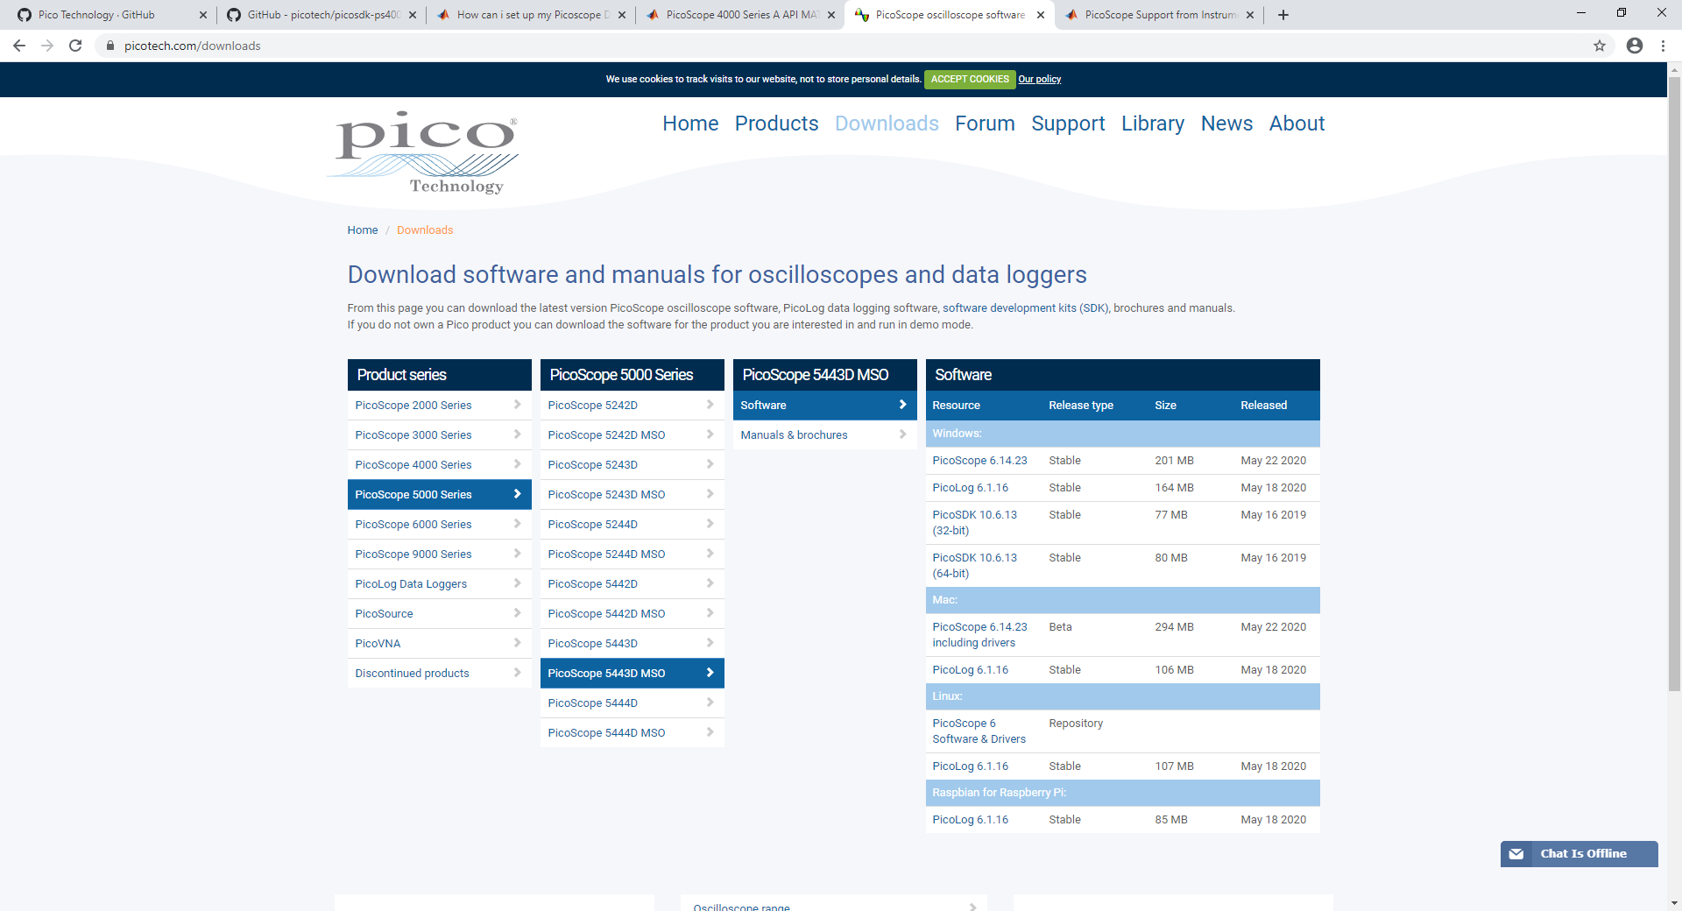

1. Copy the files from the old Picoscope SDK on lithos (**G:\Shared drives\emsg\lithos\RANDALL\picoscope-sdk-fix**):  **ps4000aWrap.dll** and **ps4000aWrap.lib** to the Picoscope SDK directory **C:\Program Files\Pico Technology\SDK\lib**
2. Download Picotech Instrument Control Toolbox Add-in from Add-in manager

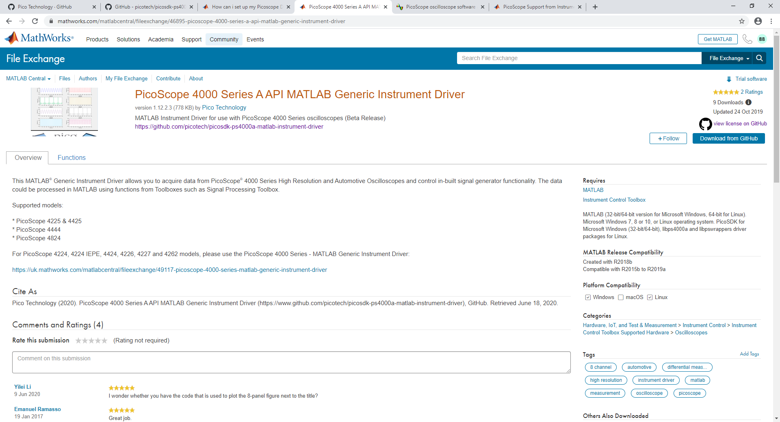

1. Download generic Picoscope MATLAB drivers from Github(This can be done through the App Center in MATLAB).
   1. [4000a](https://github.com/picotech/picosdk-ps4000a-matlab-instrument-driver)
   2. [5000](https://github.com/picotech/picosdk-ps5000a-matlab-instrument-driver)
   3. [Picoscope-support-toolbox](https://github.com/picotech/picosdk-matlab-picoscope-support-toolbox)

**Note:** I add all directories to MATLAB folder in Documents directory and add all folders to my path in **startup.m**. This is not necessary if installed through **MATLAB** App Center. Using Github ensures the latest files from Picotech as the toolboxes update with new versions of MATLAB.

1. Restart MATLAB
2. Run test script **PS4000A_ID_Block_Example** with a 4000A series picoscope to confirm to confirm function