**C196 (Part D StoryBoard)**

**Scenario 1 (Add Mentor)**

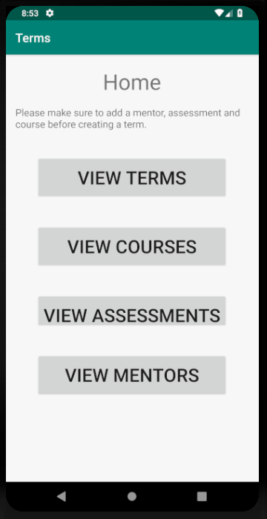 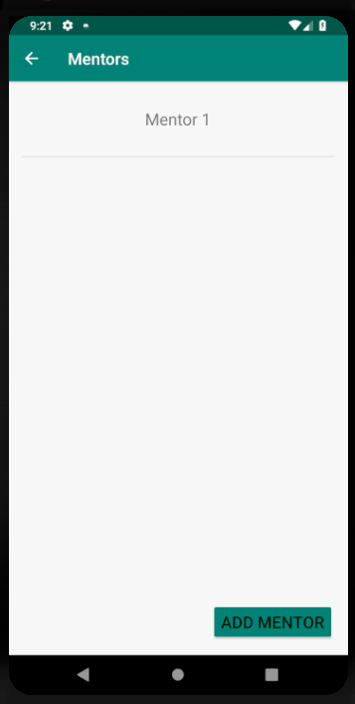 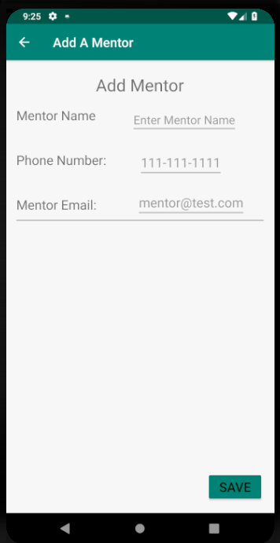

Add A Mentor

(Enter required fields then click Save)

Mentors Activity

(Tap Add Mentor)

Home Screen

(Tap View Mentors)

(Tap

**Scenario 2 (Edit Mentor)**

  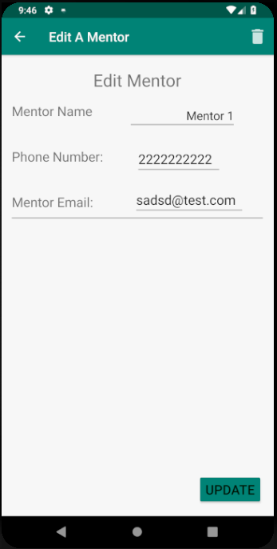

Mentors Activity

(Tap on existing Mentor)

Home Screen

(Tap View Mentors)

(Tap

Edit A Mentor

(Edit existing information and click Update or click the trash can icon to delete)

**Scenario 3 (Add Assessment)**

 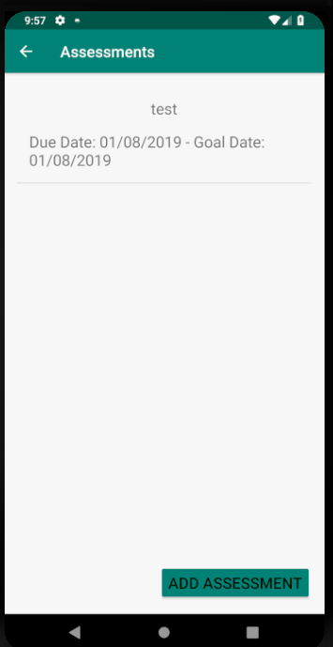 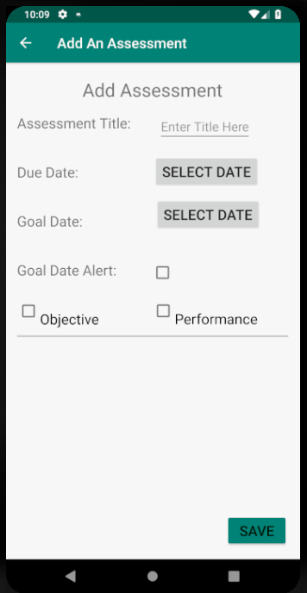

Add An Assessment

(Enter required fields then click Save)

Assessments Activity

(Tap on Add Assessment)

Home Screen

(Tap View Assessments)

(Tap

**Scenario 4 (Edit Assessment)**

  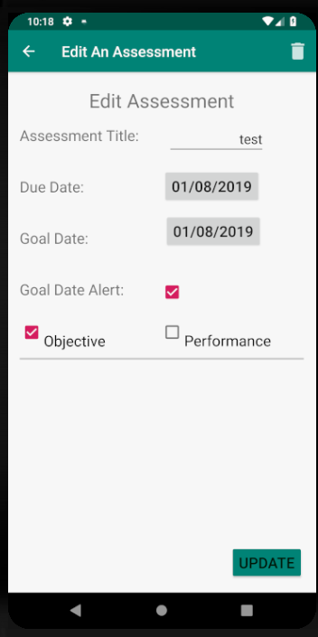

Edit An Assessment

(Edit information and then click Update or click the trash can icon on top right to delete)

Assessments Activity

(Tap on an existing assessment)

Home Screen

(Tap View Assessments)

(Tap

**Scenario 5 (Add Course)**

 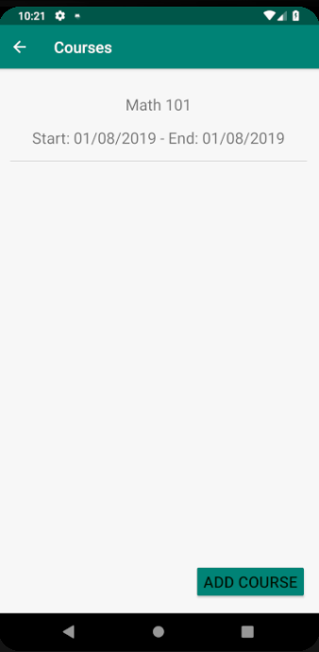 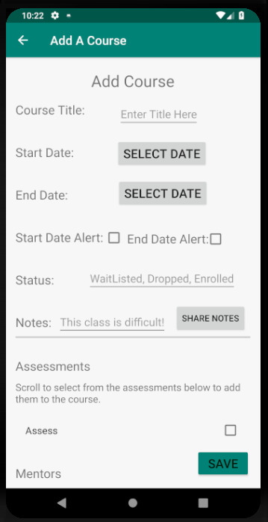

Home Screen

(Tap View Courses)

(Tap

Courses Activity

(Tap on add course)

Add A Course

(enter required information then select from existing mentors and assessments that were previously created then click Save)

**Scenario 6 (Edit Course)**

  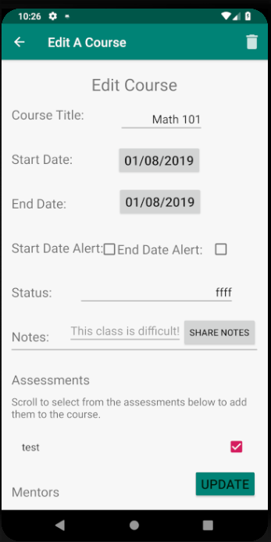

Home Screen

(Tap View Courses)

(Tap

Courses Activity

(Tap on existing course)

Edit A Course

(edit required information then select from existing mentors and assessments that were previously created then click update or click the trash icon to delete)

**Scenario 7 (Add Term)**

 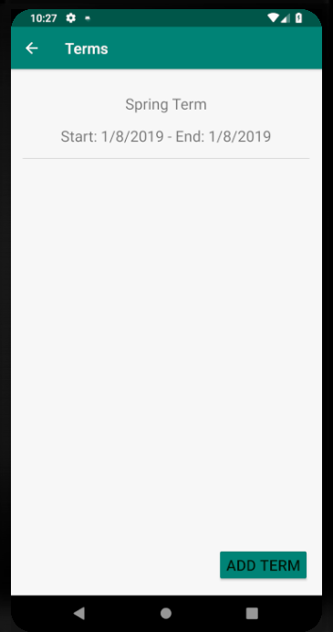 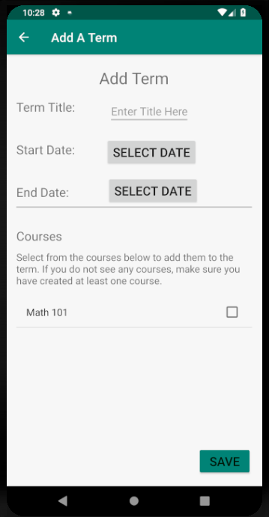

Add A Term

(Enter required information and select from the courses that were previously added then tap Save)

Home Screen

(Tap View Terms)

(Tap

Terms Activity

(Tap on Add Term button)

**Scenario 8 (Edit Term)**

  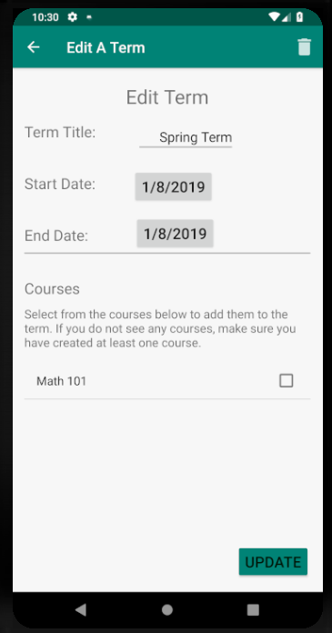

Edit A Term

(Edit required information and select from the courses that were previously added then tap Update or the trash can icon to delete)

Home Screen

(Tap View Terms)

(Tap

Terms Activity

(Tap on an existing term)