Final Assignment

Assignment 08, Assignment 09, and Assignment 10 is a group project worth 300 points. You must complete the final project to pass the course. The goal of the final is to demonstrate in a team setting you can:

* Work with an assigned dataset and chose another dataset to report on:
  + The assigned dataset is Bing Covid19 dataset: <https://github.com/microsoft/Bing-COVID-19-Data>
  + Chose an additional dataset from a website
* Build a data warehouse in SQL Server:
  + Build a database on your local instance
  + Export / Import that database to Azure SQL Server
  + Properly backup the databases and put in a folder
* Build a Data Visualization with data:
  + build two different reports using multiple data visualizations
  + show additional ways to manage the data using data management & maintenance techniques we discussed
* Explain how the data could be refreshed in a production environment:
  + The requirement here is just how you would refresh the dataset. The Big Data Technologies course build more on this principle if you chose to enroll.
* Present your finding to the class:
  + Each team will have 15 minutes to present their findings
  + Presentations will be Week 9 and Week 10
  + You must turn all parts of the assignment on time in canvas

This activity will take you about 10 to 15 hours, so plan accordingly!

# Deliverable 1: turn in at module 8 assignment folder- Select the datasets for your GROUP: Due aug 13, 2020

Step 1: View the Final_Groups folder with your team

Step 2: Contact your team and setup a zoom meeting to discuss your topic

Step 3: You must use the Bing COVID dataset

Step 4: Chose another dataset on the web. The dataset should be a csv file that you can import into SQL

Step 5: Submit your Project Name, datasets, and proposed business question by Aug 13, 2020 in excel. The folder should have sub folders with names and zipped up.

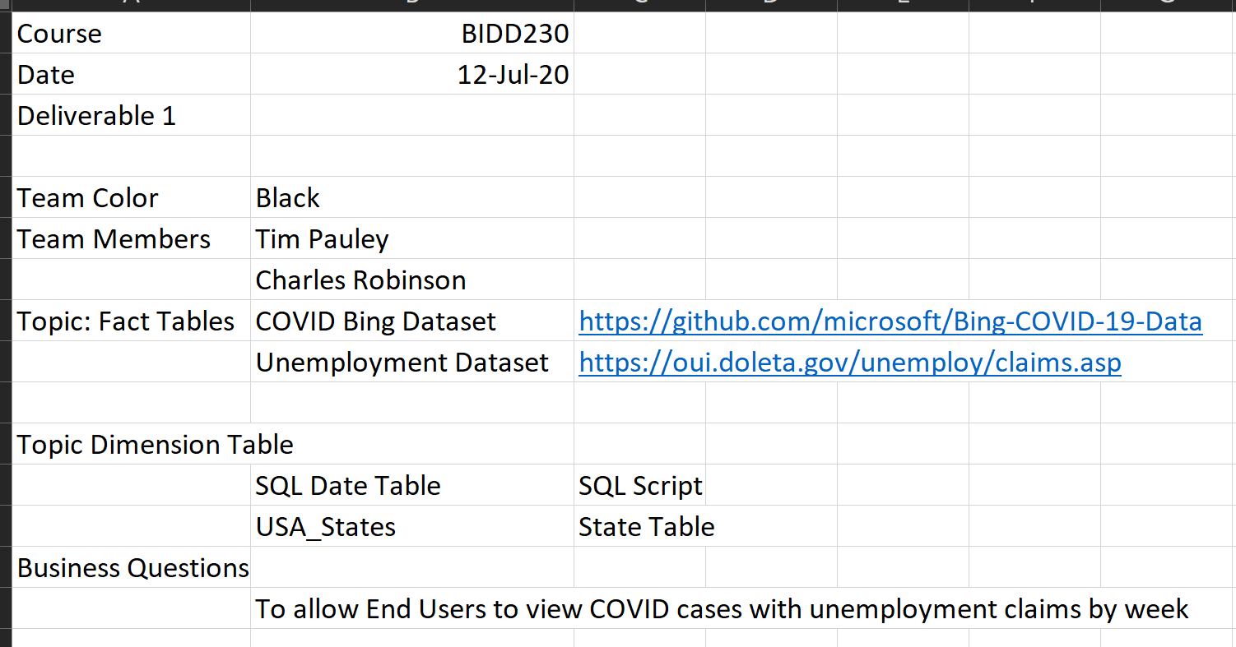

# Deliverable 2: turn into module 9 - create a data warehosue with your project color and Database name: due aug 20, 2020

Step 1: Create a data warehouse with your two datasets and date dimension table. My example below includes a State table. I added this additional table because I would like to slice the data by USA State.

Step 2: Create a local instance of your database

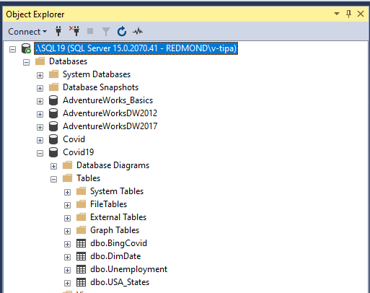

Step 3: Backup your database as an export tier application and put it in a folder named backup. As you can see below, I renamed my database with my team color and name other than COVID. For instance, my additional Fact Table Name is Unemployment. You should rename it something similar depending on the topic you chose.

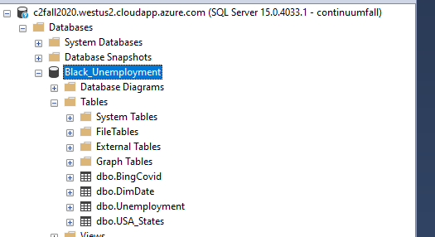

Step 4: The restored version should reside on the class server c2fall2020.westus2.cloudapp.azure.com. This is where you will connect the visualizations.

Step 5: Create a Visio Diagram outlining your project

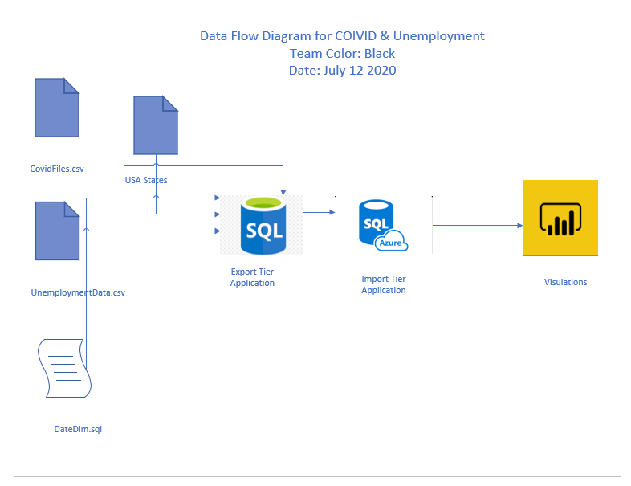

Step 6: You must include a word document with your team members responsibilities during the construction phase of the final and your plan for the presenting. This only needs to be one paragraph

# Deliverable 3: turn into module 10 - create a data visulation with your project color and name: due sept 3, 2020

Step 1: Pick a Visualization Tool we worked with during the course. You can pick Power BI (recommended), Tableau or Jupyter Notebook.

Step 2: Import the dataset into that tool and create:

* One Dashboard
  + Overall Report
    - Three visualizations that include DAX, SQL or Python code for measures.
  + Drilldown Report
    - Three visualizations that include DAX, SQL or Python code for measures.
  + Administration Report
    - Two visualizations DAX, SQL or Python code for measures.

# Example of deliverable 3

**Overall Report**

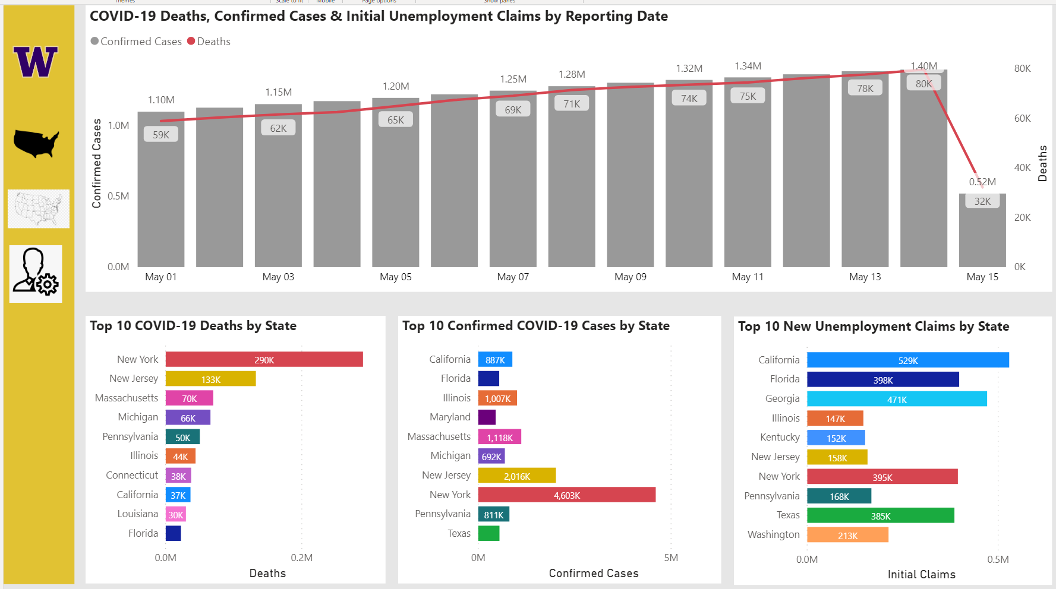

**Drilldown Report**

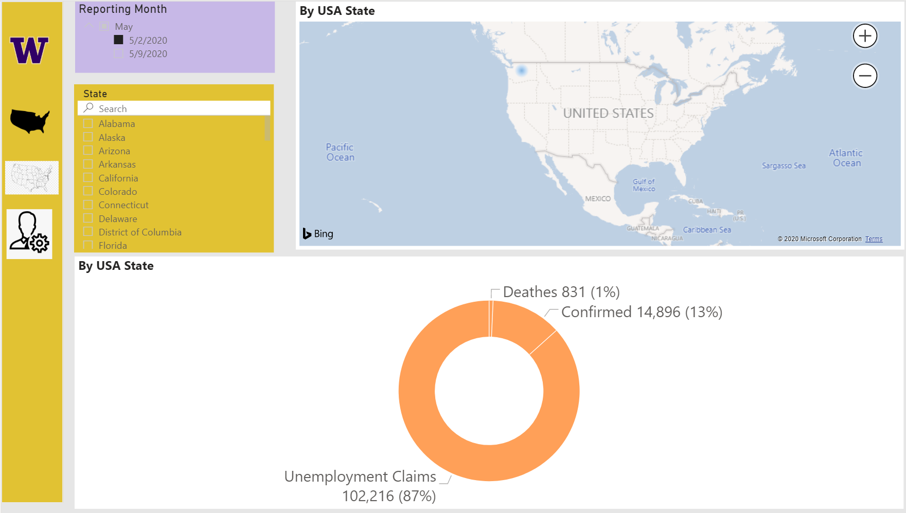

**Administration Report**

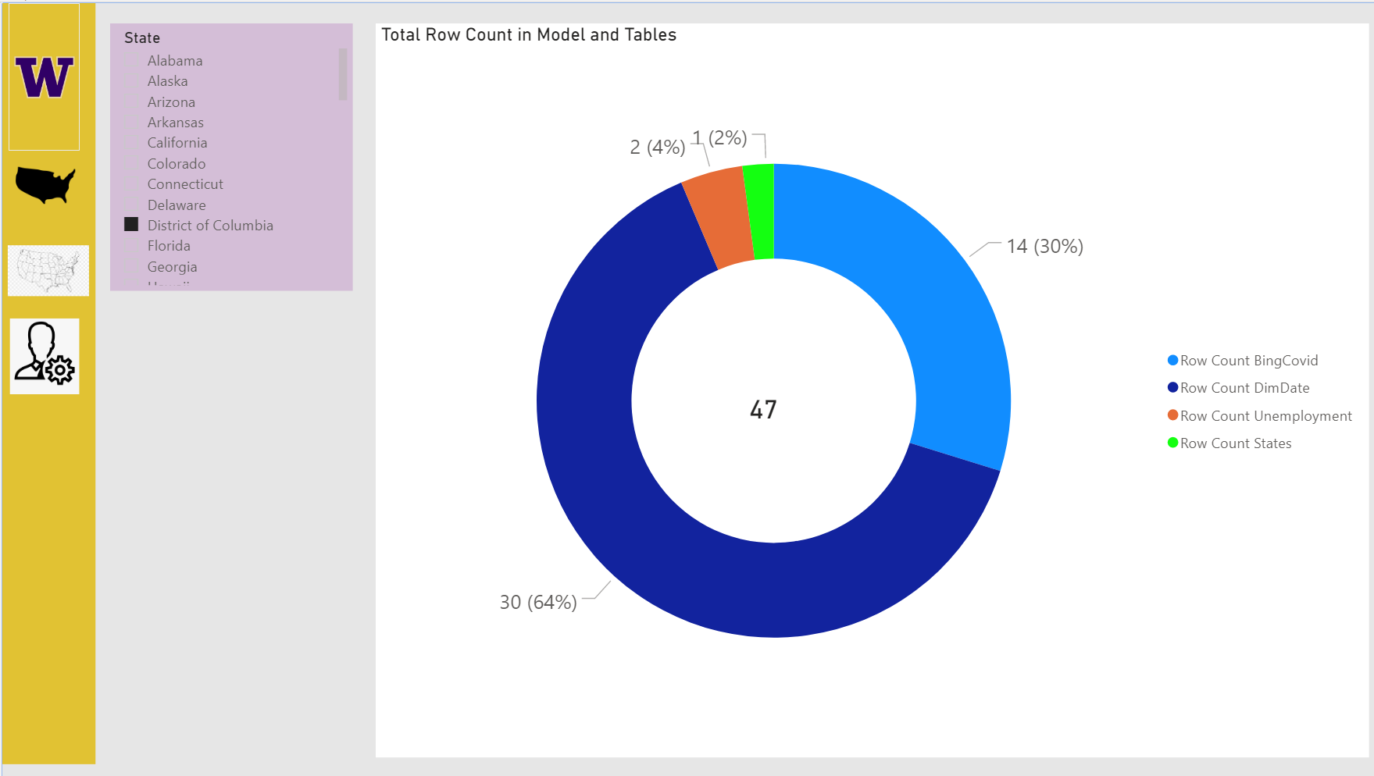

# Write a Paper

Create a Word document that ***outlines how your built your Power BI Application***. This document should be written as a technical support document that new hires can read to understand what the process does and technicians might use to troubleshoot the process. Include screenshots, please. The document should be about 2 to 4 pages (including any pictures) in length. Please use Microsoft Word or something compatible with your paper. As you do so, capture screen-shots of these and place them in your Word document.

# Submit a File to the Canvas site

After you have created your updated **AssignmentFinalYourFnameLname**, place them into one folder and ZIP that folder. Then upload the resulting ZIP file to the Canvas web site.

You’re done!