David Landes

**Restaurant Simulation**

## Design

To create an accurate model of a drive through restaurant, the customers, lines, and stations all needed to be represented. This simulation was designed to account for each of them during a 2-hour period that represents the lunch rush from 11:00 AM to 1:00 PM. Before a customer enters the line, a customer will determine if the wait will be too long based on the length of the line. In this experiment, a customer will balk if more than 7 cars are in line, otherwise they will enter the queue and remain until they reach the end of the line. There are 3 stations at which the customer will interact with the employees: The Order Station, Pay Station, and Pickup Station. Wait time for each station is calculated by a Weibull distributed random variable with a mean representative of the number of actions required. A customer’s wait includes order time, food prep time, pay time, pickup time, and time spent behind other customers in line. Food prep time is started after the order and if it is not ready by the time a customer has reached the pay station, the customer will remain at pickup until food prep has finished. This study will be performed in two different scenarios. Scenario 1 will have 1 order station, 1 pay station, and 1 pickup station. Scenario 2 will consist of 2 order stations, 1 pay station, and 1 pickup station.

## Results

The first test focused on the number of customers who stayed in line as well as the customers who left or balked. To achieve the best performance, a high number of customers must enter the line with the smallest number of people balking and leaving. This simulation used various customer arrival rates to test which rate has the best throughput to balk ratio. The data collected (Figure 1) showed that the restaurant performed best with .5 customers per minute. Over the 2-hour span, 56 customers entered the line and only 4 left. As the rate exceeded .5, throughput remained generally the same, while the amount of balks quickly increased.

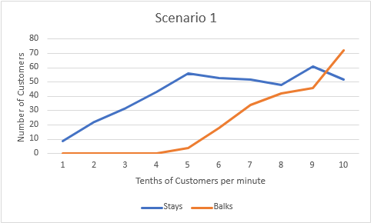

***Figure 1***

The next test focused on the same stay/balk ratio as the previous simulation, but with an extra order station specified in Scenario 2. The restaurant performed best at 0.7 customers per minute (Figure 2). A higher rate increased the number of balks while throughput only grew in small amounts, eventually leading to the throughput levelling off and balking rates overtaking. Over the 2-hours at 0.7 customers per minute, 73 customers entered the line and 9 left. In comparison to Scenario 1, Scenario 2 and the extra order station allowed approximately 20 more customers into the line.

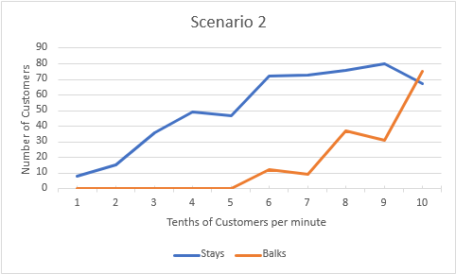

***Figure 2***

The next test evaluated the performance of each station. Over a span of 182 customers, the average time spent ordering was 2.182 minutes, paying was 1.566 minutes, preparing a customer’s order took an average of 4.887 minutes, and about 1.472 minutes for each pickup.

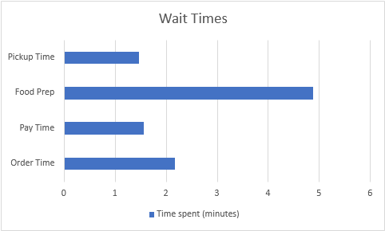

***Figure 3***

## Recommendations

To further optimize this drive through restaurant, the highest priority should be placed on reducing food preparation time. The next highest priority should be adding a second order station. This would be a worthy investment as it could send an extra 20 customers through the drive through. The extra order station was shown to reduce the number of balks in higher rates of customer arrival. However, when the customers are arriving at 0.4 customers per minute or lower, the number of order stations has little affect on customer throughput. An extra order station may not be effective unless higher rates of customers are expected.