**DAVID, LENARD G.**

**BSIS – I102**

**EDM**

**Finals Lab Task 3**

**Task 1. Query Statement**

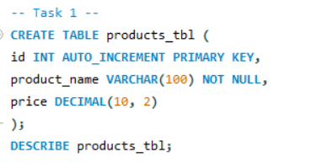

Task 2. Query Statement

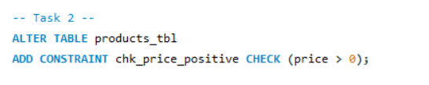

Task 3. Query Statement

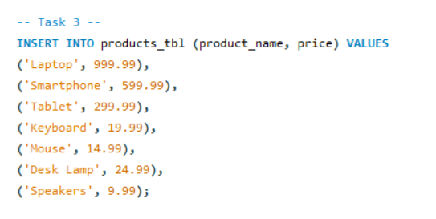Task 4. Query Statement

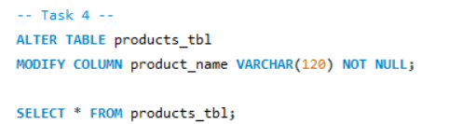

Table Structure

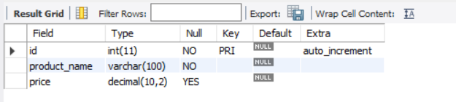

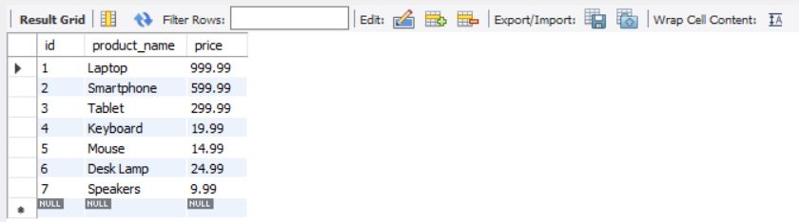

EER Screenshot

