LINGO VR README

LingoVR is an immersive, virtual reality language-learning environment. Our final prototype implements a single, “average bedroom” learning environment with 11 Chinese vocabulary words to learn.

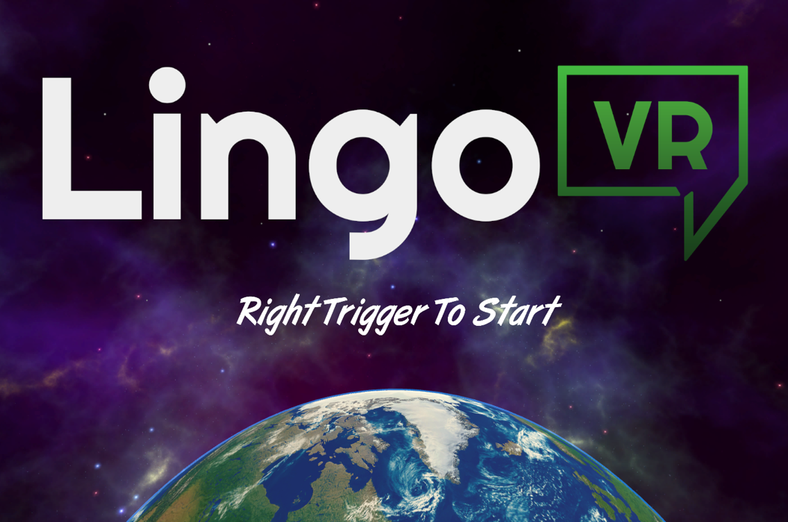

The first scene is called StartMenu.unity and is the “Title Screen” environment for the application. Load this scene to view the LingoVR logo and title sequence. Upon pulling the Vive RIGHT TRIGGER button, the bedroom learning environment will load.

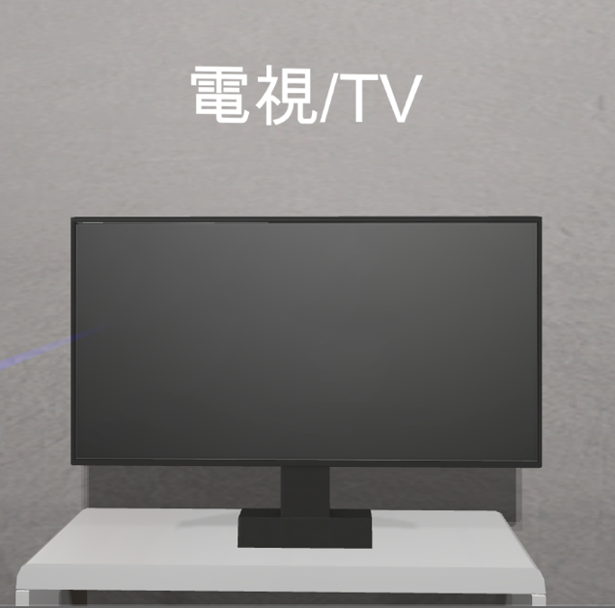

In the bedroom environment, the Vive Left Controller is used for traveling. Point the controller in the desired direction and pull the LEFT TRIGGER, and the player will move in that direction. The Vive Right Controller is used for interacting with the environment. By pointing the blue ray at an object of interest and pulling the RIGHT trigger, the item’s translation will appear and its pronunciation will play. While the white label is visible, press the RIGHT GRIP button to summon the item’s learning menu.

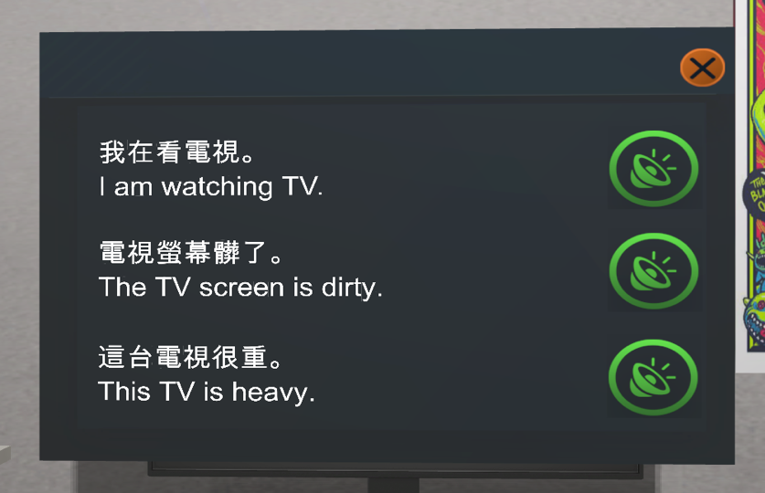

On the learning menu, there will be three related example sentences and their translations. Use the Vive Right Controller and the RIGHT TRIGGER to select any of the green audio buttons to hear the example sentence spoken aloud. To exit the menu, use the right controller and the RIGHT TRIGGER to select the red “X” button.

\***NOTE**: Due to our interaction state machine implementation, the state transitions are one way and move in a single direction. That is: To open the learning menu for an object, you must first display its learning label with the RIGHT TRIGGER, then press the RIGHT GRIP button. To open another object’s learning menu, you must first **close the currently open menu,** display the label of the target object with RIGHT TRIGGER, and then display its menu with RIGHT GRIP.

The following objects in the environment have learning labels and menus:

1. Television
2. Bookshelf
3. Shoes
4. Computer
5. Chair
6. Bed
7. Wardrobe/Closet
8. Desk/Table
9. Lamp
10. Window
11. Door