Project Report

# Project title:

Online mobile shop.

# Website Name:

M-Mobile.

# Project Description:

Our project is designed as an online shop for mobile. Customers can easily register in our website and login in. With categories, users can find different mobiles such smartphone or iPhone in the categories. And with search function, customer can find the exact item they need. With a simple click on the item, customers can browser the detail of the mobile. When they find their favorite mobile, they can add into the cart to check it out. These are the main functions of our website.

# Database Design:

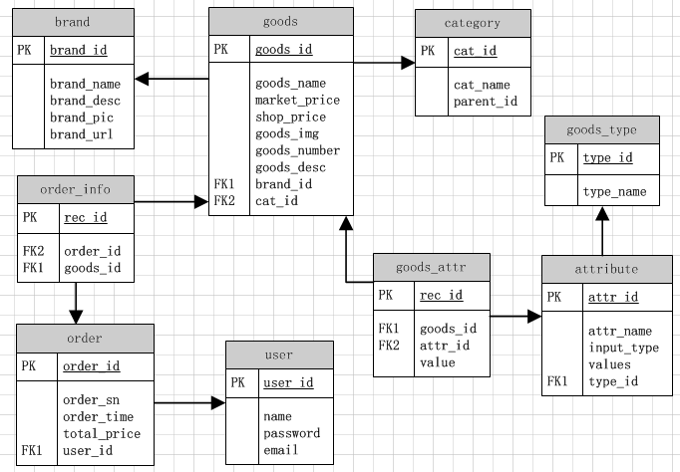

Figure 1. ER model for our project.

# Languages and Frameworks used for implementation:

We use the MVC framework of PHP, CodeIgniter, for the back-site scripting and Ajax, JQuery, JavaScript, HTML and CSS for the front-side.

# Screenshots:

* Search：

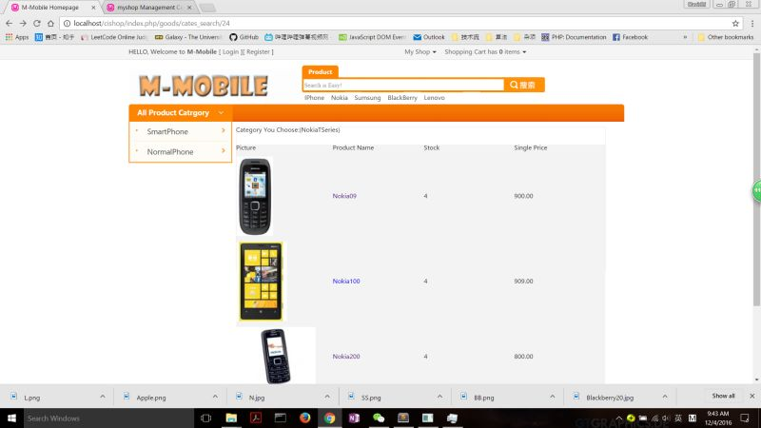

Figure 2.search function of website

* User registration：

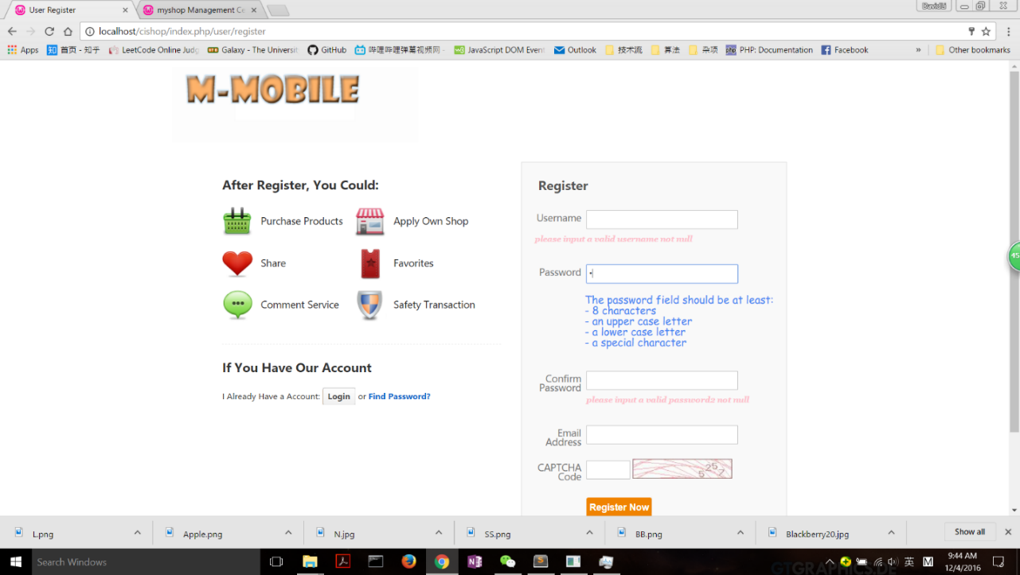

Figure 3. User register page

* Homepage：

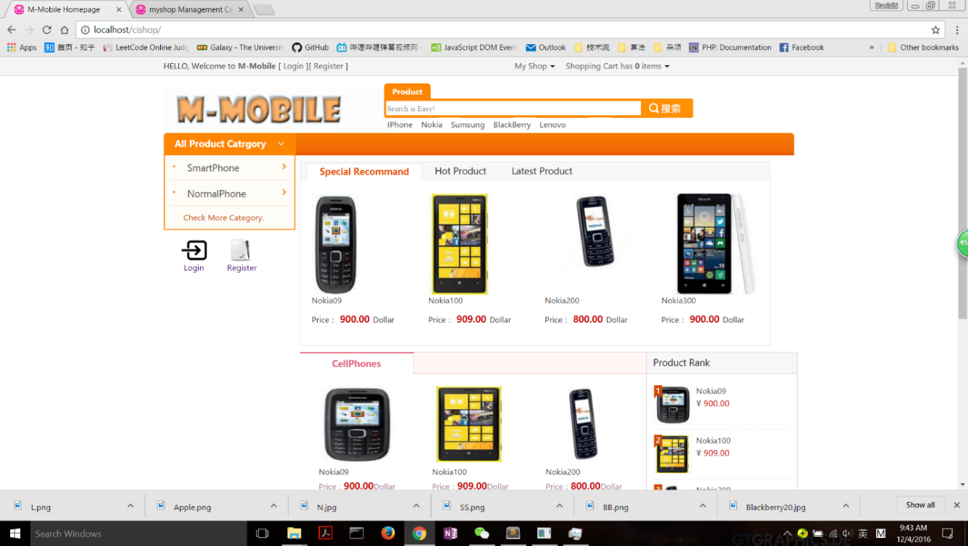

Figure 4. Homepage of website

* Shopping Cart：

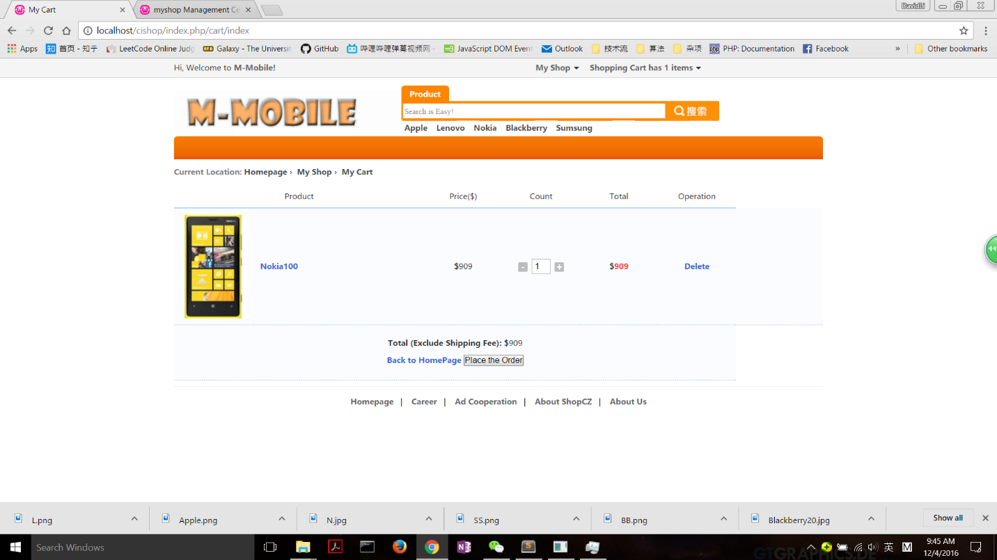

Figure 5. Shopping cart page

* Order History：

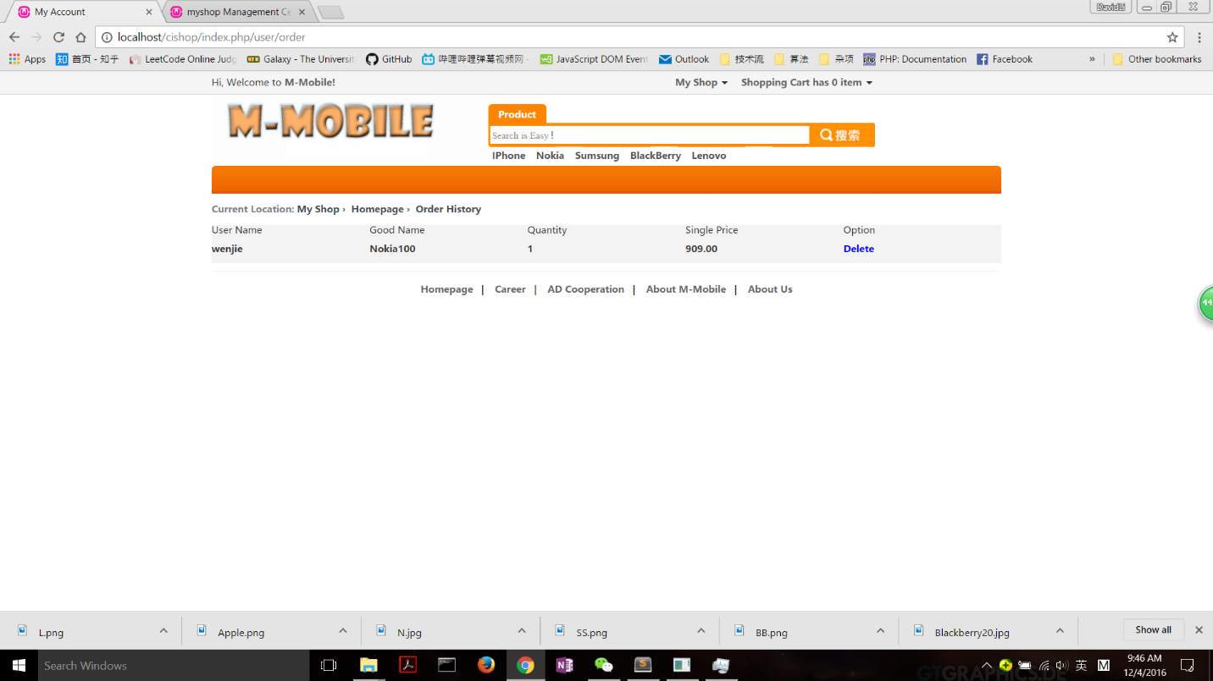

Figure 6. order history page

* Admin Interface:

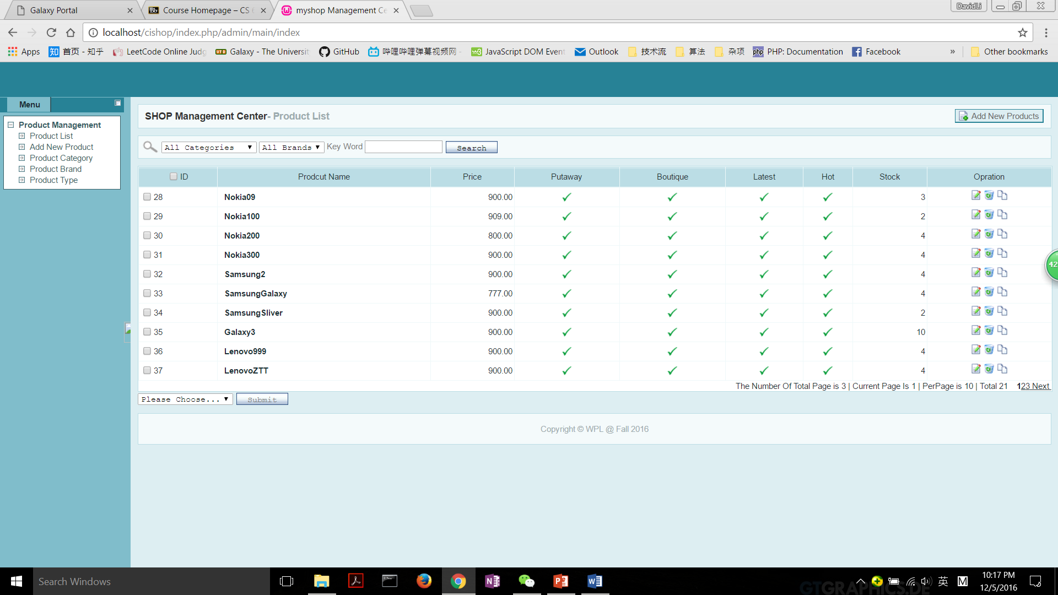

Figure 7. Administrator page

# Team members:

Name: Jingyi Liu, NetID: JXL167130

Name: Wenjie Li, NetID: WXL163530

Name: Fei Zou, NetID: FXZ160630

# Work Division：

Wenjie Li:

* Implemented Deleting Updating Listing Items and Adding new Items for admin users.
* Implemented the cart and checkout.
* Implemented the check of username and email address is it’s already registered with AJAX.
* Implemented user signup function.
* Implemented the search of products.
* Testing.

Fei Zou:

* Implemented the function of checking out all mandatory fields.
* Design the structure of database.
* Implemented the function of hashing user password and storing hashed password in the database.
* Reporting.
* Testing.

Jingyi Liu:

* Designed and modified web pages with css,html, JS.
* Implemented the order history.
* Designed rules to check if the passwords are strong enough.
* Implemented the user login function.
* Implemented the pagination function.
* Testing.

# Notice:

There is a sending email function when user register for an account, which requires a plugin. Currently, I comment out the lines in the “user.php” file which are about sending email. These line are shown as picture following. If you want to verify this function, please add these lines and put the sendemail folder which is contained in the zip file under the root directory. Eg: if you are using WAMP as server, then you should put the sendemail folder under www folder.

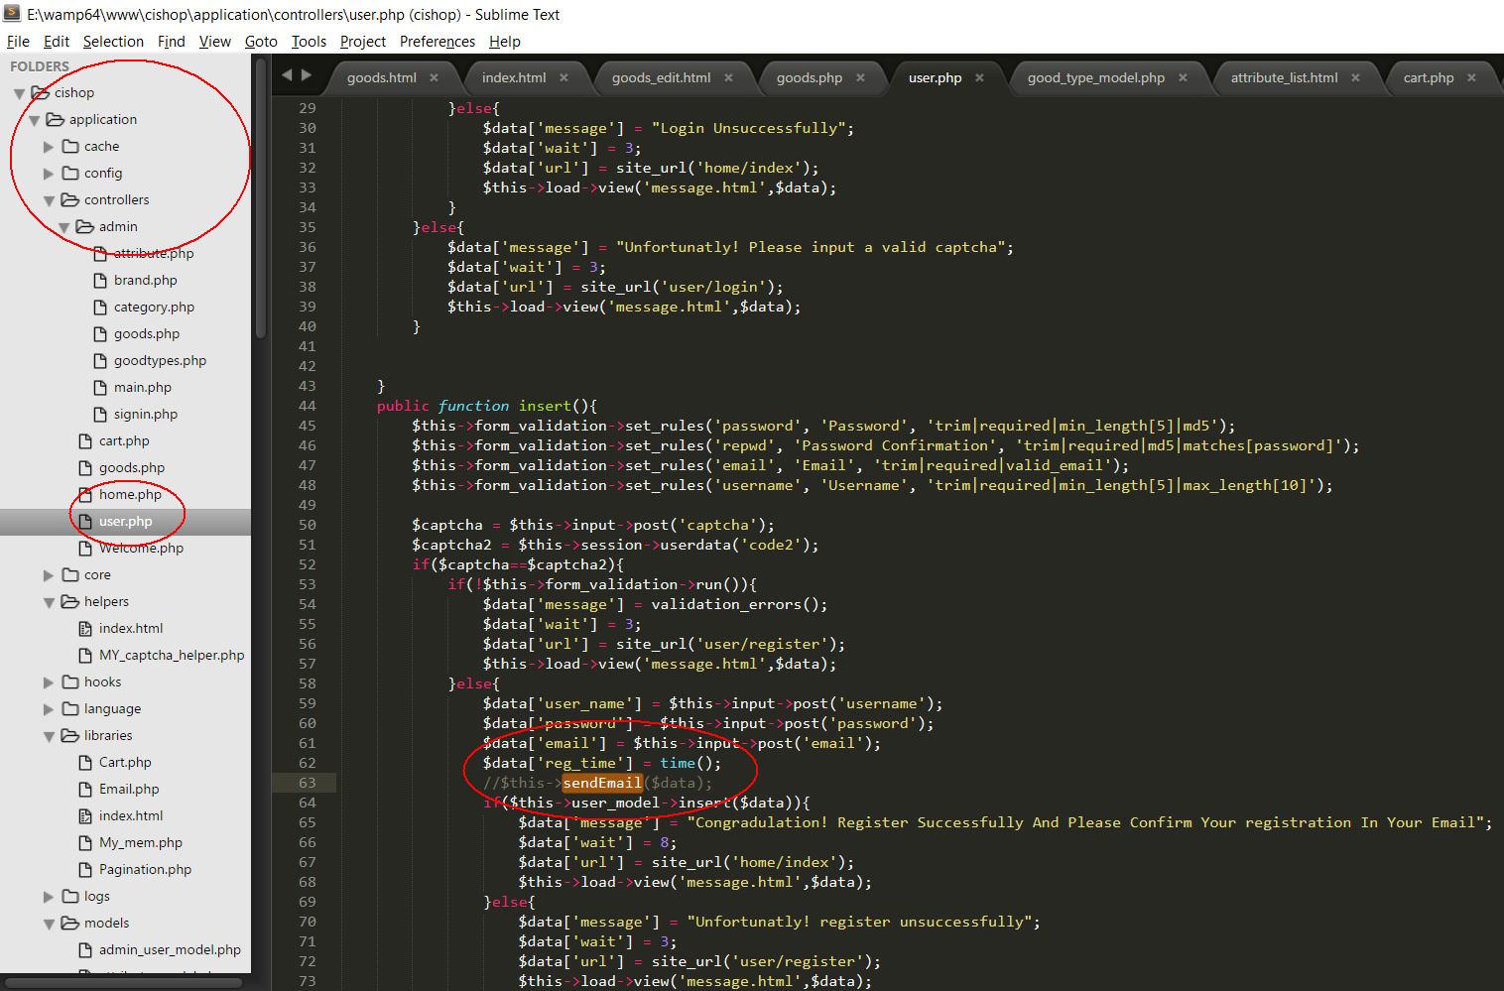

Figure 8. Instruction of testing sendmail function.