刘达伟
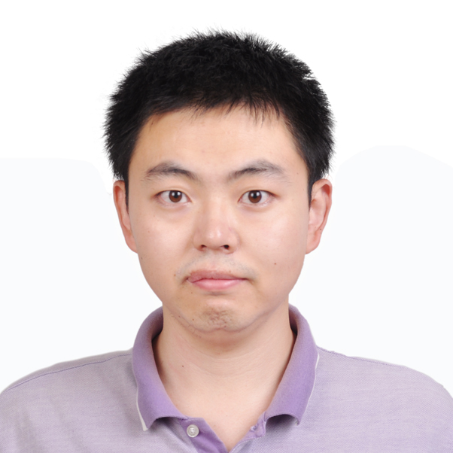
个人信息
性别: 男 出生年月: 1991年08月
籍贯: 山西省晋中市
住址: 陕西省西安市咸宁西路28号 邮编: 710049
联系电话: + (86) 137-2076-5155
邮箱地址: liudawei2015@stu.xjtu.edu.cn 或 dawei3@uablerta.ca
个人主页: https://davidliu-code.github.io/
研究领域
深度学习, 张量分解, 地震信号处理, 和时频分析
技能
Tensorflow, Pytorch, Python, GPU, CUDA, Matlab, and Parallel Computing
教育背景
- 2018年9月 – 2022年9月 (预期) | 导师: 陈文超教授
博士研究生生, 信息与通信工程, 电子与信息学部, 西安交通大学
- 2020年1月 – 2022年7月 (预期) | 导师: Mauricio D. Sacchi
联合培养博士生, 物理系, 阿尔伯塔大学, 加拿大
- 2015年9月 – 2018年7月 | 导师: 陈文超教授
硕士研究生, 电子与通信工程, 电子与信息工程学院, 西安交通大学
- 2009年9月 – 2013年7月 | 毕设导师: 吴潜蛟教授
本科生, 通信工程, 信息工程学院, 长安大学
已录取文章(5篇一作，1篇通讯)
- Dawei Liu, Haoqi Zhang, Xiaokai Wang, Wenchao Chen, Zhensheng Shi, and Zhonghua Zhao, (2022), "Separation of seismic multiple reflection-refraction based on morphological component analysis with high-resolution linear Radon transform," Geophysics (已接收, 二区SCI, IF=2.928, 一作)
- Dawei Liu, Xiangfang Li, Wei Wang, Xiaokai Wang, Zhensheng Shi, and Wenchao Chen, (2022), "Eliminating harmonic noise in vibroseis data through sparsity promoted waveform modeling," Geophysics, 87: V183-V191. (二区SCI, IF=2.928, 一作)
- Xiaokai Wang, Zhizhou Huo, Dawei Liu, Weiwei Xu, and Wenchao Chen, (2022), "A common-reflection-point gather random noise attenuation method based on the synchrosqueezing wavelet transform," Interpretation, 10, SA59-SA67. (四区SCI, IF=1.201, 三作)
- Xiaokai Wang, Dawei Liu*,and Wenchao Chen, "Accelerating seismic dip estimation with deep learning," IEEE Geoscience and Remote Sensing Letters, vol. 19, pp. 1-5, 2022. (二区SCI, IF= 3.966, 通讯作者)
- Dawei Liu, Lei Gao, Xiaokai Wang, and Wenchao Chen, (2021), "A dictionary learning method with atom splitting for seismic footprint suppression," Geophysics, 86, V509-V523. (二区SCI, IF=2.928, 一作)
- Yanglijiang Hu, Dawei Liu, Xiaokai Wang, Zhonghua Zhao and Wenchao Chen, "Attenuation of the multiple reflection-refraction in 2-d common-shot gather via random-derangement-based fx cadzow filter," IEEE Geoscience and Remote Sensing Letters, vol. 19, pp. 1-5, 2022. (二区SCI, IF= 3.966, 二作)
- Dawei Liu, Zheyuan Deng, Cheng Wang, Xiaokai Wang and Wenchao Chen, "An unsupervised deep learning method for denoising prestack random noise," IEEE Geoscience and Remote Sensing Letters, vol. 19, pp. 1-5, 2022. (二区SCI, IF= 3.966, 一作)
- Dawei Liu, Wei Wang, Xiaokai Wang, Cheng Wang, Jiangyun Pei and Wenchao Chen, "Poststack seismic data denoising based on 3-d convolutional neural network," IEEE Transactions on Geoscience and Remote Sensing, vol. 58, no. 3, pp. 1598-1629, 2020. (一区SCI, IF= 5.6, 一作)
在审文章
- Dawei Liu, Xiaokai Wang, Xiaohai Yang, Haibo Mao, Mauricio D. Sacchi, and Wenchao Chen, (2021), " Efficient seismic scattered noise attenuation in OVT domain: application of deep learning," Geophysics. (大修已提交, 二区SCI, IF= 3.966, 一作)
- Dawei Liu, Mauricio D. Sacchi, and Wenchao Chen, (2022), "Five-dimensional seismic reconstruction based on low tensor network rank via randomized parallel matrix factorization," IEEE Transactions on Geoscience and Remote Sensing. (大修中, 一区SCI, IF= 5.6, 一作)
- Dawei Liu, Wei Wang, Xiaokai Wang, Zhensheng Shi, Mauricio D. Sacchi ,Wenchao Chen, (2022), "Improving sparse representation with deep learning: a workflow for separating strong background interference," Geophysics. (审稿中, 二区SCI, IF= 3.966, 一作)
会议文章(5篇一作EI)
- Dawei Liu, Xiaohai Yang, Xiaokai Wang, Haibo Mao, Mauricio D. Sacchi, and Wenchao Chen, (2021), "Deep learning for prestack strong scattered noise suppression," SEG Technical Program Expanded Abstracts : 1601-1605. (EI, 一作)
- Haoqi Zhang, Dawei Liu, Xiaokai Wang, and Wenchao Chen, (2021), "Attenuation of multiple reflection-refraction in tau-p domain via morphological component analysis," SEG Technical Program Expanded Abstracts : 2974-2978. (EI, 二作)
- Qinlong Hou, Dawei Liu, Xiaokai Wang, and Wenchao Chen, (2021), "Adaptive DAS coupling noise suppression based on local MCA," SEG Technical Program Expanded Abstracts : 2979-2983. (EI, 二作)
- Chen Zhao, Li Jiang, Xiaokai Wang, Dawei Liu, Zhensheng Shi, and Wenchao Chen, (2021), "Prestack seismic noise attenuation based on 3D CWT," SEG Technical Program Expanded Abstracts : 2834-2838. (EI, 四作)
- Dawei Liu, Wenchao Chen, Mauricio D. Sacchi, and Hongxu Wang, (2020), "Should we have labels for deep learning ground roll attenuation?," SEG Technical Program Expanded Abstracts : 3239-3243. (EI, 一作)
- Dawei Liu, Zheyuan Deng, Xiaokai Wang, Wei Wang, Zhensheng Shi, Cheng Wang, and Wenchao Chen, (2020), "Must we have labels for denoising seismic data based on deep learning?," SEG Global Meeting Abstracts : 31-35.
- Dawei Liu, Xiaokai Wang, Zhensheng Shi, Yanhui Zhou, and Wenchao Chen, (2019), "A convolutional neural network for seismic dip estimation," SEG Technical Program Expanded Abstracts : 2634-2638. (EI, 一作)
- Dawei Liu, Xiaokai Wang, Wenchao Chen, Yanhui Zhou, Wei Wang, Zhensheng Shi, Cheng Wang, and Chunlin Xie, (2019), "3D seismic waveform of channels extraction by artificial intelligence," SEG Technical Program Expanded Abstracts : 2518-2522. (EI, 一作)
- Dawei Liu, Wei Wang, Wenchao Chen, Xiaokai Wang, Yanhui Zhou, Zhensheng Shi. Random noise suppression in seismic data: what can deep learning do? [C].2018 SEG Annual Meeting, 2018. [Cited by Professor Öz Yilmaz in his new book: Land seismic case studies for near-surface modeling and subsurface imaging, 2021.] (EI, 一作)
- Fen Zhang, Dawei Liu, Xiaokai Wang, Wenchao Chen. Random noise attenuation method for seismic data based on deep residual network[C]. 2018 CPS/SEG Annual Meeting, 2018.
- Siqi Chi, Wenchao Chen, Lu Zhang, Dawei Liu, Jianyou Chen. Three-dimensional seismic texture attributes analysis based on removed strong background noise[C]. 2018 CPS/SEG Annual Meeting, 2018.
- Jianyou Chen, Wenchao Chen, Xiaokai Wang, Dawei Liu. The DAS coupling noise removal using alternating projection iteration with united sparse transforms. 2018 CPS/SEG Annual Meeting, 2018.
- Jianyou Chen, Yuefeng Pang, Wenchao Chen, Lei Gao, Dawei Liu. The analysis of space dimensionality reduction error in SVD filtering algorithm with application to VSP wavefield separation [C].2018 CPS/SEG Annual Meeting, 2018.
已完成项目
1.基于地层结构相似区域的三维叠后地震资料智能去噪方法研究 (横向, 主要参与人)
简介：深度学习在图像去噪领域获得了极大的成功。在图像经典去噪网络DnCNN的基础上，本项目使用三维的空间卷积核构建了3D-DnCNN网络来捕捉地震数据的三维空间相关性。此外，训练样本的质量对于网络的处理结果有着重大影响。本项目提出了一种样本筛选策略将样本中对于弧状噪声压制不彻底的样本剔除，从而使得深度学习网络同时具有良好的弧状噪声的压制能力。
2.基于张量列的五维地震数据插值方法 (横向, 主要参与人)
简介：张量列 (Tensor train) 在交通数据补全上面发展迅猛。基于此，本项目使用最小化张量列的秩来补全地震数据。为了提升补全速度，本项目还提出了一种随机化的低秩矩阵分解方法。实际数据表明，本项目方法可以高效地补全五维地震数据。
获得荣誉
博士研究生国家奖学金，西安交通大学，2020年10月
优秀研究生干部，西安交通大学，2016年9月
优秀毕业生，长安大学，2013年7月
优秀共产党员，长安大学，2012年7月
优秀学生干部，长安大学，2012年5月

