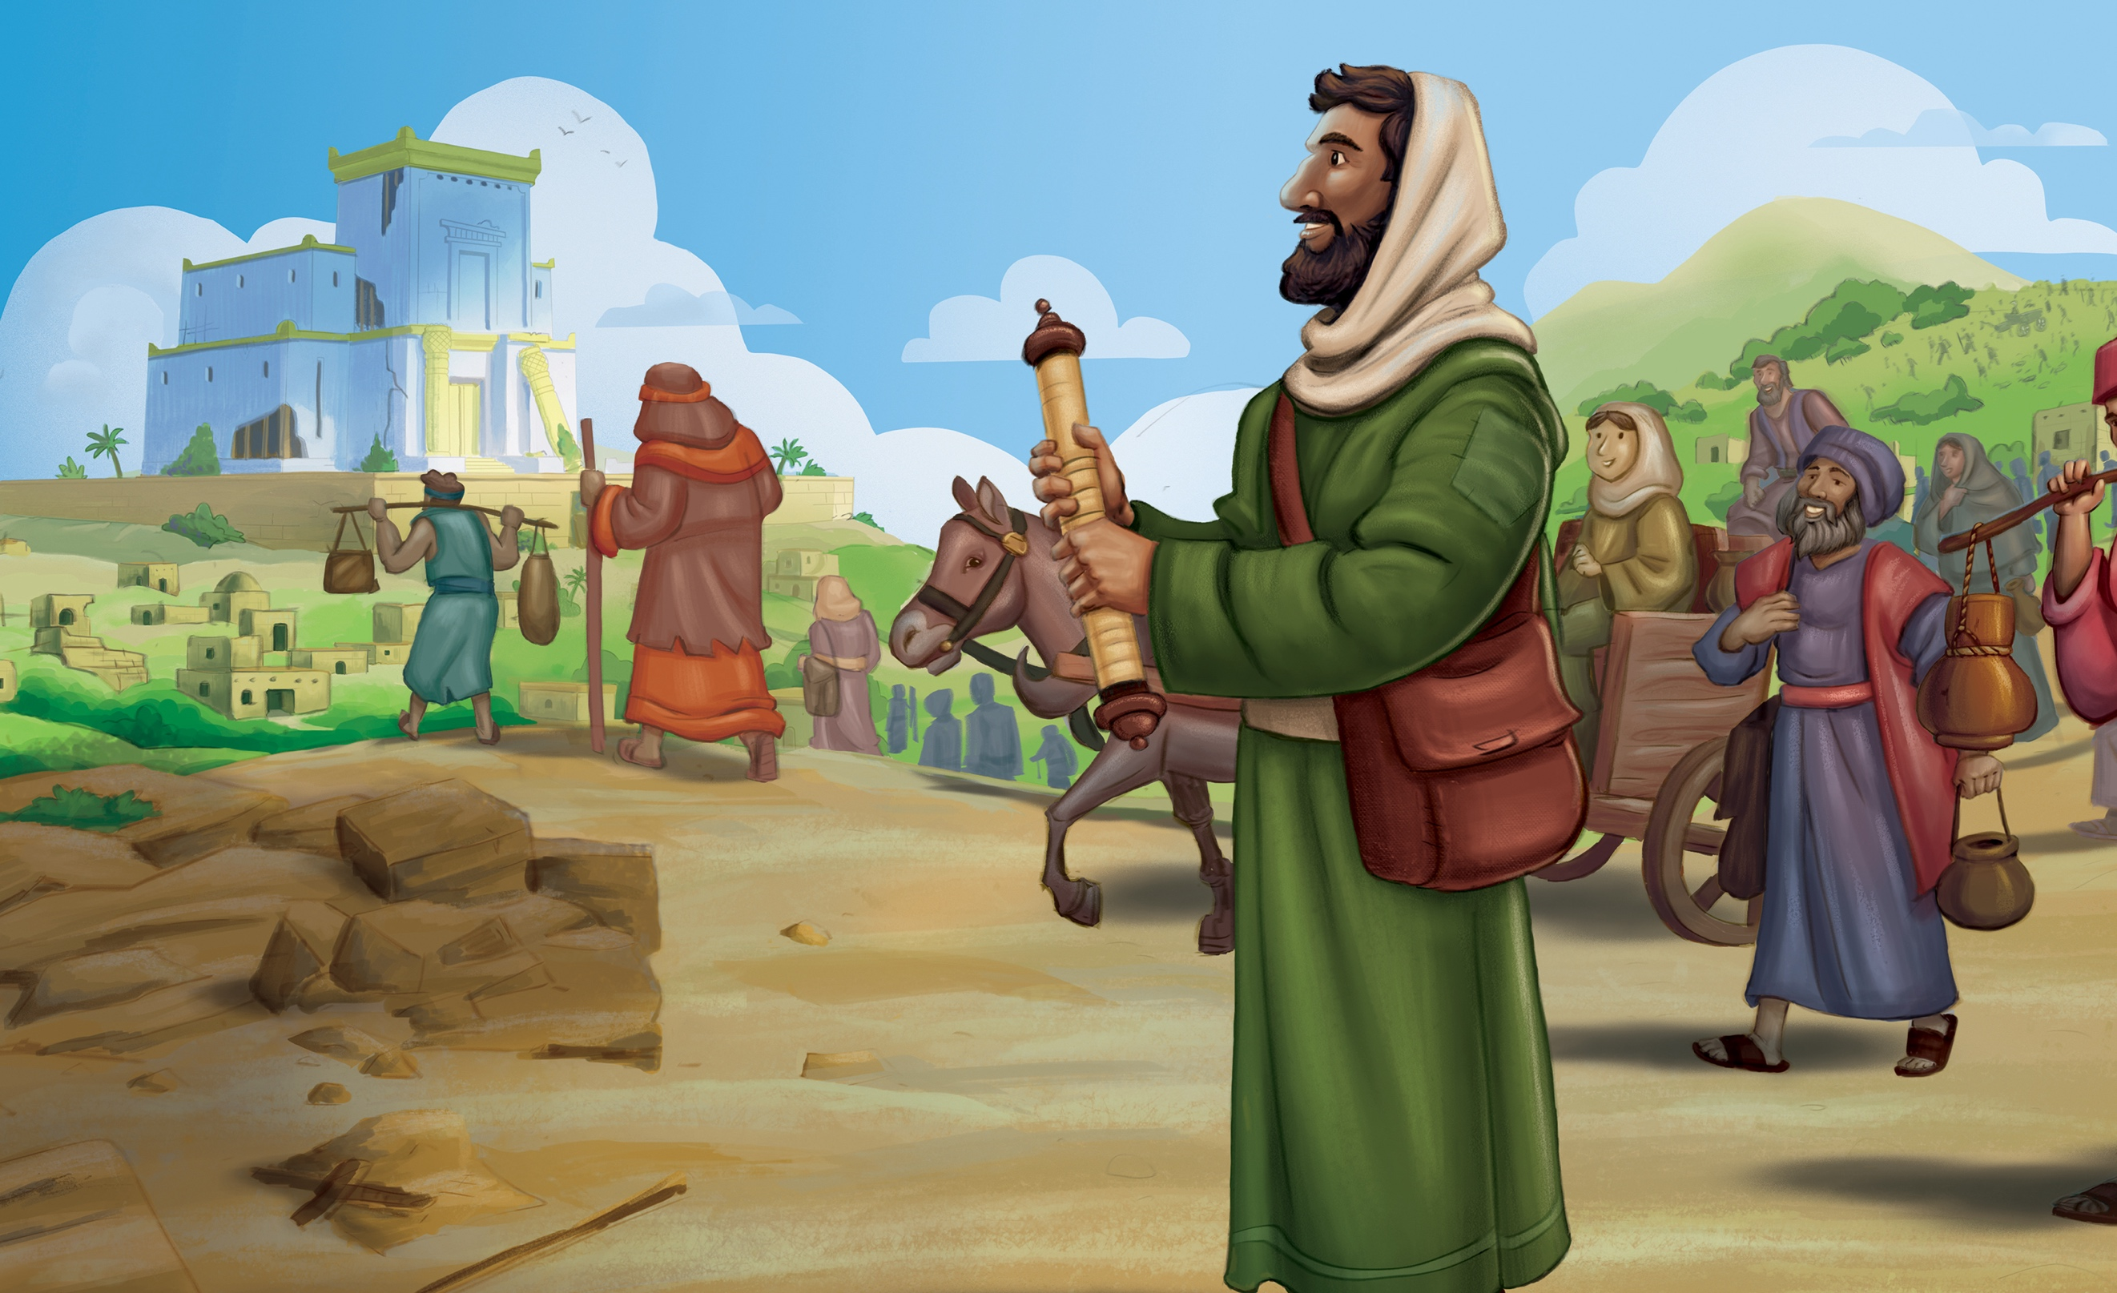

{{HEADER}}

**GOD DELIVERED  
HIS PEOPLE**

EZRA 1

**KEY PASSAGE:**

Jeremiah 17:7

**BIG PICTURE QUESTION:**

**Can God be trusted?** Yes, God cannot lie or ever be wrong, so we can trust whatever He has said.

**CHRIST CONNECTION:**

God always keeps His promises. God chose to use King Cyrus in His plan to graciously deliver His people from exile. King Cyrus’ action to free the people reminds us of Jesus, whom God chose to rescue sinners and bring us to our true home in His kingdom of grace.

**SMALL GROUPS**

1. Discussion
2. Pray

**LARGE GROUP**

1. **Welcome** the kids
2. **Countdown 30** seconds to clean up
3. **Game**
4. **Worship** with 2 songs
5. **Intro / Review**
6. **In the Bible**
7. **Bible Story Video**
8. **Memory Verse**
9. **Pray**
10. **Break into small groups** by age
11. **Large Group Activity**

**LARGE GROUP MATERIALS**

* Memory Cards – 1 set per team
* Bible per team

## LEADER BIBLE STUDY

*Please read before Sunday morning*

*Rest*. It’s a word that means something different to each one of us. For some, rest brings to mind a desire to momentarily break from the chaos of life to sleep, relax, and even recover. For others, rest is an unrealistic hope as they navigate a non-stop schedule of busyness. Yet for others, the word rest suggests an uneventful, quiet life of the mundane.

Whether it’s a nap, a vacation, or boredom that comes to mind when you think of rest, it is likely a word that triggers some desire or response. And almost universally, the thought of rest is primarily physical.

The Bible teaches that rhythms of rest are good and necessary for us; however, the Bible’s primary teaching on rest refers to the spiritual. In Ezra 1, God’s remnant is instructed to recover from their exile with … work.

This work would be costly, demanding, and long; but this work actually aimed to bring rest. How could this be so? Because their work was to build the place where they would encounter the living God, the One who gives true rest to the soul.

In Matthew 11:28-30, Jesus said, “Come to me, all of you who are weary and burdened, and I will give you rest. Take up my yoke and learn from me, because I am lowly and humble in heart, and you will find rest for your souls. For my yoke is easy and my burden is light.”

Though God clearly teaches us the benefits of a rhythm of physical rest—Sabbath—He ultimately uses physical rest to teach us of our need for a greater spiritual rest—a rest for our soul, a rest that comes in understanding that we cannot save ourselves. God has done everything necessary through Christ to save us. We are invited into this rest through the substitutionary atonement of Jesus.

**PEOPLE TO KNOW**

**Ezra:** priest and scribe sent to Jerusalem by the king of Persia. Ezra led reforms after Israel’s return from exile and helped preserve and teach Jewish law.

The people of God are instructed in Ezra 1 to begin the arduous work of building God’s dwelling place. But this work would ultimately lead to their place of rest—in God’s presence.

We too may find ourselves physically exhausted from the demanding work of faithfully following the Lord in the context He has placed us. But take heart, there is rest for your soul in the presence of God and the person of Christ.

## LARGE GROUP

**To the teacher**, have fun! Use this guide to guide you through the content. Don’t worry about reading it verbatim, make sure to drive the main points home.

### Welcome the kids!

Slide

**Teacher** should stay at the door welcoming kids and connecting with parents. Connect new kids to another volunteer. Identify another adult to facilitate a game from the Welcoming Activities list.

**Small group leaders** should play with the kids, engage with them, and let them know you’re happy they’re here! Look for new kids passed on by the teacher, make sure they’re engaged. Keep an eye for shy kids on their own, have a seat next to them and ask them how their week went.

### 30 Second Countdown

Slide

Start the countdown about 5-7 minutes after start. As it’s playing, let kids know it’s time to clean up.

**SAY** *It’s time to clean up! Please put away the games, and let’s have a seat over here.*

Ask all the kids to come sit in front of the TVs.

**Game**

Slide (will transition to next slide)

Play the game on the screen, the game includes its own instructions.

### Why we worship

Use the memory verse to pull out the truths of God’s love and promises. Encourage the kids to worship God in response.

**SAY** *“But blessed is the one who trusts in the Lord, whose confidence is in him.' Jeremiah 17:7*

**SAY** *Let’s worship God because we trust in him!*

### Worship

Slide (will automatically progress to next slides)

Worship God! Make sure to stand with the kids and follow along by singing and doing the hand motions.

At the end of worship, ask kids to have a seat.

### Intro

Slide

**SAY** *Good morning, I’m so happy you are all here! How many are you doing the 30 day challenge?! That’s awesome! Keep up the great work!!*

**SAY** *We have a really big question this week…*

Slide

***Can God be Trusted?*** *What does trust mean? [collect answers]* *Trust means believing that someone can and will do what they say they will do. So, with that definition, can we trust God?*

Slide

**SAY** *YES! God can be trusted****! God cannot lie or ever be wrong, so we can trust whatever He has said.*** *Not only does God always keep His word, He is powerful enough to do everything He says. God’s promises would be impossible for us to keep, but God always keeps His promises. Let’s say our big picture question and answer together.* ***Can God be trusted? Yes, God cannot lie or ever be wrong, so we can trust whatever He has said****.*

**IN THE BIBLE**

Slide

**SAY** *How do we know we can trust God? Where do we learn about God? [The Bible!] Who brought their Bibles this week? Excellent, thank you! Everyone else, remember to bring your Bibles! We will be reading them every week. If you do not own a Bible, let me know and we’ll get you one!*

**SAY** *The Bible is really important. It teaches us all about God, and there’s a really important thing we need to know about God: we can trust him, no matter what! The Bible is full of stories and examples of how God can be trusted!*

**SAY** *Let’s find out where today’s Bible story is today!*

Slide

Starting in Genesis, read with the class to Ezra.

Slide

**SAY** *We’re in Ezra today!*

**SAY** *God’s people did not always trust God. Even when God spoke to them through the prophets, they ignored His words and disobeyed. God told them what would happen if they did not repent of their sin. God told them they would be sent away in exile. Did God’s words come true? [Allow responses.] Yes, they did. But God also promised that He would be with them. And He was! God also promised that He would send Immanuel into the world so God’s people could be with Him forever.* ***Can we trust God? Yes, God cannot lie or ever be wrong, so we can trust whatever He has said.*** *Let’s see our Bible story to learn more about how we can trust God.*

**BIBLE STORY VIDEO**

Play the video. (auto transition to next slide)

**CHRIST CONNECTION**

### SAY *God always keeps His promises. God chose to use King Cyrus in His plan to graciously deliver His people from exile. King Cyrus’ action to free the people reminds us of Jesus, whom God chose to rescue sinners and bring us to our true home in His kingdom of grace.*

### Memory Verse

**SAY** *We have a new memory verse! This one is short and sweet.*

Slide

**SAY** *'But blessed is the one who trusts in the Lord, whose confidence is in him. ’Jeremiah 17:7*

Make sure you hear them all reading it, do it a couple of times. Try a silly voice or two with them.

Slide

### Pray

**SAY** *Let’s pray and then we’ll break into small groups.*

Let your prayer be focused on praising God for his goodness, for caring for us, and for fulfilling his promises in Jesus.

### Break into small groups

**SAY** *We’re going to head into small groups for only about 10 minutes, then regroup and have some fun with a game! Go grab your Bible as I put you into groups.*

Attempt to group the kids by age/grade. Ask kids to keep their Bibles with them.

**Make sure to track time,** give the small groups a shout out warning at 8 minutes to start in on prayer requests and prayer. Give a 30 second shout out as we near 10 minutes. Don’t rush, if a group runs a little long that’s okay.

**LARGE GROUP ACTIVITY**

Materials Needed:

* Partial Printed Verse Cards – 1 set per team
* Bible per team

Keep the kids in their small groups for this game.

**SAY** *Let’s play a little memory game! You have a series of cards your small group leader is going to lay out facing down. Just like the memory match game, you have to take turns matching. To make it challenging, each person will match on their own, away from the group! After you flip your cards over, if it’s not a match, come back to your group and let them know what you found and where. Then the next person goes.*

**SAY** *Once you have a match, bring it back to your group and start to piece together the memory verse!*

If a group is having a hard time, their leader can point to options after a little bit. If they have most or all of their cards and can’t piece together the verse, put it back up on the screen (next slide)

**SMALL GROUPS – 8-10 MINUTES**

**DISCUSSION – 5-6 MINUTES**

**SAY** *Why did God remove His people from the land and let them go back 70 years later?*

Explain to kids that God’s people had turned away from Him and continued to reject His words. Lead kids to think about how God disciplines those He loves and wants them to turn back to Him. Remind kids that God kept His promise of hope and brought His people home.

Choose a volunteer to read Jeremiah 30:11.

**SAY** *Why do difficult situations often help us turn back or grow closer to God?*

Encourage kids to remember that difficult situations give us an opportunity to trust God in ways we might not otherwise. Remind kids that we can trust God to provide everything we need.

Choose a volunteer to read Matthew 6:25.

**SAY** *How should we respond when God proves His faithfulness?*

Remind kids that we should respond in worship and thanksgiving. Encourage kids to think of ways they could show God their gratitude—thanking God in prayer, singing in worship, serving others, giving to those in need, etc.

Choose a volunteer to read Psalm 100:4-5

**PRAY - 3 MINUTES**

**Make sure to pray!** Ask the kids what they would like to pray for. Say a prayer for each kid, try to say each of their names, don’t worry so much about repeating their prayer requests. Make sure to thank God for his love and mercy through sending Jesus to die for our sins.