PRE-SUBMISSION MANUSCRIPT
Separating Cardiac Signal from Acquisition Shortcuts in Coronary Artery Disease Classification from Public Cardiac MRI JPEG Exports
A cross-fitted Attention U-Net localization and confounding-diagnostic study
David Vlad Marghidan
[Co-authors, affiliations, author order, ORCID identifiers, and corresponding-author email must be confirmed before submission]
Submission status and scope
- Prepared as a Research Article-style preprint draft for direct submission to Research Square.
- The attached simplified notebook implements the core pipeline and seven experiments (FULL, AU1, AU5, AU6-AU9). Extended AU10-AU26 and HN1-HN5B diagnostics were generated in preceding project notebooks and logs and require a versioned archive before public posting.
- The work is an internal retrospective methodological analysis. It is not an externally validated clinical diagnostic system and should not be described as one.

Metadata field | Proposed entry
Article type | Research Article (methodological / medical-imaging AI study)
Short title | Acquisition shortcuts in CAD cardiac MRI classification
Version date | 21 September 2026
Primary subject areas | Artificial intelligence; medical imaging; cardiology; machine learning methodology
Keywords | cardiac MRI; coronary artery disease; Attention U-Net; shortcut learning; acquisition confounding; nested cross-validation; patient-level evaluation

Prepared from the attached Kaggle notebook and the locked results documented across the current CAD cardiac MRI project conversations.

Abstract
Background: Public cardiac magnetic resonance (CMR) image exports can contain many slices but few independently identifiable subject units, creating a high risk of slice leakage and acquisition-related shortcut learning. We evaluated whether high internal discrimination of coronary artery disease (CAD) in a public JPEG release was localized to the heart or remained explainable by export and acquisition characteristics.
Methods: This retrospective internal analysis used 63,425 JPEG images arranged into 30 folder-defined subject units (16 Normal, 14 Sick) and 2,859 folder-defined series proxies. Demographic and scanner metadata were unavailable. Manual heart masks were quality-audited. A 4.12-million-parameter Attention U-Net was trained in five subject-excluded folds using only accepted manual masks, then used to generate cross-fitted masks. Frozen ImageNet-pretrained EfficientNet-B0 embeddings were pooled hierarchically from slice to series to subject. Logistic regression was evaluated with nested subject-level cross-validation. Prespecified diagnostics included exact ROI complements, identical-slice manual-versus-automatic mask comparisons, near-heart/far-extracardiac/fixed-periphery controls, an acquisition-style-only model, fixed-landmark intensity harmonization, and training-only residualization against provenance features.
Results: The principal Attention ROI model retained 59,351 quality-valid, final-valid slices and achieved an internal out-of-fold AUROC of 0.964 (95% patient-bootstrap CI, 0.893-1.000); the exact complement achieved 0.830 (0.652-0.964), with a paired AUROC difference of 0.134 (0.022-0.281). On 2,047 identical quality-valid manual-mask slices, the manual ROI and cross-fitted automatic ROI achieved AUROCs of 0.955 and 0.964, respectively (difference -0.009; 95% CI, -0.080 to 0.054). However, an acquisition/export-style-only control achieved AUROC 0.906. Fixed-landmark harmonization retained high ROI discrimination (0.946), while provenance-only classification achieved 0.763. Training-only residualization reduced the harmonized ROI AUROC to 0.817 (0.643-0.960), which was not clearly higher than provenance alone. A 200-replicate patient-label permutation test for the primary ROI model yielded an empirical one-sided P value of 0.00498.
Conclusions: The public release contains a reproducible internal CAD-associated signal that is stronger inside the Attention-defined cardiac region than in its exact complement. Nevertheless, strong acquisition, peripheral, and provenance controls, together with the drop after deconfounding, show that the apparent performance cannot be interpreted as evidence of clinically generalizable cardiac pathology recognition. External subject-level validation on independently curated DICOM studies with sequence, scanner, demographic, and reference-standard metadata is required.
Keywords: cardiac magnetic resonance; coronary artery disease; Attention U-Net; shortcut learning; acquisition confounding; nested cross-validation; reproducibility
Principal interpretation
- The high AUROC is an internal association in one small public export, not an externally validated clinical probability.
- Mask source was not the main performance bottleneck on identical manually annotated slices.
- The central scientific result is the confounding diagnosis: acquisition/export information remains predictive and materially explains the ROI representation.

Abbreviations
Abbreviation | Meaning
AUPRC | Area under the precision-recall curve
AUROC | Area under the receiver operating characteristic curve
CAD | Coronary artery disease
CI | Confidence interval
CMR | Cardiac magnetic resonance
DICOM | Digital Imaging and Communications in Medicine
LR | Logistic regression
OOF | Out-of-fold
PCA | Principal component analysis
ROI | Region of interest
QC | Quality control

1. Introduction
Coronary artery disease is commonly assessed through a combination of clinical history, functional testing, anatomical imaging, and invasive or non-invasive reference standards. Cardiac magnetic resonance can capture anatomy, function, perfusion, tissue characterization, and scar, but these signals depend strongly on acquisition sequence, scanner settings, timing, field of view, and post-processing. In a public image export, those same factors can become shortcuts: a model may distinguish how images were acquired or exported rather than the pathology of interest.
The source publication associated with the public dataset describes 63,648 CMR images and 1,224 original participants. By contrast, the public folder release used in this project yielded 63,425 readable images grouped into only 30 Directory_* units. This mismatch is scientifically consequential. A random image split would place nearly identical slices from the same folder-defined unit in both training and validation sets and would produce a misleading estimate of generalization. The present work therefore treats the Directory_* folder as the indivisible statistical grouping unit while explicitly avoiding the claim that the public folder hierarchy reconstructs the 1,224 original participants described in the source paper.
The project evolved from a high-performing ROI classifier into a systematic investigation of why the classifier performed well. The final questions were: (1) does discrimination remain when every split is performed at the folder-defined subject-unit level; (2) is the signal concentrated inside a manually supervised, cross-fitted cardiac localization; (3) does automatic mask quality explain the result; and (4) how much of the representation can be predicted from acquisition, export, image-count, and provenance variables?
We designed a leakage-resistant pipeline that combines manual-mask auditing, patient-excluded Attention U-Net segmentation, frozen EfficientNet feature extraction, hierarchical aggregation, nested cross-validation, and a large family of negative and deconfounding controls. The intended contribution is methodological: to show how an apparently strong medical-imaging classifier can be stress-tested before it is interpreted as clinically meaningful.

2. Methods

2.1 Study design and data source
This was a retrospective secondary analysis of a publicly available cardiac MRI JPEG export. The analysis used the folder labels Normal and Sick as the binary outcome. No age, sex, symptoms, scanner manufacturer, field strength, acquisition protocol, sequence label, treatment, comorbidity, or patient-level reference-standard metadata were available in the release. Consequently, subgroup analyses and clinical calibration could not be performed.
The dataset was discovered recursively under class folders. Each Directory_* folder was used as a folder-defined subject unit, and its immediate child folder was treated as a series proxy; deeper subfolders did not create new units. Images located directly under Directory_* were assigned to a __ROOT__ proxy. This contract was fixed before model evaluation. The term “subject unit” is used throughout to distinguish the computational grouping unit from the original clinical participants reported in the source article.
Dataset-identity safeguard
Before public posting, the authors should archive the dataset release fingerprint, document the direct correspondence that motivated the 30-unit grouping, and obtain permission if that correspondence is cited. The manuscript must not imply that the Kaggle folder hierarchy independently verifies the 1,224 participants in the source article.

2.2 Cohort and leakage audit
The final discovery pass identified 30 folder-defined subject units (16 Normal and 14 Sick), 63,425 images, and 2,859 series proxies. Each image received a stable token formed from subject unit, series proxy, and a SHA-256 digest of its relative path. The same token linked the image, manual mask, cross-fitted prediction, quality record, and feature-bank row.
An exact decoded-pixel audit in the extended research suite identified 1,094 duplicate groups, with no exact group spanning two subject units or the two class labels. A complete perceptual-hash radius search identified 24 cross-unit candidate edges, including 10 cross-label candidates; these were treated as screening candidates rather than confirmed duplicates. No image-level split was used. Outer classification folds and segmentation folds were formed only from whole subject units.

2.3 Image standardization and quality control
Images were read in grayscale. Uniform dark edge runs were removed conservatively only when their mean, standard deviation, and dark-pixel fraction satisfied fixed thresholds, while retaining at least 60% of each native dimension. The remaining content was robustly scaled using the 1st and 99th percentiles, resized with preserved aspect ratio so that its long side occupied 240 pixels, and centered on a 256×256 canvas. A binary content mask separated anatomical pixels from added padding.
Quality control was label-blind. On a 128-pixel thumbnail, the pipeline measured dynamic range, Laplacian variance as a blur indicator, and median-absolute residual noise after Gaussian smoothing. Global thresholds were combined with per-subject 3rd-percentile blur and 97th-percentile noise thresholds. The resulting quality flag was used for manual-mask eligibility and for Attention-feature construction, but never used the class label.

2.4 Manual annotation audit and review sampling
Manual masks were stored as binary PNG files keyed by the image token. Masks were resized with nearest-neighbour interpolation and rejected when unreadable, empty or nearly empty, nearly full-frame, unmatched to the manifest, or associated with a quality-invalid image. Only accepted, non-empty, quality-valid masks could train the Attention U-Net. The current core notebook enforces at least 800 accepted masks, representation in all five segmentation folds, and masks from more than five subject units.
The review interface was implemented with an HTML5 canvas and standard Jupyter widgets for Kaggle compatibility. It supports drawing, erasing, saving, accepting the automatic mask, clearing, deleting, and logging every action. Novel review queues exclude images that already have any manual-mask file, images reviewed in the same round, quality-invalid images, and images perceptually similar to any manually reviewed image. Importantly, an intentionally empty manual mask is rejected from training but still acts as a review reference, thereby preventing selection of near-duplicate low-information images. New samples are distributed round-robin across subject units and series proxies, with a default maximum of 10 new images per unit per round.

2.5 Cross-fitted Attention U-Net
The segmentation network was a four-level Attention U-Net with Group Normalization, SiLU activation, bilinear upsampling, and attention gates on encoder-decoder skip connections. With 24 base channels, the implementation contained 4,123,385 trainable parameters. Training used 256×256 grayscale inputs, deterministic flips, small rotations, contrast and brightness perturbations, AdamW optimization, and a loss equal to 0.5 binary cross-entropy plus 0.5 soft Dice loss.
Segmentation was cross-fitted in five deterministic subject-level folds. For target fold k, all images and masks from units assigned to k were excluded from training and threshold calibration. A deterministic 20% subset of the remaining subject units formed the validation cohort for early stopping and threshold selection. The threshold was chosen from 0.25 to 0.70 to optimize patient-balanced Dice while penalizing invalid predictions. Thus, every downstream image from a target subject unit was localized by a model that had not been trained on any image from that unit.
After thresholding, the largest connected component was retained and a morphological closing was applied. Masks were rejected when their area was below 0.3% or above 65% of the image, peak probability was below 0.50, or boundary contact was excessive. Invalid masks were re-evaluated with horizontal-flip test-time averaging and fixed threshold offsets. The pipeline intentionally provided no central-square fallback; unresolved failures remained invalid and entered the review queue.

2.6 Feature views and frozen encoder
For each quality-valid image, the pipeline created aligned 224×224 views. The primary view (AU1) retained intensities inside a 15-pixel-dilated Attention support and set the exterior to zero after region-only percentile normalization. AU5 used the exact non-padding complement of that support and normalized it independently. AU6 and AU7 substituted accepted manual supports for ROI and complement, respectively. AU8 and AU9 used cross-fitted Attention supports on exactly the same images as AU6 and AU7, enabling a fair mask-source comparison without changing the image set.
A frozen ImageNet-pretrained EfficientNet-B0 converted each view to a 1,280-dimensional embedding. No class label was used during image preprocessing, mask prediction, feature extraction, or pooling. Within each subject unit, slice embeddings were averaged within each series proxy and the resulting series means were averaged with equal weight, preventing long series from dominating solely through slice count.

2.7 Classification and statistical analysis
Classification used one feature vector per subject unit. Five stratified outer folds generated pooled out-of-fold predictions. Within each outer training cohort, three-fold inner cross-validation selected the inverse regularization parameter C from 0.01, 0.1, 1, and 10. Standardization and PCA retaining 95% of training variance were refit inside every inner and outer training partition. The classifier was class-balanced liblinear logistic regression. A decision threshold was selected from inner out-of-fold training scores using Youden’s index and then applied unchanged to the outer fold.
Primary metrics were AUROC, AUPRC, Brier score, sensitivity, specificity, accuracy, F1 score, positive predictive value, and negative predictive value. AUROC and other patient-level metrics were assigned 95% nonparametric bootstrap intervals with 2,000 resamples. Model comparisons used paired patient-bootstrap differences. The extended suite repeated nested splits over 10 seeds and performed 200 patient-label permutations for the primary model as a signal and implementation sanity test. These procedures quantify internal uncertainty but do not replace external validation.

2.8 Confounding and localization diagnostics
The extended project suite added controls beyond the seven-mode simplified notebook. Near-heart, far-extracardiac, and fixed-shape peripheral views used frozen cross-fitted masks and identical retained rows. An acquisition-style-only model used label-blind global intensity summaries, JPEG size, image-quality indicators, padding/geometry, and image/series-count structure but no cardiac-localized EfficientNet representation. Label-blind fixed-landmark histogram canonicalization produced harmonized ROI and complement representations. Finally, a training-only residualization model predicted the harmonized ROI PCA scores from provenance features using Ridge regression; the classifier received only the residual scores. The Ridge penalty and logistic-regression C were selected jointly inside inner subject-level cross-validation, and no validation-unit provenance was used to fit the residualizer.

2.9 Relationship between the attached notebook and the extended suite
The attached notebook is a compact Kaggle execution package. It implements dataset discovery, quality auditing, manual-mask auditing, five-fold cross-fitted Attention U-Net training and prediction, the manual review loop, frozen EfficientNet feature extraction, hierarchical pooling, nested evaluation, and seven experiment modes: FULL_IMAGE, AU1, AU5, and AU6-AU9. It does not include the complete code paths for AU10-AU26 or HN1-HN5B. Those controls are supported by saved results from preceding project notebooks and are reported here because they materially change the scientific interpretation. Before public posting, the exact notebooks, environment, output summaries, and hashes that generated those controls must be archived as supplementary material.
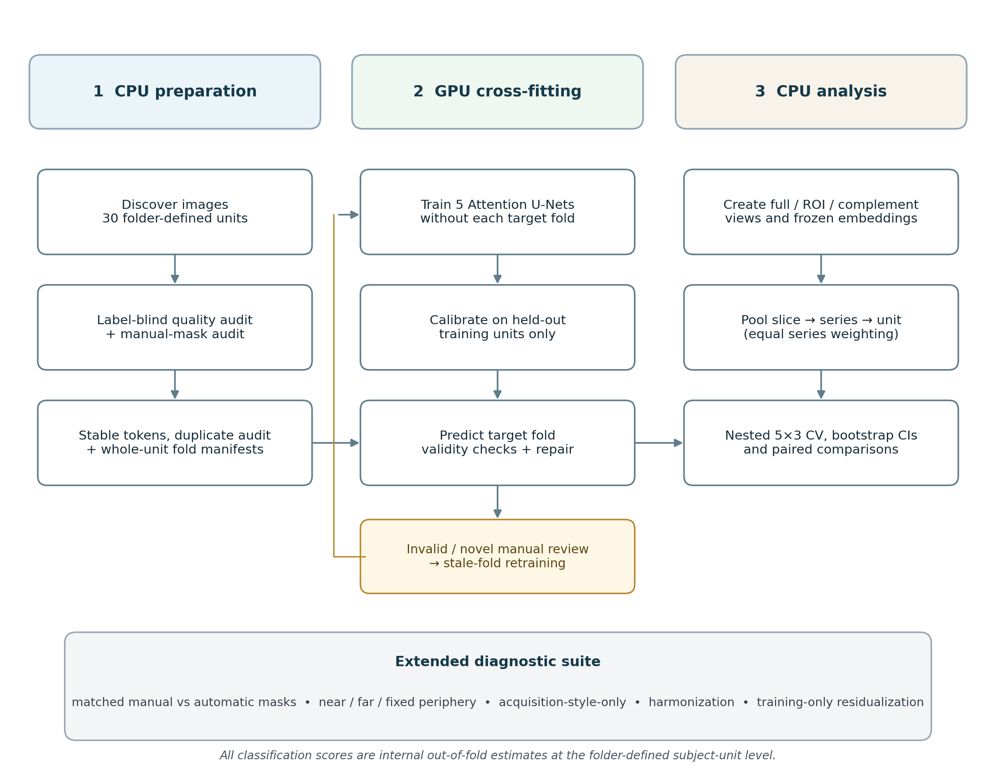
Figure 1. End-to-end pipeline and diagnostic structure. The attached notebook covers the core CPU-GPU-CPU path and seven principal feature modes; the bottom diagnostic row summarizes extensions from the broader project suite.

3. Results

3.1 Cohort, images, and usable feature rows
The public release contained 63,425 discovered images across 30 folder-defined subject units and 2,859 series proxies. The class distribution was 16 Normal and 14 Sick. The primary Attention-feature bank retained 59,351 images after label-blind quality control and final mask-validity checks. No demographic or scanner subgroup could be described because such metadata were absent.
The exact-duplicate audit found no cross-unit exact pixel duplicate and no exact duplicate crossing the class labels. Perceptual-hash candidates remained a review signal only. The fixed five-fold outer manifest contained six subject units per fold; the first fold contained four Normal and two Sick units, and each other fold contained three units per class.

3.2 Primary ROI and exact-complement models
The cross-fitted Attention ROI model (AU1) achieved an internal out-of-fold AUROC of 0.964 (95% CI, 0.893-1.000), AUPRC 0.961, sensitivity 0.929, specificity 0.875, and F1 0.897. The independently normalized exact complement (AU5) achieved AUROC 0.830 (0.652-0.964), AUPRC 0.844, sensitivity 0.786, specificity 0.875, and F1 0.815. The paired AUROC difference was 0.134 (0.022-0.281), supporting stronger discrimination in the Attention-localized representation while also demonstrating substantial information outside it.
Across 10 repeated nested split assignments, AU1 had a median AUROC of 0.951, interquartile range 0.944-0.965, and range 0.924-0.973. In 200 patient-label permutations with the split structure held fixed, the observed AUROC was 0.964, the null median was 0.489, and the empirical one-sided P value was 0.00498. This supports the existence of a stable dataset association, but it does not identify whether the association is pathological, anatomical, or acquisition-related.

3.3 Manual versus automatic localization on identical images
The final matched comparison used 2,047 non-empty, quality-valid manual-mask images from all 30 subject units. The Attention mask was valid on all 2,047 matched images. On this exact image subset, the manual ROI (AU6) achieved AUROC 0.955 and the cross-fitted automatic ROI (AU8) achieved 0.964. The manual-minus-automatic difference was -0.009 (95% CI, -0.080 to 0.054). Manual and automatic complements achieved 0.759 and 0.732, respectively, with a difference of 0.027 (-0.062 to 0.121).
The matched automatic ROI exceeded its matched automatic complement by 0.232 (95% CI, 0.063-0.429). The manual ROI exceeded its manual complement by approximately 0.196 (95% CI, 0.045-0.380). These findings indicate that localization matters, but the marginal classification effect of replacing the cross-fitted mask with the manual mask was not distinguishable in this small cohort. Therefore, increasing the number of manual masks alone is unlikely to resolve the principal generalizability problem.

3.4 Extracardiac and acquisition controls
The exact complement could still contain near-heart anatomy and patient-specific holes in the predicted mask. The extended suite therefore decomposed it into a near-heart ring, a far-extracardiac region, and a fixed-shape periphery. Their AUROCs were 0.857, 0.844, and 0.808, respectively. None of the paired differences among these controls and the full complement clearly excluded zero. A bottom-right peripheral quadrant retained a repeated-split median AUROC of approximately 0.821. This pattern is inconsistent with a signal confined to the myocardium or coronary territory.
The acquisition/export-style-only model (AU19), which contained no cardiac-localized EfficientNet embedding, achieved AUROC 0.906 in the locked split and a 10-repeat mean of 0.833. When the AU1 subject embeddings were residualized against the AU19 feature vector entirely within training partitions, AUROC fell to 0.719. The unresidualized AU1 model exceeded this residualized model by 0.246 (95% CI, 0.071-0.429). These results show that a large fraction of the apparently cardiac representation can be predicted from acquisition and export characteristics.

3.5 Harmonization, fixed budget, and provenance residualization
Fixed-landmark histogram canonicalization retained a high ROI AUROC (HN1, 0.946; 95% CI, 0.848-1.000), while its exact complement remained predictive (HN2, 0.817; 0.629-0.969). A deterministic fixed-budget variant using at most 12 series and eight slices per series per subject unit achieved AUROC 0.848 (0.683-0.982), approximately 0.098 lower than the full harmonized ROI. This decrease indicates that series and slice volume, and therefore protocol sampling, contributed to the apparent performance.
A provenance-only model based on native geometry, JPEG size, quality, padding, and image/series counts achieved AUROC 0.763 (0.567-0.924). The primary fold-local deconfounded model (HN5A) first standardized and reduced HN1 embeddings by training-only PCA, predicted those scores from provenance by training-only Ridge regression, and classified only the residual scores. HN5A achieved AUROC 0.817 (0.643-0.960), AUPRC 0.811, sensitivity 0.857, and specificity 0.625. It was 0.129 lower than HN1 (paired 95% CI, -0.299 to -0.004) and only 0.054 higher than provenance alone (95% CI, -0.183 to 0.317). Thus, the study did not establish a statistically separable cardiac signal beyond provenance after deconfounding.
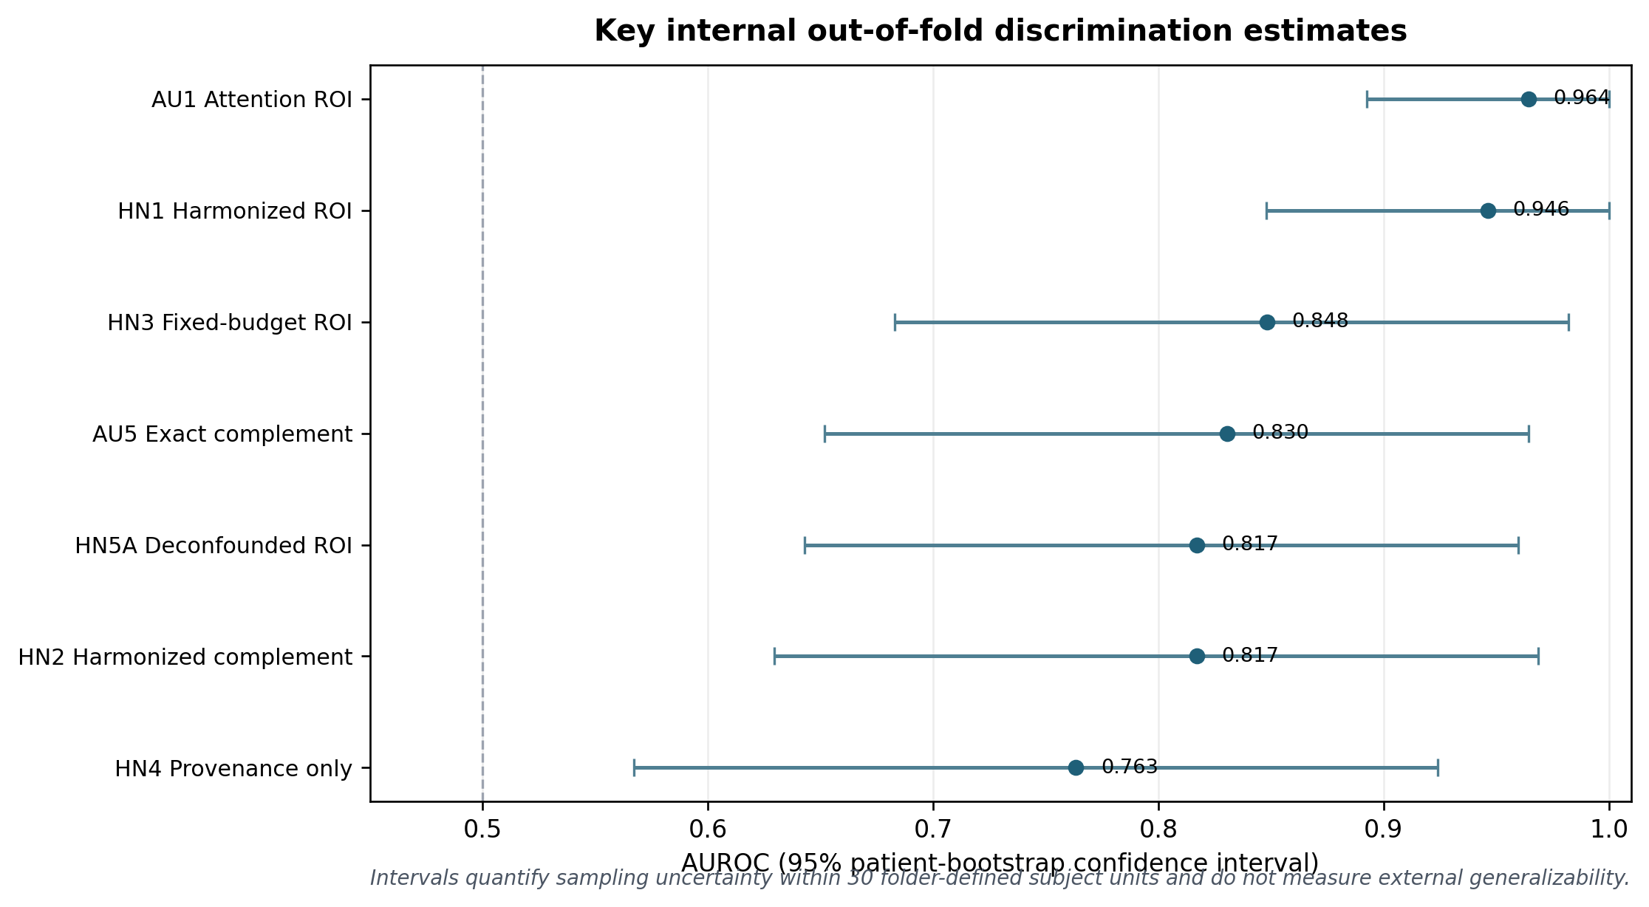
Figure 2. Key internal AUROC estimates. AU1 and HN1 are high, but the complement and provenance controls are also predictive, and training-only deconfounding (HN5A) substantially reduces discrimination.
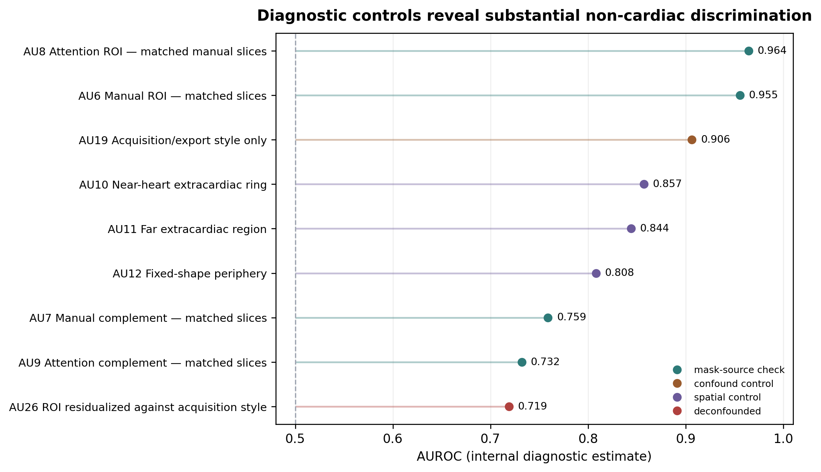
Figure 3. Diagnostic control AUROCs. Manual and automatic ROIs behave similarly on the same images, while acquisition, extracardiac, and peripheral controls retain substantial discrimination. Point estimates without displayed confidence intervals are internal diagnostics and should not be read as clinical performance claims.

3.6 Consolidated numerical results
ID | Representation | Analysis set | AUROC (95% CI) | AUPRC | Interpretation
AU1 | Cross-fitted Attention ROI | 30; 59,351 slices | 0.964 (0.893-1.000) | 0.961 | Primary internal model
AU5 | Exact Attention complement | 30; 59,351 slices | 0.830 (0.652-0.964) | 0.844 | Substantial non-ROI signal
AU6 | Manual ROI, matched subset | 30; 2,047 slices | 0.955 | not extracted | Same images as AU8
AU8 | Attention ROI, matched subset | 30; 2,047 slices | 0.964 | not extracted | No clear loss versus manual
AU7 | Manual complement, matched subset | 30; 2,047 slices | 0.759 | not extracted | Same images as AU9
AU9 | Attention complement, matched subset | 30; 2,047 slices | 0.732 | not extracted | Matched complement
AU10 | Near-heart extracardiac | 30 | 0.857 | not extracted | Frozen diagnostic
AU11 | Far extracardiac | 30 | 0.844 | not extracted | Frozen diagnostic
AU12 | Fixed-shape periphery | 30 | 0.808 | not extracted | Frozen diagnostic
AU19 | Acquisition/export style only | 30 | 0.906 | not extracted | No cardiac embedding
AU26 | AU1 residualized against AU19 | 30 | 0.719 | not extracted | Training-only residualizer
HN1 | Fixed-landmark harmonized ROI | 30; 59,351 slices | 0.946 (0.848-1.000) | 0.951 | Harmonization alone
HN2 | Fixed-landmark complement | 30; 59,351 slices | 0.817 (0.629-0.969) | 0.832 | Complement remains predictive
HN3 | Fixed-budget harmonized ROI | 30; 1,877 slices | 0.848 (0.683-0.982) | 0.796 | Sampling-volume sensitivity
HN4 | Provenance only | 30 | 0.763 (0.567-0.924) | 0.738 | Geometry/export/counts
HN5A | HN1 residualized from HN4 | 30 | 0.817 (0.643-0.960) | 0.811 | Primary deconfounded model
HN5B | HN3 residualized from HN4 | 30 | 0.665 | not extracted | Fixed-budget deconfounded diagnostic

CI = patient-bootstrap confidence interval. “Not extracted” means that the value was not available in the locked project summary used to assemble this manuscript and must not be guessed. AU10-AU26 and HN1-HN5B require the extended archived suite for reproduction.

4. Discussion

4.1 Main findings
The pipeline produced a strong and internally stable association between the public dataset label and a cross-fitted cardiac ROI representation. The label-permutation analysis makes a coding error or purely random association unlikely. The exact ROI outperformed its exact complement, and the same direction was present for both manual and automatic masks. These are real methodological achievements: the model does not rely on image-level leakage, every ROI used for classification is generated by a segmenter that excluded the target unit, and the primary result persists across split seeds.
The central finding, however, is that localization did not isolate a clinically interpretable cardiac signal. The exact complement remained highly discriminative. Far-extracardiac and fixed-periphery controls remained predictive. A compact model built solely from acquisition and export style approached the primary ROI model. Harmonization did not remove the signal, and fold-local residualization against provenance materially reduced it. The appropriate conclusion is therefore not “CAD can be diagnosed from these JPEGs with AUROC 0.96,” but “this public release contains a strong CAD-associated dataset signature whose pathological component cannot be separated from acquisition and provenance with the available metadata.”

4.2 What the manual-mask experiments show
The project initially hypothesized that imperfect heart masks explained the elevated complement performance. The exact matched-subset experiment directly tested this explanation. Manual and cross-fitted automatic masks gave almost the same ROI AUROC on the same 2,047 images, and their complement models were also similar. The result does not prove anatomically perfect segmentation: there was no independent expert segmentation test set and no inter-rater analysis. It does show that, at the present sample size and for this classification pipeline, replacing automatic masks with manual masks did not materially change discrimination. Additional annotation remains valuable for localization reliability, but it is not the highest-yield route to establishing clinical validity.

4.3 Why acquisition shortcuts are plausible
JPEG exports discard much of the structured information available in DICOM while preserving numerous site- and protocol-specific signatures: field of view, aspect ratio, interpolation, padding, intensity mapping, compression level, matrix size, sequence prevalence, and the number of images and folders. If class labels were collected under different protocols, scanners, patient pathways, or export conventions, these variables can act as proxies for the outcome. The high AU19 and HN4 results, the peripheral quadrant signal, and the fixed-budget sensitivity are consistent with this mechanism. Similar cross-institution failures have been documented when medical-imaging models learn hospital-specific rather than disease-specific features.

4.4 Implications for model development
Future optimization should not target the highest internal AUROC on this dataset. The next study should lock the present model and evaluate it on independently collected subject-level DICOM studies with verified identifiers, scanner/vendor/site metadata, named sequences, and a clinically defined CAD reference standard. A multi-site design should include a site-held-out or temporally held-out test set and should report performance after harmonization, fixed acquisition budgets, and explicit adjustment for site and protocol. Sequence-aware modelling may then be justified, but sequence labels should be derived from DICOM metadata or expert annotation rather than inferred from folder counts alone.
The project has already initiated the more appropriate next step: seeking access to a clinical MRI cohort under institutional ethics review, IT-controlled anonymization, and data-protection safeguards. If cardiac MRI is unavailable, the same methodological framework can be applied to a clinically coherent brain MRI task, but results from a different anatomy and outcome must be presented as a separate study rather than as validation of the CAD classifier.

4.5 Reporting and reproducibility
The manuscript follows the spirit of CLAIM and TRIPOD+AI by naming the analysis unit, image and subject counts, partition strategy, preprocessing, model architecture, hyperparameter-selection scope, uncertainty intervals, and limitations. The remaining reproducibility gap is version consolidation. The simplified notebook is suitable for the primary pipeline, whereas the strongest confounding conclusions depend on extended notebook branches. Before posting, the authors should freeze one repository commit, export a machine-readable environment, include the fold manifest and experiment summaries, and label exploratory versus confirmatory analyses.

5. Limitations
1. The effective sample size was 30 folder-defined subject units, not 63,425 independent observations. Confidence intervals are therefore wide and sensitive to a few units.
2. The public release did not provide independently verifiable mapping to the 1,224 original participants described in the source publication. Directory_* was the computational grouping unit, and the manuscript cannot prove that it is identical to an original participant identifier.
3. Age, sex, risk factors, symptoms, scanner vendor, field strength, sequence names, acquisition parameters, treatment history, and patient-level reference-standard details were unavailable.
4. Images were JPEG exports rather than original DICOM studies. Compression, intensity remapping, padding, and folder composition may encode label-associated acquisition pathways.
5. The study had no external validation cohort, no independent clinical reader benchmark, no prospective evaluation, and no assessment of transportability across sites or scanners.
6. Manual masks were produced within the project and lacked an independent expert test set and inter-rater reliability analysis. Classification similarity between manual and automatic masks is not a segmentation-accuracy metric.
7. The project evaluated many diagnostic representations during iterative development. Although final comparisons were locked and paired, selection across exploratory analyses can make nominal intervals and P values optimistic.
8. The attached simplified notebook cannot alone regenerate AU10-AU26 and HN1-HN5B. A complete versioned code and result archive is required before the preprint can claim full computational reproducibility.
9. ImageNet pretraining and mean pooling impose modelling assumptions that were not compared with domain-specific self-supervised encoders or sequence-aware temporal models in an independent cohort.

6. Conclusion
A subject-grouped, cross-fitted Attention U-Net pipeline identified a strong internal CAD-associated signal in a public cardiac MRI JPEG release, and the signal was stronger in the localized cardiac ROI than in the exact complement. The result survived repeated splits and label permutation, and manual masks did not materially improve classification on identical images. Nevertheless, acquisition/export-style, peripheral, complement, and provenance-only controls were strongly predictive, and fold-local deconfounding substantially reduced ROI performance. The present model should therefore be understood as a rigorous diagnosis of dataset structure and shortcut learning, not as a clinically validated CAD diagnostic system. Independent DICOM-based external validation is the necessary next experiment.

7. Declarations

7.1 Ethics approval and consent to participate
This study was a secondary computational analysis of a publicly released, de-identified image dataset. The source publication reports institutional approval and patient consent for the original data collection. The present authors did not recruit participants or access direct identifiers. [AUTHOR ACTION REQUIRED: obtain and insert the institutional determination for the present secondary analysis, such as exempt/not-human-subjects research, and verify the exact ethics wording against the dataset licence and local requirements.]

7.2 Consent for publication
No identifiable participant information is included. [AUTHOR ACTION REQUIRED: confirm whether the institution requires a formal “not applicable” statement.]

7.3 Availability of data and materials
The image data are available from the third-party public release associated with the source publication. The authors do not control that repository and cannot guarantee continued access or redistribution rights. The exact dataset URL, access date, release fingerprint, file count, and applicable licence should be added before submission. A manifest containing no image pixels may be shared to document the analyzed cohort.

7.4 Code availability
The core analysis is implemented in the notebook cad-cardiac-mri-project-dvm(20260921-114931).ipynb. Before posting, the authors will archive the exact extended notebooks that generated AU10-AU26 and HN1-HN5B, the environment specification, fold manifest, prediction files, and summary JSON files at a persistent repository and will insert the URL and DOI here. The current draft must not claim that one notebook reproduces every reported diagnostic.

7.5 Competing interests
The authors declare that they have no competing interests. [AUTHOR ACTION REQUIRED: obtain confirmation from every listed author.]

7.6 Funding
[AUTHOR ACTION REQUIRED: insert all financial and in-kind support and describe the funders’ role, or state that the work received no specific funding.]

7.7 Author contributions
David Vlad Marghidan: conceptualization, data curation, software, formal analysis, investigation, visualization, and drafting. [AUTHOR ACTION REQUIRED: add Professor Smaranda Belciug and any other contributors only after authorship eligibility, order, affiliations, ORCID identifiers, and approval of the submitted version have been confirmed. Distinguish supervision, methodology, clinical interpretation, and resources.]

7.8 Acknowledgements
The author acknowledges the research supervision provided within the INFusion AI research context at the University of Craiova. [AUTHOR ACTION REQUIRED: obtain permission to name all acknowledged individuals and institutions and verify the official laboratory name.]

7.9 Use of generative AI in manuscript preparation
Generative AI tools were used to assist with organization, language editing, and conversion of the project record into a manuscript draft. All scientific claims, numerical results, code descriptions, references, authorship information, and declarations must be checked and approved by the authors before submission. No AI system is an author.

References
1. Khozeimeh F, Sharifrazi D, Izadi NH, et al. RF-CNN-F: random forest with convolutional neural network features for coronary artery disease diagnosis based on cardiac magnetic resonance. Scientific Reports. 2022;12:11178. doi:10.1038/s41598-022-15374-5. DOI
2. Ronneberger O, Fischer P, Brox T. U-Net: Convolutional Networks for Biomedical Image Segmentation. In: MICCAI 2015. LNCS 9351:234-241. doi:10.1007/978-3-319-24574-4_28. DOI
3. Oktay O, Schlemper J, Le Folgoc L, et al. Attention U-Net: Learning Where to Look for the Pancreas. arXiv:1804.03999. 2018. doi:10.48550/arXiv.1804.03999. DOI
4. Tan M, Le QV. EfficientNet: Rethinking Model Scaling for Convolutional Neural Networks. Proceedings of Machine Learning Research. 2019;97:6105-6114. Publisher page
5. Mongan J, Moy L, Kahn CE Jr. Checklist for Artificial Intelligence in Medical Imaging (CLAIM): A Guide for Authors and Reviewers. Radiology: Artificial Intelligence. 2020;2:e200029. doi:10.1148/ryai.2020200029. DOI
6. Tejani AS, Klontzas ME, Gatti AA, et al. Checklist for Artificial Intelligence in Medical Imaging (CLAIM): 2024 Update. Radiology: Artificial Intelligence. Published online 29 May 2024. Publisher page
7. Collins GS, Moons KGM, Dhiman P, et al. TRIPOD+AI statement: updated guidance for reporting clinical prediction models that use regression or machine learning methods. BMJ. 2024;385:e078378. doi:10.1136/bmj-2023-078378. DOI
8. Zech JR, Badgeley MA, Liu M, Costa AB, Titano JJ, Oermann EK. Variable generalization performance of a deep learning model to detect pneumonia in chest radiographs: a cross-sectional study. PLoS Medicine. 2018;15:e1002683. doi:10.1371/journal.pmed.1002683. DOI
9. Research Square. How do I submit a preprint? Preprints Help Center. Accessed 21 September 2026. Research Square guidance

Technical Appendix A. Detailed explanation of the attached four-cell Kaggle pipeline
This appendix explains the exact attached notebook rather than the broader historical suite. The notebook contains nine cells: five markdown/instruction cells, one large definitions cell, and three execution cells. The execution order is deliberately CPU → GPU → CPU so that a Kaggle accelerator can be enabled only for the stages that benefit from it.

A1. Cell 1 — all definitions
The definitions cell contains the complete object model: settings, runtime management, dataset discovery, file I/O, image processing, quality auditing, manual-mask auditing, Attention U-Net architecture and training, cross-fitted inference, review queue selection, HTML mask editor, EfficientNet feature extraction, streaming hierarchical pooling, nested evaluation, and orchestration. Merely running this cell initializes no CUDA model; it is safe in a CPU session.
Component | Responsibility | Scientific safeguard
Settings | Centralizes paths, devices, image geometry, segmentation, classification, and review constants. | Prevents hidden parameter drift across cells.
DatasetManager | Scans Normal/Sick, defines Directory_* unit and immediate-child series proxy, creates stable tokens and deterministic segmentation folds. | No image-level or series-level split.
ImageProcessor | Dark-edge detection, percentile scaling, aspect-preserving 256 canvas, 224 classifier views, pHash. | Label-blind and spatially aligned masks/views.
QualityManager | Dynamic range, blur, residual noise, patient-adaptive thresholds. | Bad images excluded without using disease labels.
MaskManager | Manual-mask reading, area QC, manifest linkage, minimum-data enforcement. | Empty/blurred masks never train the segmenter.
SegmentationManager | Attention U-Net training, validation, threshold calibration, repair, checkpoint fingerprints. | Target subject fold excluded from segmenter training.
ReviewManager / MaskEditor | Invalid/novel/manual/all queues; pHash diversity; HTML canvas; action log. | Auditable human correction loop.
FeatureManager | Creates full/ROI/complement/manual matched views; frozen EfficientNet; pooling. | Exact same-slice comparison of mask sources.
EvaluationManager | Locked outer folds, inner C selection, PCA, LR, bootstrap and paired comparisons. | Hyperparameters and thresholds chosen without outer test units.
CADPipeline | Coordinates caches, invalidation, CPU/GPU stages, and status. | Resumable, fingerprinted Kaggle execution.

A2. Cell 2 — initial CPU stage
The CPU stage constructs or reuses the dataset manifest, quality audit, and manual-mask audit. It checks that the dataset root contains Normal and Sick folders, that the same Directory_* identifier is not present in both classes, and that generated image tokens are unique. It does not need the Kaggle GPU. The stage must succeed before training because it defines which manual masks are eligible and which subject unit belongs to each segmentation fold.
- Dataset scan: filenames and folders only; pixels are decoded later.
- Quality audit: cached using file size, modification time, and pHash.
- Manual-mask audit: accepts only non-empty, quality-valid masks inside fixed area bounds.
- Failure conditions: fewer than 800 accepted masks, a segmentation fold without accepted masks, or too few represented subject units.

A3. Cell 3 — GPU stage
The GPU stage reopens the same workspace, trains only stale Attention U-Net folds, and predicts masks for each target fold. A valid checkpoint fingerprint can bypass training before CUDA is initialized, which avoids paying for a GPU when no work is needed. On CUDA, automatic mixed precision and channels-last tensors are enabled. On CPU, the same code remains executable with smaller batches.
1. For each target fold, collect accepted masks from all other folds.
2. Split the remaining subject units into training and validation units.
3. Train with deterministic augmentation and early stopping.
4. Select a probability threshold using only validation units.
5. Generate masks for the target fold using its excluded-patient checkpoint.
6. Apply mask-validity rules, test-time averaging, and threshold repair.
7. Write fold parts, hashes, and prediction audit rows so interrupted runs can resume.

A4. Cell 4 — final CPU stage
The final stage offers three actions. “Evaluate” builds or loads the feature bank and performs nested subject-level evaluation. “Review” opens a chosen manual-review queue without using the GPU. “Status” reports whether manifests, checkpoints, predictions, features, and evaluations are present. Feature extraction defaults to CPU in the simplified notebook, although it can explicitly use CUDA through CAD_FEATURE_DEVICE when desired.
Recommended Kaggle execution sequence
- Session 1, CPU accelerator: run definitions; run initial CPU stage; audit counts and workspace paths.
- Session 2, GPU accelerator: run definitions; set CAD_ATTENTION_DEVICE=cuda; train/regenerate cross-fitted masks; save /kaggle/working outputs.
- Optional CPU review session: edit invalid or novel masks; save manual PNGs and review log.
- GPU again only after manual changes: stale checkpoint fingerprints force retraining of affected folds.
- Final CPU session: evaluate, export summaries and figures, and verify that all units have out-of-fold predictions.

A5. Exact experiment definitions in the attached notebook
Mode | Support / image subset | Purpose
FULL_IMAGE | All manifest rows; full standardized image. | Reference representation; not cohort-matched to filtered Attention modes.
AU1_ATTENTION_ROI | Final-valid, quality-valid cross-fitted Attention support, dilated by 15 pixels. | Primary cardiac-localized model.
AU5_ATTENTION_COMPLEMENT | Exact non-padding complement of AU1, independently normalized. | Tests information outside predicted cardiac support.
AU6_MANUAL_ROI | Accepted manual support on non-empty quality-valid manual images. | Manual localization reference.
AU7_MANUAL_COMPLEMENT | Exact complement on the same manual images. | Manual outside-support control.
AU8_ATTENTION_MATCHED_MANUAL_ROI | Cross-fitted Attention support on the exact AU6 image tokens. | Isolates manual-vs-automatic support source.
AU9_ATTENTION_MATCHED_MANUAL_COMPLEMENT | Attention complement on the exact AU7 image tokens. | Matched complement comparison.

A6. Important implementation details
- Any manual-mask file, including a deliberately empty file, is considered “reviewed” for novel-image sampling; empty masks remain excluded from training.
- The segmenter’s training and validation units are disjoint from the target prediction fold.
- The classifier receives one vector per subject unit, not one label per image.
- Series proxies receive equal weight after within-series averaging, so a long series does not automatically dominate.
- PCA, standardization, C selection, and the classification threshold are fitted only on training partitions.
- Scores are cross-validated model scores, not externally calibrated clinical probabilities.
- Caches are fingerprinted from data files, mask hashes, settings, and prediction summaries; changed manual masks invalidate affected downstream outputs.

Technical Appendix B. Locked settings
Domain | Locked value
Runtime | Seed 42; workers 0; CPU threads up to 8; AMP and channels-last on CUDA.
Image geometry | Segmentation 256×256; classifier 224×224; content long side 240.
Robust scaling | 1st-99th percentile; region minimum 64 pixels; 256-bin histogram.
Quality | Minimum dynamic range 12; minimum Laplacian variance 4; maximum noise ratio 0.30; per-unit 3rd/97th percentiles.
Segmentation | 5 folds; base channels 24; 12 epochs; patience 4; AdamW, lr 1e-3, weight decay 1e-4.
Segmentation loss | 0.5 binary cross-entropy + 0.5 soft Dice.
Manual mask QC | Minimum 800 accepted; area ratio 0.0005-0.98.
Prediction QC | Area ratio 0.003-0.65; peak probability ≥0.50; boundary touch ≤0.35; 5×5 closing.
Attention support | 15×15 dilation kernel.
Encoder | Frozen ImageNet EfficientNet-B0; 1,280-dimensional embedding.
Classifier | StandardScaler → PCA 95% → class-balanced liblinear LR.
Cross-validation | 5 outer folds; 3 inner folds; C ∈ {0.01, 0.1, 1, 10}.
Uncertainty | 2,000 patient-bootstrap resamples in the core notebook.
Review | 10 new images per unit; pHash radius 6; default queue 300; brush radius 8.

Technical Appendix C. Project-wide conclusion map
Question | Strongest evidence | Conclusion | Caveat
Is the primary score caused by image leakage? | Whole-unit folds, cross-fitted segmenter, no cross-unit exact duplicates, label permutation P=0.00498. | Direct slice leakage is not the main explanation. | Only 30 grouping units; original participant mapping is unresolved.
Is signal stronger in the cardiac ROI? | AU1 0.964 vs AU5 0.830; paired difference 0.134 (0.022-0.281). | Yes, internally. | Complement remains highly predictive.
Are automatic masks too poor? | On 2,047 identical images, AU6 0.955 vs AU8 0.964; difference CI crosses zero. | Mask source is not the main classification bottleneck. | No independent segmentation Dice test or inter-rater study.
Is AU5 only near-heart anatomy or mask holes? | Near, far, fixed-periphery and quadrant controls all remain predictive. | No; substantial signal is distributed outside the ROI. | Diagnostics are internal and were developed iteratively.
Does intensity harmonization solve the problem? | HN1 0.946; HN2 0.817; HN4 0.763. | No. | Harmonization may not remove all scanner/export signatures.
How much does provenance explain? | AU19 0.906; AU26 0.719; HN5A 0.817 and not clearly above HN4. | A large component is acquisition/provenance-related. | Residualization can also remove correlated biological signal.
Is the model clinically valid? | No external DICOM cohort, no clinical metadata, no site-held-out test. | Not established. | External validation is mandatory.

Technical Appendix D. Superseded and exploratory findings
Earlier project branches reported very high AUROCs for MONAI-derived or Attention-derived heart views, multiple mask-only and shuffled controls, and series-harmonized subsets. These runs were valuable for hypothesis generation but were superseded because the exact mask source, manual-mask count, retained rows, and control definitions changed during development. The manuscript therefore prioritizes the latest locked AU1/AU5, exact matched manual comparisons, acquisition controls, and HN deconfounding suite. Earlier values should appear only in a version-history supplement, not be mixed into the primary results table.
- The transition from image-level intuition to subject-unit evaluation corrected the largest potential leakage mechanism.
- MONAI pseudo-masks were useful for bootstrapping review but are not the final segmenter-training labels in the attached simplified notebook.
- The manual review workflow evolved from broad pseudo-mask correction to balanced, patient-distributed, perceptually novel sampling.
- The main scientific target changed from maximizing AUROC and minimizing AU5 to identifying the source of AU5 and quantifying acquisition confounding.
- The old combined fixed-budget-plus-residualization result should not be treated as the primary deconfounded estimate; HN5A is the corrected full-cohort residualized candidate.

Technical Appendix E. Research Square submission checklist
Permanent-posting warning
Research Square states that a posted preprint receives a DOI and cannot ordinarily be removed. All authors, affiliations, numerical results, declarations, licences, and supplementary files should therefore be finalized before selecting “Proceed with my preprint.”

Item | Required action | Status
Manuscript file | DOCX is accepted. Review all visible placeholders and remove the “pre-submission draft” cover warning only after completion. | Open
Title / abstract | Copy exactly from the final file; Research Square posts entered metadata as supplied. | Open
Authors | Confirm eligibility, order, affiliations, ORCID, corresponding author, and approval of public posting. | Open
Figures | Upload high-resolution Figure 1-3 files separately if requested; ensure captions match. | Prepared
Supplement | Archive the full extended code suite, environment, fold manifest, OOF predictions, and summary JSON. | Open
Data statement | Insert dataset URL, access date, licence, release fingerprint, and redistribution constraints. | Open
Ethics | Insert local institutional determination for secondary public-data analysis. | Open
Competing interests | A statement is required by Research Square; obtain confirmation from every author. | Open
Funding | Insert funding and in-kind support, including the funders’ role. | Open
Code availability | Add persistent repository DOI and commit hash. | Open
Reporting checklist | Complete CLAIM 2024; consider TRIPOD+AI items relevant to a diagnostic prediction model. | Open
Clinical wording | Retain “internal,” “folder-defined subject unit,” and “not externally validated.” | Locked
Repository review | Verify that no images, personal data, credentials, or unlicensed material are included. | Open
Target journal policy | Check whether the eventual journal permits preprints and disclose the DOI during submission. | Open

Technical Appendix F. Proposed Research Square portal metadata

F1. Title
Separating Cardiac Signal from Acquisition Shortcuts in Coronary Artery Disease Classification from Public Cardiac MRI JPEG Exports: A Cross-Fitted Attention U-Net Study

F2. Short plain-language summary
We built a leakage-resistant cardiac MRI pipeline that predicts heart regions using a model that never saw the target subject unit, then classifies CAD at the subject-unit level. The model separated the two dataset classes very well internally, and the heart region was more informative than its complement. However, image-export and acquisition characteristics were also highly predictive, and removing their influence sharply reduced performance. The study therefore demonstrates how to diagnose shortcut learning rather than establishing a clinical CAD test.

F3. Keywords
cardiac MRI; coronary artery disease; Attention U-Net; medical imaging AI; shortcut learning; dataset bias; acquisition confounding; patient-level cross-validation; deconfounding; reproducibility

F4. Suggested article type and subject areas
Research Article. Suggested subject areas: Artificial Intelligence and Machine Learning; Medical Imaging; Cardiology; Research Methodology; Biomedical Engineering.

Technical Appendix G. Reproducibility package to archive before posting
1. Exact dataset manifest with relative paths, class labels, folder-defined subject units, series proxies, file sizes, modification times, and non-reversible hashes.
2. Exact- and perceptual-duplicate audit CSV files and reviewed candidate examples where redistribution is permitted.
3. Accepted manual-mask audit, review history, and mask hashes; do not include unlicensed source images.
4. Five segmentation-fold checkpoint files, calibration thresholds, fingerprints, and prediction audit.
5. Feature-bank fingerprints and patient-level pooled embeddings, subject to data-licence review.
6. Locked outer-fold manifest and every patient-level OOF prediction CSV.
7. Machine-readable summary JSON for all primary and diagnostic experiments.
8. One complete code release that includes the simplified core and extended AU/HN controls, or clearly separated repositories with exact cross-links.
9. Environment lock file with Python, PyTorch, torchvision, OpenCV, NumPy, pandas, scikit-learn, and operating-system/CUDA versions.
10. A README that reproduces CPU initialization, GPU training/prediction, optional review, and CPU evaluation in order.

Author verification record
Area | Verification required before public posting
Numerical integrity | Re-run or independently compare all table values against saved OOF prediction files; do not rely only on console logs.
Cohort identity | Document why Directory_* is the grouping unit and how it relates—or does not relate—to the 1,224 participants in the source paper.
Authorship | Obtain explicit approval from every author and acknowledged contributor.
Ethics / privacy | Obtain the institutional determination and confirm the public dataset terms.
Reproducibility | Archive the extended suite required for AU10-AU26 and HN1-HN5B.
Clinical interpretation | Have a qualified cardiac MRI clinician review terminology, sequence claims, and the intended-use statement.
Final platform preview | Check title, abstract, author metadata, figures, declarations, and supplements in Research Square before permanent posting.

End of pre-submission draft

