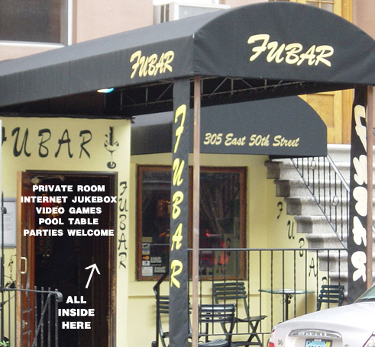

SUN MON TUES WED THURS FRI SAT
REVERSE HAPPY HOUR!
11PM - 2AM!

$3 MILLER PINTS
ALL NIGHT!
MONDAY MADNESS!

$10 FOR 3 DRINKS

4PM – 9PM!
TWO FOR TUESDAY!

2 FOR 1 DRINKS

4PM – 8PM!

WILD WEDNESDAY!

2 FOR 1

DRINKS!
4PM – 8PM!

$5 MARGARITA

PINTS

TICKET NIGHT!

$12 FOR 4 DRINKS

4PM – 9PM!
BEER, WINE
& MIXED DRINKS
$4

4PM –9PM!
BEER,
WINE & MIXED DRINKS
$4

4PM –9PM!

-EVERY HAPPY HOUR HAS $3 MILLER LITE PINTS!!!
-$3 PBR & TECATE CANS ALWAYS!!!

FUBAR
305 EAST 50TH ST. (CORNER OF 50TH & 2ND AVE.)
(212) 872-1325
www.fubar-nyc.com

