ÇUKUROVA UNIVERSITY

INSTITUTE OF NATURAL AND APPLIED SCIENCES

MSc THESIS

|  |
| --- |
| AN EVALUATION OF NATIONAL FOOD SYSTEMS ACCORDING TO THE SEVEN METRICS OF SUSTAINABLE NUTRITION SECURITY |

**David M. MUKAJANGA**

*Agricultural Economics Department*

September, 2023

**ÇUKUROVA UNIVERSITY**

**INSTITUTE OF NATURAL AND APPLIED SCIENCES**

**MSc THESIS APPROVAL**

|  |
| --- |
| AN EVALUATION OF NATIONAL FOOD SYSTEMS ACCORDING TO THE SEVEN METRICS OF SUSTAINABLE NUTRITION SECURITY |

**David Mbelwa MUKAJANGA**

***Agrıcultural Economıcs Department***

This Master’s Thesis was evaluated by the following Jury Members on ..../..../...... and was approved by unanimity / majority of votes.

Jury : Prof. Dr. Dilek Bostan BUDAK (Advisor) ................

: Prof.

: Prof.

**This thesis was written at the Department of Agricultural Economics, Institute of Natural and Applied Science.**

**Thesis number:**

**Prof. Dr. Sadık DİNÇER**

**Director**

**Institute of Natural and Applied Science**

**This work was supported by the Presidency of Türks Abroad and Related Communities**

**Note:** The usage of specific declarations, tables, figures and photographs presented in the present thesis or any other reference without citation is subject to “The law of Arts and Intellectual Products” number 5846 of the Turkish Republic.

CONTENTS

ABSTRACT 1

ÖZ 2

GENİŞLETİLMİŞ ÖZET 4

LIST OF TABLES 5

LIST OF FIGURES 6

1. INTRODUCTION 1

1.1 Background 1

1.2 History of Sustainability in Food Systems 2

1.3 Objectives of this Research 2

2. PREVIOUS STUDIES 4

2.1 On Dimensions of Sustainability 4

2.2 On Methodologies Used To Measure Sustainability 6

2.2.1 Linear Programming 6

2.2.2 Life-Cycle Assessments 7

2.2.3 Material Flow Analysis 7

2.2.4 Input-Output Analyses 8

2.2.5 Global Access to Nutrition Index 8

2.3 On The Seven Metrics of Sustainable Nutrition Security 9

3. MATERIALS AND METHODS 13

3.1 Materials 13

3.1.1 Sample Size 13

3.1.2 Base Year 13

3.1.3 Sources of Data 13

3.2 Methods 16

3.2.1 Tools Used 16

3.2.2 Data Preparation 16

3.2.3 Data Analysis 17

4. RESULTS AND DISCUSSION 21

4.1 Country Groups overall scores. 21

4.2 Food Nutrient Adequacy 22

4.2.1 Energy From Non-Staple Foods 23

4.2.2 Shannon Diversity Index 26

4.2.3 Multiple Functional Attribute 27

4.2.4 Nutrition Balance Score 28

4.3 Ecosystem Stability 29

4.3.1 Ecosystem Status 30

4.3.2 Per Capita GHG Emissions From Agriculture 30

4.3.3 Per Capita Net Freshwater Withdrawals 32

4.3.4 Per Capita Energy Use From Non-Renewable Sources 33

4.3.5 Per Capita Land Use in Agriculture 34

4.4 Food Affordability and Availability 35

4.4.1 Food Affordability 35

4.4.2 Food Availability 36

4.5 Socialcultural Wellbeing 37

4.6 Resilience 38

4.6.1 ND-GAIN 39

4.6.2 Food Production Diversity 40

4.7 Food Safety 41

4.8 Waste and Loss Reduction 42

5. Conclusion 44

6. References 45

**CUKUROVA UNIVERSITY**

**INSTITUTE OF NATURAL AND APPLIED SCIENCES**

**MSc THESIS**

|  |
| --- |
| AN EVALUATION OF NATIONAL FOOD SYSTEMS ACCORDING TO THE SEVEN METRICS OF SUSTAINABLE NUTRITION SECURITY |

**David Mbelwa MUKAJANGA**

***Advisor: Prof. Dr. Dilek Bostan BUDAK***

***Department of Agricultural Economics***

# ABSTRACT

It is more important than ever to measure and ensure the sustainability of food systems. There are now more people suffering from nutrition related disorders than forecasted before, despite massive developments in agricultural industrialization and globalization. This, combined with the fact that global agricultural production is facing real threats from climate change, it has become clearer and clearer to the global policy makers that it is imperative to study and understand the sustainability of food systems. This is such an attempt. The goal of this thesis was to use the most up-to-date free data online to study the performance of countries in four income groups globally on the seven metrics of sustainable nutrition metrics as proposed by Gustafson and others (2016). A combination of MANOVA and ANOVA analyses was used to assess statistical significance of differences in performance of these countries’ food systems on aforementioned metrics above, a goal being to know whether the size of an economy was a good predictor to such performance or not. Along with this objective, the study aimed at looking at the status of performance of food systems from these different income groups on the seven metrics aforementioned above.

***Keywords:*** *Food Systems, Nutrition Security*

**ÇUKUROVA ÜNIVERSİTESİ**

**FEN BİLİMLERİ ENSTİTÜSÜ**

**YÜKSEK LİSANS TEZİ**

|  |
| --- |
| YEDİ SÜRDÜRABİLEN BESLENME GÜVENLİĞİ ÖLÇÜMLERE GÖRE ULUSAL GIDA SISTEMLERI DEĞERLENDİRMESI |

**David Mbelwa MUKAJANGA**

***Danışman: Prof. Dr. Dilek Bostan BUDAK***

***Tarım Ekonomisi Anabilim Dalı***

# ÖZ

Abstract goes here.

***Anahtar Kelimeleri:*** *Gıda Sistemleri, Beslenme Güvenliği*

# GENİŞLETİLMİŞ ÖZET

Extended abstract in Turkish. (It starts with an idented paragraph).

# LIST OF TABLES

Table 2.1: The Seven Metric of Sustainable Nutrition Security and their Indicators. 10

Table 3.1: The List of Sources for Each Metric’s Data 14

Table 4.1: Percent of Daily kilocalorie Intake From Each Food Group in Each Country Group. 21

Table 4.5: ANOVA Coefficients for EPI’s of Different Country Groups 26

Table 4.6: ANOVA Output for Agricultural GHG per capita. 27

Table 4.7. ANOVA output for Per Capita Non-Renewable Energy Use in Agriculture 29

Table 4.8. ANOVA Output of Per Capita Land Use Between Income Groups 30

Figure 4.9. ANOVA Output For Food Affordability Score Among Income Groups 31

Table 4.10. ANOVA Output for Food Availability 32

Table 4.11. ANOVA Output for Gender Equity Values Between Income Groups 33

Table 4.12. ANOVA Output for the ND-GAIN Index 34

# LIST OF FIGURES

**LIST OF ABBREVITIONS**

GHG : Green House Gas

GHGE : Green House Gas Emissions

FAO : Food and Agriculture Organization of the United Nations

WHO : World Health Organization

LCA : Life-Cycle Assessment

MFA : Material Flow Analysis

MCAR : Missing Completely At Random

MFAD : Modified Functional Attribute Diversity

DRI : Daily Reference Intakes

QI : Qualifying Index

NB : Nutrient Balance

Kcal : Kilo-calories

MANOVA : Multiple Analysis of Variance

US : United States

UN : United Nations

KNN : K-Nearest Neighbor

MICE : Multiple Imputation by Chained Equations

WB : World Bank

# INTRODUCTION

## Background

Currently, there are deeper and more nuanced nutritional problems in food systems globally than anticipated before (Lang, 2010). This happens despite massive success in grain yield improvements and supply chain expansion that occured in the second half of the twentieth century (Lang, 2010). On top of that, there is an increasing pressure on ecological resources of production that threatens the sustainability of the current agricultural supply system (FAO and WHO, 2020; Gustafson et al., 2016; Harrison et al., 2022).

Over the past two decades, the global community has recognized the failure of current food systems to meet the nutritional goals, albeit in a sustainable manner (Johnston et al., 2014; Lang, 2010). On the nutritional side, there is a problem commonly reffered to as “The Triple Burden of Malnutrition”; the persistence of hunger at a global scale, growing rates of obesity, and the hidden hunger: the prevalance of people with inadequate intake of essential minerals and vitamins for proper body function (del Valle M et al., 2022; Johnston et al., 2014; Lang, 2010). There were almost 720 to 811 million people who faced hunger in 2020, 118 more than in 2019 (del Valle M et al., 2022), and obesity is becoming an issue even in poor countries (Lang, 2010). The amount of people with hidden hunger was estimated to be between 1 to 2 billion in 2021 (del Valle M et al., 2022).

On the ecology, agriculture is being blamed for the depletion of fresh-water resources, soil degradation, biodiversity disruption and several others. (Molden, 2013) shows that agriculture is responsible for 70% of fresh water withdrawals at a global scale. (Tilman et al., 2017) shows that the conversion of natural ecosystems to croplands and pasture lands is one of the greatest drivers of biodiversity loss. (Diaz & Rosenberg, 2008) shows that the over-application of fertilizers and its misuse results in nitrogen and phosphorous runoffs, creating poisonous lakes and rivers, and thus affecting negatively the ecological systems that depend on those ecological resources. Apart from this danger, there are concerns about the extent to which climate change will likely affect the function and productivity of food systems in the near future (Myers et al., 2017).

## History of Sustainability in Food Systems

Before sustainability emerged as a central theme in global development policy, most of global efforts were directed towards reducing hunger, undernutrition, and food insecurity (del Valle M et al., 2022). The goal was quite noble, considering that as a policymaker in the 1980’s, ones focus would’ve been on how to feed an increasing global population without knowing the unforeseen consequences of the blueprint you have at hand (Lang, 2010; *Population*, n.d.). Since 1920’s and 1930’s, there was a wide adoption of a policy framework that encouraged agricultural industrialization, production intensification, and food globalization due to the high global burden of underfed people and the successes in applied sciences of soil and animal breeding (Lang, 2010). The policy was successful. It intensified farms and created timely supply chains that overcame seasonality and geo-biological barriers of food products through global trade (Lang, 2010).

It wasn’t until the turn of the 21st century that the global community realized the consequences of this approach (Harrison et al., 2022). It exacerbated existing inequalities and putting a negative pressure on natural resources (Harrison et al., 2022). The success of the system also crumbles in its own doing, as despite there being more food produced and marketed than ever before, the global community still suffers from nutrition-related diseases than it was originally forecasted (del Valle M et al., 2022; Lang, 2010). Since then, the focus has been on developing food systems that deal with both malnutrition, over-nutrition, and undernutrition, all the while while maintaing sustainable development at societal and ecological level (Harrison et al., 2022).

## Objectives of this Research

The extent of the problems mentioned above and their impact to the food system and the environment has been associated with the size of economy countries have achieved (Lang, 2010; Malassis, 1983). (Lang, 2010), for example, recognized that the extent of these problems and their relative importance is highly dependent on the size of an economy. Other studies have also come to a conclusion that when it comes to nutritional or welfare outcomes of food policies and rural development policies that heavily depend on agriculture, a one-size-fits-all approach doesn’t work (Behrens et al., 2017; Harrison et al., 2022). This study is a continous attempt to evaluate the strengths and weaknesses of national food systems of different countries in different sizes of economies towards achieving sustainable nutrition security. It is a continous attempt since the first attempt done by Gustafson and others (Gustafson et al., 2016) which defined the metric, and a later study by Chaudhary and others (Chaudhary et al., 2018), had either taken a too narrow scope when it came to the number of countries in the study (Gustafson et al., 2016) or a rather outdated data for the countries (Chaudhary et al., 2018 used datasets from 2011). With that in mind, the following are the objectives of the study:

1. To assess the performace of countries of different income groups on the seven metrics of sustainable nutrition by using the most up-to-date data up until the period of the COVID-19 pandemic (2019).
2. To assess the statistical significance of the size of an economy on the seven metrics.

The study will contribute to the body of literature by providing an up-to-date outlook of the subject matter and hopefully provide a clearer picture to policy-makers on what they should look out for when it comes to designing food systems that will likely lead to sustainable nutrition security.

# PREVIOUS STUDIES

## On Dimensions of Sustainability

Defining the dimensions of a sustainable food system has been a challenge since the beginning (Harrison et al., 2022; von Braun et al., 2021b). For some countries, sustainability means dealing with the environmental issues caused by food system operations, for other countries it is dealing with the nutritional issues, and yet for others it is dealing with the socio-economic issues (Harrison et al., 2022).

Attempts to define sustainability had started since 1986, but it wasn’t until 2010 that a widely accepted definition of sustainability, albeit in-terms of diets, was coined (Gussow & Clancy, 1986; Harrison et al., 2022). The definition defined sustainable diets as those which cause low environmental impacts and contribute to food and nutrition security, and thus a healthy life for present and future generations (Harrison et al., 2022).

But, like how other studies later came to mention (Boylan et al., 2020; Finley et al., 2017), defining the sustainability of a food system by defining a sustainable diet is an incorrect way of approaching the problem. (Boylan et al., 2020) for example, points out that all sustainable diets have a threshold beyond which the diet no longer remains sustainable. They give an example cited from Finley and others (Finley et al., 2017), that plant-based diets, which are now popularly known to be the most sustainable, will continue to be sustainbale as long as a certain proportion of the population in a particular country hasn’t yet adopted the diet. They show that once a particular population threshold is reached, a plant-based diet will cease to be sustainable, as the need to import plant-based foods into the food system will increase the GHG emissions associated with importation. After that, a food system that relies only in this deemed sustainable diet won’t be sustainable anymore.

If that wasn’t enought, findings from another study (Behrens et al., 2017) concerning the reduction of environmental impacts when adopting a nationally recommended diet vis-a-vis a national average diet also show that a diet can be sustainable in one place but not in others. According to their research, adopting a nationally recommended diet led to a significant decrease of environmental impacts in high-income countries, a slight decrease in middle-income countries, but an increase in low-income countries. Boylan and others (Boylan et al., 2020) takes it further by proposing that not only nationally recommended diets, but also nationally recommened food systems, can be sustainbale in some places and not in others.

Other studies (von Braun et al., 2021a) explained that a practical definition of a sustainable food system has to: 1) Be able to support global and national efforts to bring about a positive change and acceleration towards Sustainable Development Goals (SDG’S); 2) Be precise enough in defining domains for policy and porgrammatic action, and broad enough not to exclude any social, economic, and environmental aspects of sustainability. The problem with the two definitions above is that each one relies heavily on one analytical approach, each of which are indespensible but inadequate when used independently.

Works that focused on the sustainability of food systems and tried to analyse it tended to adopt a positive approach; the one that goes into detail to explain how food systems work and how they can/should be changed (*HLPE Report # 12 - Nutrition and Food Systems*, n.d.; Malassis, 1983). They approach the issue of sustainability by mapping all food system actors and how they work, and then use that map for policy-setting (von Braun et al., 2021b).

Works that looked at sustainable and healthy diets tend to adopt a normative approach, the one that starts by first setting value-judged goals about what it is that should be achieved and then work backwards to design the system accordingly (Auestad & Fulgoni, 2015; Johnston et al., 2014; *Sustainable Diets and Biodiversity - Directions and Solutions for Policy, Research and Actions*, n.d.).

The first approach, if implemented separately, tends to collapse under the sheer scale and complexity of real-life food systems (von Braun et al., 2021b). The second approach, also when implemented independently, leads to the danger of wishful thinking, that is, setting goals that aren’t achievable (von Braun et al., 2021b).

Von Braun and others (von Braun et al., 2021a) propose a holistic approach that starts with the second approach (since it starts from the SDG’S), and then measure those goals using the positive tools that are at hand. The resulting goals will then be appropriate enough for scientific and political action (von Braun et al., 2021b).

Other attempts on defining a what a sustainable food system is came in the form of international conferences on nutrition and food security (Harrison et al., 2022). Made between 2013 and 2019, these conferences aimed to tackle the issue of which conceptual frameworks can lead to a sustainable food system. Many publications on the topic came out, some more robust than others (Harrison et al., 2022). Authors of (Harrison et al., 2022) noted that; while some of the publications attacked only a single aspect of a the issue (Thompson et al., 2013), some were well rounded, including the environmental, economic, and societal goals (Harrison et al., 2022).

In 2019, the Food and Agriculture Organization of United Nations (FAO) released a publication that provided an authoritative guidance on what a sustainable food system should have (FAO and WHO, 2020). The document had 16 dimensions which FAO believed a food system should have if it is to quote; “Promote all dimensions of individuals’ health and wellbeing; have low environmental pressure and impact, and is accessible, affordable, safe, equitable, and culturally acceptable.” (FAO and WHO, 2020). The guiding principles were intended to provide a flexible framework, upon which policy-makes in different economies can target their policy actions (Harrison et al., 2022).

Clear methodologies and indicators to measure how a food system will perform within these dimensions had not been mentioned though. Most studies that tried to tackle that problem had to go back and hand-pick several indicators and methodologies from social and environmental sciences. The following part of this chapter will explore the different methodologies and indicators used so far in the literature.

## On Methodologies Used To Measure Sustainability

### Linear Programming

One of the earliest methodologies from the more recent studies, linear programming was first used in nutritional sustainability studies in the UK’s Livewell Project in 2014 (Johnston et al., 2014). The aim of the study was to understand how UK’s diets can achieve nutritional adequacy, affordability, and reduced environmental impact (Johnston et al., 2014). It goes without saying that those three were the main metrics used for the study.

The study was carried out at the time when there wasn’t any definitive metric at hand, and most used metrics at that time were nutritional indexes that didn’t cover much the whole scope of sustainability (environmentally, socially, or economically) (Johnston et al., 2014). The authors of (Johnston et al., 2014) that the methodology has several dimensions which causes confusion of how it should be used. They point out, for example, that should the measurement be framed in-terms of agricultural growth such that you reduce hunger to X amountsby Y amounts of inputs used? Or should one use constraints such as good nutrition is achieved at certain levels of emissions?

There was also a problem of which indicators to use. The first implementation of this methodology only evaluated dietary recommendations based on the GHG emissions. But there weren’t any indicators to be used to measure other dimensions such as cultural relevance or ecosystem health (Johnston et al., 2014). Authors who explored this method recognize the need to develop better metrics and indicators to be used for this model (Johnston et al., 2014; Thompson et al., 2013).

### Life-Cycle Assessments

Used primarily in diet based studies, this methodology looks at environmental impacts of a product in its life-cycles, from inception to consumption (Auestad & Fulgoni, 2015; Muralikrishna & Manickam, 2017). A very good tool for natural-resource based food system analyses, the methodology has a problem of one-dimensionality, that is, exploring everything only in an environmental impacts perspective (Auestad & Fulgoni, 2015). It is also burdened by the problem of non-objectivity as results from different LCAs tend to be contradictory to one another (Ekvall, 2019). This is due to the fact that at the beginning of any LCA analysis, the researcher defines subjective goals which in-turn influence very much the methodology used therein (Ekvall, 2019).

There is also a problem of which type of an LCA is done, and why. The two major types of LCAs are *Attributional* and *Consequential* (Ekvall, 2019). Attributional LCA aims at pinning the environmenal impacts of a product’s production or consumption to one of its processes (Ekvall, 2019). On the other hand, consequential LCAs studies hor the relevant environmental flows of the current supply chain will change as a result of decision changes (Ekvall, 2019). As one can see, an LCA for a study like this would have a limited scope, and this wouldn’t suffice the envisioned goals of this research.

### Material Flow Analysis

This is one of the most popular methods in resource accounting literature. It is a method that studies the transportation, transformation, and storage of materials within a defined system (Allesch & Brunner, 2015). A system in this context can be a production process, a firm, a country, or simply a chemical reaction, as long as it is a productive force (Ayres et al., 1999).

The method is based on the mass-balance principle and it gives rise to Substance Flow Analysis (SFA). SFA is a similar method, only that it looks at substances rather than economic or ecological entities themselves (Brunner, 2012). Both methods are robust considering the fact that they measure things in mass (which is immutable across space and time) and they have been applied extensively in industrial econlogy studies where LCA had been a design tool for policy (Fischer-Kowalski, 1998; Kytzia et al., 2004).

This strength is what has been critised of them in other literature, stating that they don’t really capture the immaterial forces that shape and influence real-world production system (Kytzia et al., 2004). (Kytzia et al., 2004) for example mentioned that neither MFA, SFA, nor LCA capture the cultural, social, and economic factors that drive industrial production, factors that are very relevant in the real-world. Together with this issue, these three techniques don’t address a major issue in food system sustainability literature, that is, they don’t have a set of metrics that can be applied explicitly to food system sustainability analysis. That being said, they have been used extensively to measure metrics that are already in-place from other conceptural frameworks (Gustafson et al., 2016).

### Input-Output Analyses

Developed by Wassily Leontief in 1936 (Boylan et al., 2020), this is a method that is useful in tracing economic activity across different industries (Boylan et al., 2020). It also checks the consumption and value added on a particular product (Boylan et al., 2020). The method follows a life cycle approach similar to an LCA, and it is one of principle methods used in LCAs (Boylan et al., 2020). It is not confined into looking only at environmental impacts though, but rather capable of analyzing both social-economic and environmental impacts of products across industries.

It is a very good and robust method, only that it doesn’t have a conceptual framework specifically designed for food system sustainability assessment. A researcher has to first go and tailor the dimensions of sustainability he/she will work on, and then use the method, as it was used in Boylan et al (Boylan et al., 2020). This makes it dependent to other frameworks such as the Seven Metrics of Nutritional Sustainability to some degree.

### Global Access to Nutrition Index

This is a corporate-ranking methodology created back in 2013 by the Global Alliance for Improved Nutrition (GAIN) for the purpose of ranking how well companies do in-terms of marketing nutritious, ethical and legally compliant foods (Johnston et al., 2014). It is now maintained by the Access To Nutrition Initiative (ATNI), which collects data from global Food and Beverage (F&B) companies in relation to their policies and commitments to facilitate good nutrition through their products and marketing (Johnston et al., 2014).

The index has three key areas of measurements;

* 1. The Corporate Profile, which measures a company’s policies, practice and disclosure related to promoting good nutrition and preventing malnutrition and undernutrition in all forms;
  2. The Product Profile, which assesses the nutritional quality of a company’s product portfolio across different markets, taken by analyzing the levels of fat, sugar, salt, fruit and vegetables, and other components within an individual product;
  3. The Baby-Milk Substitute / Complimentary Foods (BMS / CF) Marketing Assessment, which assesses whether the marketing policies of major global baby food manufacturers are in full compliance of the International Code of Marketing of BMS and subsequent World Health Assembly (WHA) resolutions; and whether they have the management systems in place that can ensure proper implementation of those policies (*210630-ATN-_-Global-Methodology-Report_V4.Pdf*, n.d.).

The metric is very good for showing which companies (though only those that provide sufficient data to the ATNI) do more to influence sustainable diets, but it is not a good methodology for measuring sustainability according the scope mentioned so far. It doesn’t cover issues related to environmental sustainability, contribution of companies to climate change, and a fair treatment of workers and communities, all of which are among pillar aspects of the social and environmental dimensions of a food system sustainability analysis (Gustafson et al., 2016). It also fails to cover the contribution that companies, as a node of players in the food system, have on influencing sustainable diets (Johnston et al., 2014). This makes it a relatively an undesirable methodology for a full food system sustainability assessment.

## On The Seven Metrics of Sustainable Nutrition Security

Proposed by Gustafson et al (Gustafson et al., 2016), the aimed at bridging the gap between nutritional thinking, food security, and sustainability in food system analyses (Gustafson et al., 2016). The authors proposed seven nutritional security metrics, covering nutrition, climate change, societal welfare, and micro and macro food economics. The metrics were created after a consensus report by scientists in the aforementioned fields and a stakeholder workshop involving stakeholders from governments, academia, and industry (Gustafson et al., 2016). The metrics are shown in the table below:

Table 2.1: The Seven Metric of Sustainable Nutrition Security and their Indicators.

|  |  |  |
| --- | --- | --- |
| The Metric | Indicator | Weights |
| Food Nutrient Adequacy | Non-Staple Food Energy | 0.20 |
| Shannon Diversity | 0.20 |
| Modified Functional Attribute Diversity (MFAD) | 0.20 |
| Nutrient Density Score | 0.20 |
| Share of Population With Adequate Nutrients | 0.20 |
| Ecosystem Stability | Ecosystem Status | 0.20 |
| Per-Capita GHG Emissions | 0.20 |
| Per-Capita Net Freshwater Withdrawals | 0.20 |
| Per-Capita Non-Renewable Energy Use | 0.20 |
| Per-Capita Land Use | 0.20 |
| Food Affordability & Availability | Food Affordability | 0.25 |
| GFSI Food Availability Score | 0.25 |
| Poverty Index | 0.25 |
| Income Inequality | 0.25 |
| Sociocultural Wellbeing | Gender Equity | 0.25 |
| Extent of Child Labor | 0.25 |
| Respect for Community Rights | 0.25 |
| Animal Health & Welfare | 0.25 |
| Resilience | ND-GAIN Country Index | 0.50 |
| Food Production Diversity | 0.50 |
| Food Safety | Foodborne Disease Burden | 0.50 |
| GFSI Food Safety Score | 0.50 |
| Waste & Loss Reduction | Pre & Post-Consumer Food Waste | 1 |

GFSI: Global Food Security Index; ND-GAIN: Notre Dame Global Adaptation Index. For a deeper definition of the metrics and their indicators, visit (Gustafson et al., 2016)

According to the authors, two of the main criteria used in creating the metrics were: 1) To avoid needless creation of new metrics when suitable ones already exist in the literature; 2) The metrics being based on open data (Gustafson et al., 2016). These give a very good relevance to the method, as they avoid unnecessary repetition and make sure that studies can easily be made by anyone, using these metrics, without much bureaucracy. The scope of the metrics also provides a conceptual framework that adequately covers the whole scope of sustainability when it comes to food systems (Boylan et al., 2020), something that is very useful in policy-setting and country comparison.

While other methods such as Input-Output analyses can be hailed for producing a framework in which different aspects of food and nutrition security can be measured under an identical scope (Boylan et al., 2020), most of them don’t provide this tailored set of indicators specifically for food system analysis. Besides, most of these methods, such as LCA analysis, are part of measurements used within the seven metrics framework to measure indicators that are measurable in a life-cycle perspective (Gustafson et al., 2016).

The methodology also creates what (von Braun et al., 2021a) calls a right definition of a sustainable food system, that is, one that is precise enough to narrow down policy goals and assist in the implementation of national and global development agenda, but also one that is detailed enough not to exclude any aspects of the economic, social and ecological dimensions of sustainability. Input-Output Analyses, for example, doesn’t have these dimensions inherently as a method, but instead, it is left on the descretion of the researcher to go and look for appropriate metrics that can measure such dimensions of sustainability in food systems. Such an approach brings everybody back to the problem of national and regional agenda, where dimensions of sustainability which are less relevant to some are left unmeasured (Harrison et al., 2022).

It is therefore important that even though the metrics do contain indicators that cannot be measured at the same scale at different geographical areas in some dimensions (Boylan et al., 2020), they still provide an adequate platform for measuring exactly what sustainability of a food system is. It can also be said further that the difference in scale culminates to an adequate, location specific performance of a metric, as opposed to a standard scale, which might, in some cases obscure or misrepresent the true performance of a region. Boylan et al (Boylan et al., 2020) for example, criticised food affordability as one of the indicators that can’t be measured in a life-cycle perspective (because it is only relevant to consumers), but affordability is an important dimension in all food security analyses (von Braun et al., 2021a), and measuring it makes the conceptual framework complete.

# MATERIALS AND METHODS

## Materials

### Sample Size

According to (Hair et al., 2018), the base analysis for this study, MANOVA, requires a minimum of 5 respondents in each of the groups to be analysed. A dataset containing 216 countries and their sizes of economies was taken from the World Bank Group’s database (The World Bank Group, 2019). The countries are recognized under the Standard Country or Area Codes for Statistical Use (M49) of the United Nations (UN).

All countries from each income group were included in the study. Although countries were unevenly distributed in the dataset (High income countries: 79; Lower middle: 55; Upper middle: 55; and Low income 27) it wasn’t deemed a problem since the dataset represented the entire population of countries around the world. Such being the case, including every country in the dataset whose income group was specified was the best way to ensure robustness in the results.

In the case of the food groups selected for the first and second indicators of the first metric, the sample size included all groups available in the FAOSTAT (*FAOSTAT*, n.d.-a) database. The resulting dataset contained 98 different foods which letter were aggregated into different food groups as the need arose.

### Base Year

Year 2019 was selected to be the base year for the study since this was the year immediately before the COVID-19 pandemic. As there were many hurdles associated with data collection in the period during the pandemic, it was deemed diligent to not include any years during the pandemic period. And as the study itself was conceived near the end of the pandemic (early 2022), the base year of 2019 was deemed the best year to represent global economy when many countries were operating in their normal conditions.

### Sources of Data

Data used for the study was sourced from various online open-source databases. Table 3.1 shows the list of all the indicators used and their sources of data.

Table 3.1: The List of Sources for Each Metric’s Data

|  |  |  |
| --- | --- | --- |
| Metric | Indicator | Source |
| Food Nutrient Adequacy | Non-Staple Food Energy | (*FAOSTAT*, n.d.-a) |
| Shannon Diversity | (*FAOSTAT*, n.d.-a) |
| Modified Functional Attribute Diversity | (*FAOSTAT*, n.d.-a) & (*SR11-SR28 : USDA ARS*, n.d.) |
| Nutrient Density Score | (*FAOSTAT*, n.d.-a), (*SR11-SR28 : USDA ARS*, n.d.) & (Otten et al., 2006) |
| Population Share with Adequate Nutrients | Not Used |
| Ecosystem Stability | Ecosystem Status | (Yale Center For Environmental Law And Policy-YCELP-Yale University & Center For International Earth Science Information Network-CIESIN-Columbia University, 2023) |
| Per-Capita GHG Emissions | (Ritchie et al., 2020) |
| Per-Capita Net Freshwater Withdrawals | (Ritchie & Roser, 2017) |
| Per-Capita Non-Renewable Energy Use | (*FAOSTAT*, n.d.-b) |
| Per-Capita Land Use | (Ritchie & Roser, 2013) |
| Food Affordability & Availability | Food Affordability | (*Global Food Security Index (GFSI)*, 2023) |
| GFSI Food Availability Score | (*Global Food Security Index (GFSI)*, 2023) |
| Poverty Index | Insufficient Data |
| Income Equality | Insufficient Data |
| Sociocultural Wellbeing | Gender Equity | (World Economic Forum, n.d.) |
| Extent of Child Labor | Insufficient Data |
| Respect for Community Rights | (*Resources | Environmental Democracy Index*, n.d.) |
| Animal Health & Welfare | (*World Animal Protection | Animal Protection Index*, n.d.) |
| Resilience | ND-GAIN Country Index | (Dame, n.d.) |
| Food Production Diversity | (*FAOSTAT*, n.d.-c) |
| Food Safety | Foodborne Disease Burden | Outdated Data |
| GFSI Food Safety Score | (Impact, n.d.) |
| Waster & Loss Reduction | Pre & Post-Consumer Food Waste & Loss | (*Food Waste per Capita*, n.d.) |

As one can see from the table above, 5 out of 23 targeted indicators weren’t assessed. For the indicator “*Percentage of The Population With Adequate Nutrients”*, separate data on the nutrient intakes of the targeted nutrients (Zinc, Niacin, Vitamin B-6, Calcium, Riboflavin, Folate, Vitamic C, and Vitamin A) wasn’t available. (Arsenault et al., 2015) proposed a method of estimating values of this indicator by using the food supply data, but***

In the case of the Poverty Index and the Income Inequality indicators; up-to-date data was available in the available databases (Hasell, Arriagada, et al., 2023; Hasell, Roser, et al., 2023) but when the data was filtered to include the relevant variables (the base year of 2019, both rural and urban areas, and all ages) both two dataset remained with 2 low income countries. This sample size was too small for the analysis that was to follow on the data.

Same for the Extent of Child Labour. An up-to-date dataset was available at ILO’s website (ILO, 2020), but when it was filtered to include the targeted variables (both male and female sexes, an age-band of ‘5-17 years old, and the base year of 2019) only 4 countries remained. This was to represent all 4 income group for the study and yet still, some of the four countries identified as a single income group. With this much small data, no meaningful analysis could be done.

In the case of Foodborne Disease Burden, the only available data was the one taken in 2010. Another problem was that the results were presented in-terms of geographical regions instead of individual countries, which is opposite from what this study aimed to achieve. Now one could go inside and pick countries based on their size of economies from these regions, but since a lot must have changed from the last 9 years which is the difference between the base year of this study and the time period the dataset was taken, a lot could have changed at the regional level thus making the dataset outdated for the study.

## Methods

### Tools Used

The main tools used for data handling and analysis were the statistical packages of the Python programming language. These include Pandas for data handling, Seaborn for visualization, and Statsmodels and Scipy for model fitting and data transformation.

### Data Preparation

Since the main methods of analysis for this study were ANOVA and MANOVA, a thorough data preparation exercise was done on each dataset. This was to ensure that datasets don’t violate the statistical assumptions of the two methods. The preparation process included dealing with missing values, removing extreme values, and transforming the data to follow assumptions of ANOVA and MANOVA.

As all indicators in this study had to be represented in a scale of 0 – 100, the study used a following equation adopted from (Gustafson et al., 2016) to transform all values that weren’t in that scale into it:

Where:

is the indicator that is scaled

unit (eg., a country that is considered)

= the median of the full range of values in the indicator considered in the particular year.

### Data Analysis

#### Metric 1 – Indicator 1: Non-Staple Food Energy

For this indicator, the dataset of per capita daily consumptions of 98 foods (in kilocalories) from 186 countries globally was taken from FAO’s balance sheets (*FAOSTAT*, n.d.-a). The foods were grouped into 13 major food groups according to the grouping done earlier in the United State’s Food Composition Tables (*SR11-SR28 : USDA ARS*, n.d.). After data cleaning and transformation, the analysis continued by looking at the descriptives statistics of the dataset, and then calculating the p-values of MANOVA for the dataset by using the Statsmodels package of python.

#### Metric 1 – Indicator 2: Shannon Diversity Index

For this second indicator; the study used the food supply data from FAO’s Food Balance Sheets. The data represented national per capita annual food supply in Kg. Again, the sample was the same 98 foods taken in the first indicator, and after evaluating that the type and extent of missing data was both too large and not random to ignore, the step to impute the missing values was taken. Two multiple imputation methods were used on the data (KNN and MICE), and the result of their r-statistics compared. The dataset imputed by MICE turned out to be more robust, with an adjusted rsquare of 0.8905 compared to the 0.8821 of the one imputed by using KNN. The imputed data was then aggregated to create the same 13 food groups as created in the first indicator, and then the next step to calculate the indeces was taken.

To calculate the indeces, the following formula was used (Gustafson et al., 2016):

Where: = The Share (by weight) of the food item in the food supply. The results were then grouped according to the income group the country is in. ANOVA and descriptive statistics were then used to analyze the data. Results are presented in the following chapter.

#### Metric 1 – Indicator 3: Modified Functional Attribute Diversity (MFAD)

For this indicator, a more complex approach had to be used. The first step was to get the per capita annual food supply data for the food groups used. This dataset was already at hand from the previous metric; the Shannon Diversity Index. The second step was to get a hold of food composition data so that one can know the nutritional value each food has. This was taken from the USA’s food composition databases (*SR11-SR28 : USDA ARS*, n.d.). The data therein contained nutritional values of 149 nutrient per 100g of the food indicated. To get the nutrient supply information from each size of economy, the food supply value were converted from kilograms to grams. The values were then multiplied by the nutritional values in the food composition table and then the MFAD function was created. To put it simply, the MFAD function shows the diversity in the supply of nutrients in an economy. The function was created by using the formula below (Remans et al., 2014).

Where:

*n* = the number of food groups,

*d* =the dissimilarity between any two of the given food groups (*i* and *j*) as defined by their nutritional values.

*N* = number of nutrients used for the study.

The indeces were again grouped according to the size of an economy, and then the study continued to the next steps of the analysis.

#### Metric 1 – Indicator 4: Nutrient Balance Score

For the fourth indicator; Nutrient Balance Score, two of the datasets needed for developing the indeces were already ready from the first and third indicators (Non-staple Energy and MFAD). The remaining task was only to get the recommended dietary reference intakes. These were obtained from (Otten et al., 2006).

To calculate the index, two steps had to be followed: 1) To calculate the Qualifying Indeces (QI) of each individual food group in the dataset, 2) To calculate the Nutrient Balance (NB) scores of the composite meal and present it in-terms of percentage.

For the first step, the following formula for calculating a QI of a single meal was used (Fern et al., 2015):

Where:

= Daily energy needs of the population age group under consideration (kcal)

= Energy in the amount of the food or meal analyzed (kcal)

= Amount of qualifying nutrients in the food analyzed (g, mg or mcg)

= DRI (Daily Reference Intakes) of qualifying nutrients for the target section of the population .i.e. Male, Female, or Children.

= Number of qualifying nutrients considered

For the second step, the following formula was used (Fern et al., 2015):

Where:

*NB =* Nutrient Balance Score

= Value for the Qualifying Index of an individual nutrient (both truncated and non-truncated)

= Number of qualifying nutrients considered.

The truncated values mentioned above refers to the QI of individual foods that were cut-off when they exceeded one ( = 1.00). This was so because, according to previous studies (Fern et al., 2015); = 1.00 denotes meeting the dietary requirement of the targeted nutrient. The remaining amounts of the nutrients represented by the portion where > 1.00 served no nutritional purpose. According to (Fern et al., 2015), this helps to offset the influence of foods with abnormally high quantities of a certain qualifying nutrient.

For the other metrics, a simple data cleaning exercise of filtering columns and rows to fetch the data needed was all that needed to make the data ready for ANOVA and other steps of the analysis. For this, several python statistical packages were used, including Pandas for data manipulation, SciPy and Scikit-learn for ANOVA and MANOVA, and Seaborn and Matplotlib for data visualization.

# RESULTS AND DISCUSSION

## Country Groups overall scores.

High income dominated all other groups in all metrics. An ANOVA analysis comparing the results of all country groups in all seven metrics revealed a statistically significant influence of the variable “income group” to the performance on the seven metrics at 0.05 significance level (p < 0.05). The graph below shows the performance of each income group in each of the seven metrics.

Figure 4.1. Performance of Each Country Group in Each of the Seven Metrics

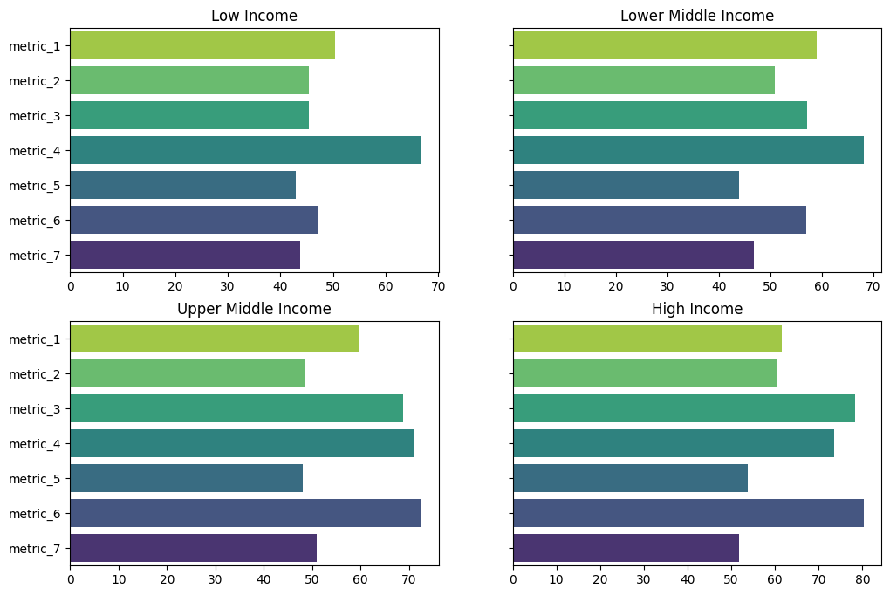Table 4.1. ANOVA Output Between Income Groups and Performance

|  |  |  |  |  |
| --- | --- | --- | --- | --- |
|  | sum_sq | Df | F | PR(>F) |
| C(variable) | 1095.696220 | 3.0 | 3.73781 | 0.024606 |
| Residual | 2345.108307 | 24.0 | NaN | NaN |

Figure 4.2. Close-up Comparison Between Country Groups On The Seven Metrics

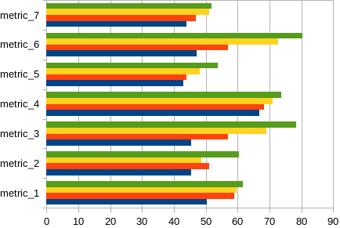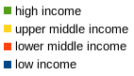These results differ to the results by (Chaudhary et al., 2018b; Gustafson et al., 2016) where high income countries performed relatively poor than other countries on the second and the seventh metrics (Ecosystem stability, Waste and Loss Reduction). Unsuprising though, and as mentioned in other studies that employed the metric (Chaudhary et al., 2018b; Gustafson et al., 2016), high income countries dominated in other metrics that focused on socio-economic welfare (food nutrition adequacy, food affordability and availability, social cultural wellbeing, etc). In these metrics, most of their indicators showed a statistically significant positive relationship between the size of an economy and its performance on the metric. Below is an articulate exploration results of analyses from each metric and its indicators.

## Food Nutrient Adequacy

In this metric, the high income countries emerged the first. Their overall metric score was 52, followed by upper middle income which had 51.8, then lower middle income with 50.7, and then low income with 45.8. As one can see, the difference in the overall metric score wasn’t at all that large, and so one has to check the performance of each country group within the target indicators. This is explained in the paragraphs that follow. Below is a visualization of the metric scores.

Fig 4.1. Metric scores for the first metric: Food Adequacy

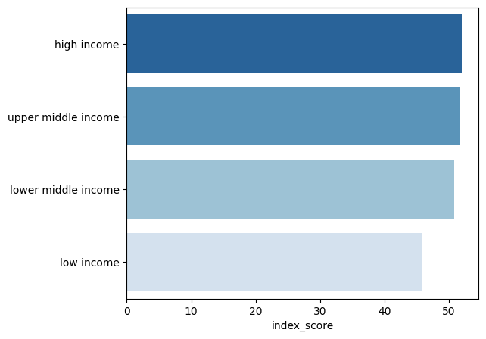

### Energy From Non-Staple Foods

The data from the analysis showed a variation of what foods are considered staples in what income groups. Unlike (Gustafson et al., 2016), this study didn’t categorize staple foods as just cereals, roots and tubers, and plantains. Rather, staple foods were recognized as the ones contributing equal to or more than 12.5% of the total median daily calorie intake per capita. This was based on recommendations by (Mäkelä & Rautavirta, 2018) and (FAO, n.d.), both of whom who agreed that staples can be anything depending on the factors that determine food supply and consumption in a particular country.

Coming to the results, high income countries emerged victors, consuming 38.3% of their median daily calorie intake from non-staples. Lower middle income came second at 32.6%, upper middle income third at 31.3% and low income fourth at 18.1%. MANOVA showed a statistically significant difference among groups with a *p* value of less that 0.01 (p < 0.01).

According to these results, there is a non-linear relationship between the size of an economy and the amount of kilocalories obtained from non-staple foods. Lower middle income countries exceeded upper middle income countries in this metric, which means that the size of economy doesn’t influence this indicator linearly. The table below presents the percentage of median kilocalorie intake contributed by each food group daily.

Table 4.2: Percent of Daily kilocalorie Intake From Each Food Group in Each Country Group.

|  |  |  |  |  |  |
| --- | --- | --- | --- | --- | --- |
| Income group | Staple Foods | Percent of Median Daily Calorie Intake | | Non-Staple Foods | Percent of Median Calorie Intake |
| Low Income | Cereals | 55.8 | | Starch & Sugars | 4.4 |
| Legumes & Products | 3.7 |
| Fruits & Plantains | 3.5 |
| Dairy & Egg Products | 2.1 |
| Roots & Tubers | 13.5 | | Beef Products | 1.8 |
| Vegetables | 1.4 |
| Finfish / Shellfish Products | 0.4 |
| Poultry | 0.4 |
| Seeds, Nuts, and Oils | 12.6 | | Pork | 0.4 |
| Spices & Herbs | 0 |
| Infant Foods | 0 |
| Lower Middle Income | Cereals | 54.6 | | Starch & Sugars | 9.0 |
| Roots & Tubers | 5.0 |
| Dairy & Egg Products | 4.3 |
| Fruits & Plantains | 3.9 |
| Beef Products | 3.0 |
| Legumes & Products | 3.0 |
| Seeds, Nuts, and Oils | 12.8 | | Vegetables | 1.8 |
| Poultry | 1.0 |
| Finfish / Shellfish Products | 0.9 |
| Pork | 0.6 |
| Spices & Herbs | 0.1 |
| Infant Food | 0 |
| Upper Middle Income | Cereals | 41.8 | | Dairy & Egg Products | 8.6 |
| Fruits & Plantains | 4.4 |
| Beef Products | 4.1 |
| Roots & Tubers | 3.4 |
| Poultry | 3.3 |
| Seeds, Nuts, and Oils | 14.9 | | Vegetables | 2.5 |
| Pork | 2.2 |
| Legumes & Products | 1.9 |
| Starch & Sugars | 12.5 | | Finfish / Shellfish Products | 0.7 |
| Spices & Herbs | 0.1 |
| Infant food | 0.1 |
| High Income | Cereals | | 32.4 | Starch & Sugars | 11.7 |
| Beef Products | 5.7 |
| Pork | 5 |
| Fruits & Plantains | 4.2 |
| Poultry | 3.6 |
| Seeds, Nuts, and Oils | 15.6 | | Roots & Tubers | 2.8 |
| Vegetables | 2.5 |
| Finfish / Shellfish Products | 1.5 |
| Dairy & Egg Products | 12.5 | | Legumes & Products | 1 |
| Spices & Herbs | 0.2 |
| Infant Food | 0.1 |

Fig 4.1: Percent of Median Kcal Intakes From Non-Staples

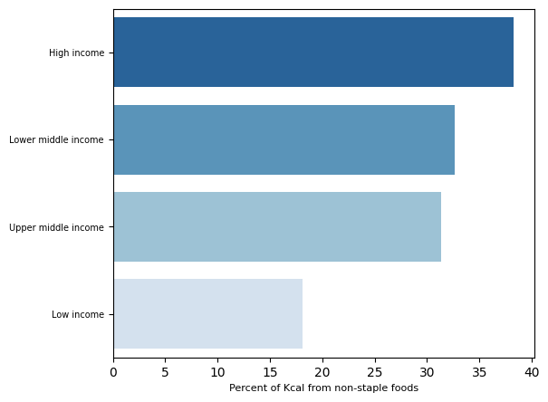

### Shannon Diversity Index

Just like the indicator before it, this indicator also showed a statistically significant difference between income groups. High income countries performed best, followed by upper middle income countries, lower income middle income countries, and low incomes. This arrangement shows a positive linear relationship between the size of an economy and its performance on this indicator. The figures below present the output of ANOVA as well as the performance indeces of countries in this metric.

Table 4.3: The Output of ANOVA coefficients for Shannon Diversity

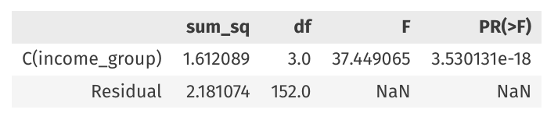

4‑1: Note the value of the PR(>F) coefficient. This is the coefficient that displays the p-value.

Fig 4.3: The Mean values of Shannon Diversity Indeces in Different Income Groups

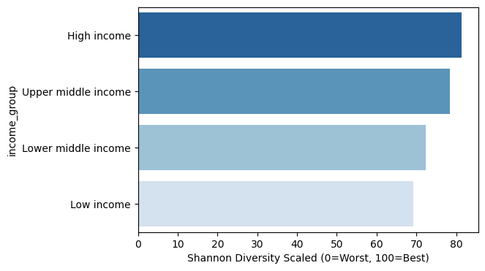

### Multiple Functional Attribute

In this indicator, Lower middle income countries emerged winners, with a total MFAD score of 51.48. Upper middle income countries followed with 49.57, high income came third with 47.36, and then lastly low income, with 34.81. The arrangement of this order reveals that there might be a non-linear relationship between the two factors. This is further proved by the results of ANOVA, w,hich showed statistical insignificance in the MFAD values of each country group. So, despite there being a visible difference in the final MFAD values in each country group, one has to conclude that there is no statistical significance between them and the country groups.

Fig 4.4: MFAD values for different country groups

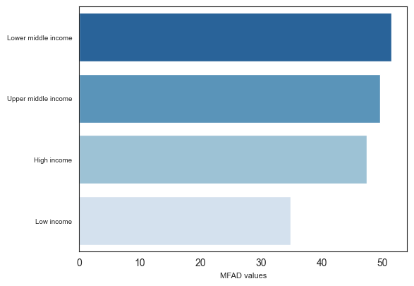

Table 4.4. ANOVA output for Size of Economy vs MFAD values.

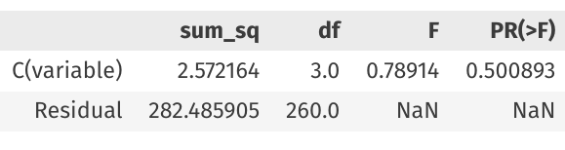

### Nutrition Balance Score

In this indicator, there seems to be a very small difference between income groups. The deductive nature of the dataset prevented one from performing ANOVA on it, but a quick examination of nutrient balance scores for males and females in each income group shows a relatively small difference, although that difference seems to favor high income countries. In the dataset, high income countries scored a nutrient balance score of 79.47 for males and 79.34 for females, upper middle income countries 79.43 for males and 79.31 for females, lower middle income 79.397 for males and 79.286 for females, and low income countries 79.296 for males and 79.174 for females. A savvy examination of the data shows that there is a perceptible linear relationship between income groups and nutrient balance score, a positive one, as it increases, albeit in small amount, as countries move from low income to high income. Below is the resulting dataset.

Table 4.5: Nutrient Balance Scores For Different Country Groups

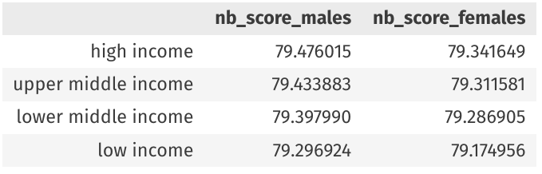

## Ecosystem Stability

In this metric, high income countries emerged victors with an index score of 60.2, followed by lower middle income (50.93), followed by upper middle income (48.67), and lastly low income (45.38). A close inspection on how country groups are arranged reveals that there is a possibly non-linear relationship between the variable “income groups” and the performance on this index. Below is a graphical presentation of the performance values.

Fig 4.5. Performance on the second metric: Ecosystem Stability

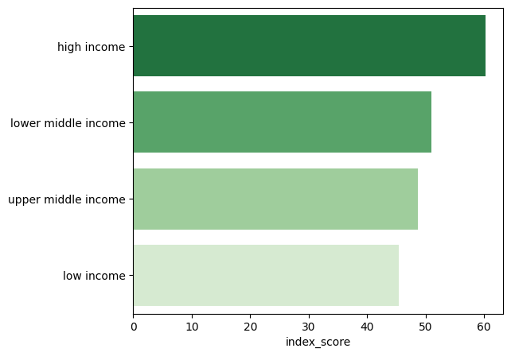

A deeper inspection of how country groups performed in each indicator might be essential in understanding the reason for the non-linear relationship.

### Ecosystem Status

In this metric, the difference in the size of the economy had a statistically significant impact on the outcome of the indicator. The ANOVA output for the analysis was *p < 0.001*. Higher income countries tend to score better in this metric, with median values of 57.20 for high income countries, 43.60 for upper middle income, 34.20 for lower middle, and 32.25 for low-income. Their distribution showed a clearer picture though. The KDE distribution plot of high income countries’ values was leptokurtic in nature, showing the presence of a lot of outliers at both ends of the spectrum. The distribution curves of the remaining country groups mesokurtic in nature, showing a rather close range of values in these country groups.

Table 4.6: ANOVA Coefficients for EPI’s of Different Country Groups

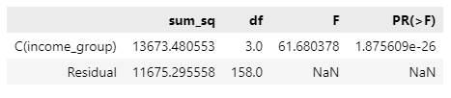

Fig 4.6: Distribution of EPI values for different country groups

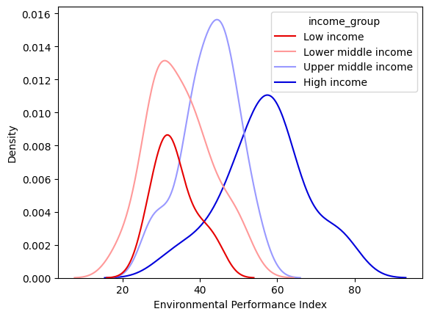

### Per Capita GHG Emissions From Agriculture

For this indicator, the difference in sizes of incomes didn’t cause any statistically different outcome in different countries. The p value of ANOVA was 0.5899, larger than the alpha value of 0.05. This was further shown by the median values for this indicator which weren’t much different among the country groups. For all country groups, the median values were 50. Below are the distributions of different countries in this indicator, along with its ANOVA output.

Fig 4.7: Per Capita GHG emissions from Agriculture

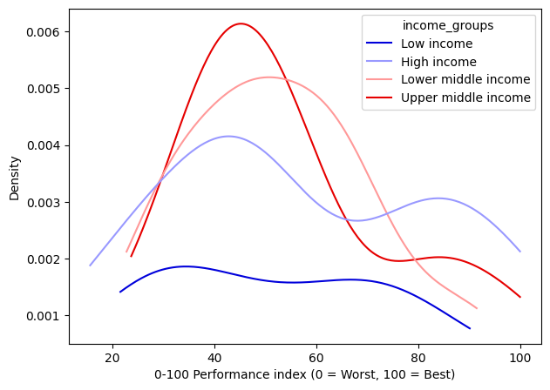

Table 4.7: ANOVA Output for Agricultural GHG per capita.

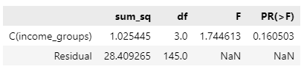

### Per Capita Net Freshwater Withdrawals

The ANOVA of this indicator showed that the size of an economy causes a statistically significant effect between countries. The p-value was less than 0.01 (1.499603e-18). An examination of the median values for this indicator agreed with this, showing a median value of 11.5% withdrawals in high income countries, 59.9% in upper middle income, 80.6% for lower middle income, and 76.1% for low income countries. Here, the relationship between the size of an economy and this indicator might also be non-linear, observing that low income countries withdrew less that lower middle income countries. The graph below shows the KDE distribution of different income groups in this indicator.

Fig 4.8: The KDE Distribution of Water Withdrawals According to Country Group

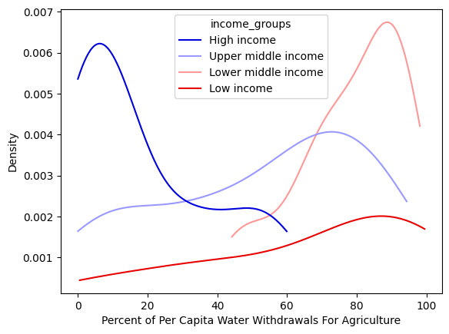

Fig 4.9: Median Per Capita Water Withdrawals For Agriculture in Different Income groups

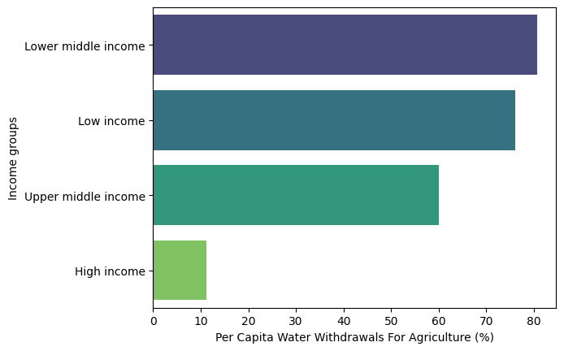

### Per Capita Energy Use From Non-Renewable Sources

The ANOVA analysis for this indicator showed a statistically significant difference between income groups and proved the alternative hypothesis that sizes of income determine the outcome of this particular indicator. The relatioship between the two variables also seem to be linear as the per capita non-renewable energy used in agriculture increased as countries changed from one income group to another. High income countries used a median of 0.00589 TJ per capita, Upper middle 0.003237 TJ, lower middle 0.000746, and low income 0.000190 TJ (Terajoules). Below are the ANOVA results and a comparison of their means.

Table 4.8. ANOVA output for Per Capita Non-Renewable Energy Use in Agriculture

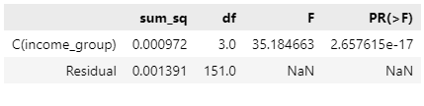

Fig 4.10: Median Per Capita Energy Use in Agriculture From different Country Groups

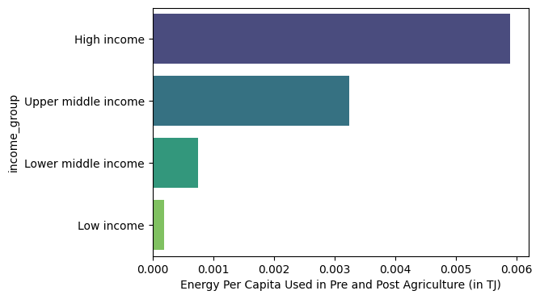

### Per Capita Land Use in Agriculture

Like the previous indicator in this metric, the ANOVA analysis for this indicator showed a statistically significant difference between countries in different income groups (p < 0.01). There seems to be a negative linear relationship between the two variables such that per capita land increase used in agriculture reduces as a country becomes richer. This makes sense considering the productivity increases that are usually common in high income countries compared to low income countries when it comes to agriculture. The difference between lower and upper middle income countries on this metric seems negligible though, though lower middle income countries still use a slightly larger median amount of land for agriculture per capita. Below are the figures displaying the ANOVA results for the indicator, along with the comparison of its median values.

Table 4.9. ANOVA Output of Per Capita Land Use Between Income Groups

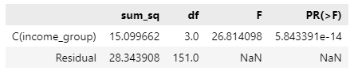

Fig. 4.11. Median Per Capita Land Use According to Income groups

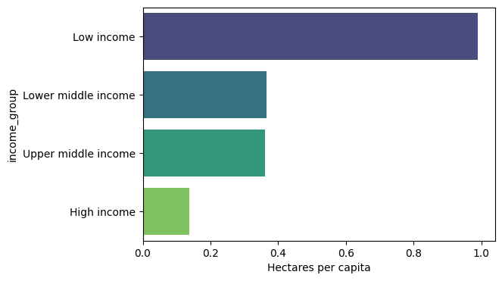

## Food Affordability and Availability

As mentioned in the materials and methods section of this writing, 2 of the 4 indicators of this metric weren’t used. Again, high income countries won by a considerably good margin. Their total score in this metric is 78.4, followed by upper middle income who have 68.9, then followed by lower middle income who have 57.1, then lastly by low income countries who have 45.4. The figure below presents a graphical presentation of these findings.

Fig. 4.12. Country Group Scores on Metric 3: Food Affordability and Availability

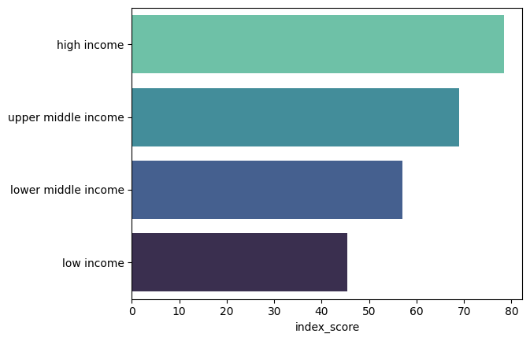

### Food Affordability

The ANOVA of this indicator showed a statistically significant difference caused by size of income (p < 0.01). The sample size 34 high income countries, 15 low income countries, 30 lower middle income countries, and 23 upper middle income countries led to this output. Median affordability score for low income countries was 42.6, 59.85 for lower middle, 78.00 for upper middle, and 89.35 for high income. Here, there is a positive linear relationship suggesting that affordability increases as a country becomes richer.

Table 4.10. ANOVA Output For Food Affordability Score Among Income Groups

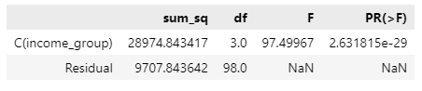

Fig 4.13. Barplot of Median Food Affordability Scores

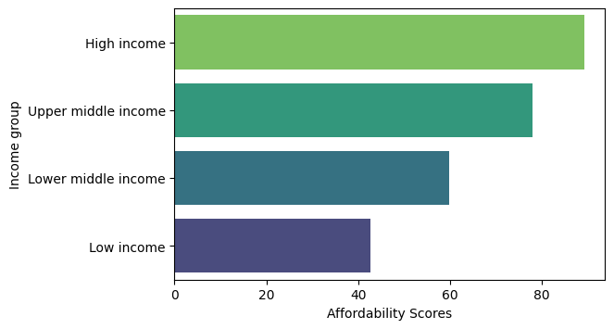

### Food Availability

Just like the previous indicator, the size of an economy shows to cause a statistically significant difference in food availability between countries (p < 0.01). Again, the relationship is positively linear, meaning you are more likely to find food easier in higher income countries than in lower. The median availability values for high income countries are 67.45, 59.8 for upper middle, 54.3 for lower middle, and 48.2 for low income. Below are the figures displaying the ANOVA output and the barplot of this analysis.

Table 4.11. ANOVA Output for Food Availability

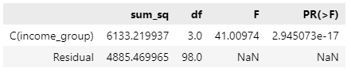

Fig 4.14. Median Food Availability Values

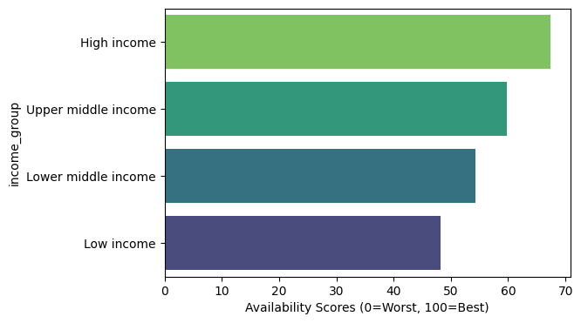

## Socialcultural Wellbeing

3 out of 4 indicators for this metric didn’t have enough data. That being the case, the inference for the metric was taken from only one of its indicators, which is the gender gap index. According to this indicators, there is a statistically significant difference between income groups and the relationship between the two variables seems to be positively linear. The ANOVA output of the indicator had a p-value smaller than 0.01 (p < 0.01). Below are figures showing the ANOVA output for the indicator, and the bargraph of each country’s median values.

Table 4.12. ANOVA Output for Gender Equity Values Between Income Groups

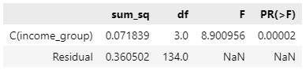

Fig 4.15. Gender Gap Index Values

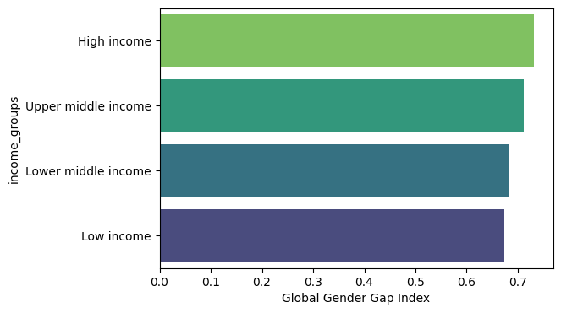

## Resilience

Here, high income countries again take the mantle, leading all other groups with an overall score of 53.8. The metric seems to have a positively linear relationship with size of an economy, as the score goes on increasing as the size of an economy gets larger. The remaining scores are as following: 48.01 for upper middle income, 43.88 for lower middle income, and 42.98 for low income. The graph below gives a graphical presentation of these results.

Fig 4.16. Metric Score for the Fifth Metric: Resilience.

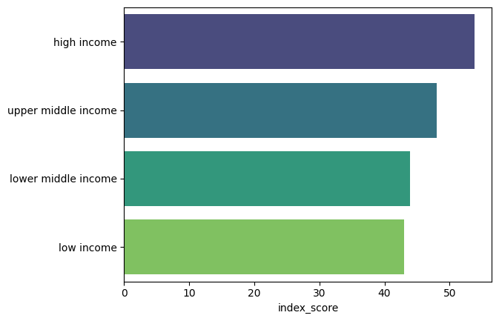

### ND-GAIN

The ANOVA of this indicator shows a statistically significant difference between country groups. The p-value is less than 0.01 (p < 0.01). The relationship also appears to be positively linear, with the score getting better as countries change into higher income groups. The median index for high income countries in this indicator is 61.69, followed by upper middle income with 49.75, followed by lower middle income with 41.9, followed by low income at 35.29. The following are ANOVA output and barplot of the median values for this indicator.

Table 4.13. ANOVA Output for the ND-GAIN Index

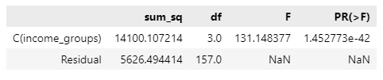

Fig. 4.17. Median ND-GAIN Values

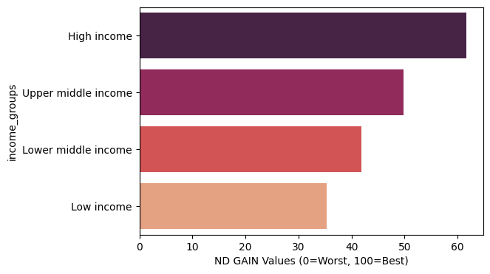

### Food Production Diversity

Scores in this indicator didn’t show any statistically significant difference between income groups. The p-value was larger than the 0.05 threshold (p > 0.05), and the median scores among income groups also portrayed this. Here, low income came first with an indicator score of 50.6, upper middle income second with 46.27, high income third with 45.94, and lower middle income fourth with 45.84. As one can see, the arrangement of income groups in this ranking suggests a non-linear relationship between this and the size-of-economy variable, which to a large extent might have also skewed the results of the ANOVA analysis. Below is a visualizations of median value performance of income groups in this indicator, and the corresponding ANOVA output.

Table 4.14. ANOVA Output for Food Production Diversity

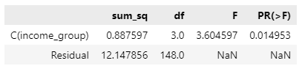

Fig 4.18. Median Values Food Production Diversity

## Food Safety

As mentioned in the materials and methods section, this metric had only one indicator in it that was usable. The GFSI food safety score showed a statistically significant difference between income groups, with high income countries leading, followed by upper middle income, lower middle income, and lastly low income. As one can see, the relationship is positively linear, with food safety proposedly increasing as the size of an economy increases. The graph below presents the results of this indicator, along with the corresponding ANOVA output for it.

Table 4.15. ANOVA Food Safety Score

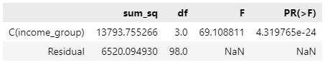Fig. 4.19. Median Food Safety Among Income groups

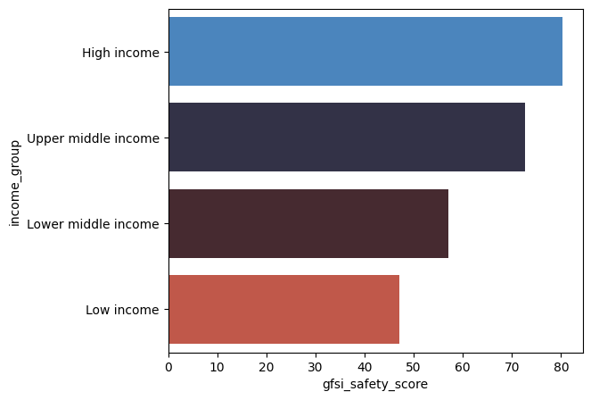

## Waste and Loss Reduction

In this metric, high income countries again came first, with an overall score of 51.82. Upper middle income came second with 51.04, lower middle income third with 46.81, and low income last with 43.82. The ANOVA analysis showed a statistically significant difference between countries at the threshold of 0.01. Below are the ANOVA output and a graphical visualization of the performance values of different income groups in this metric.

Table 4. 16. ANOVA Output: Waste & Loss Reduction vs Size of Economy



Fig. 4.20. Performance of Different Country Groups in Metric 7: Waste and Loss Reduction

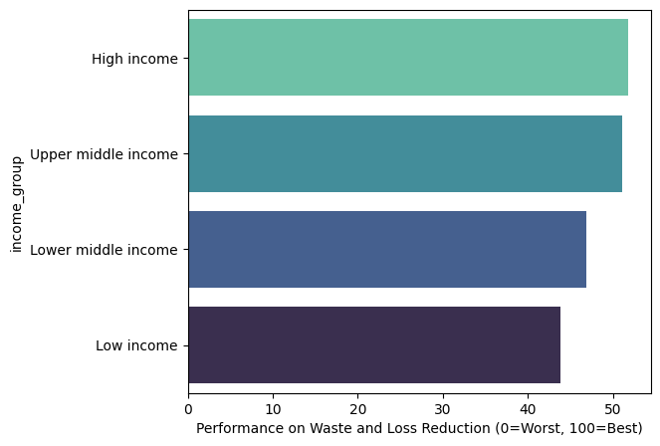

# Conclusion

As displayed via several chapters above, there is still a huge room for improvement in the data sourcing side of things for this method to be robust in doing an up-to-date analysis based on size of economy. Several key indicator couldn’t be deduced, which robs away from the robustness of the methodology itself.

Nonetheless, there are still valuable insights that have been accrued from the study, be it as limited as it was. We see that, different from what previous studies denoted about high income countries, they now perform better than all other groups when it come to waste and loss reduction, a metric whose data was as current as expected. The study also showed the weaknesses and strengths in each income group, which is a stepping stone for analyses that may base on sustainable nutrition security in the future. A future study like this is recommended in order to cover what this study hasn’t been able to cover with the current available data on the indicators of interest.

# References

Allesch, A., & Brunner, P. H. (2015). Material Flow Analysis as a Decision Support Tool for Waste Management: A Literature Review. *Journal of Industrial Ecology*, *19*(5), 753–764. https://doi.org/10.1111/jiec.12354

Arsenault, J. E., Hijmans, R. J., & Brown, K. H. (2015). Improving nutrition security through agriculture: An analytical framework based on national food balance sheets to estimate nutritional adequacy of food supplies. *Food Security*, *7*(3), 693–707. https://doi.org/10.1007/s12571-015-0452-y

Auestad, N., & Fulgoni, V. L., III. (2015). What current literature tells us about sustainable diets: Emerging research linking dietary patterns, environmental sustainability, and economics. *Advances in Nutrition*, *6*(1), 19–36. Scopus. https://doi.org/10.3945/an.114.005694

Ayres, R. U., Ayres, L., & Ayres, L. W. (1999). *Accounting for Resources, 2: The Life Cycle of Materials*. Edward Elgar Publishing.

Behrens, P., Kiefte-de Jong, J. C., Bosker, T., Rodrigues, J. F. D., de Koning, A., & Tukker, A. (2017). Evaluating the environmental impacts of dietary recommendations. *Proceedings of the National Academy of Sciences*, *114*(51), 13412–13417. https://doi.org/10.1073/pnas.1711889114

Boylan, S. M., Thow, A.-M., Tyedmers, E. K., Malik, A., Salem, J., Alders, R., Raubenheimer, D., & Lenzen, M. (2020). Using Input-Output Analysis to Measure Healthy, Sustainable Food Systems. *Frontiers in Sustainable Food Systems*, *4*. https://doi.org/10.3389/fsufs.2020.00093

Brunner, P. H. (2012). Substance Flow Analysis. *Journal of Industrial Ecology*, *16*(3), 293–295. https://doi.org//10.1111/j.1530-9290.2012.00496.x

Chaudhary, A., Gustafson, D., & Mathys, A. (2018a). Multi-indicator sustainability assessment of global food systems. *Nature Communications*, *9*(1), Article 1. https://doi.org/10.1038/s41467-018-03308-7

Chaudhary, A., Gustafson, D., & Mathys, A. (2018b). Multi-indicator sustainability assessment of global food systems. *Nature Communications*, *9*(1), Article 1. https://doi.org/10.1038/s41467-018-03308-7

Dame, M. C. W. // U. of N. (n.d.). *Country Index // Notre Dame Global Adaptation Initiative // University of Notre Dame*. Notre Dame Global Adaptation Initiative. Retrieved August 28, 2023, from https://gain.nd.edu/our-work/country-index/

del Valle M, M., Shields, K., Alvarado Vázquez Mellado, A. S., & Boza, S. (2022). Food governance for better access to sustainable diets: A review. *Frontiers in Sustainable Food Systems*, *6*. Scopus. https://doi.org/10.3389/fsufs.2022.784264

Diaz, R. J., & Rosenberg, R. (2008). Spreading dead zones and consequences for marine ecosystems. *Science*, *321*(5891), 926–929. Scopus. https://doi.org/10.1126/science.1156401

Ekvall, T. (2019). Attributional and Consequential Life Cycle Assessment. In *Sustainability Assessment at the 21st century*. IntechOpen. https://doi.org/10.5772/intechopen.89202

FAO. (n.d.). *Dimensions of need—Staple foods: What do people eat?* Retrieved February 15, 2022, from https://www.fao.org/3/u8480e/U8480E07.htm#The sources of food

FAO and WHO. (2020). Sustainable healthy diets. In *Sustainable healthy diets*. https://doi.org/10.4060/ca6640en

*FAOSTAT*. (n.d.-a). Retrieved January 1, 2023, from https://www.fao.org/faostat/en/#data/FBS

*FAOSTAT*. (n.d.-b). Retrieved August 28, 2023, from https://www.fao.org/faostat/en/#search/energy

*FAOSTAT*. (n.d.-c). Retrieved August 28, 2023, from https://www.fao.org/faostat/en/#data/QCL

Fern, E. B., Watzke, H., Barclay, D. V., Roulin, A., & Drewnowski, A. (2015). The nutrient balance concept: A new quality metric for composite meals and diets. *PLoS ONE*, *10*(7). Scopus. https://doi.org/10.1371/journal.pone.0130491

Finley, J. W., Dimick, D., Marshall, E., Nelson, G. C., Mein, J. R., & Gustafson, D. I. (2017). Nutritional Sustainability: Aligning Priorities in Nutrition and Public Health with Agricultural Production. *Advances in Nutrition*, *8*(5), 780–788. https://doi.org/10.3945/an.116.013995

Fischer-Kowalski, M. (1998). Society’s Metabolism. *Journal of Industrial Ecology*, *2*(1), 61–78. https://doi.org/10.1162/jiec.1998.2.1.61

*Food waste per capita*. (n.d.). Our World in Data. Retrieved August 29, 2023, from https://ourworldindata.org/grapher/food-waste-per-capita

*Global Food Security Index (GFSI)*. (2023, August 28). Global Food Security Index (GFSI). https://impact.economist.com/sustainability/project/food-security-index

Gussow, J. D., & Clancy, K. L. (1986). Dietary guidelines for sustainability. *Journal of NutritionEducation*, *18*(1), 1–5. Scopus. https://doi.org/10.1016/S0022-3182(86)80255-2

Gustafson, D., Gutman, A., Leet, W., Drewnowski, A., Fanzo, J., & Ingram, J. (2016). Seven Food System Metrics of Sustainable Nutrition Security. *Sustainability*, *8*(3), Article 3. https://doi.org/10.3390/su8030196

Hair, J. F., Anderson, R. E., Tatham, R. L., & Black, W. C. (2018). Multivariate Data Analysis. In *Multivariate Data Analysis, Multivariate Data Analysis B2—Multivariate Data Analysis, Multivariate Data Analysis* (Vol. 87).

Harrison, M. R., Palma, G., Buendia, T., Bueno-Tarodo, M., Quell, D., & Hachem, F. (2022). A Scoping Review of Indicators for Sustainable Healthy Diets. *Frontiers in Sustainable Food Systems*, *5*. Scopus. https://doi.org/10.3389/fsufs.2021.822263

Hasell, J., Arriagada, P., Ortiz-Ospina, E., & Roser, M. (2023). Economic Inequality. *Our World in Data*. https://ourworldindata.org/economic-inequality

Hasell, J., Roser, M., Ortiz-Ospina, E., & Arriagada, P. (2023). Poverty. *Our World in Data*. https://ourworldindata.org/poverty

*HLPE Report # 12—Nutrition and food systems*. (n.d.).

ILO. (2020). *Child Labour (Child Labour)*. Child Labor. https://www.ilo.org/global/topics/child-labour/lang--en/index.htm

Impact, E. (n.d.). *Global Food Security Index (GFSI)*. Retrieved February 18, 2022, from https://impact.economist.com/sustainability/project/food-security-index/

Johnston, J. L., Fanzo, J. C., & Cogill, B. (2014). Understanding sustainable diets: A descriptive analysis of the determinants and processes that influence diets and their impact on health, food security, and environmental sustainability. *Advances in Nutrition*, *5*(4), 418–429. Scopus. https://doi.org/10.3945/an.113.005553

Kytzia, S., Faist, M., & Baccini, P. (2004). Economically extended—MFA: A material flow approach for a better understanding of food production chain. *Journal of Cleaner Production*, *12*(8), 877–889. https://doi.org/10.1016/j.jclepro.2004.02.004

Lang, T. (2010). Crisis? What Crisis? The Normality of the Current Food Crisis. *Journal of Agrarian Change*, *10*(1), 87–97. https://doi.org/10.1111/j.1471-0366.2009.00250.x

Mäkelä, J., & Rautavirta, K. (2018). Chapter 5—Food, Nutrition, and Health in Finland. In V. Andersen, E. Bar, & G. Wirtanen (Eds.), *Nutritional and Health Aspects of Food in Nordic Countries* (pp. 127–143). Academic Press. https://doi.org/10.1016/B978-0-12-809416-7.00005-6

Malassis, L. (Ed.). (1983). *Food Systems Analysis*. https://doi.org/10.22004/ag.econ.198267

Molden, D. (2013). *Water for food water for life: A Comprehensive assessment of water management in agriculture* (p. 645). Scopus. https://doi.org/10.4324/9781849773799

Muralikrishna, I. V., & Manickam, V. (2017). Chapter Five—Life Cycle Assessment. In I. V. Muralikrishna & V. Manickam (Eds.), *Environmental Management* (pp. 57–75). Butterworth-Heinemann. https://doi.org/10.1016/B978-0-12-811989-1.00005-1

Myers, S. S., Smith, M. R., Guth, S., Golden, C. D., Vaitla, B., Mueller, N. D., Dangour, A. D., & Huybers, P. (2017). Climate Change and Global Food Systems: Potential Impacts on Food Security and Undernutrition. *Annual Review of Public Health*, *38*, 259–277. Scopus. https://doi.org/10.1146/annurev-publhealth-031816-044356

Otten, J., Hellwig, J. P., & Meyers, L. D. (Eds.). (2006). *Dietary Reference Intakes: The Essential Guide to Nutrient Requirements* (p. 11537). National Academies Press. https://doi.org/10.17226/11537

*Population*. (n.d.). Our World in Data. Retrieved December 15, 2022, from https://ourworldindata.org/grapher/population

Remans, R., Wood, S. A., Saha, N., Anderman, T. L., & DeFries, R. S. (2014). Measuring nutritional diversity of national food supplies. *Global Food Security*, *3*(3), 174–182. https://doi.org/10.1016/j.gfs.2014.07.001

*Resources | Environmental Democracy Index*. (n.d.). Retrieved August 28, 2023, from https://www.environmentaldemocracyindex.org/node/13967.html

Ritchie, H., & Roser, M. (2013). Land Use. *Our World in Data*. https://ourworldindata.org/land-use

Ritchie, H., & Roser, M. (2017). Water Use and Stress. *Our World in Data*. https://ourworldindata.org/water-use-stress

Ritchie, H., Roser, M., & Rosado, P. (2020). CO₂ and Greenhouse Gas Emissions. *Our World in Data*. https://ourworldindata.org/emissions-by-sector

*SR11-SR28: USDA ARS*. (n.d.). Retrieved January 25, 2023, from https://www.ars.usda.gov/northeast-area/beltsville-md-bhnrc/beltsville-human-nutrition-research-center/methods-and-application-of-food-composition-laboratory/mafcl-site-pages/sr11-sr28/

*Sustainable Diets and Biodiversity—Directions and solutions for policy, research and actions*. (n.d.). Retrieved December 14, 2022, from https://www.fao.org/3/i3004e/i3004e00.htm

The World Bank Group. (2019). *World View: Size of the Economy*. World Development Indicators; The World Bank Group. http://wdi.worldbank.org/table/WV.1

Thompson, S., Gower, R., Darmon, N., Vieux, F., Murphy-Bokern, D., & Maillot, M. (2013). *A Balance of Healthy And Sustainable Food Choices For France, Spain and Sweden*.

Tilman, D., Clark, M., Williams, D. R., Kimmel, K., Polasky, S., & Packer, C. (2017). Future threats to biodiversity and pathways to their prevention. *Nature*, *546*(7656), 73–81. Scopus. https://doi.org/10.1038/nature22900

von Braun, J., Afsana, K., Fresco, L. O., Hassan, M., & Torero, M. (2021a). Food system concepts and definitions for science and political action. In *Nature Food* (Vol. 2, Issue 10, pp. 748–750). https://doi.org/10.1038/s43016-021-00361-2

von Braun, J., Afsana, K., Fresco, L. O., Hassan, M., & Torero, M. (2021b). *Food Systems* [Report]. Center for Development Research (ZEF) in cooperation with the Scientific Group for the UN Food System Summit 2021. https://doi.org/10.48565/scfss2021-re63

*World Animal Protection | Animal Protection Index*. (n.d.). Retrieved August 28, 2023, from https://api.worldanimalprotection.org/

World Economic Forum. (n.d.). *Global Gender Gap Report 2020—Reports—World Economic Forum*. Retrieved February 18, 2022, from https://reports.weforum.org/global-gender-gap-report-2020/

Yale Center For Environmental Law And Policy-YCELP-Yale University & Center For International Earth Science Information Network-CIESIN-Columbia University. (2023). *2022 Environmental Performance Index (EPI)* [dataset]. Palisades, NY: NASA Socioeconomic Data and Applications Center (SEDAC). https://doi.org/10.7927/DWT2-9K25