Connection on Aiven
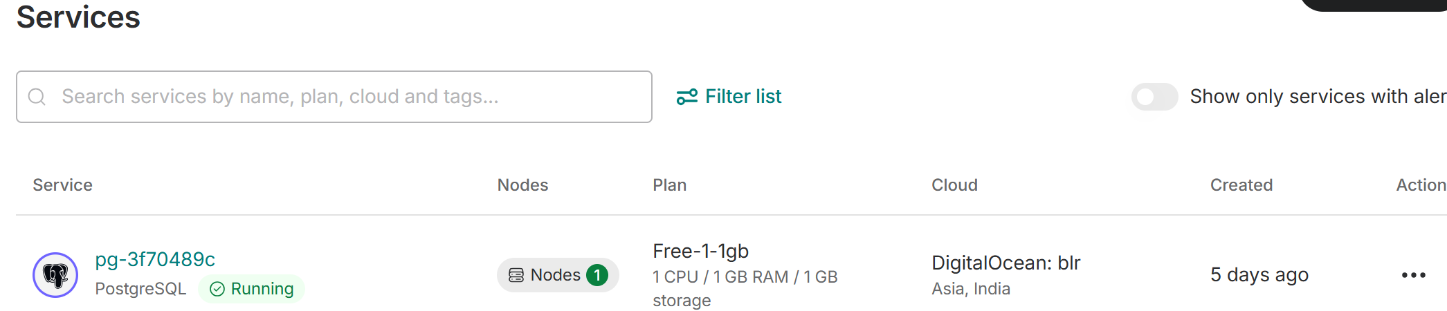
Connection Information
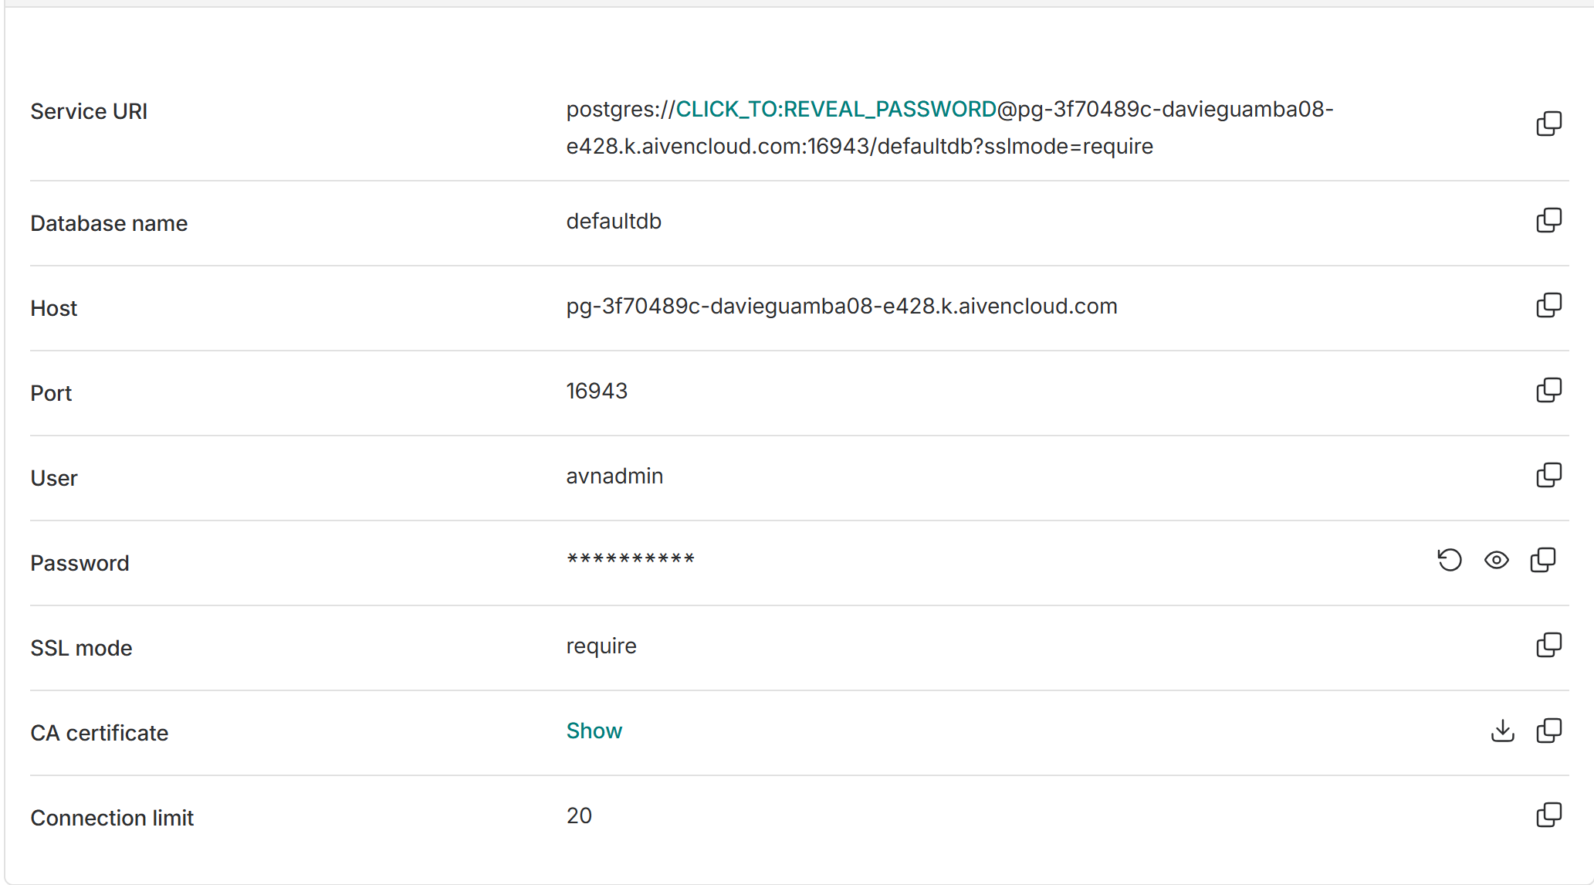
Creating new database on Dbeaver (Ctrl+Shift+N)-Select Postgresql
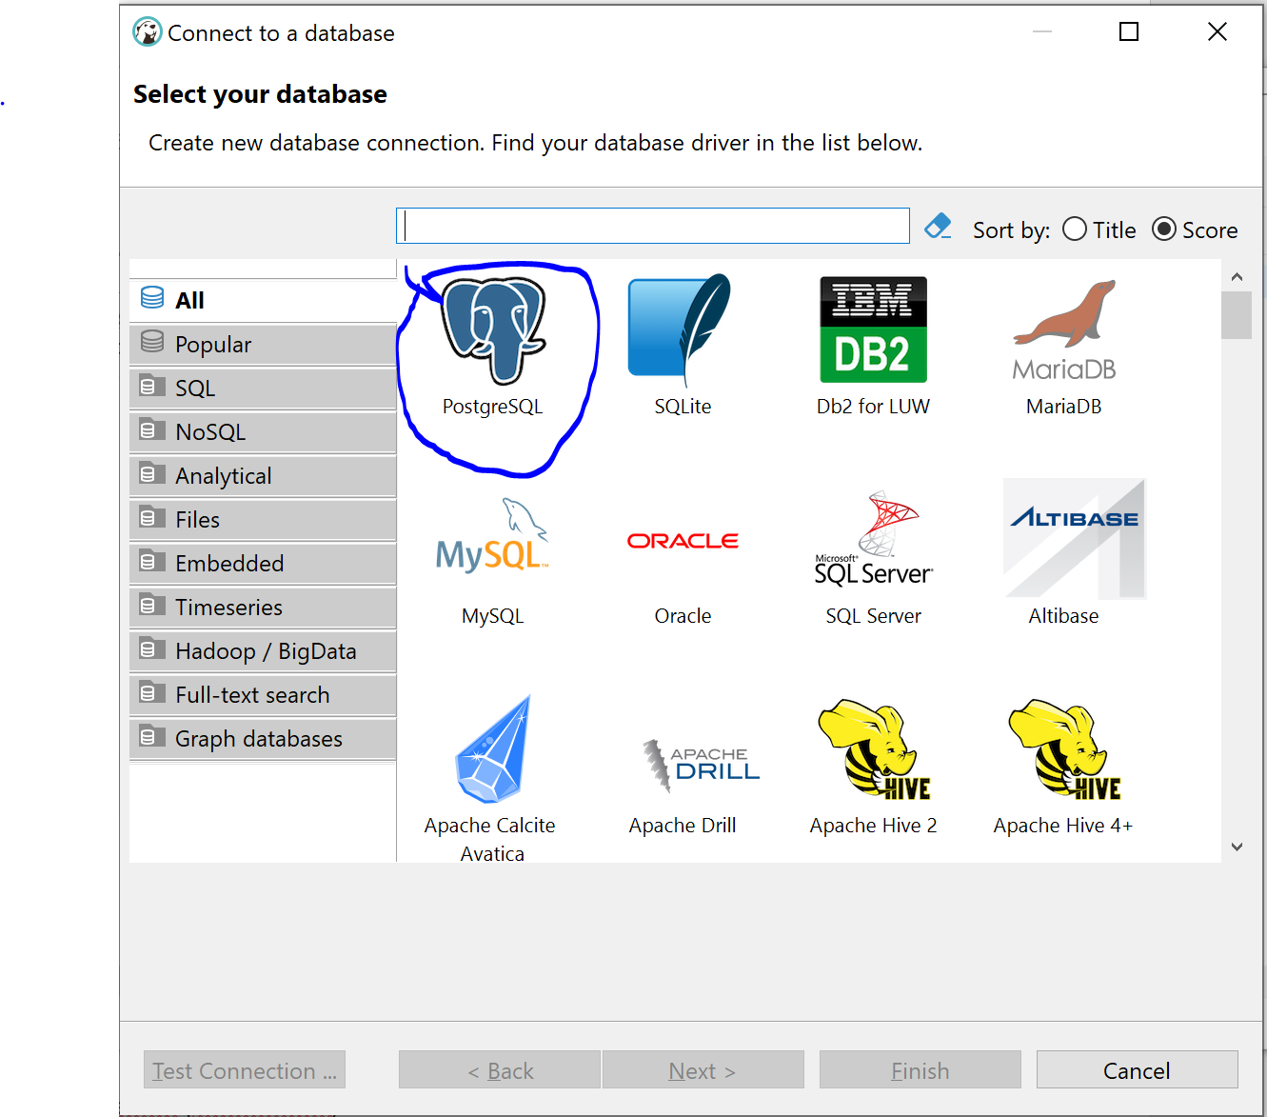
Click Next and input details from aiven
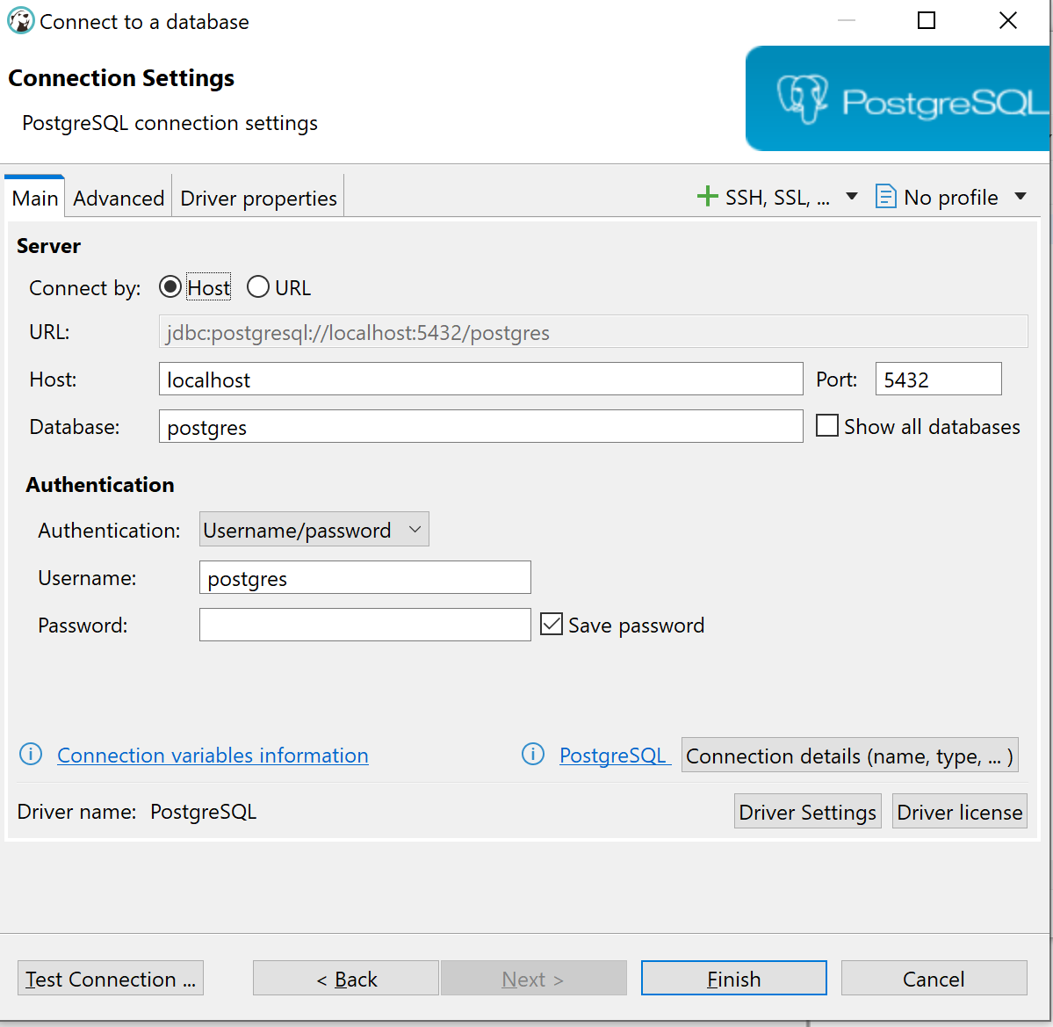
Done as below -Click Test Connection
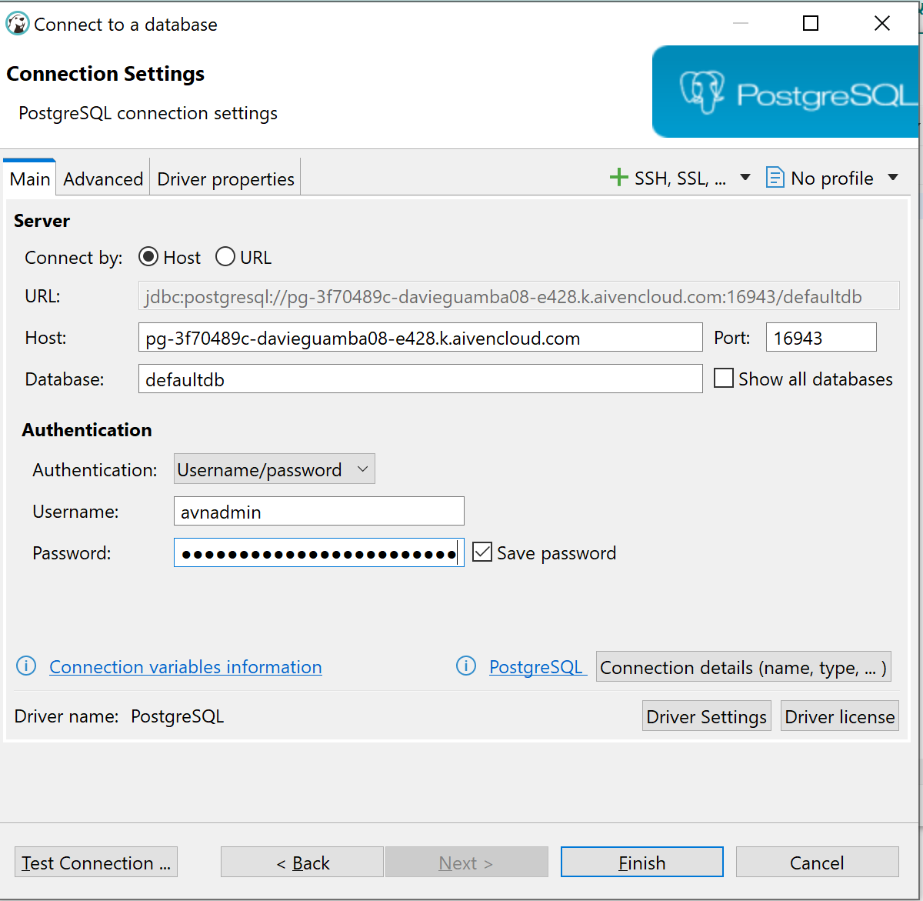
Click Ok & Finish
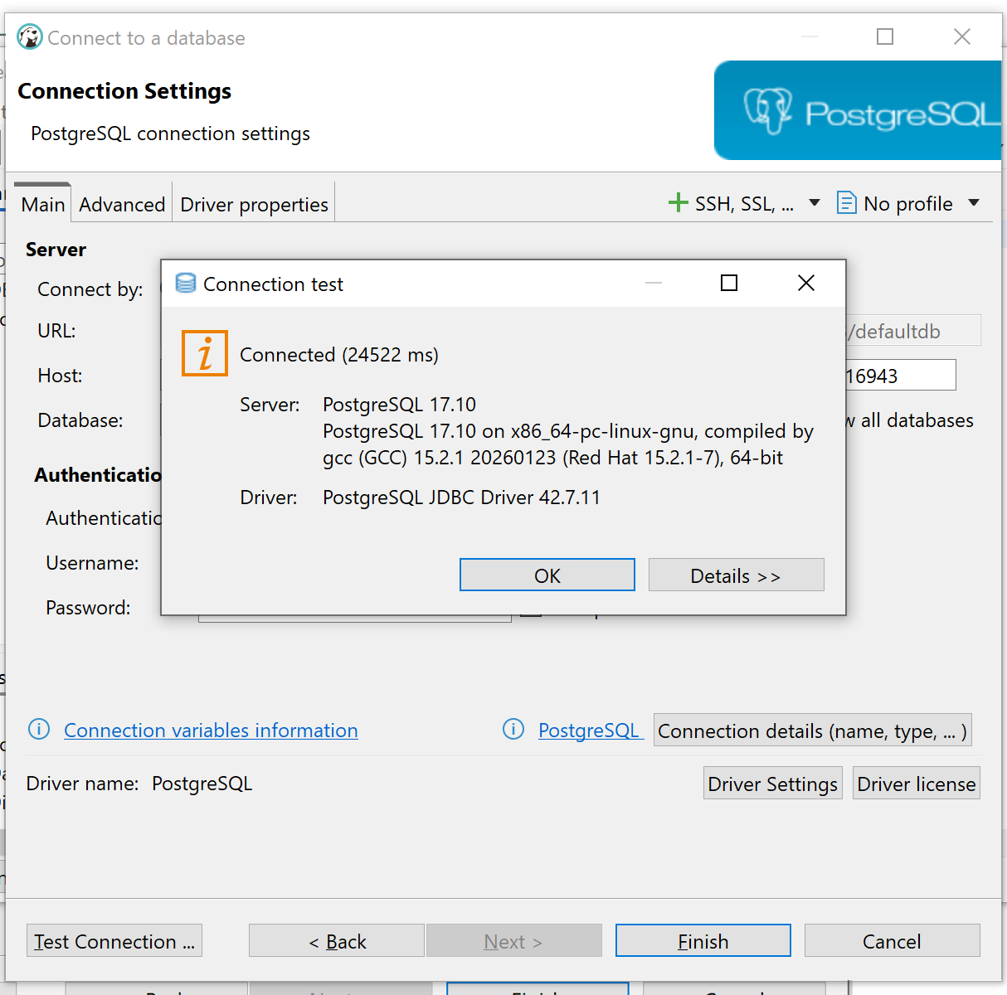
On dbeaver, select your database(you can create a schema prior or use the public schema)
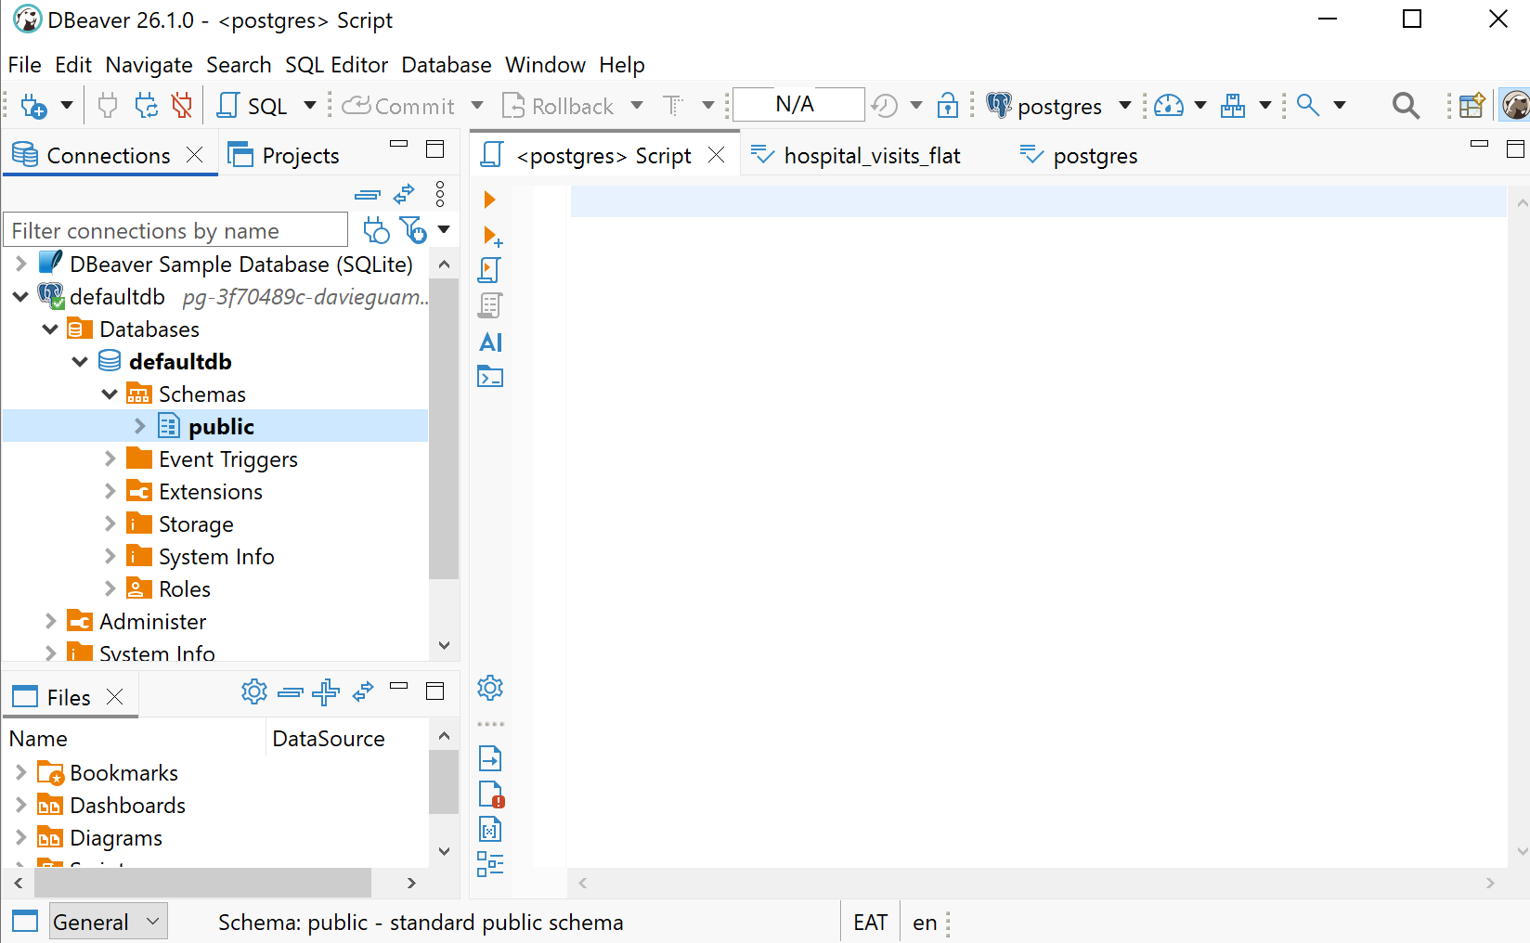
On the public schema, right click and select import data to import the file-Jcars. Select input files and click on Browse to select the file location.
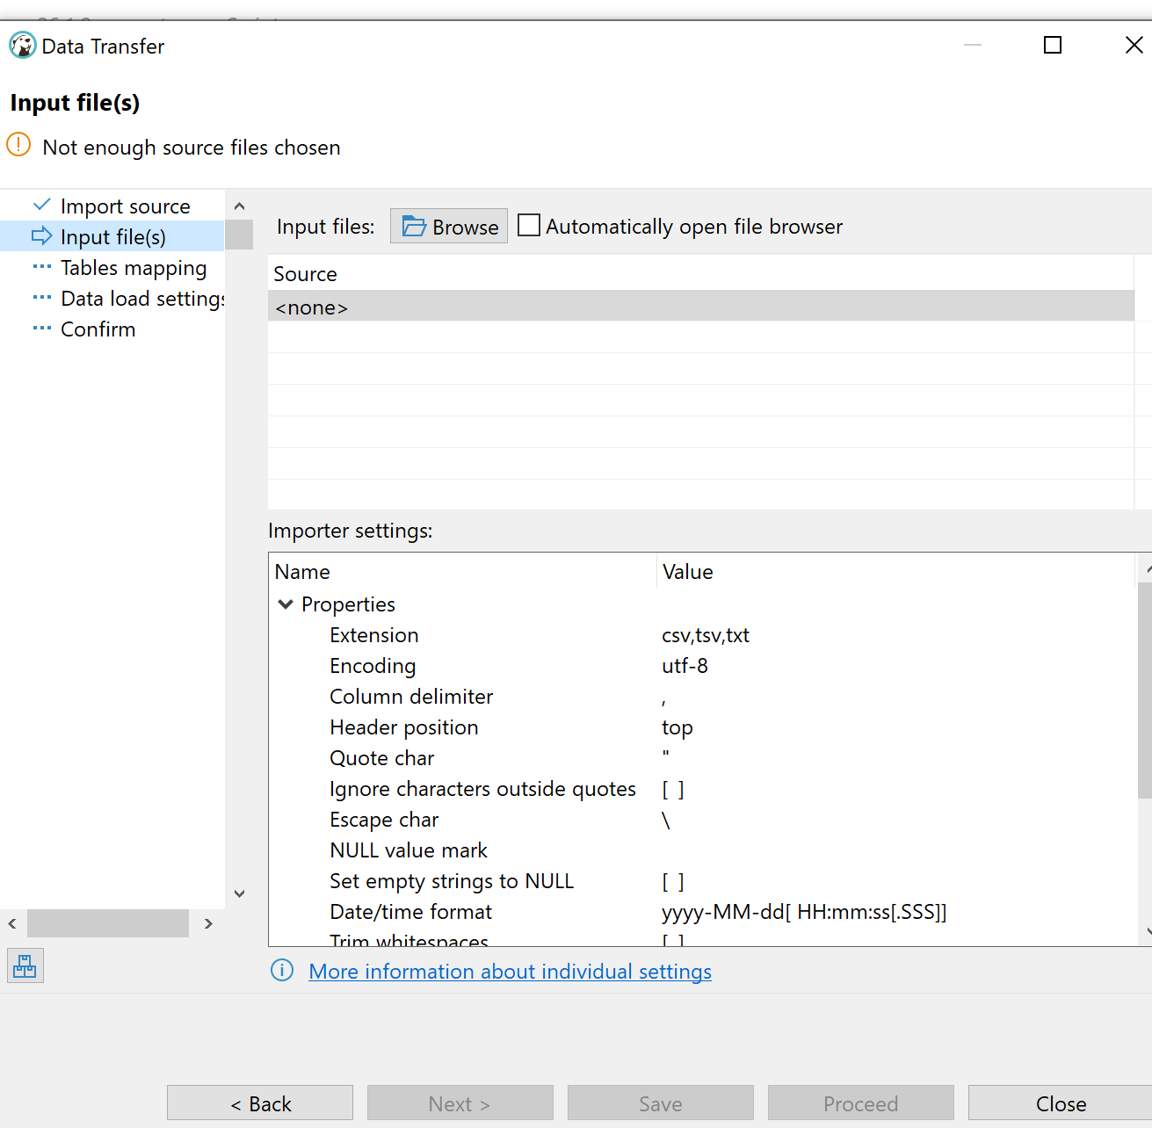
Select file and click on open.
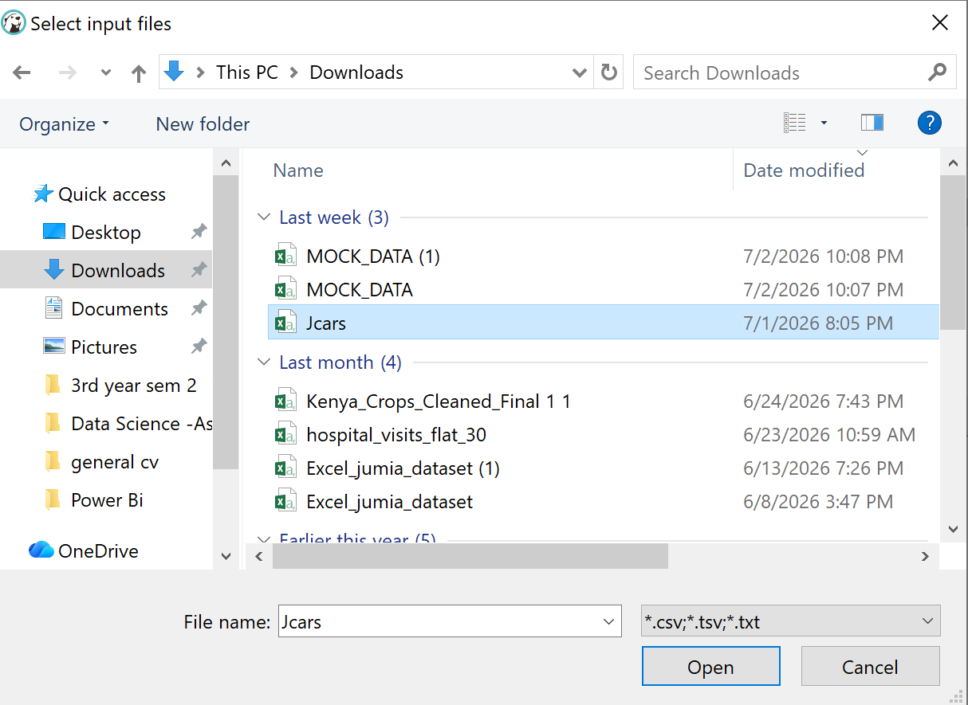

Click Proceed.
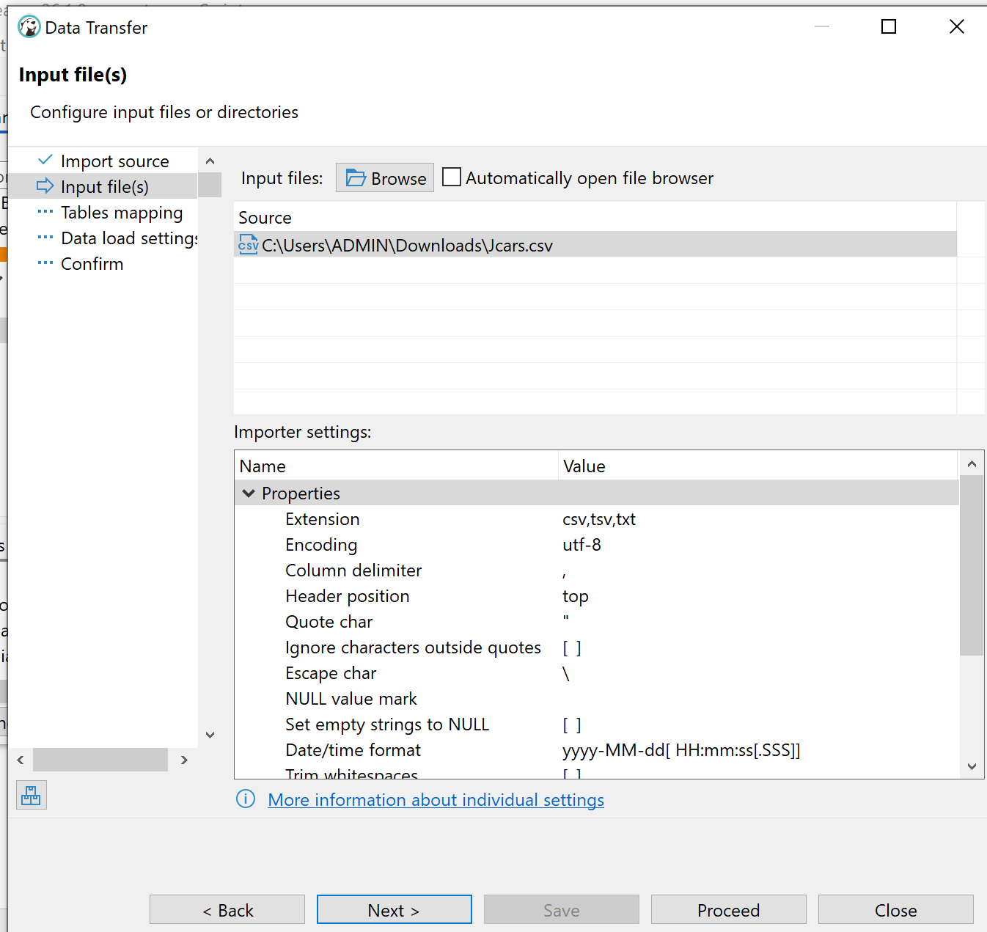
Click Proceed again.
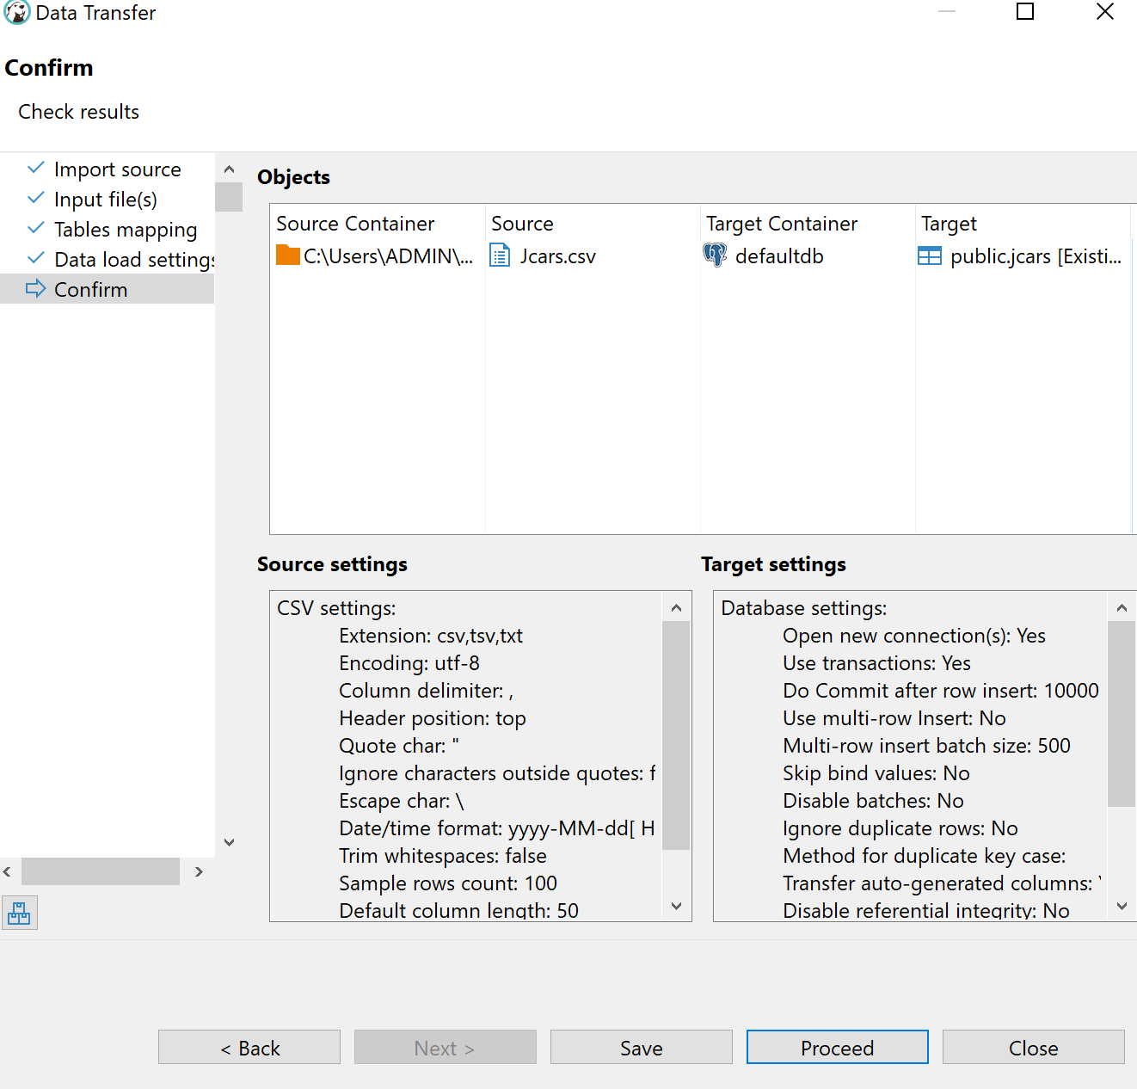
Adding SSL Certificate
Download the certificate from Aiven
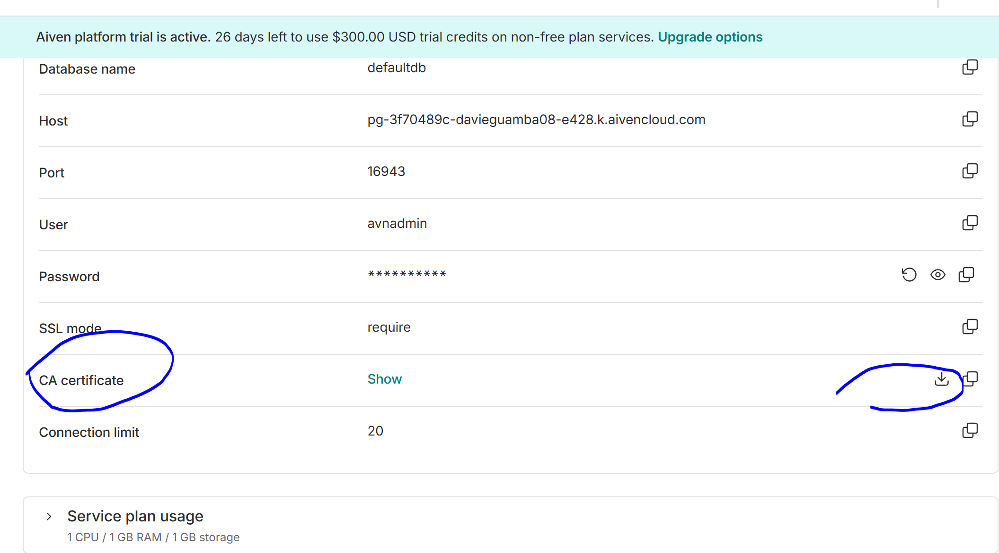
From the Control Panel, select Manage Certificate.
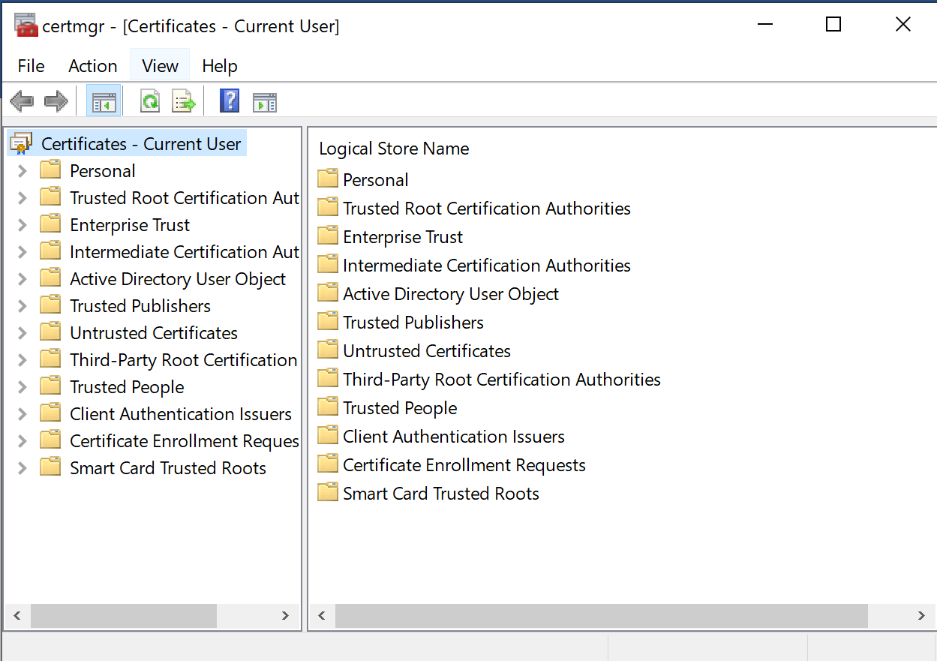
Click on Trusted Root Certification
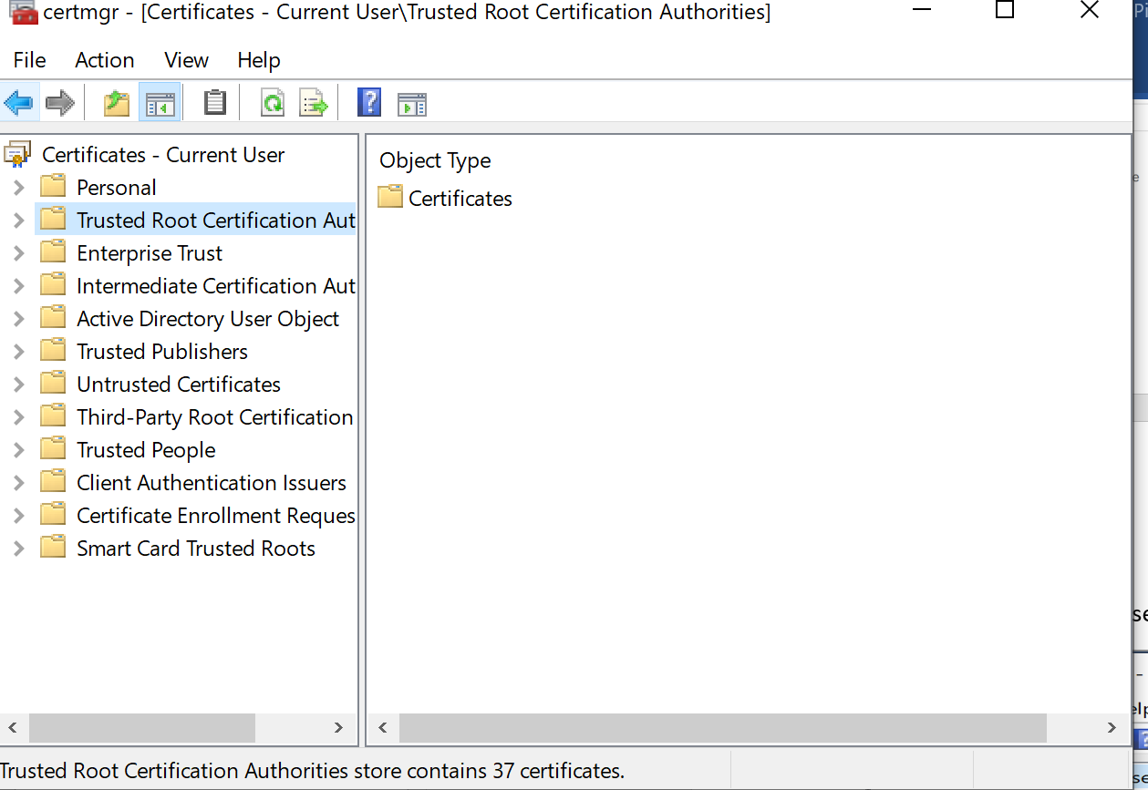
Right Click on Certificates, select All Tasks Then import
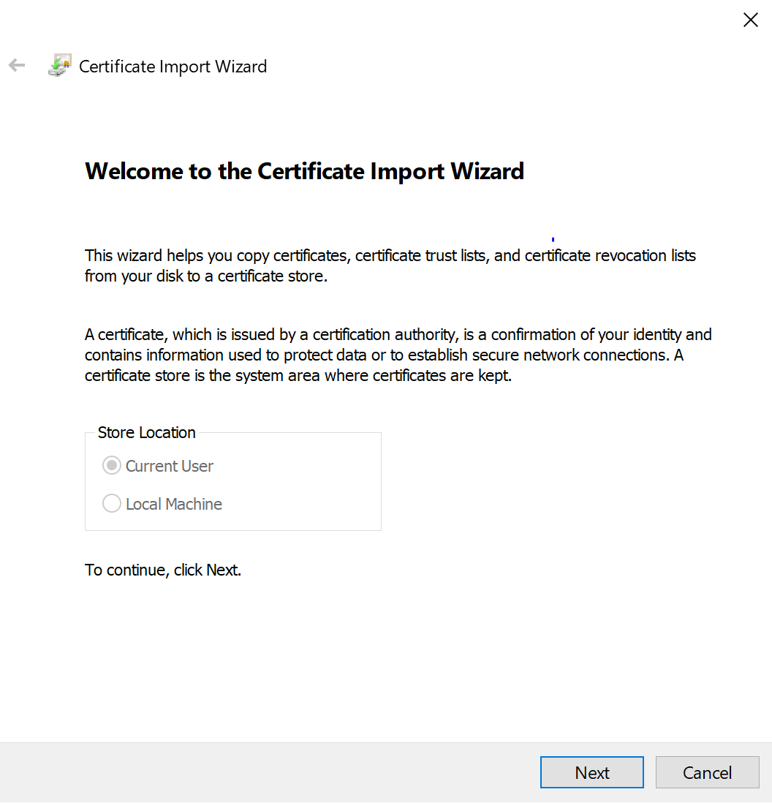
Click Next then browse to file location then click Next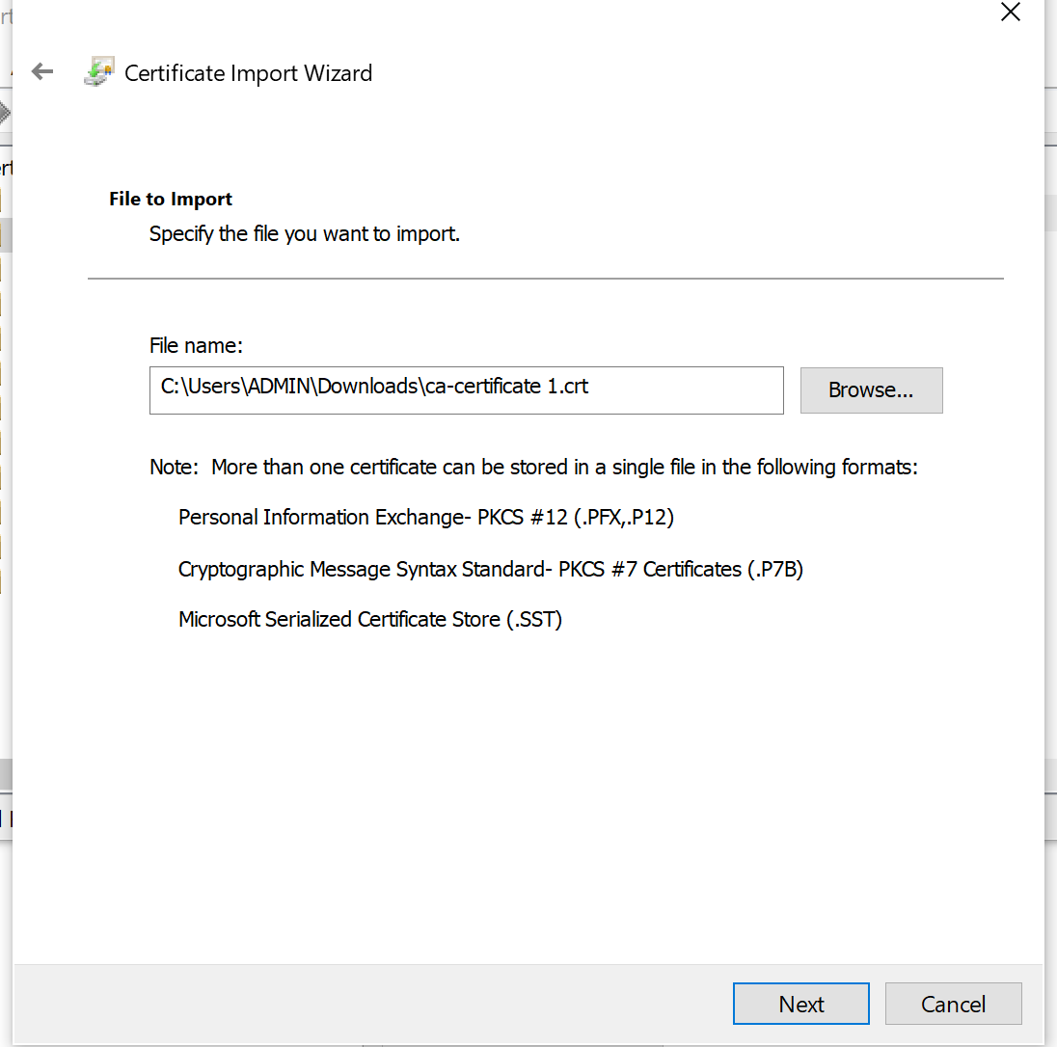
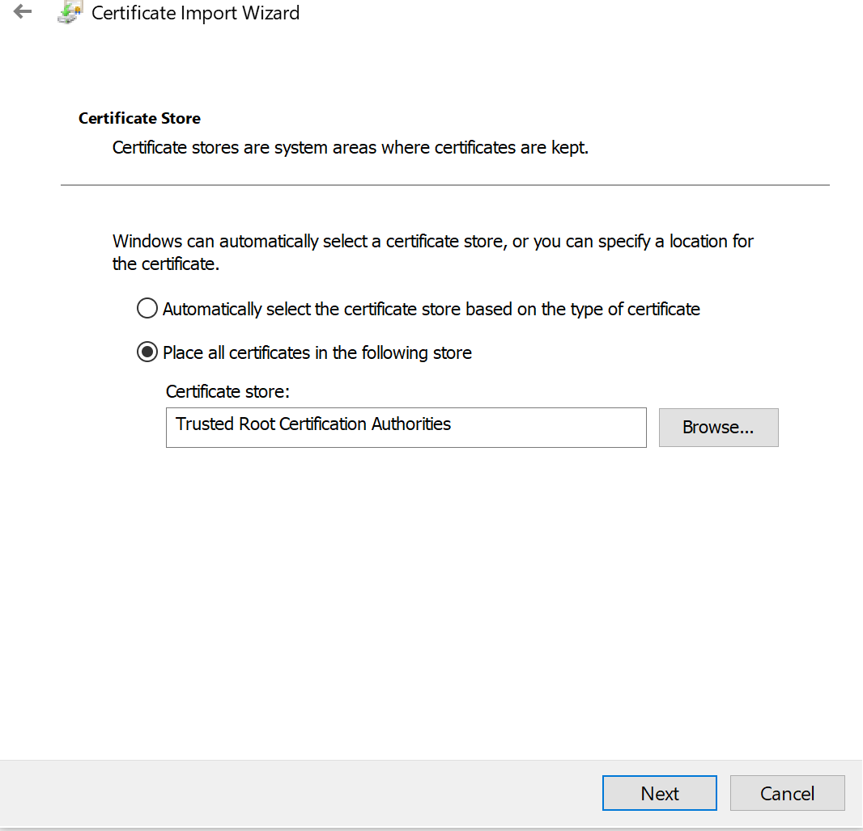
Click Finish
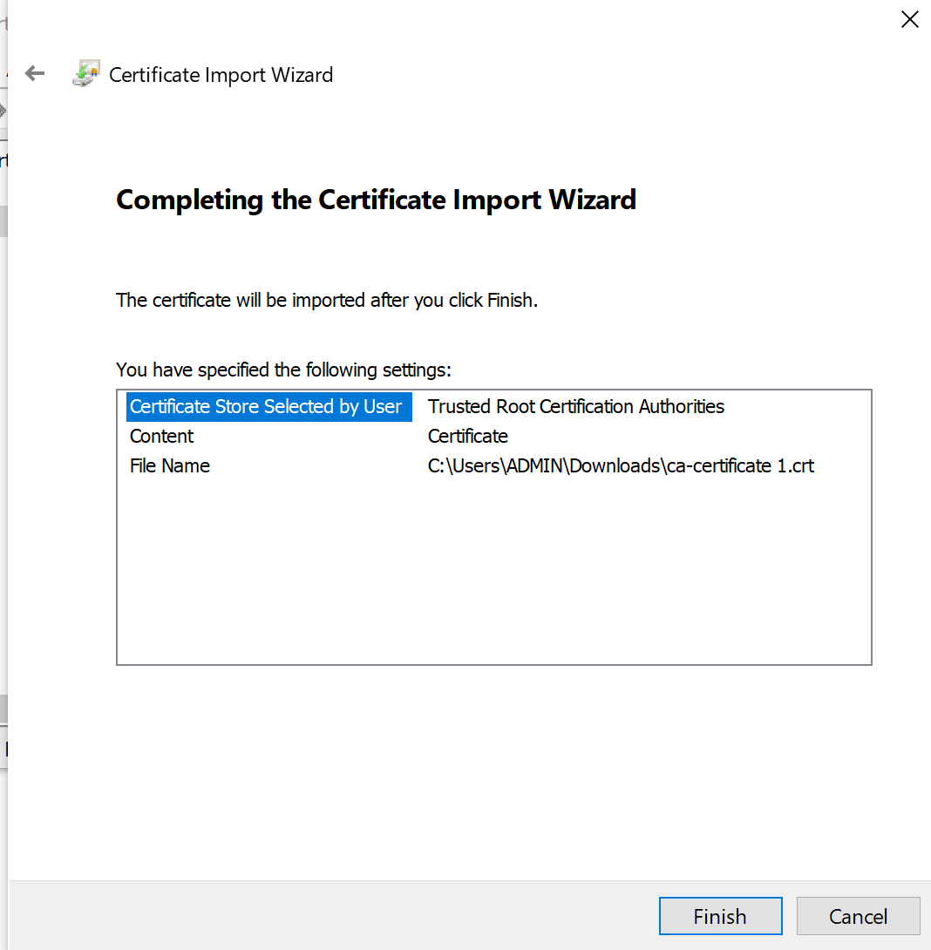

CONNECTING POWER BI TO POSTGRESQL
On Powerbi , Click on Blank Report , then click on get data
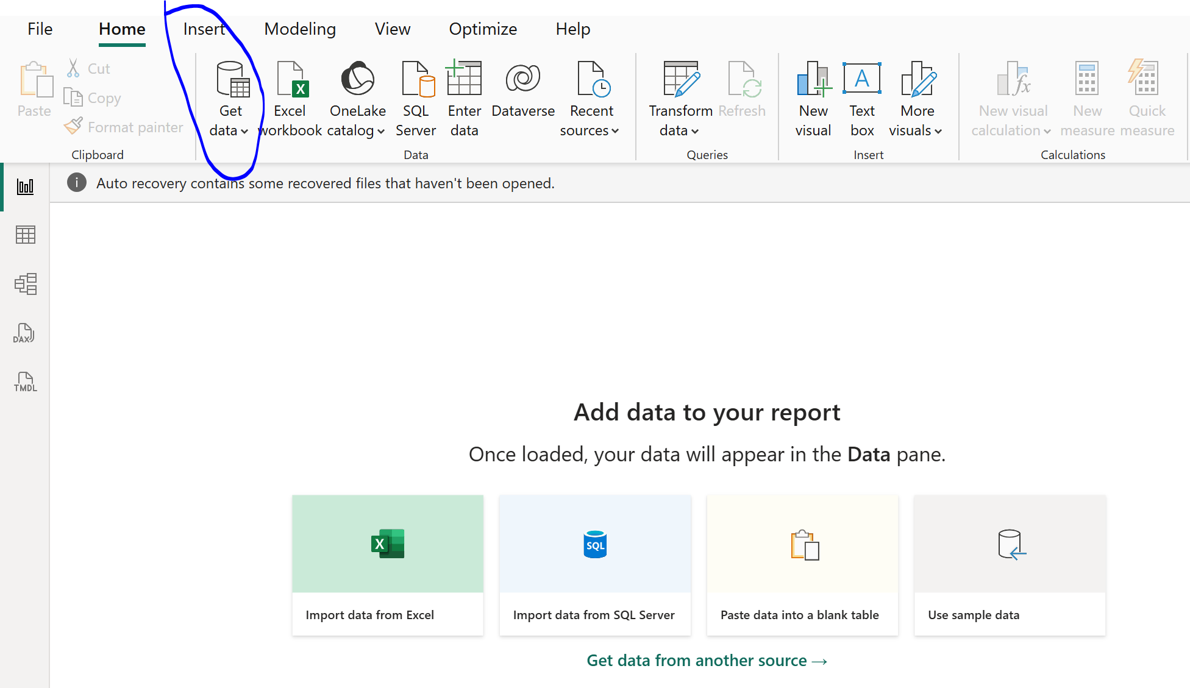

Click on more
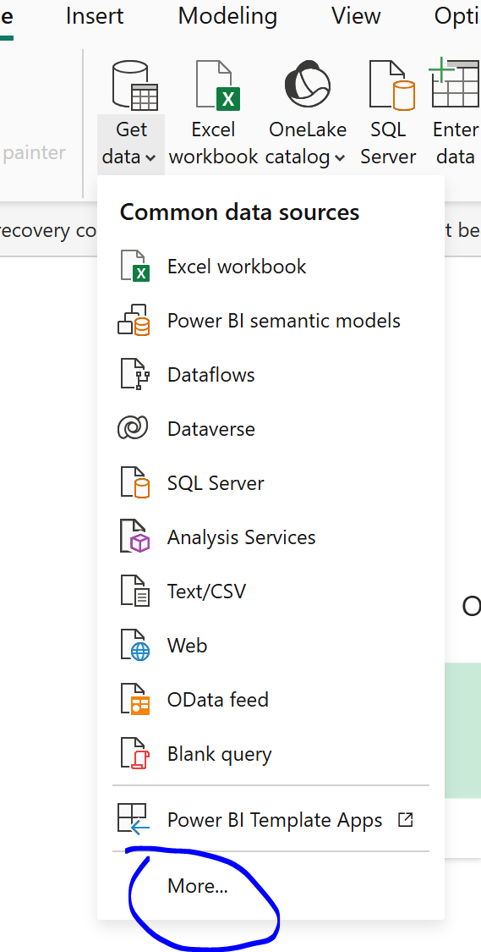
Click on databases and select postgresql
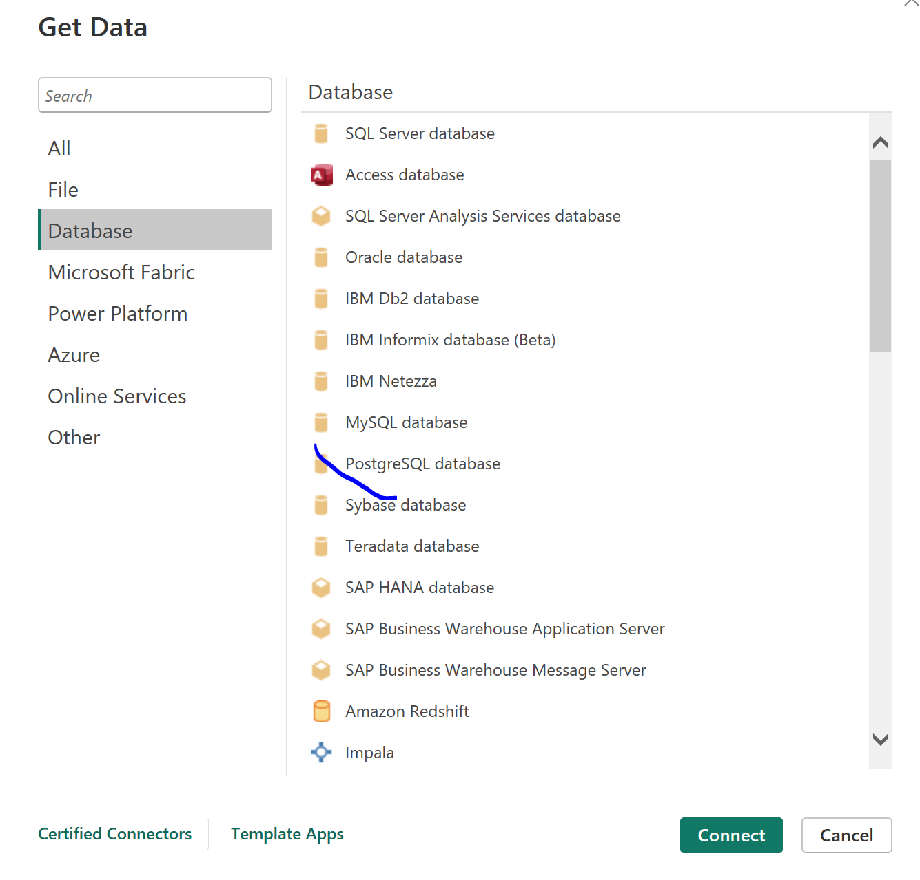
Fill in details as below from aiven
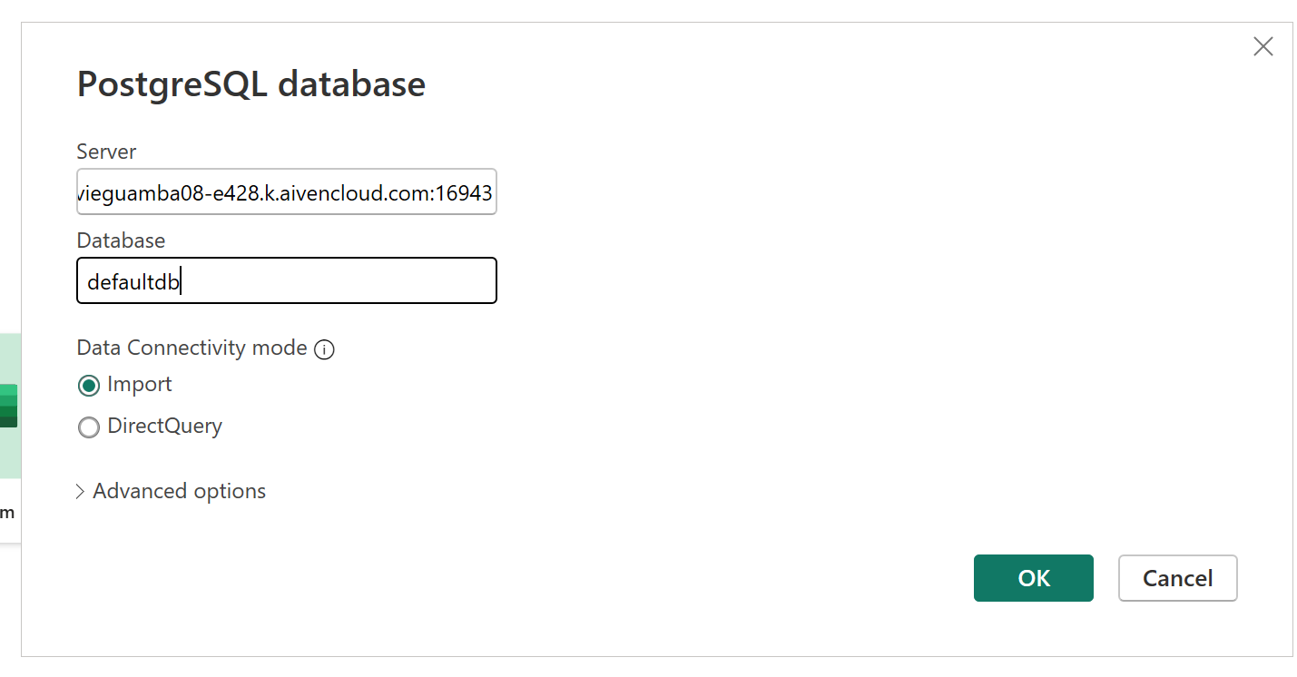
File Appears here as below, click on refresh if the file doesnot appear here
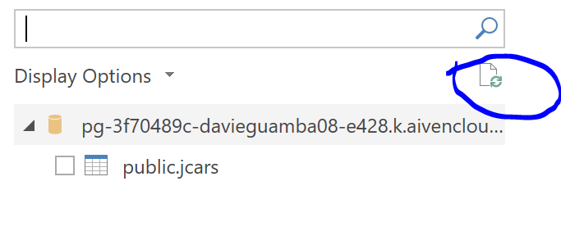
Select the file and clean on transform data to clean the data in power bi.

