**Personal Budget Analysis**

C964 – Computer Science Capstone

Western Governors University

**Part A: Letter of Transmittal**

February 25, 2024

Julia Smith, CTO

YourBudgetApp

123 Budget Dr

Greenville, South Carolina

Dear Ms. Smith,

This company has been growing quickly in the personal budgeting space. However, we are not differentiating ourselves from the competition. While we excel at customer service, and our product is top notch in terms of quality and stability, we need something to separate us from the competition. Something that will retain the people willing to try it but prefer what they are used to and pull in people who may not have even bothered to try the product. My proposed feature will do just that.

By implementing machine learning into our product, we will offer something not commonly seen in the personal budget space. The implementation of machine learning will enable our customers to see the future potential of their budgeting habits and allow a new dimension to their decision-making process. Machine learning can be implemented into the budget such that the customer chooses what data to forecast and how. With this proof of concept, you approve production of we can build out a full featured forecasting system with feedback from our community.

The first iteration of the machine learning build will take a week of work from myself and an additional developer, at a cost of $3000. I will provide the data for developing and testing from my personal budget, scrubbed appropriately for my personal security. The final product will not be storing data separately from what is already used in the application, we will not be implementing any cloud-based services; Everything will be done on the user's local machine and open sourced just as the rest of the product currently is. My educational background is in machine learning implementations of this nature and I am passionate about instilling strong personal finance skills into people enabling them greater flexibility and autonomy in life; Making me uniquely qualified to lead and develop this new product.

I am available to answer any additional questions and I look forward to hearing from you. Thank you for considering my proposal, I hope we can move forward with this idea to provide new and exciting products for our customers.

Sincerely,

David Mitchell, Project Lead

Part A: Project Recommendation

**Problem Summary**

There is an abundance of personal budget apps on the market today, all offering their own spin on this age-old product need. To distinguish ourselves from the rest of the pack we need something unique to offer our customers that will keep them around in the long term. Every budget app, including ours offers historical reporting, few if any attempts to look into the future for the individual. Implementation of machine learning will enable our company to stand apart from the competition and offer the customer something they cannot get elsewhere. In this Project we will implement machine learning forecasting in our app's suite of reporting capabilities. This will give the user access to a new dimension of information to better enable them to make decisions on their budget.

**Application Benefits**

The implemented machine learning will look at the historical data stored locally on the user's system, this is the data generated by normal use of the application, income, and spending information, as well as where the user allocates their available funds. The user can then select which categories of their budgets they would like a forecast for. Once they have a visual of the potential future of the decisions, they are making they will have a better picture of what can be done to reach whatever goals they have in mind for themselves. This creation of value for the customer will result in value for the company and all its stakeholders, as well as strong user retention and capturing market share from the competition.

**Application Description**

The machine learning implementation will take user generated budget data (income, expenses, transaction information, budget allocation amounts, etc.), normalize the data as necessary, analyze the data and finally display through graphical visual aids and text based explanations results of the analysis based on what the user selected to be analyzed. The results will include things such as the expected balance of their tracked 401k account at fixed points in the future or the balance of an emergency fund based on historical use of the emergency fund.

**Data Description**

All the data comes directly from the customers use of our budget app. All the data is transaction data that includes the date of the transaction, the budget category associated with the transaction, and the dollar amount of the transaction. The date, category, and transaction amount are the independent variables used by the machine learning and the predicted future balance or transaction amounts are the variables provided to the user after the machine learning has finished it work. The project's major limitations include the accuracy and completeness of the user's data, as well as smaller data sets suffering from worse predictions. The final limitation is the choice of algorithm used by the machine learning implementation can affect the accuracy of the forecasts.

**Objectives**

This project's objective is to create a product that will create a new avenue of value for our budget customers. This will be accomplished through a new budget reporting feature that uses machine learning to forecast the future state of the user budget in each selected category. The User will be able to select what portions of their budget they would like to see forecasts for, as well as how far out to forecast as well as the period the forecast is broken into (e.g., monthly vs weekly change). Finally, the product will include visual and text-based information generated as well as layperson instruction on interpreting the provided forecast as well as the potential limitations of it.

**Methodology**

Development will follow the agile methodology. The agile methodology is most appropriate for this project given the need for regular feedback from the end user. Agile is flexible enough to respond to changes throughout the iterative nature of the project's development. Planning will begin with laying out the vision and big picture deliverables of the project, then breaking those down into smaller scale pieces to be built. We will then move on to design, laying down the specific framework of each portion of the application and how they will interact with one another. Next, we will develop the actual product to be used by the end user. The Product will be sent to the internal testing teams for testing, if all goes well the product will be deployed to users. Follow a short period for user feedback we will review the product, the processes used and feedback from the user, laying out what we can do better, and changes needed to the product for the user. Finally starting the whole cycle over again for the next iteration and feature set to be developed.

**Funding Requirements**

This Project will take about a week of work from two developers. The necessary code bases and libraries are Python, Sktime for the machine learning algorithm, and Matplotlib for the graphical representation of the information. All of these are open source, freely available and do not require additional funding.

**Data Precautions**

The data used for testing the product before launch will be provided by myself using my personal data and will be properly scrubbed beforehand. The final product will use the user’s existing data that is stored locally on their machine. There are no additional data precautions necessary since all data is stored and used locally and will not be leaving the user's machine.

**Developer’s Expertise**

My qualifications to lead this project include a bachelor's degree in computer science from Western Governors University (WGU) which had a focus on machine learning and its application. Beyond my academic qualifications growing up working class and attending WGU fulltime while also working full time, I have the lived experience of what people who may not have a strong understanding of personal finance essentials want and need out of budgeting software.

**Part B: Project Proposal**

**Problem Statement**

Implement a machine learning algorithm into the personal budget allowing the user to make informed decisions based on more information than is available to them from other budget software. Building up a suite of choices for regression forecasting based on the individual's budget, dynamically adjusting as necessary based on the sort of forecasting sought after by the user. A user looking for a forecast of the change in their utility bills needs a different forecast than one looking to forecast their 401K balance.

**Client (or Customer) Summary**

The user of this product is the user, or potential user, of our budgeting software. The use of regression algorithms will enable the customer to have access to a much wider range of information regarding their budget and spending habits, this additional information we provide through application of machine learning will enable the user to be a more informed budgeter and spender.

**Existing System Analysis**

The user is currently making use of budgeting software that has been operating on the same fundamentals that budgeting has always operated under. The system does not have many flaws if we are looking strictly at the fundamentals of budgeting, but when we look at the human element you can find many. Most relevant to the project is a user's lack of access to information to use for decision making, whether that be ignorance of personal finance principles or the unwillingness to seek out information outside of what is put in front of them. This lack of information access is at the heart of the problem this project seeks to solve.

**Data**

The raw data used in this project comes directly from the budgeting app being improved upon. The data in the final product will be collected, processed, and managed on the local machine. Collection will happen at the time of user input into the application. Management and storage of the data will happen through a combination of an SQLite database and Pandas library data frames. The SQLite database stores all the raw transaction and budget data while the data frame is used to retrieve and store the data to be used in the user requested forecasting. Normalization and transformation of the data will be accomplished using pandas. Regression processing will be handled by the sktime library and visual aid display of the data will be handled by matplotlib. Data anomalies will be excluded or normalized where possible, with a warning to the final user as necessary to account for how that will affect the forecasts provided. Data used during development will be provided by myself and scrubbed for privacy beforehand.

**Project Methodology**

Development will follow the Agile Methodology with the following as the initial starting points for each phase:

1. Plan: Develop a python backend program for generating various forecasts based on a user's personal budget data. Beginning with a Mortgage balance forecaster and expanding from there with user feedback.

2. Design: The backend of the app will have several modules, each serving a specific purpose for the full app, to assist with future expansion of the product’s features. A module to serve as the user interface, here a simple command line interface, later replaced with a graphical interface when integration with the full budget program takes place. A module that serves to pull requested data from the database. Finally, a module to transform, process, and display the data to the user

3. Development: here the app is developed beginning with a basic user interface for testing functionality as it is developed, followed by working out the database connections, then the data transformation and finally the processing and display of the data.

4. Test: Here the program is passed to internal testing for validation of the app's functionality, ensure all end user facing information is presented in a manner that the greatest number of people will understand it with little to no trouble, as well as validating the accuracy of the regression used.

5. Deployment: the program is then pushed out to the budget app's main dev team to be integrated into the full application.

6. Review: working with information from the main dev team, internal lessons learned, and customer feedback, we will adjust objectives, deliverables, and methods as necessary for the next iteration of the project.

**Project Outcomes**

The final deliverables will be the following:

* Machine learning application, with a simple command line interface, for demonstration and testing, to be implemented into the full budget software.
* A user guide for installing the necessary components for using the machine learning software and a straightforward guide to its use.
* A post-implementation report discussing the final product, lessons learned and potential future improvements or additions to the software.

**Implementation Plan**

The application will be coded on a module-by-module basis. The first module to be built will be the regression and plotting module, this being developed first enables the dev team to know how to structure the Data frames and Database queries being used to limit the amount of data transformations that need to occur along the way, changes to the regression algorithms at a later date if necessary when testing with the final data will be much less code intensive than rewriting database queries given that the sktime library uses a universal syntax for the majority of its regressions.

The next module will be the Data frame and Database modules used to retrieve and transform the data for use by the regressions. This allows us to already know how the data needs to be structured and simplify the process of writing database queries and data frame transformations.

The final module will be the user interface module. Given that it will be a simple interface for interim use until implementation into the full budget app this will be the easiest to code as it only needs explanatory text and function calls. The interface will be strictly command line with popup windows for the graphics that need displayed.

Finally, the application will be tested to ensure all modules communicate appropriately, all displayed graphics are scaled and labelled appropriately, and the explanatory text is sufficiently clear and understandable as well as succinct. Once that has been verified along with strong code commenting, the application will be passed onto the main dev team for implementation in the full budget app.

**Evaluation Plan**

The first iteration of the project was designed to forecast the users mortgage balance based on their payments and principal balance. Given that this does not actually need machine learning the forecasting can be compared against amortization calculators to judge its effectiveness, as well as the mean absolute percentage error to judge the forecast against existing data. The regression does not need to be perfectly in line with the amortization calculator as that is not its primary purpose but being close implies the regression will be useful as rough guide for the end user and the underlying code will be a good jumping off point for further functionality in the future.

Standalone database management software can be used to test the accuracy of the database queries to ensure they are pulling data correctly when compared to querying the database directly. Finally, the user interface, explanatory text and graphics can be validated through round tables with other developers and alpha testers in the full app implementation.

**Resources and Costs**

The Project does not require any additional hardware not already provided to the assigned developers. Software required includes Python and the libraries Matplotlib, Pandas and SKTime which are freely available and will not incur any costs. Application Development will take two developers one week of work to complete at a cost of $3000.

**Timeline and Milestones**

• Provide a projected timeline, including start dates and end dates for each milestone (a table is

acceptable).

|  |  |  |  |
| --- | --- | --- | --- |
| Activity | Assigned resource | Start | End |
| Project approval | Executive board | 2/4/24 | 2/8/24 |
| Project meeting: layout project architecture and first iteration deliverables | Project team | 2/11/24 | 2/11/24 |
| regression and plotting module development | Project team | 2/12/24 | 2/12/24 |
| SQLite and Pandas Data frame Development | Project team | 2/13/24 | 2/13/24 |
| Interface development, testing and code clean up | Project team | 2/14/24 | 2/14/24 |
| Final project delivered, code review and final approval with manager | Project team, manager | 2/15/24 | 2/15/24 |

**Part C: Application**

The files included in the project zip file include:

* 1. __pycache__
* 2. db.sqlite
* 3. DBQuery.py
* 4. main.py
* 5. regression.py

**Part D: Post-implementation Report**

**A Business (or Organization) Vision**

Building a Budgeting application that stands out from the crowded market is difficult. Building an application that attracts new customers, takes market share from the competition, and retains those customers is even more difficult. We are solving that problem by applying machine learning to the users budgeting experience. Once the included application is fully integrated into the budgeting app, there will be additional reporting alongside traditional budget reports. These additional reports will be machine learning algorithms used to predict the future state of some portion of the user's budget. The first iteration (included here), a proof of concept, predicts the users mortgage balance based on the information they put into the budget themselves.

**Datasets**

The Dataset used in the testing and development of this project is my personal budget data from the budget application this project is intended to be integrated into, the delivered product will make use of the user's personal data. The raw data is stored in an SQLite database and then passed to a Pandas data frame to be processed for regression. When The Data is Processed The program sums up the transactions for each month into a single dollar amount, this is done to ensure the data has a fixed amount of time between data points which is necessary for the machine learning algorithm to function. The data is made into two separate data sets, one with the previous transformations. The second data set takes the transactions and creates a running balance of the mortgage. These two datasets are passed to the machine learning algorithm for a multivariate regression. The algorithms predictions are then passed to another data frame to be used in the reporting and graphics shown to the user. The Data is stored locally on the user's machine using with password protection and optional encryption. There are no additional security concerns as the data never leaves the user's machine nor is it moved out of the application to a separate program.

**Data Product Code**

To ensure future expansion and maintenance of the application the code has been broken into modules. The modules are the user interface, a module for querying the SQLite database and a module for the regression analysis and display of the data. The data is pulled from the database and stored into two data frames. The first data frame takes the transactions and sums them into per month totals, the second database does the same transformation then one additional transformation turning the transactions into running totals of the balance of the mortgage. Those data frames are then passed to the machine learning algorithm for training and prediction. The algorithm uses a 60/40 split on the data for training and testing and performs predictions 50 years into the future from the most recent month available in the data. The visualizations provided to the user include a scatter plot showing the data provided to the algorithm. The plots are also color coded based on which data points are used to train the algorithm and which points are used for testing. This same graphic includes a line showing the algorithms predictions compared to the provided data. The second provided visual is a stem plot showing the change in mortgage balance each month, this plot excludes the transaction for the starting balance as this would make the visual unreadable. The third visual is a bar chart showing the balance of the user's mortgage at selected periods of time in the future. The algorithm uses a multivariate first-degree polynomial regression provided by the SKTime library; this method was chosen as it gave an acceptable mean absolute percentage error in testing. Future iterations of the product will include some user choice as to what kind of regression to apply and information on how to select a regression based on each regression's result.

**Objective (or Hypothesis) Verification**

The Objective of this project was to develop a product that would allow the budget applications user to make more informed choices in their budgeting and spending habits. While there is a long way for the project to go to be truly effective at this purpose, The deliverables provided take a large step in the right direction. The Product is a strong proof of concept and a good foundation for further iterating into a full-fledged product for the end user.

**Effective Visualization and Reporting**

The data visualizations were most helpful in Exploring and testing the regression algorithms alongside the use of the mean absolute percentage error. Once the data was appropriately transformed for use in the regression, testing involved running the regression, graphing the regression against the provided data, and checking the mean absolute percentage error. A handful of regressions were tested as a single variable regression and with a second variable passed to the algorithm. The polynomial regression was tested as both a first- and second-degree polynomial. Of the tested regressions the first-degree polynomial gave the best visual fit as well as the best mean absolute percentage error with the limited data available. Finally, the visualizations included here serve the end user in making decisions based on the data provided by the user as well as the predictions made by the program's algorithms.

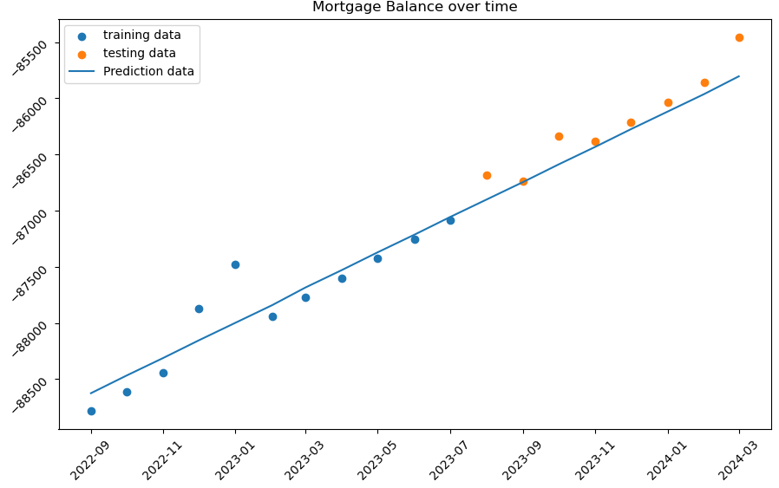This Visualization shows the user’s data, the blue points are the data used in the training of the algorithm, and the orange dots represent the data used to test the algorithm. The line represents the predictions made by the algorithm after it has been trained.

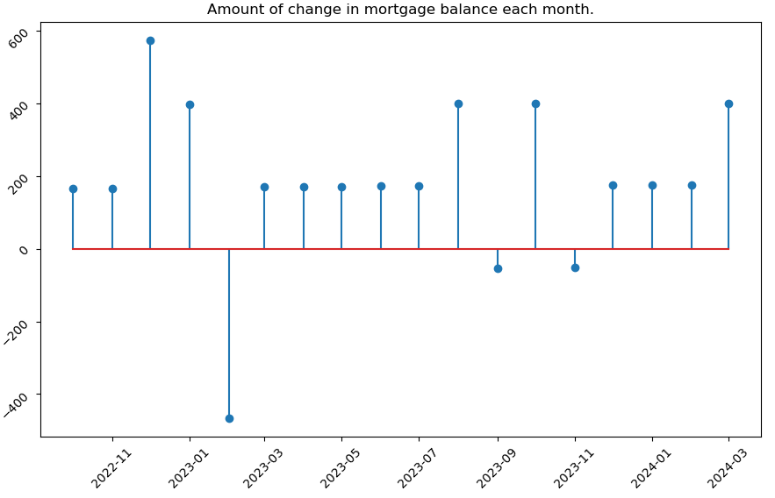

This Visualization shows the amount of change in the balance of the budget. The drastic fluxuations from one month to the next are indicative of bad record keeping and could be used to help the user identify that problem.

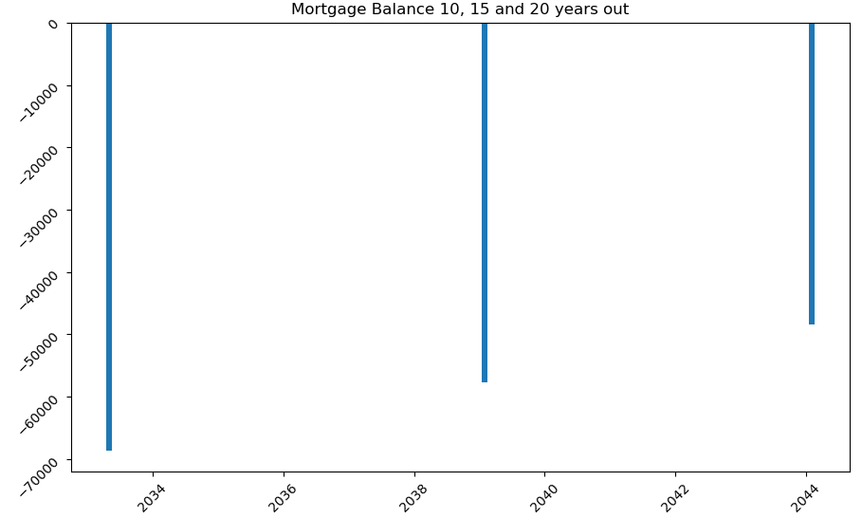

This final visualization displays the balance of the Mortgage at 10, 15, and 20 years beyond the most recent date in the provided data. Given that the data is accurate this information could be used to decide to adjust the amount of money the user is putting towards their mortgage.

**Accuracy Analysis**

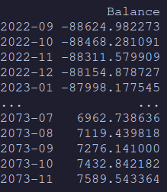The objective metric used to assess the accuracy of the regression metric was the mean absolute percentage error. The methods for measuring the accuracy of the regression could be improved in the future in a few ways depending on what forecasting gets implemented in the future. One way to test the accuracy of the regression on the used data would be to compare the results to an amortization calculator given that the data is predicting a mortgage balance. The Image to the left shows the head and tail of the data predicted by the regression used in the project and the image below shows the predicted value at 30 years in the future. The reported mean absolute percentage error is 0.16301931145627177%, a smaller percentage is generally indicative of a better prediction, however the predicted values are low in the given regression as we know Mortgages longer than 30 years 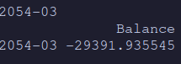are quite uncommon the algorithm is predicting a balance beyond the thirty-year point.

**Application Testing**

Continually throughout the development process testing was performed to validate each function was working appropriately. Database queries were compared alongside data pulled from the database using a Database management program to ensure the validity of both the query and the data pulled when that query is passed to the database by python. The data frames used by the regression were checked and rechecked against the database and the math checked manually to ensure the transformations were happening as expected. The regression was displayed graphically repeatedly to visually check it against the given data as well as running the mean absolute percentage error report after each change to check the regressions mathematical accuracy. The visual data was tested by passing the graphs back and forth between developers to check for readability and adjust, as necessary.

**Application Files**

In order to run this program, you will need the latest versions of the following:

* Python programming language
* Pandas Data analysis library
* SkTime machine learning library
* Matplotlib visualization library

The application files needed, and included in the zip file, are:

* 1. __pycache__
* 2. db.sqlite
* 3. DBQuery.py
* 4. main.py
* 5. regression.py

The db.sqlite file contains the raw budget data and is used only for reference by the python program. All other files are a part of the program directly.

**User Guide**

Before the program can be run Python must be installed along with the libraries necessary, Pandas, SkTime, and Matplotlib. To install Python and the necessary libraries follow these steps:

Installing python on windows

1. Open a web browser and navigate to python.org.
2. Go to the downloads page by clicking the downloads link.
3. Under “Download the latest version for windows,” click the download python 3.12.2 button.
4. In the pop up select where you want to save the python install file.
5. Open File Explorer and Navigate to the location where you saved the python install file.
6. Double click the file to begin installation. Select the install now option and wait for installation to complete.
7. Once the installation is complete python is now installed and you can close the installer.

Installing python libraries

1. Click the start button
2. In the search bar type cmd and press enter to open a terminal window
3. Type or copy the following commands to install the necessary libraries. Wait for each install to finish before entering the next command.
   1. py -m pip install sktime
      1. this command will automatically install pandas another required library
   2. py -m pip install matplotlib
4. You can now close the terminal window.

Running the application:

1. Once python and the necessary libraries are installed open File Explorer and navigate to where you downloaded the machine learning program zip file.
2. Right click the zip file and select extract all and then click extract.
3. Navigate to the folder that you extracted the zip file to.
4. You can then double click the file named main to open a terminal and run the application. Follow the directions provided in the program.

**Summation of Learning Experience**

• Describe how your previous experience (academic or professional) readied you for this project.

• Describe any additional learning or resources needed to complete this project.

• Describe how this experience contributed to your concept of lifelong learning.

My Time at Western Governors university prepared me for this project by giving me the knowledge and skills to apply what I have learned to the project as well as the skills necessary to learn on my own the things I needed for the project but was not yet knowledgeable about. My personal life gave me the experience of knowing that the topic for the project was not just interesting and important to myself but potentially useful to many other people trying to gain a better understanding and command of their personal finances.

To complete this project, I had to gain a deeper understanding of Databases and how they are normalized as they grow more complex, I had to gain an understanding of the Python libraries used and the ability to parse and understand the documentation provided with them. This Project has further developed my ability to actively and quickly acquire and assimilate new information and apply that knowledge to an ongoing project. As a person who has many hobbies and interests that frequently come and go on a whim, this skill has always been an important part of my concept of lifelong learning. That skill enables me to synthesize information from all of my interests and allows me to generate new ideas and solutions that may not always be obvious or conventional to others around me.