C950 Task-2 WGUPS Write-Up

David Mitchell
ID # 000273705
WGU Email: dmitc19@wgu.edu
12/08/23

C950 Data Structures and Algorithms II

A. Hash Table
Hash Table:
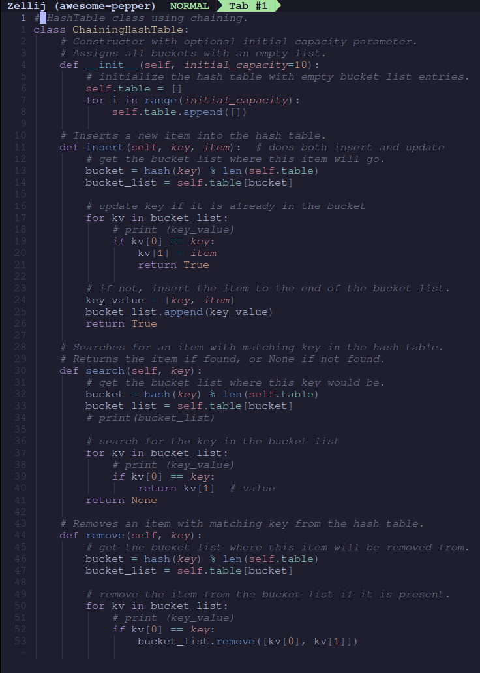

B. Look-Up Functions
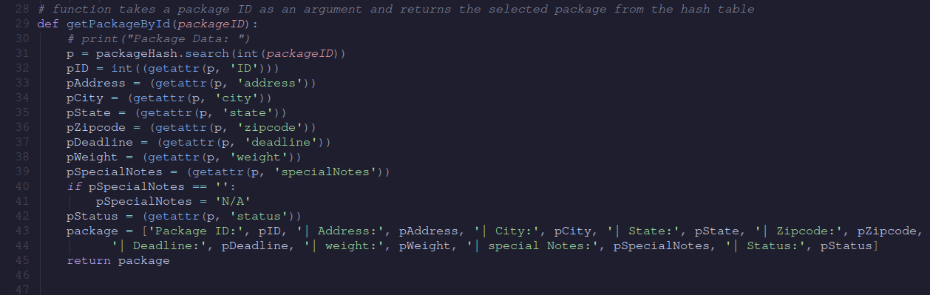

C. Original Code
Function to sort packages by deadline:
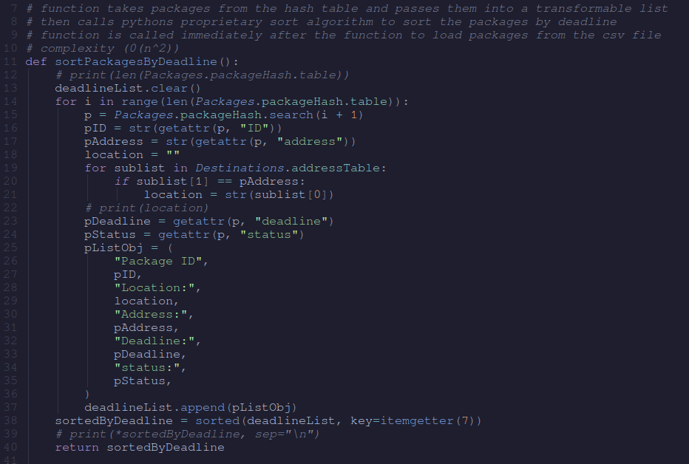
Function that loads trucks per notes and then distributes remaining packages:
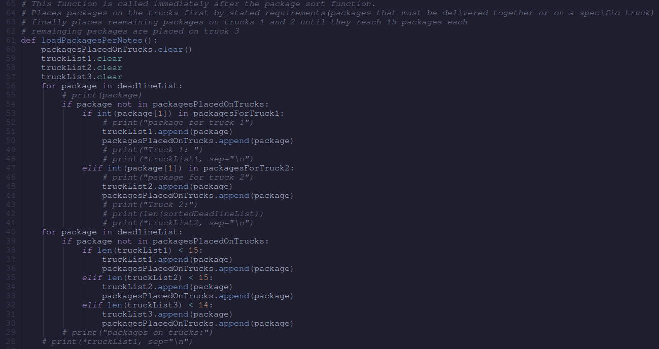

Accessory functions to get locations in list for routing and flattening nested lists for appending back to truck list:
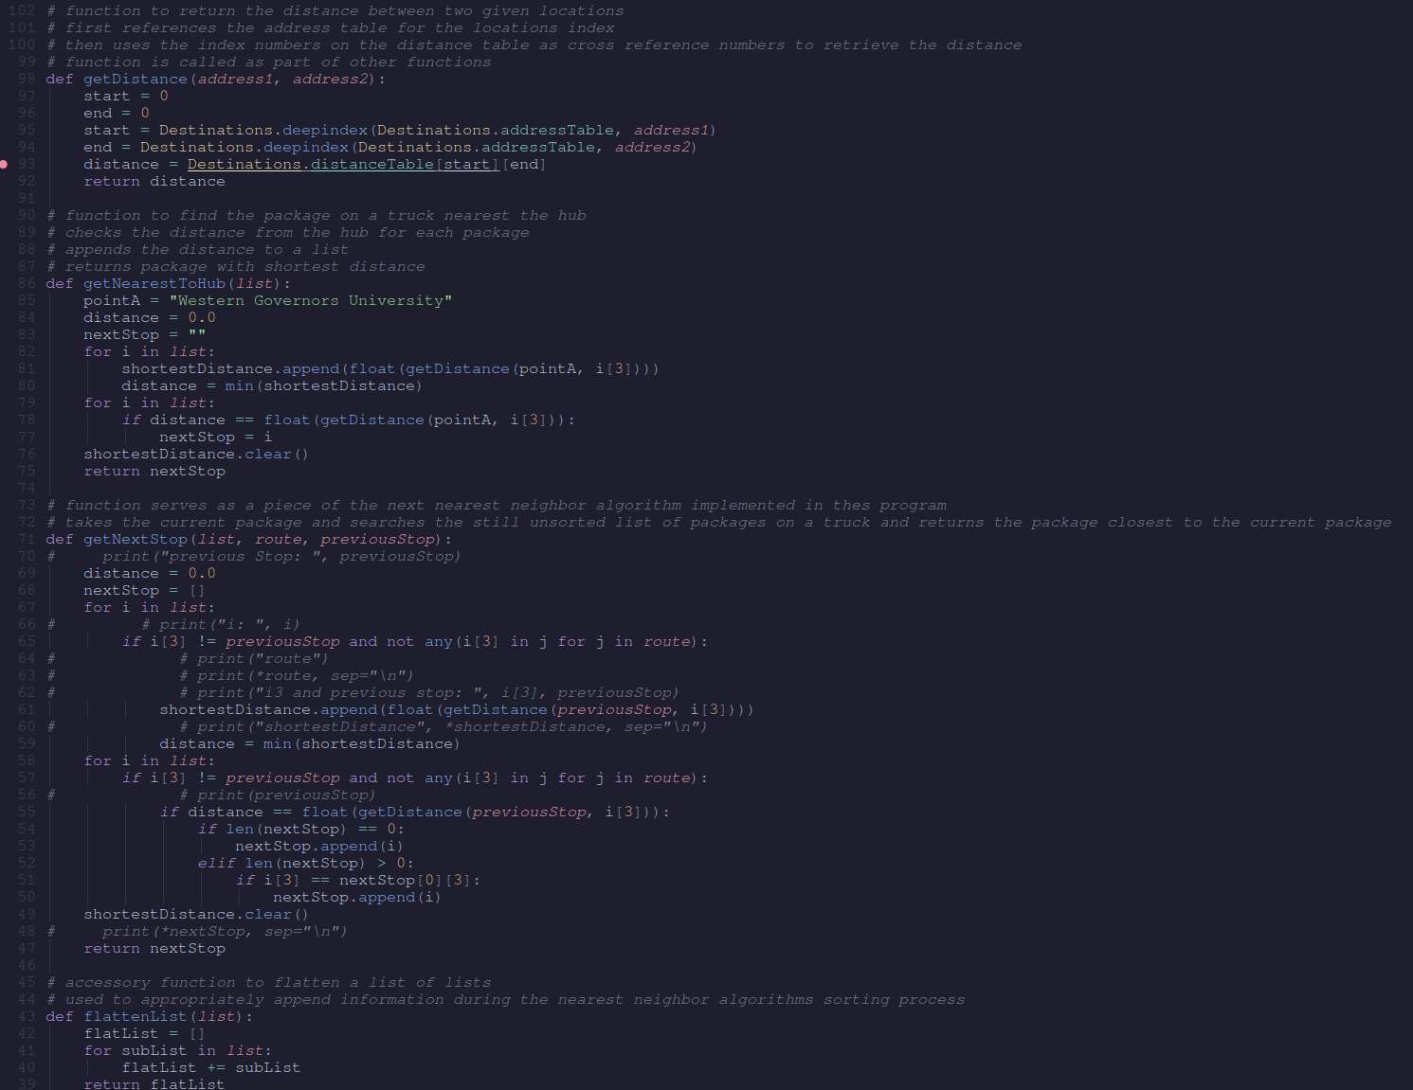

Main algorithm function:
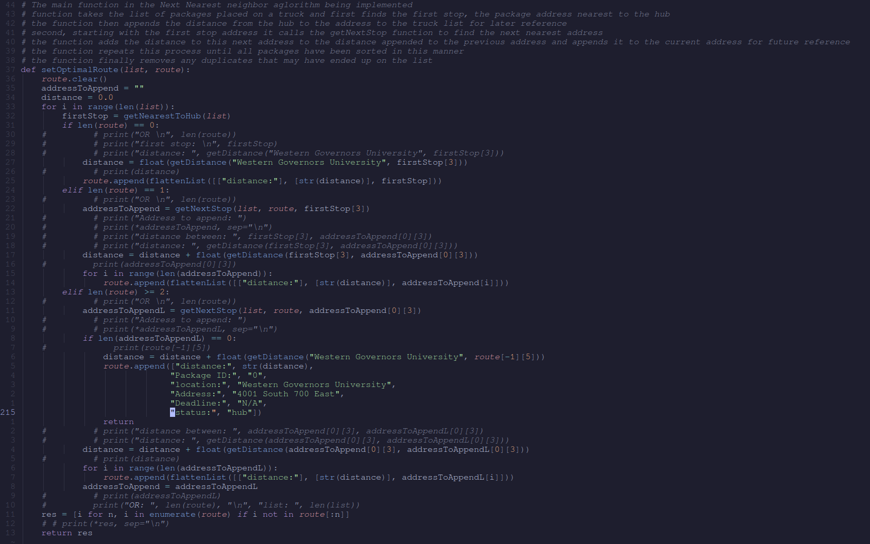

C1. Identification Information
main.py screenshot:

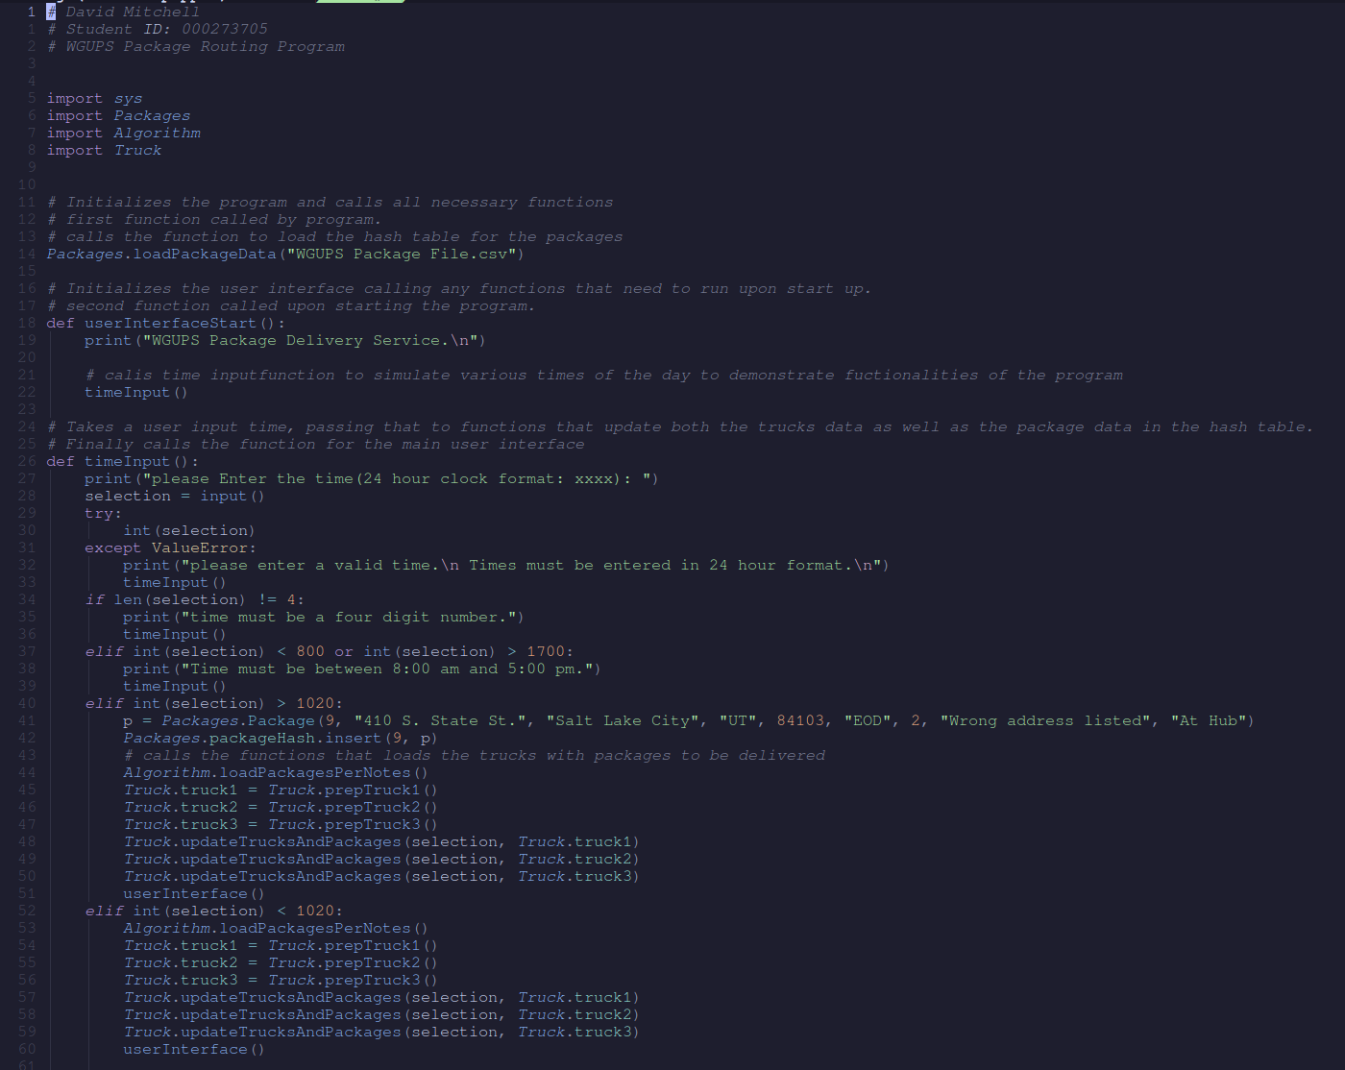
C2. Process and Flow Comments
Process and flow screenshot:
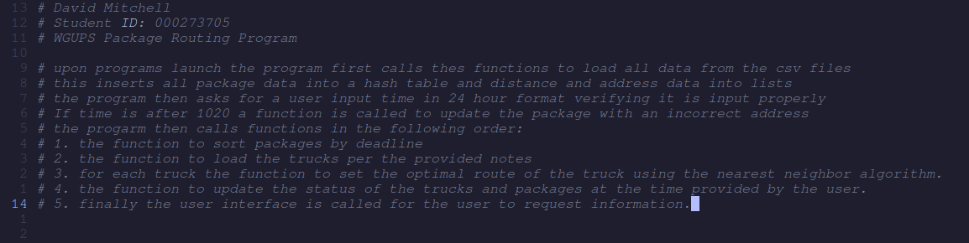

D. Interface
Interface screenshots:
1.
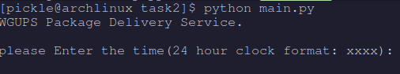

2.
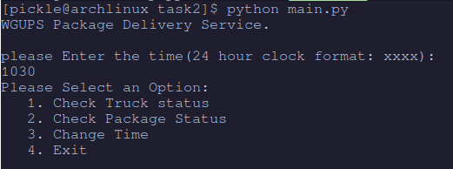

D1. First Status Check
Status of truck 1 and its packages at 9:00 am:
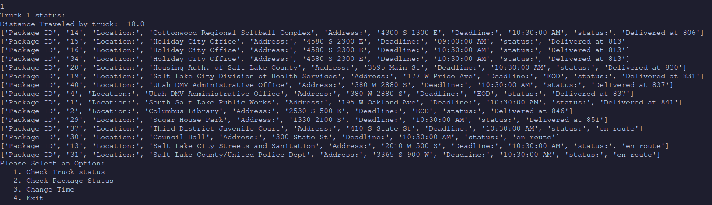
Status of truck 2 and its packages at 9:00 am:
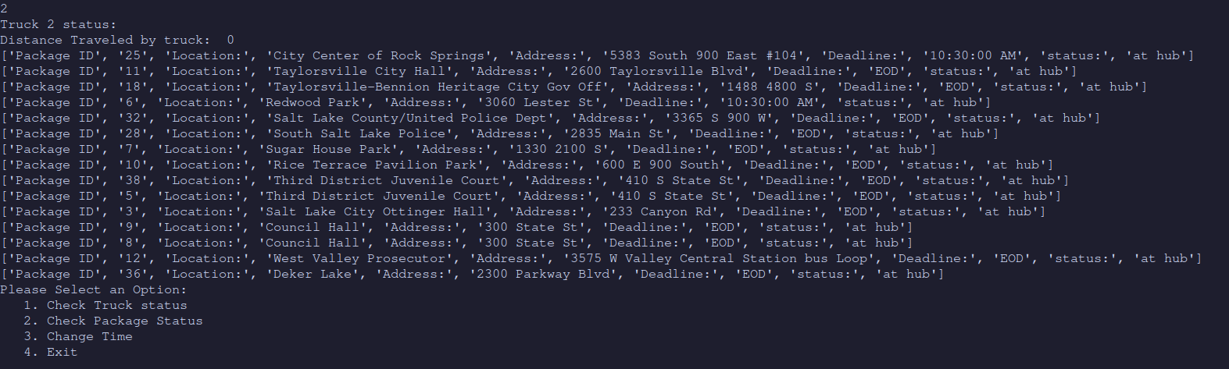

Status of truck 3 and its packages at 9:00 am:
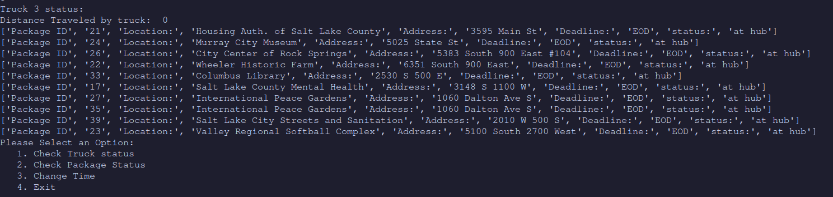

D2. Second Status Check
Status of Truck 1 and its packages at 10:00 am:
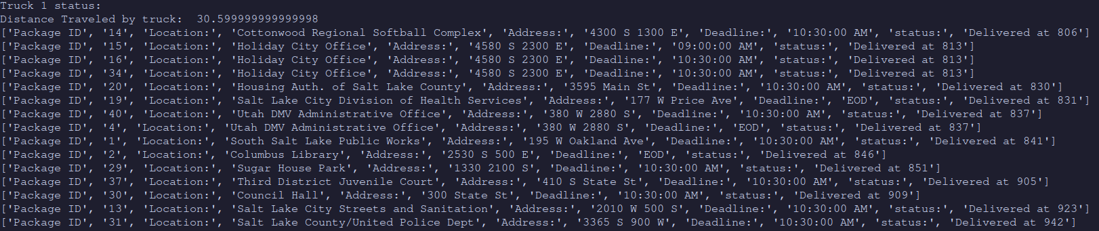
Status of Truck 2 and its packages at 10:00 am:
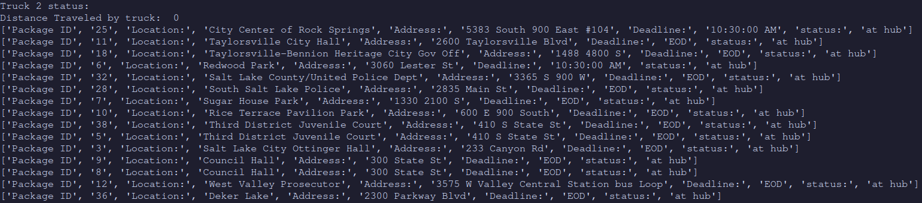
Status of Truck 3 and its packages at 10:00 am:
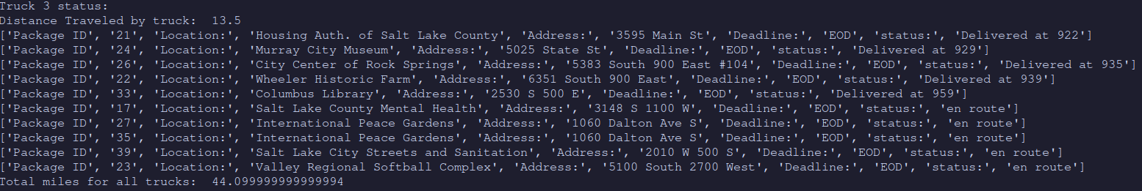

D3. Third Status Check
Status of Truck 1 and its packages at 1:00 pm:
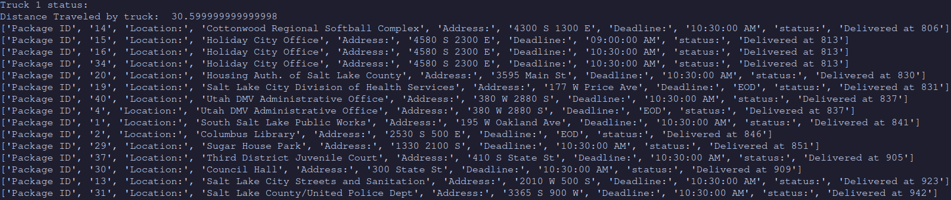
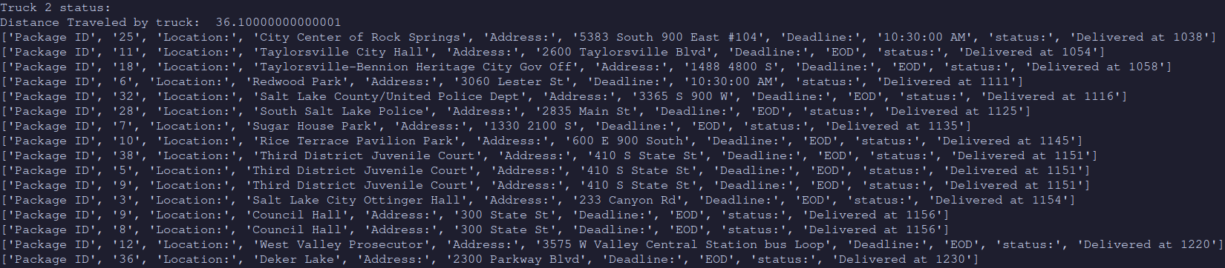
Status of Truck 2 and its packages at 1:00 pm:

Status of Truck 3 and its packages at 1:00 pm:
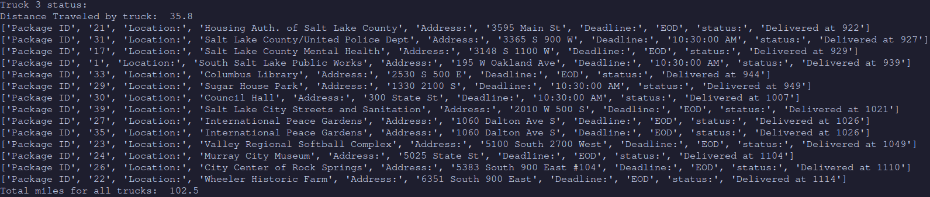

E. Screenshot of Code Execution
Program at launch:
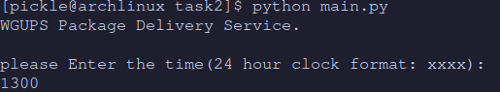
Program main menu:
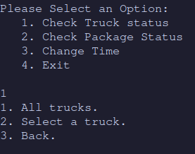

Program Status of all trucks and their packages:
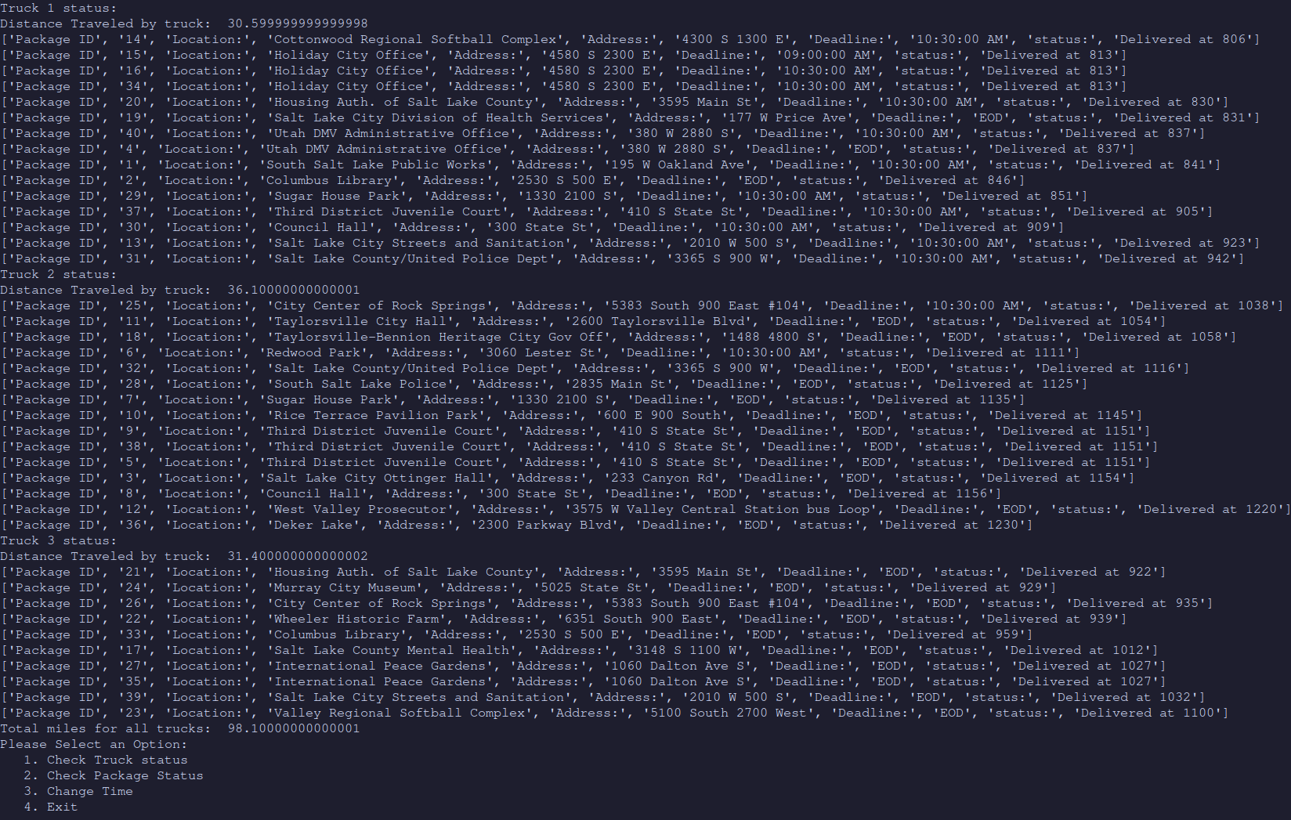
Program total miles and back to main menu with exit:

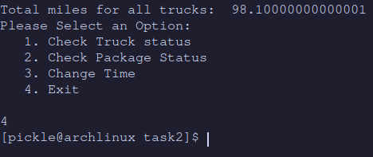

Project files:
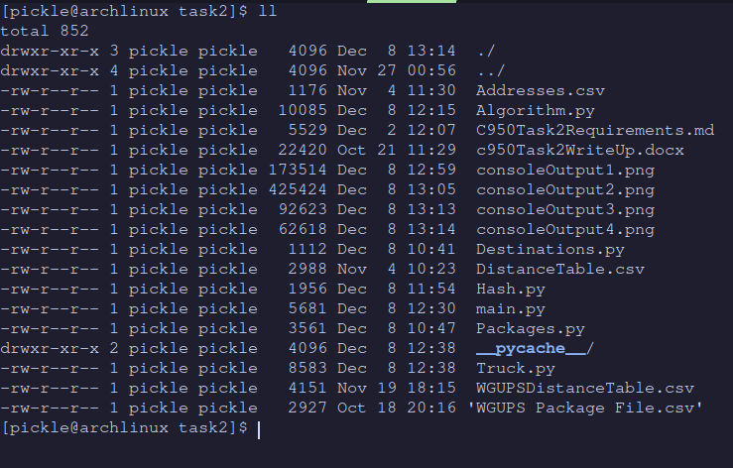
Console output screenshots located in project root directory

F1. Strengths of the Chosen Algorithm
The strength of the next nearest neighbor algorithm is that it is relatively simple to implement and understand. The algorithm also does a decent job of approximating an optimal solution while not being heavy on resources in terms of time complexity.

F2. Verification of Algorithm
The algorithm successfully delivers all the packages in a combined total of 102.5 miles, 37.5 miles undes the requirement. All packages were delivered by their stated deadline and other requirements. This can be verified by launching the program and entering a time of 1300. You can then look at the status of each truck individually or all at once through option 1, or look at the statuses of just the packages through option two. Option two can look up one specific package or print all packages collectively

F3. Other Possible Algorithms
There are many alternative algorithms available to find a solution to these requirements. Two possible choices are the brute force algorithm and the branch and bound method.

F3a. Algorithm Differences
The brute force algorithm differs from the nearest neighbor algorithm in a few ways. The brute force algorithm is substatially more costly in process time as it finds all possible solutions and then picks the best. The nearest neighbor approach in contrast probably won’t find the perfect solution but will not be nearly as costly in proccessing time.

The branch and bound algorithm differs from the nearest neighbor approach in a few ways. The Branch and bound algorithm explores every possible route, but eliminates routes that are not promising in terms of distance, while the nearest neighbor simply picks the locally optimum routes. The branch and bound will find a more optimal solution than nearest neighbor but is more difficult to understand and implement.

G. Different Approach
In Future reimplementations of the code, I would approach the user interface code in a way that is more readable for future maintainers of the code. I would also refactor the algorithm code for the same purpose.

H. Verification of Data Structure
The data structures successfully deliver all the packages in a combined total of 102.5 miles, 37.5 miles undes the requirement. All packages were delivered by their stated deadline and other requirements. This can be verified by launching the program and entering a time of 1300. You can then look at the status of each truck individually or all at once through option 1, or look at the statuses of just the packages through option two. Option two can look up one specific package or print all packages collectively

H1. Other Data Structures
Potential alternative data structures include a hash table implemented with a more complex hashing function. Another possible data structure is the Dictionary data structure.

H1a. Data Structure Differences
The more complex hash table would enable larger data sets while reducing the risk of collisions and data loss from the collisions, while maintaining a similar time complexity as hash tables have a fixed lookup time.

The dictionary data structure would functions quite similarly to the hash table but has the benefit of easier implementation in python. The hash table implementation has the benefit of fixed time complexity that the dictionary would not have.

I. Sources

J. Professional Communication

