CISM 621 Lab 4: VLAN Configuration with Telnet and SSH Remote Access
Student Name: Mafalo David Mothiba
Student No: 38724839
Date: 26 October 2025

- Network Diagram
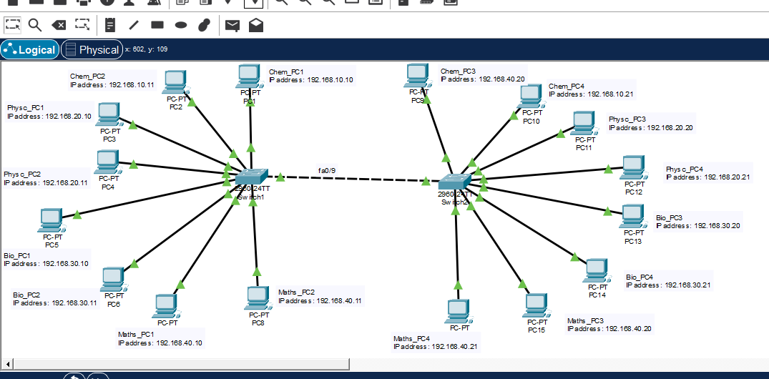

Ping from same VLAN 10 (Chem_PC1 to Chem_PC2)
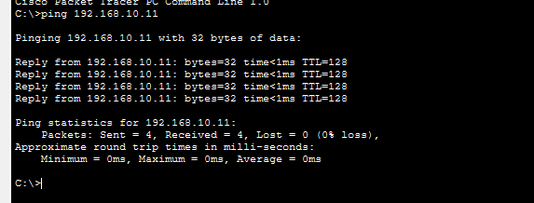

Ping from Different VLAN (Chem_PC1 to Physc_PC3)
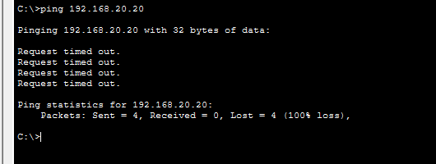

- VLAN Table

VLAN on Switch 1
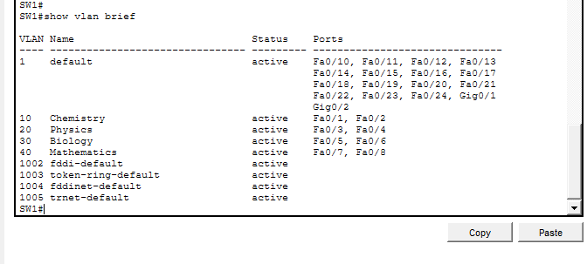

VLAN on Switch 2
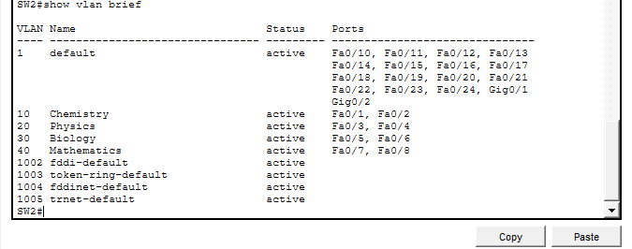

Trunk status on switch 1

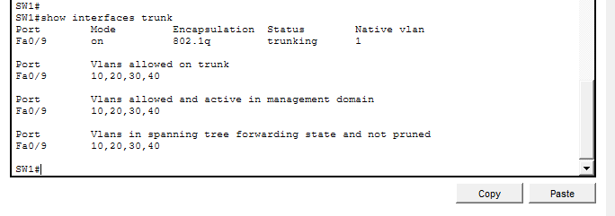
Trunk status on switch 2

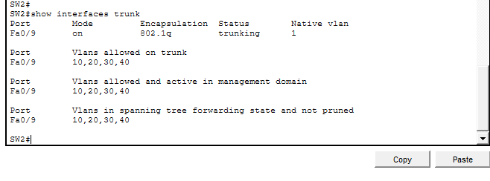
Telnet and SSH Login Attemp

- Telnet login
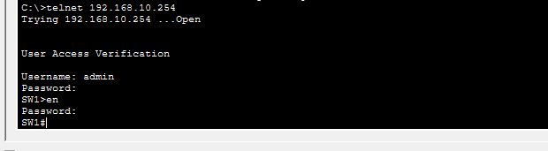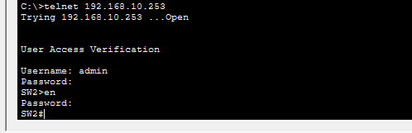

- SSH login
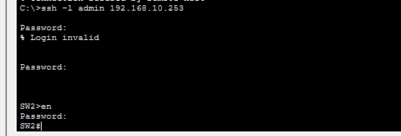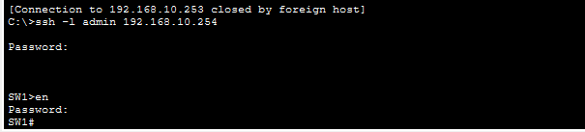

- Telnet and SSH are both methods for managing devices from afar, but they are not at all the same when it comes to security. Telnet sends data like usernames and passwords in plain text, which means that it can be read and used by people who aren't supposed to. On the other hand, Secure Shell (SSH) encrypts all contact between the client and server. This keeps data private and stops people from watching or messing with it. SSH also supports secure authentication using keys or encrypted passwords, making it a far safer option for managing network devices. Overall, SSH provides strong encryption and integrity, while Telnet offers no security features and is considered outdated for modern networks.

