TruongDuy 1.23.19

Duy Truong

January 23, 2019

## R Markdown

$$\overset{̂}{y}=b_{0}+b_{1}x$$

PROBLEM 1 :

Using the purity data from Problem 2.7, calculate the estimates for the true slopes and true intercept using RMarkdown

## [1] 0.0329736

## [1] -1.84507

PROBLEM 2:

Calculate the estimate of the true error variance. Interpret

## [1] 0.03614274

The smaller our MSres is the more reliable our data is since there is less variability

PROBLEM 3:

Plot the data and the fitted simple linear regression line in one graph

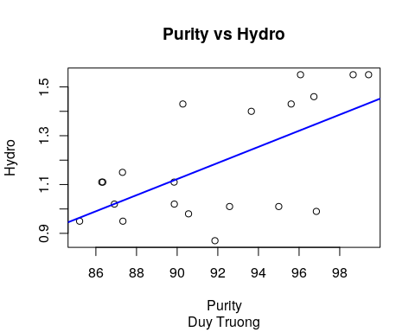

PROBLEM 4:

Verify (using R) Properties 1,2,4 and 5 of the least squares fit

## [1] -1.665335e-15

## P1 P2 P4 P5  
## 1 TRUE TRUE 1.926237e-13 9.550303e-15

HOMEWORK 2:

## [1] 3.386119

## [1] 0.003291122

## [1] 11.4658

## [1] 0.003291122

## Analysis of Variance Table  
##   
## Response: yi  
## Df Sum Sq Mean Sq F value Pr(>F)   
## xi 1 0.41441 0.41441 11.466 0.003291 **  
## Residuals 18 0.65057 0.03614   
## ---  
## Signif. codes: 0 '***' 0.001 '**' 0.01 '*' 0.05 '.' 0.1 ' ' 1