4) Coordinate systems

4.1) Universal Transversal Mercator (UTM) accuracy

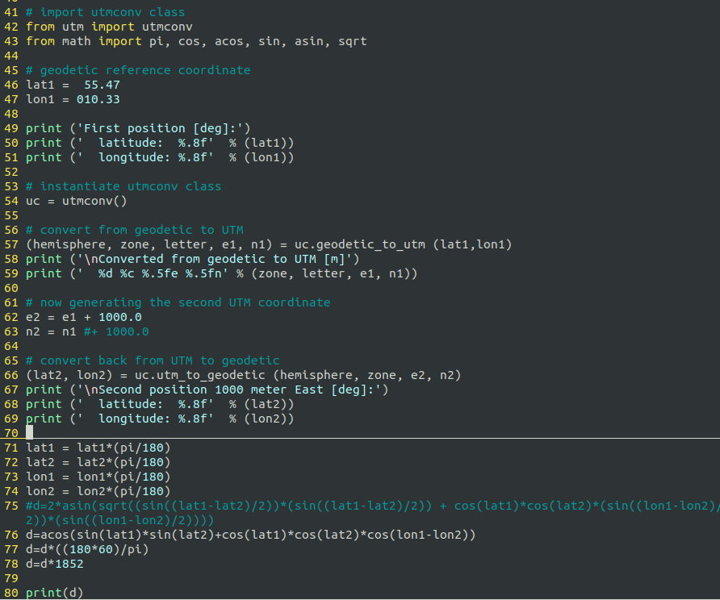In the figure above we can see a modified utm_test.py.

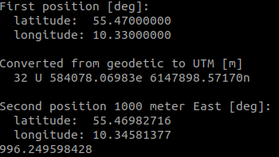In the next figure we can see the output of the script where chosen initial position is chosen first and then converted to UTM. UTM is then modified by the distance of 1km to north or east. It is after that when UTM is converted back to latitude and longitude.

We have two positions in lat and lon for which we can calculate the distance using the great circle distance. We have to convert the input into radians first. Since we want the result in meters we convert the output of the function which is distance in radians into distance of nautical miles. Finally we take multiply the nautical miles by the number of meters in one nautical mile and we get our result.

By keeping one point and modifying it in both directions we will see a difference in results of total distances between the points. This is because longitude distance depends on how close you are to the equator and latitude doesn’t.

The 0 in the longitude reference position is there because longitude can have a range of 180 degrees so we use three digits for longitude.

4.2) National Marine Electronics Association (NMEA) 0183 data

4.2.1) This plot shows the altitude 4.2.2) This plot show the number of

of the drone over a period of time. satellites tracked.

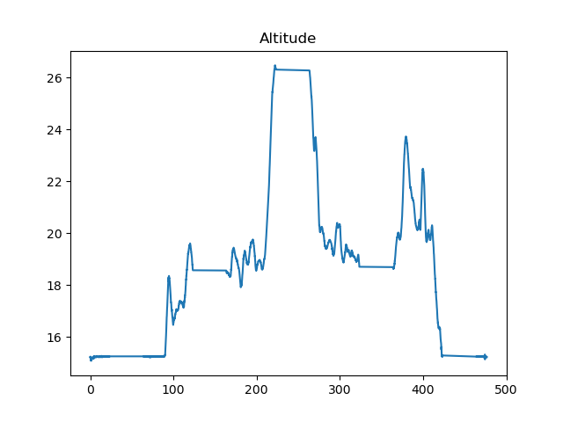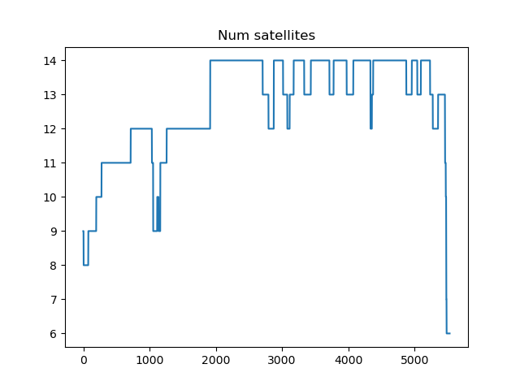

4.2.3) Map showing the drone track during 4.2.4) Plot showing static GNSS accuracy

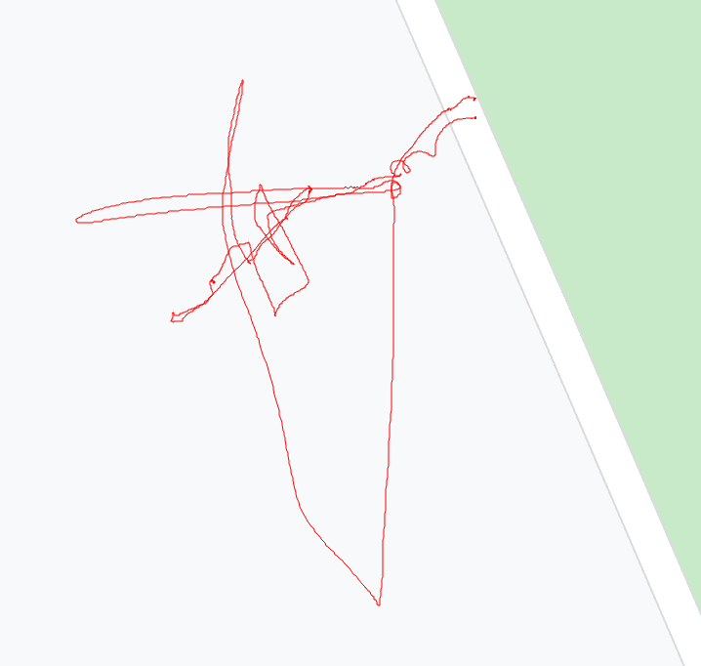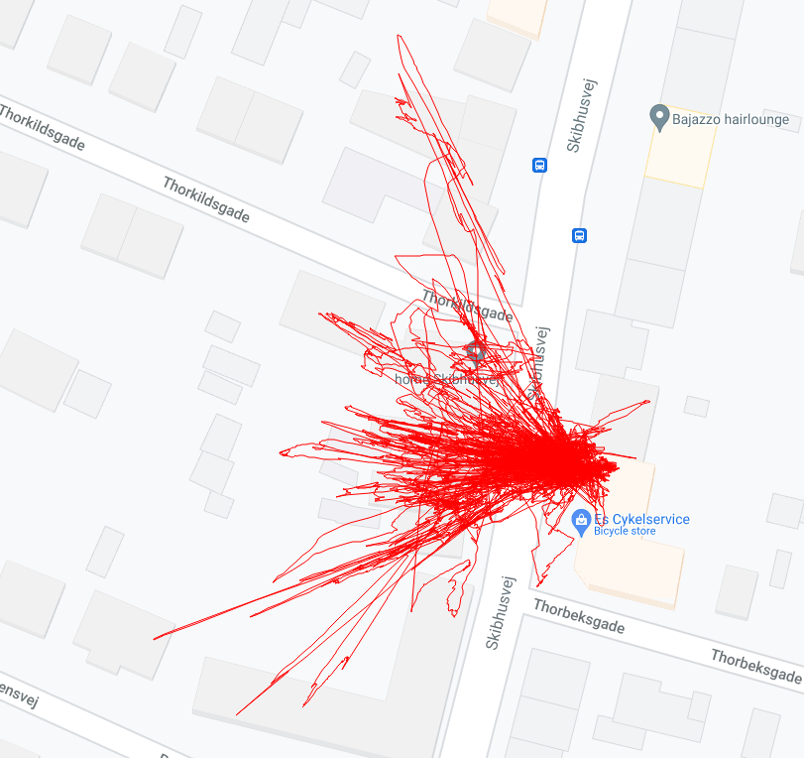the flight over 24 hours.