3.2 Near field absorption and Fresnel zones

3.2.1 Near field absorptions

The near field is an electromagnetic field around an object. These regions can be for example around a transmitting antenna or formed from reflected radiation. The near field is formed close to its source unlike the far field. The boundary between the two regions is only vaguely defined and 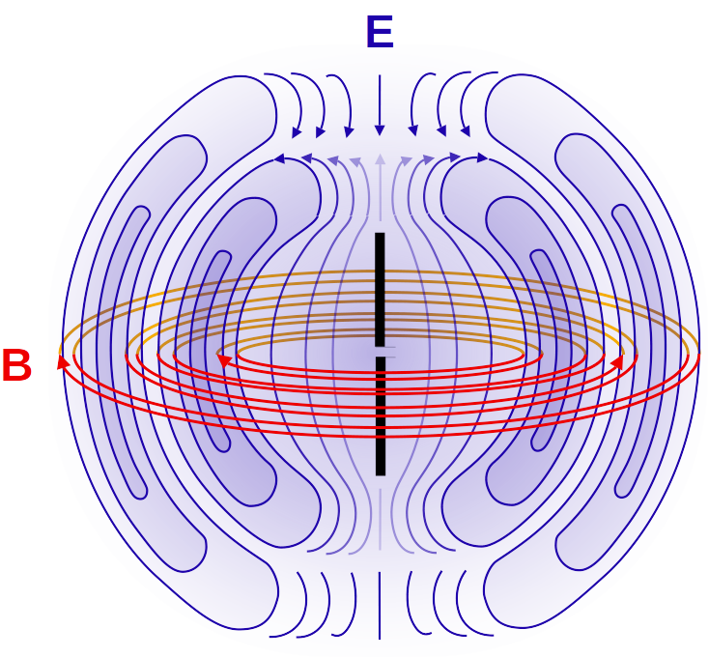has more a mathematical meaning then physical. In the near-field electric and magnetic strength decrease rapidly with distance: the radiative

field decreases by the inverse-distance

squared, the reactive field by an inverse

cubed law. Power decreases by the inverse

of the fourth and

sixth power. This ensures that the

effects disappear quickly from the source

of the EM field. That is the main factor

contributing to the signal attenuation.

3.2.2 Fresnel zones

Fresnel zone is a 3D elliptical region between the transmit antenna and the receive antenna. The size of the ellipse is determined by the frequency of operation and the distance between the two sites. The Fresnel zone should be clear of any obstacles for the proper functioning of the antennas. It is divided into three areas. Zone one has the strongest signal and zone three the weakest.

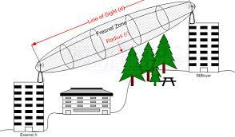

It relates to the drone and telemetry links because between both there is a transmiter and a receiver so we will need to clear out any obtructions between them because of the Fresnel zone otherwise they may not work as intended.

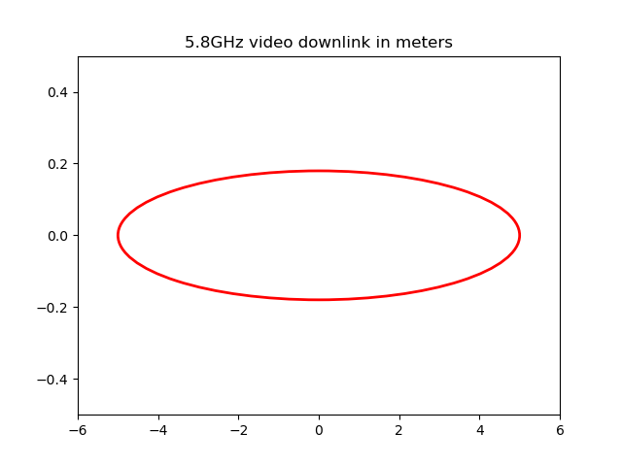3.2.3 Plotting Fresnel zones

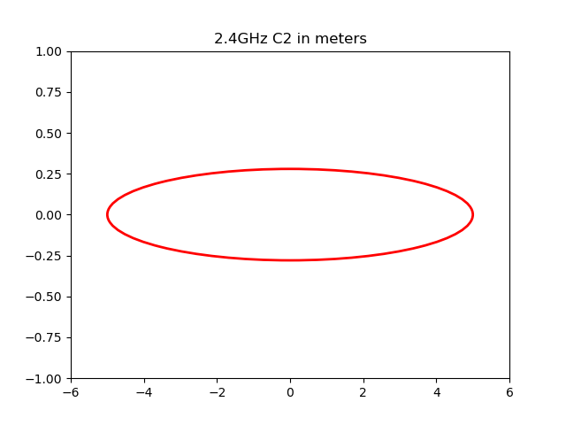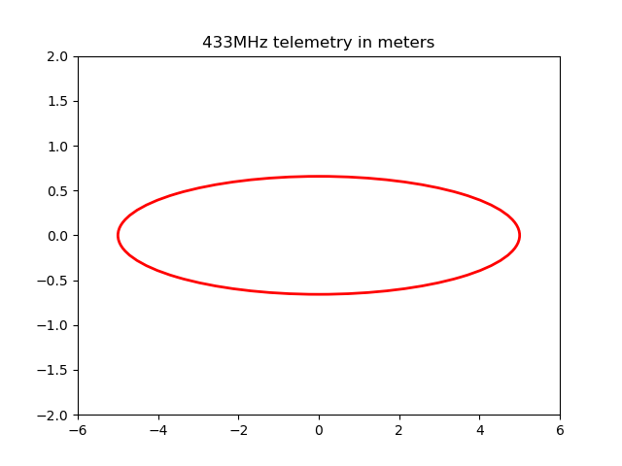

3.2.4 Fresnel zone loss

Calulating the eqation of the eliptical fresnel zone radius and knowing the ridge is in the middle and more than 40% of the zone must be blocked we can estimate how much space between the line of sight and the ridge we would need. Radius = 2.49888112 m, space needed is 1.999104 m for 2.4 GHz. Radius = 1.60744906 m, space needed is 1.28595 m for 5.8 GHz. Radius = 5.88311405 m, space needed is 4.706 m for 443 MHz.