Use of mental health care plans and disadvantage
Dr David Fong
Dr Rowena Ryan
Dr Bronwyn Wells
Dr Franziska Levin
cohealth Kensington medical team
2025-05-29
Table of contents

Photo by Matthew Ball on Unsplash
Exploring the question of whether Mental Health Care Plans (and the billing of them) are driven by patients, and the patient’s expected utility of MHCPs to unlock government funding for private psychological services.
The number of MHCP-eligible patients at coHealth who were billed MHCPs in the previous twelve months were divided into groups according to concession card holder patients (either health care card ‘HCC’ or pension card) and high-prevalence and low-prevalence mental health disorders.
It is postulated that concession card holders have lower financial resources and are less able to utilise the government subsidies unlocked by MHCP plans for private psychology. This is because private psychology fees are far greater than the government subsidy to use private psychology.
Mental health conditions can be broadly divided into low- and high- frequency mental health conditions. High-frequency mental health conditions are the common mental health conditions such as anxieyt and depression. Low-frequency mental health conditions are the less common, and often more serious and lifelong conditions, of schizophrenia and bipolar affective disorder. It is postulated that patients with low-prevalence mental health disorders have more severe mental health conditions and are at greater need of mental health assessments and services.
 | Total  (N=2544) | Collingwood  (N=527) | Fitzroy  (N=711) | Kensington  (N=450) | Laverton  (N=164) | Paisley  (N=692)
Mental Health Plan
Yes | 323 (12.7%) | 55 (10.4%) | 115 (16.2%) | 60 (13.3%) | 32 (19.5%) | 61 (8.8%)
No | 2221 (87.3%) | 472 (89.6%) | 596 (83.8%) | 390 (86.7%) | 132 (80.5%) | 631 (91.2%)
Concession card
Yes | 2071 (81.4%) | 433 (82.2%) | 610 (85.8%) | 358 (79.6%) | 117 (71.3%) | 553 (79.9%)
No | 473 (18.6%) | 94 (17.8%) | 101 (14.2%) | 92 (20.4%) | 47 (28.7%) | 139 (20.1%)
condition
High-prevalence | 2022 (79.5%) | 434 (82.4%) | 536 (75.4%) | 369 (82.0%) | 122 (74.4%) | 561 (81.1%)
Low-prevalence | 522 (20.5%) | 93 (17.6%) | 175 (24.6%) | 81 (18.0%) | 42 (25.6%) | 131 (18.9%)
coHealth clinics, May 2025, 'active' patients
Concession card holders (with either high-prevalence or low-prevalence mental health conditions) have lower annual rates of mental health care plans billing (11.8% vs 16.7%).
 | No Concession  (N=473) | Concession  (N=2071)
Mental Health Plan
Yes | 79 (16.7%) | 244 (11.8%)
No | 394 (83.3%) | 1827 (88.2%)
coHealth clinics, May 2025, 'active' patients
Low-prevalence conditions (schizophrenia and bipolar affective disorder) are often severe and lifelong mental health conditions. Patients with schizophrenia and bipolar affective disorder can benefit from psychological therapies. If mental health care plans were done on the basis of need, it would be expected that more patients with low-prevalence conditions would have mental health care plans compared to patients with high-prevalence mental health conditions. People with low-prevalence conditions have a similar, if slightly lower, rate of mental health care plans than those with high-prevalence conditions (11.7% vs 13.0%).
 | High-prevalence  (N=2022) | Low-prevalence  (N=522)
Mental Health Plan
Yes | 262 (13.0%) | 61 (11.7%)
No | 1760 (87.0%) | 461 (88.3%)
coHealth clinics, May 2025, 'active' patients
Probability comparison
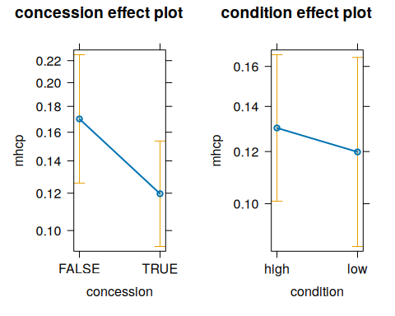
 | Logistic model |  |  | Logistic model - clinic random effect
 | Odds ratio | CI (95%) | p | Odds ratio | CI (95%) | p
(Intercept) | 0.201 | [0.157, 0.255] | <0.001 | 0.209 | [0.147, 0.297] | <0.001
Concession holder | 0.672 | [0.510, 0.893] | 0.005 | 0.664 | [0.500, 0.880] | 0.004
Low-frequency condition | 0.948 | [0.697, 1.274] | 0.730 | 0.910 | [0.672, 1.232] | 0.543
SD (Intercept clinic) |  |  |  | 1.330
Num.Obs. | 2544 |  |  | 2544
R2 Marg. |  |  |  | 0.008
R2 Cond. |  |  |  | 0.032
AIC | 1934.3 |  |  | 1922.6
BIC | 1951.9 |  |  | 1946.0
ICC |  |  |  | 0.0
Log.Lik. | -964.172
F | 4.218
RMSE | 0.33 |  |  | 0.33
The odds ratio of having been billed a mental health care plan, according to concession card status and low-vs-high prevalence mental health condition (coHealth GP clinics, May 2025)
:::
 | Total  (N=2544) | Collingwood  (N=527) | Fitzroy  (N=711) | Kensington  (N=450) | Laverton  (N=164) | Paisley  (N=692)
Mental Health GP Consult
Yes | 189 (7.4%) | 31 (5.9%) | 45 (6.3%) | 24 (5.3%) | 23 (14.0%) | 66 (9.5%)
No | 2355 (92.6%) | 496 (94.1%) | 666 (93.7%) | 426 (94.7%) | 141 (86.0%) | 626 (90.5%)
Concession card
Yes | 2071 (81.4%) | 433 (82.2%) | 610 (85.8%) | 358 (79.6%) | 117 (71.3%) | 553 (79.9%)
No | 473 (18.6%) | 94 (17.8%) | 101 (14.2%) | 92 (20.4%) | 47 (28.7%) | 139 (20.1%)
condition
High-prevalence | 2022 (79.5%) | 434 (82.4%) | 536 (75.4%) | 369 (82.0%) | 122 (74.4%) | 561 (81.1%)
Low-prevalence | 522 (20.5%) | 93 (17.6%) | 175 (24.6%) | 81 (18.0%) | 42 (25.6%) | 131 (18.9%)
coHealth clinics, May 2025, 'active' patients
 | No Concession  (N=473) | Concession  (N=2071)
Mental Health GP Consult
Yes | 27 (5.7%) | 162 (7.8%)
No | 446 (94.3%) | 1909 (92.2%)
coHealth clinics, May 2025, 'active' patients
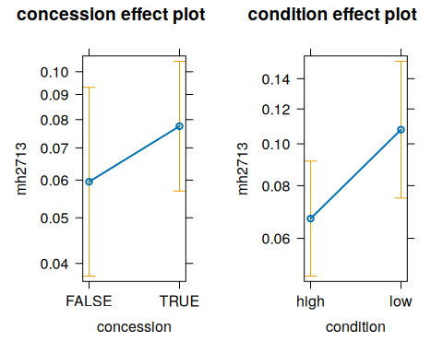
 | Logistic model |  |  | Logistic model - clinic random effect
 | Odds ratio | CI (95%) | p | Odds ratio | CI (95%) | p
(Intercept) | 0.058 | [0.038, 0.083] | <0.001 | 0.057 | [0.035, 0.092] | <0.001
Concession holder | 1.273 | [0.845, 1.987] | 0.268 | 1.329 | [0.866, 2.039] | 0.194
Low-frequency condition | 1.699 | [1.212, 2.354] | 0.002 | 1.685 | [1.208, 2.350] | 0.002
SD (Intercept clinic) |  |  |  | 1.377
Num.Obs. | 2544 |  |  | 2544
R2 Marg. |  |  |  | 0.018
R2 Cond. |  |  |  | 0.048
AIC | 1340.4 |  |  | 1335.8
BIC | 1357.9 |  |  | 1359.1
ICC |  |  |  | 0.0
Log.Lik. | -667.186
F | 6.251
RMSE | 0.26 |  |  | 0.26
The odds ratio of having been billed a GP mental health consult according to concession card status and low-vs-high prevalence mental health condition (coHealth GP clinics, May 2025)
 | Total  (N=2544) | Collingwood  (N=527) | Fitzroy  (N=711) | Kensington  (N=450) | Laverton  (N=164) | Paisley  (N=692)
Chronic Disease Management Plan
Yes | 756 (29.7%) | 126 (23.9%) | 147 (20.7%) | 164 (36.4%) | 67 (40.9%) | 252 (36.4%)
No | 1788 (70.3%) | 401 (76.1%) | 564 (79.3%) | 286 (63.6%) | 97 (59.1%) | 440 (63.6%)
Concession card
Yes | 2071 (81.4%) | 433 (82.2%) | 610 (85.8%) | 358 (79.6%) | 117 (71.3%) | 553 (79.9%)
No | 473 (18.6%) | 94 (17.8%) | 101 (14.2%) | 92 (20.4%) | 47 (28.7%) | 139 (20.1%)
condition
High-prevalence | 2022 (79.5%) | 434 (82.4%) | 536 (75.4%) | 369 (82.0%) | 122 (74.4%) | 561 (81.1%)
Low-prevalence | 522 (20.5%) | 93 (17.6%) | 175 (24.6%) | 81 (18.0%) | 42 (25.6%) | 131 (18.9%)
coHealth clinics, May 2025, 'active' patients
 | No Concession  (N=473) | Concession  (N=2071)
Chronic Disease Management Plan
Yes | 102 (21.6%) | 654 (31.6%)
No | 371 (78.4%) | 1417 (68.4%)
coHealth clinics, May 2025, 'active' patients
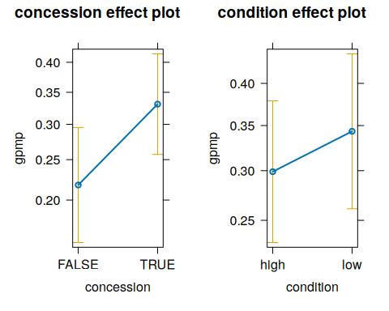
 | Logistic model |  |  | Logistic model - clinic random effect
 | Odds ratio | CI (95%) | p | Odds ratio | CI (95%) | p
(Intercept) | 0.271 | [0.216, 0.336] | <0.001 | 0.267 | [0.177, 0.402] | <0.001
Concession holder | 1.631 | [1.287, 2.082] | <0.001 | 1.779 | [1.393, 2.272] | <0.001
Low-frequency condition | 1.197 | [0.971, 1.472] | 0.089 | 1.227 | [0.992, 1.516] | 0.059
SD (Intercept clinic) |  |  |  | 1.478
Num.Obs. | 2544 |  |  | 2544
R2 Marg. |  |  |  | 0.018
R2 Cond. |  |  |  | 0.061
AIC | 3079.5 |  |  | 3020.7
BIC | 3097.0 |  |  | 3044.0
ICC |  |  |  | 0.0
Log.Lik. | -1536.756
F | 10.558
RMSE | 0.46 |  |  | 0.45
The odds ratio of having been billed a GP chronic disease management plan 'GPMP', according to concession card status and low-vs-high prevalence mental health condition (coHealth GP clinics, May 2025)

