David Pérez

1.

To install both OS´s it is needed to install the Windows 7 first, and then select the Windows 10 iso and install the OS in the free space of the virtual disk.

Getting to the OS selecting screen we have to click on “change default or select other options” to change the default OS and the timer. 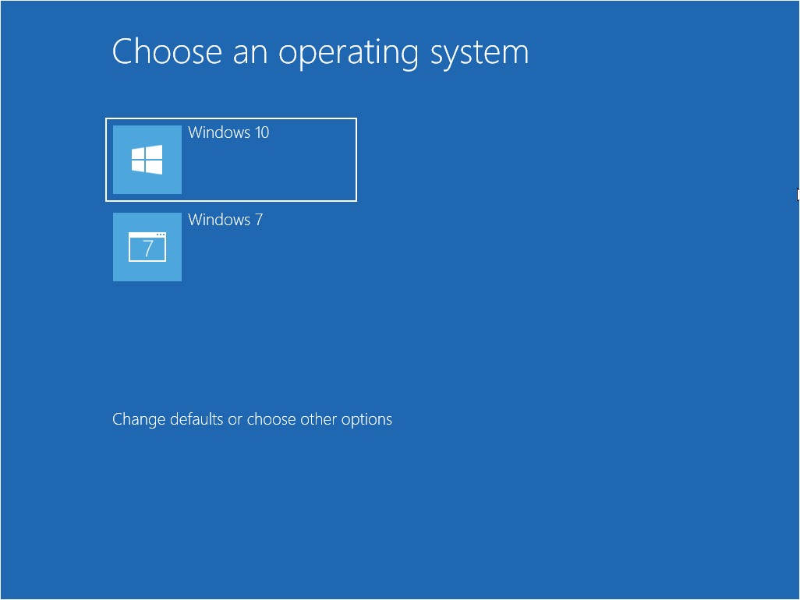

Then, click on “chose a default operative sistem” and select Windows 7.

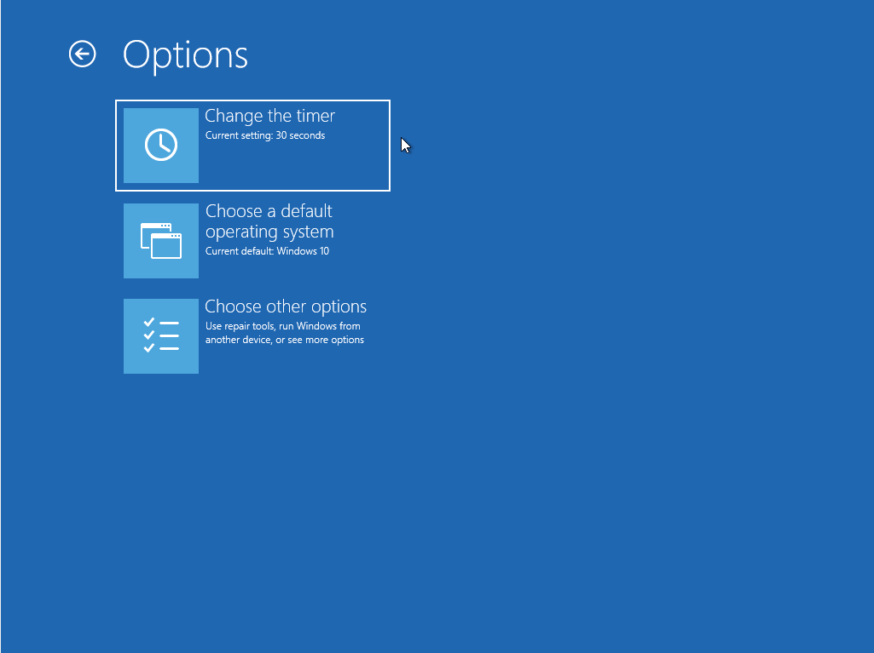

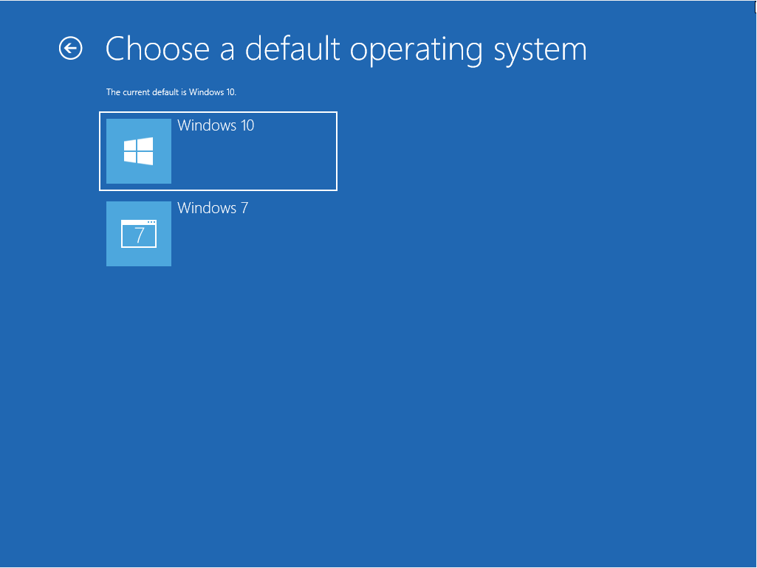

Once selected, the next step is changing the timer to 5 seconds.

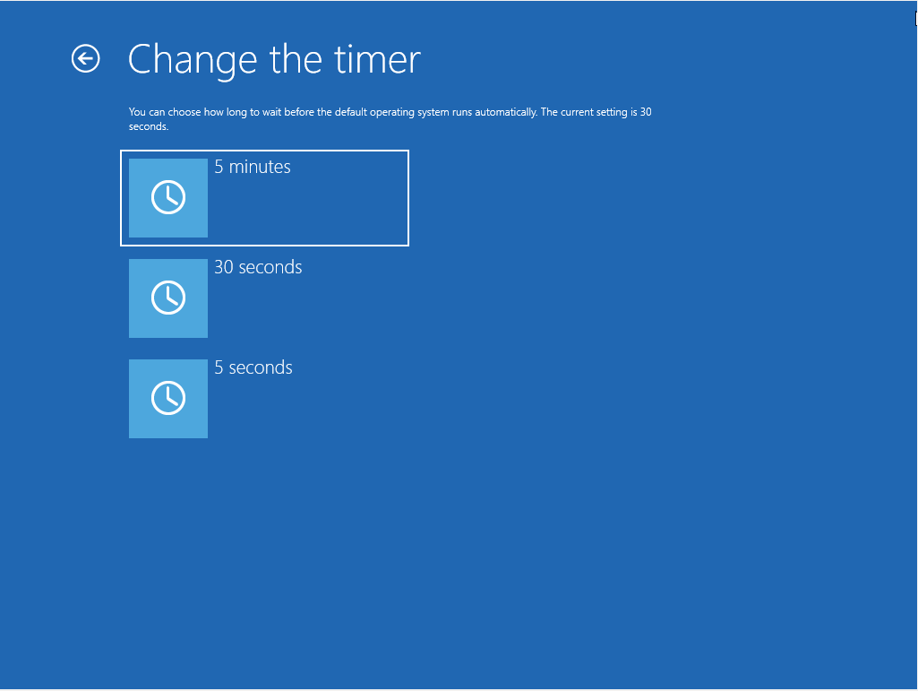

2. a)

To install both OS´s we have to do the same steps than in exercise 1.

To change the bootloader options in Ubuntu we have to, first, open the termianal to write commands.

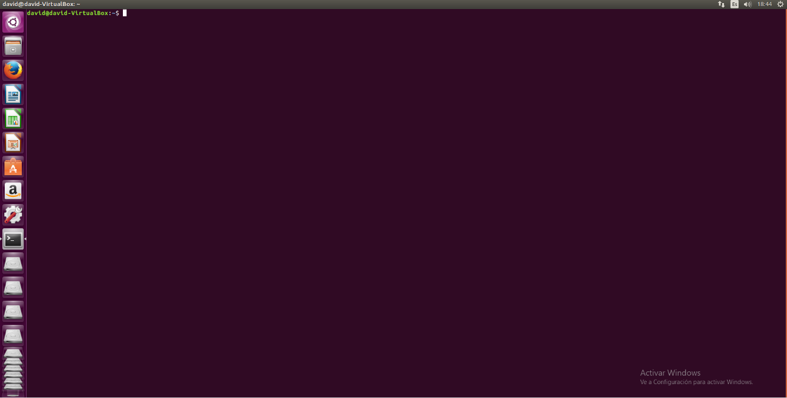

Then, write sudo su to have administrator privileges and write our user password. 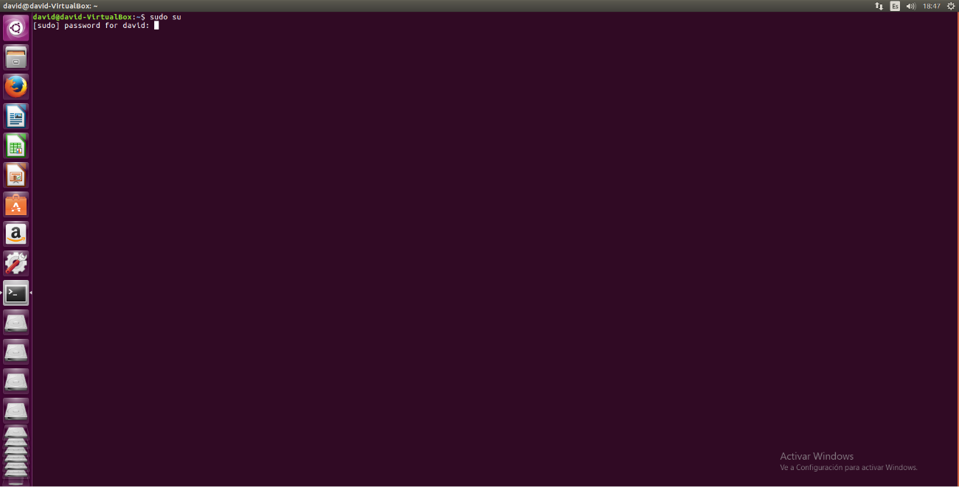

Then info we have to tipe“nano /etc/default/grub” and to change them rewrite the following lines: 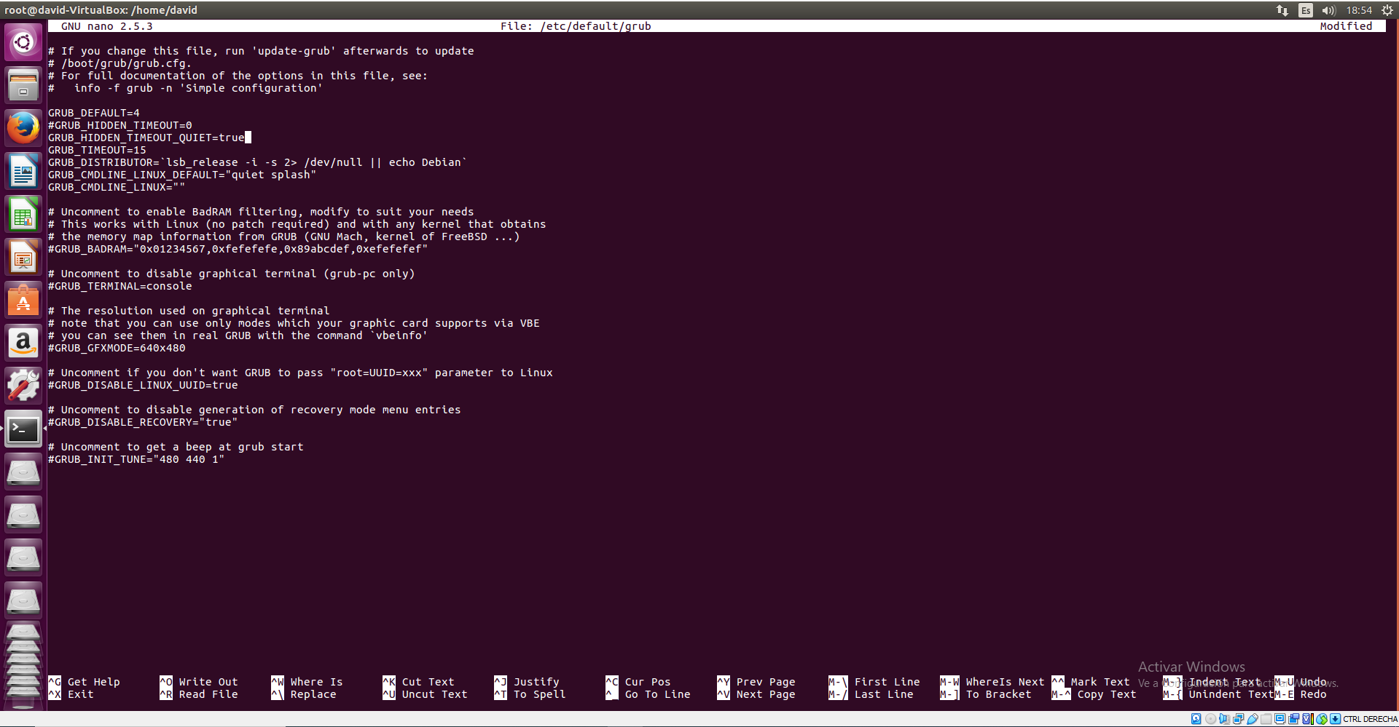

-GRUB_DEFAULT=4

-GRUB_HIDDEN_TIMEOUT_QUIET=true

-GRUB_TIMEOUT=15

Then, to aply the changes, we have to write “update-grub”.

b)

Now we have to change the settings this way:

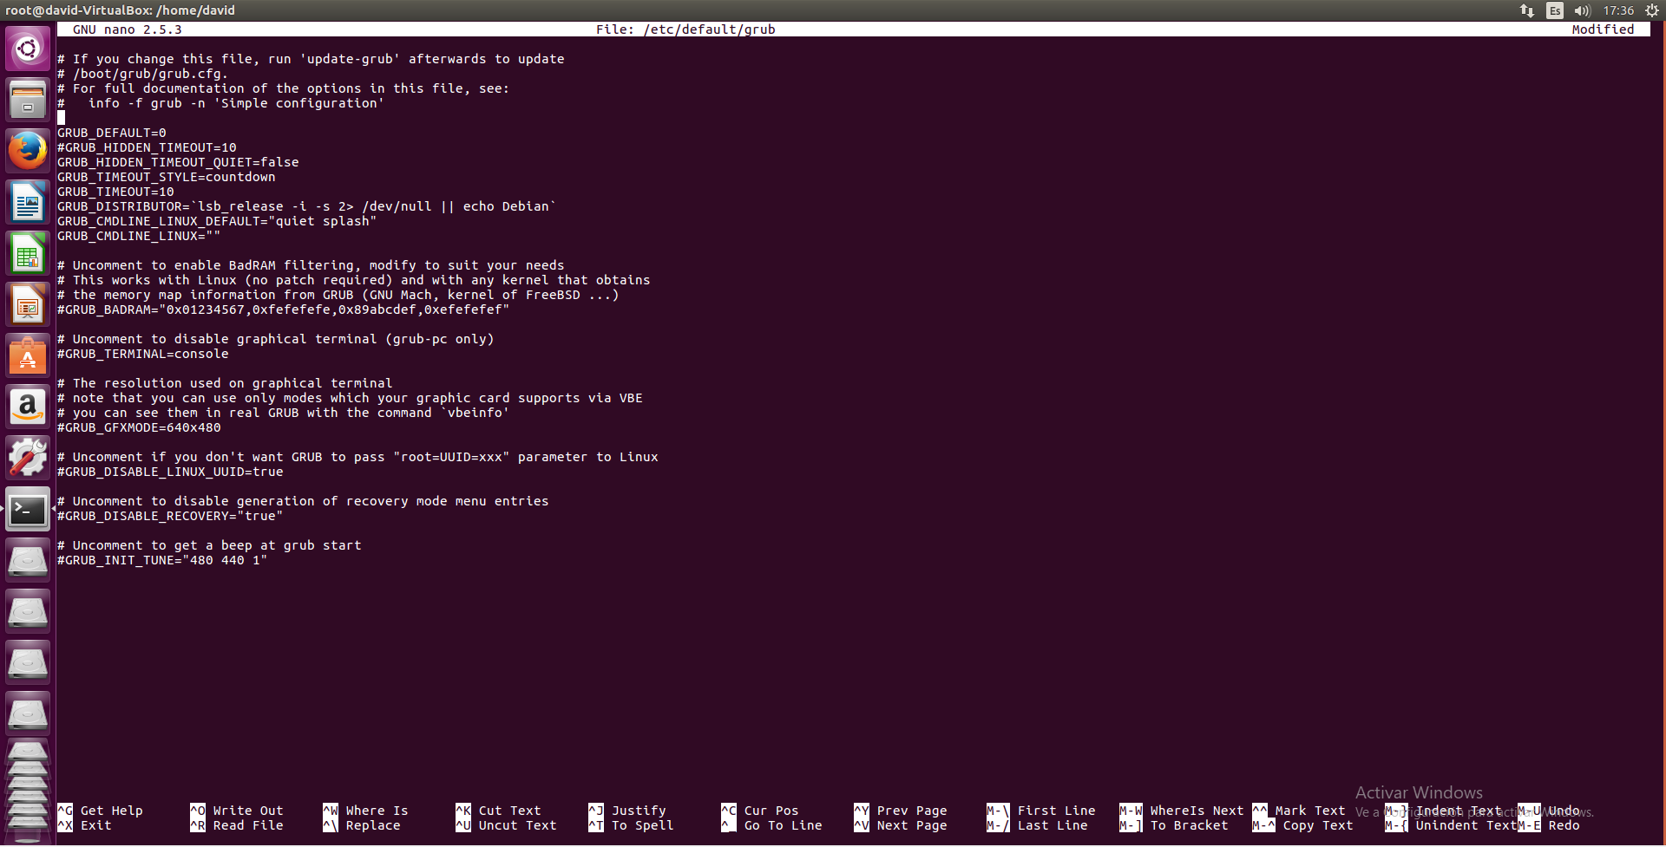

-GRUB_DEFAULT=0

#GRUB_HIDDEN_TIMEOUT=10

-GRUB_HIDDEN_TIMEOUT_QUIET=false

-Add the line GRUB_TIMEOUT_STYLE and write countdown

-GRUB_TIMEOUT=10

Then, to aply the changes, we have to write “update-grub”

We have got to do one more thing for this excercise, open the next settings lines by writing “nano /etc/grub.d/30_os.prober

Once opened we have got to go to the bottom line and write a “#” before the last line begins.

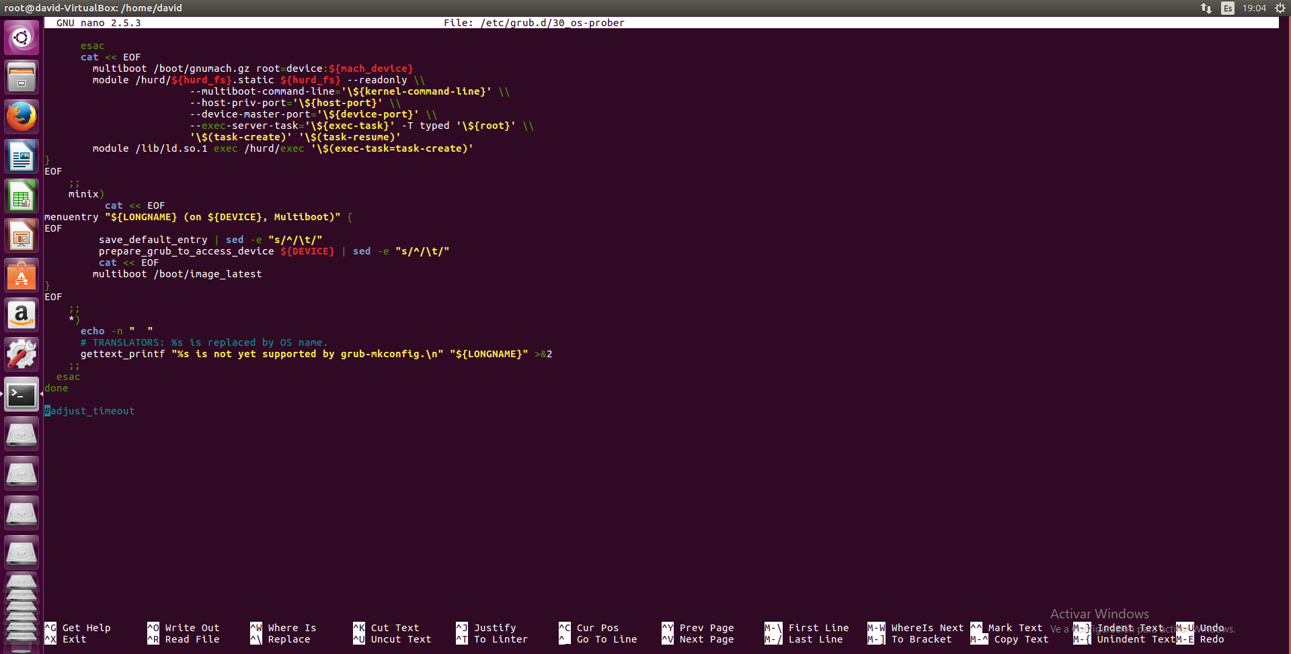

c)

Fort the next one write the settings in the following way: 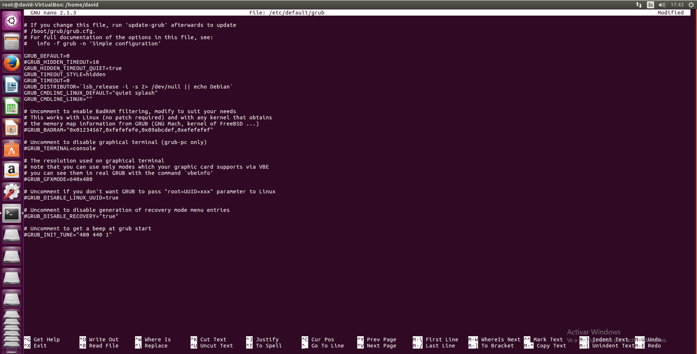

d)

Fort this one write the settings in the following way: 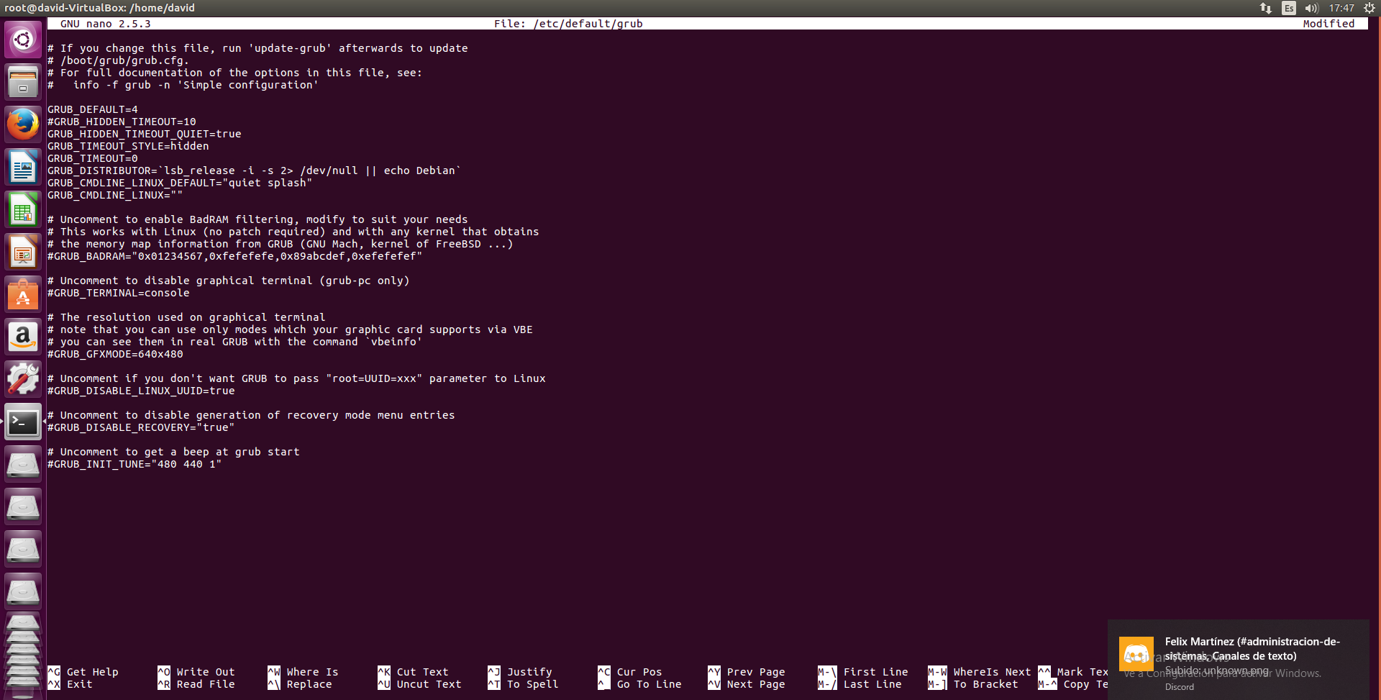

3.

If you have lost the Ubuntu bootloader and cant Access to Ubuntu, you will have to select the Ubuntu iso and select “try” instead of “install” and then write the following lines in the Ubuntu terminal:

