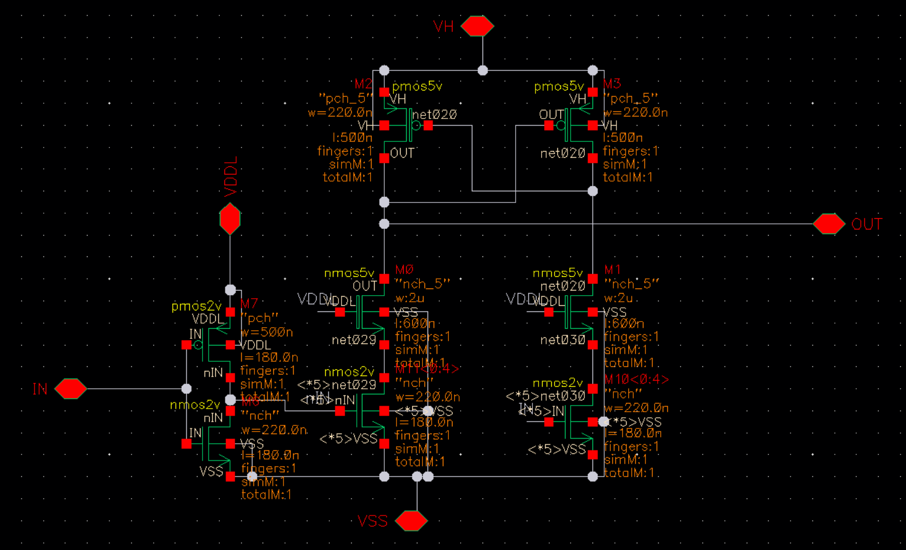
Btw, the subsequent discussion mainly focuses on the situation at maximum Vc, which is the minimum pulse width scenario.
Before the design, this is the original LS performance as the baseline:
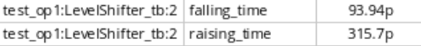
The above shows the original version of the LS. You can see that its falling time is very fast but the raising time is very slow. This results in Vgs being difficult to reduce after rapidly rising in the minimum pulse width situation, forming the Vgs shown in the figure:
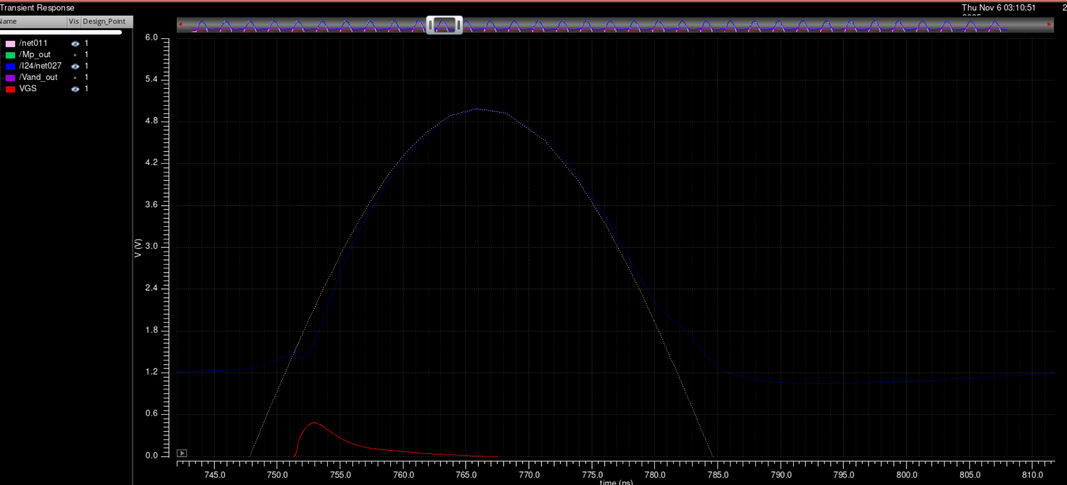
This kind of Vgs control is not very “clean”, and most of it is in the subthreshold region. Now I've noticed that the system speed is limited by the LS, resulting in Mp being unable to switch on and off as required. Moreover, because "VDD" itself is a sin signal, the LS requirement for the falling speed is lower than the rising speed. But the current LS rises much slower than it falls.
So my first step is to try resizing this LS to balance its up and down speeds a bit. This does help somewhat, but not much. The effect is as shown in the figure: ←

It can only be said to have some effect, but not much. So I still decided to change the architecture. I looked at some papers and finally decided to use this one:
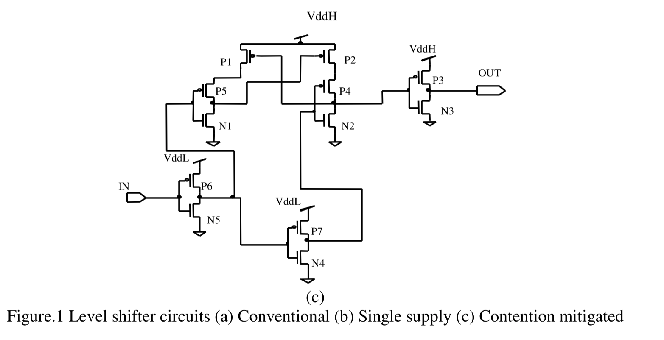
However, I didn't directly build it according to the method in the figure. I removed the first low-voltage INV and the last high-voltage INV. This way the positive and negative of the voltage won't swap, but the delay is reduced.
The result is as shown in the figure:
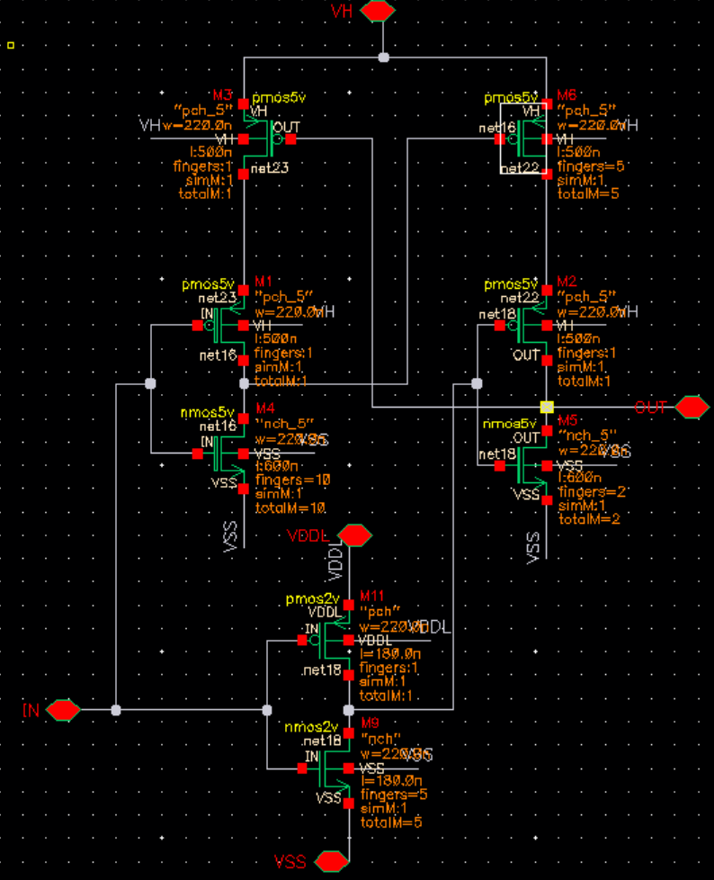

At the beginning, I used a sizing method similar to that in the paper, but I found that although there was improvement, the rise was still slower than the fall. So I made the two sides of the LS asymmetric.
I first increased the area of M4, so that when the LS input goes from 0 to 1, M1 turns off quickly, and M4 rapidly pulls down the voltage on the M6 gate to quickly conduct M6. After testing, I set the finger count of M4 to 10, and having more doesn't provide much benefit.
Then I increased the area of M6 to speed up the voltage rise. But this sacrifices the voltage fall speed. After sweeping, I set its finger count to 5, and at the same time set M5's finger count to 2 to compensate for some loss in fall speed. The final result is as follows:
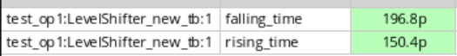
I reduced the rise speed by nearly half compared to the original, while the fall speed is slightly slower than the rise speed. This is more balanced.
Finally, I stacked the nmos of the inverter to reduce static leakage current. Somehow this reduced the rise time. The circuit diagram and results are as shown in the figure:
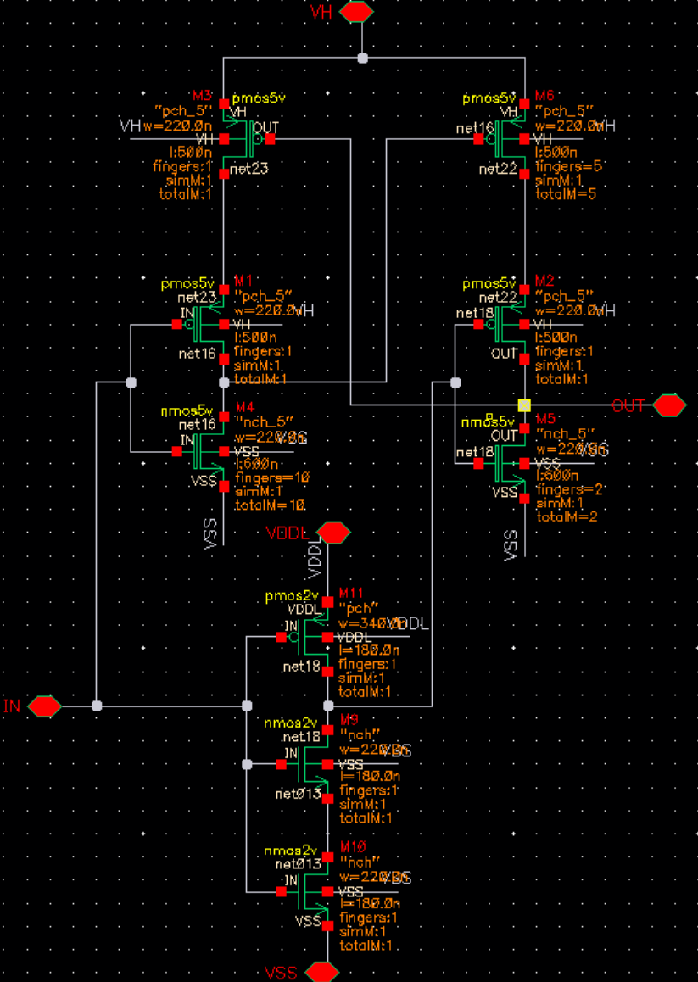
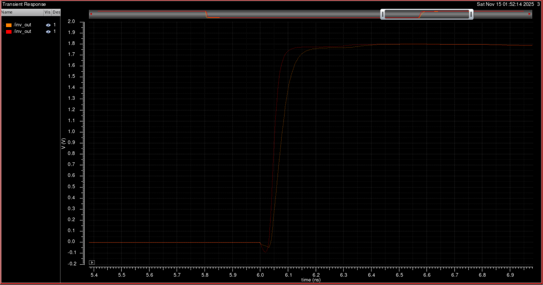
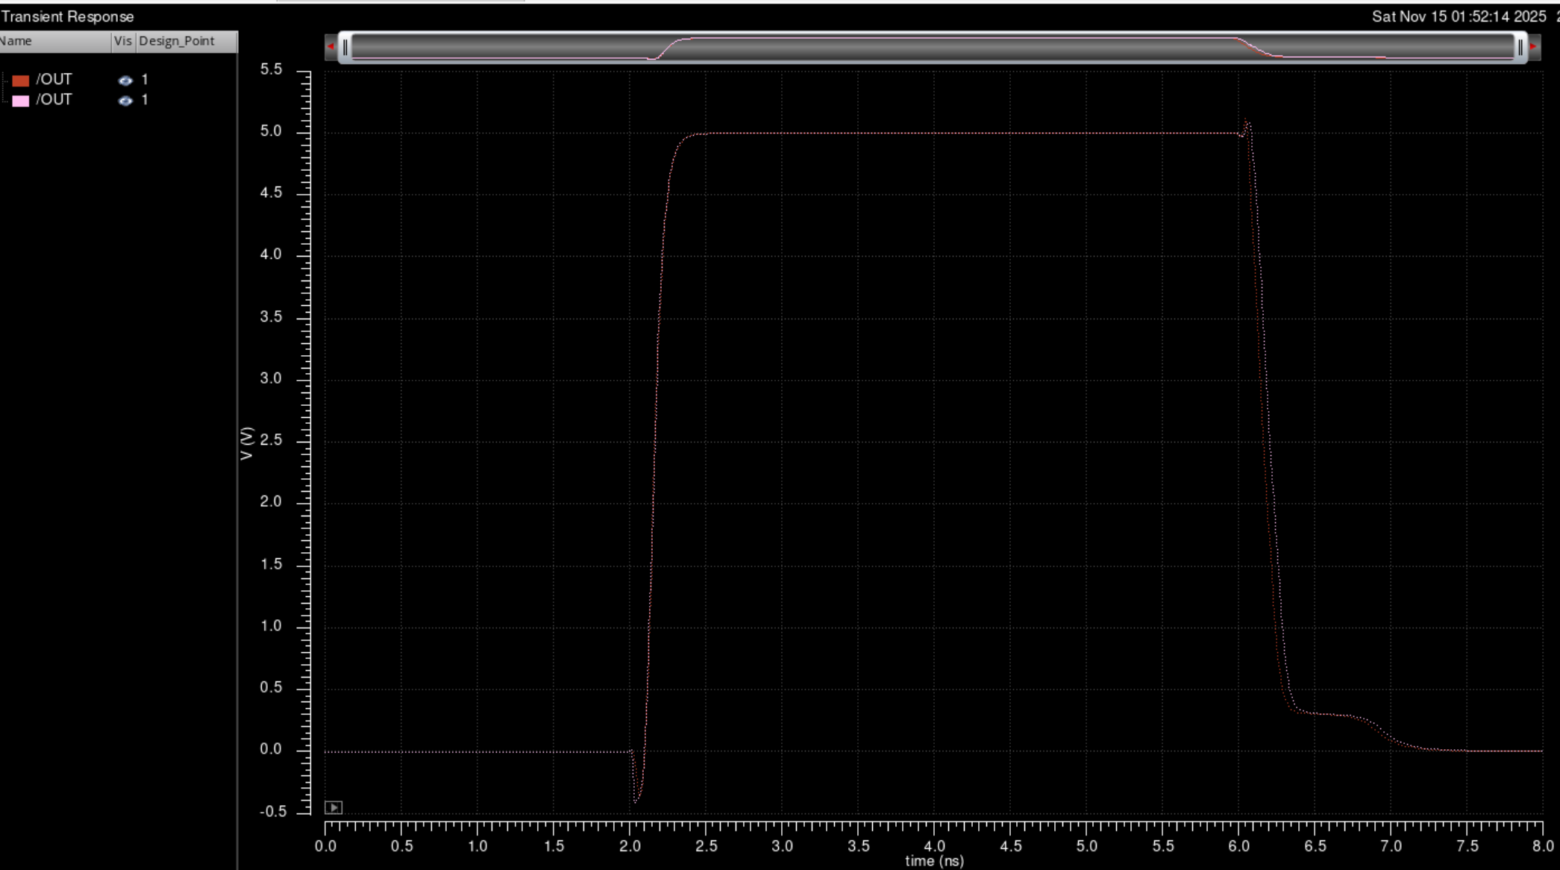
It can be seen that because the inverter has a much faster speed when pulling up the level, the final falling time is reduced.
The current delay is as shown in the figure:
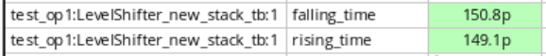
It seems like I got a "free" improvement in fall speed. I tried scaling other parts again, but the improvement in rise speed is very limited, and it will greatly reduce the fall time, so I kept the other parts unchanged.
Finally, I put the new LS into the original test bench for testing. The results are as shown in the figure:
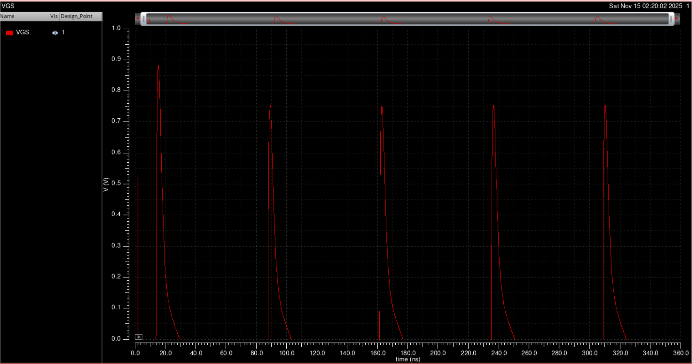
Now the spike of Vgs is very sharp. You can see the improvement is very obvious. Not only is the pulse width greatly shortened, but the control signal is also much cleaner.
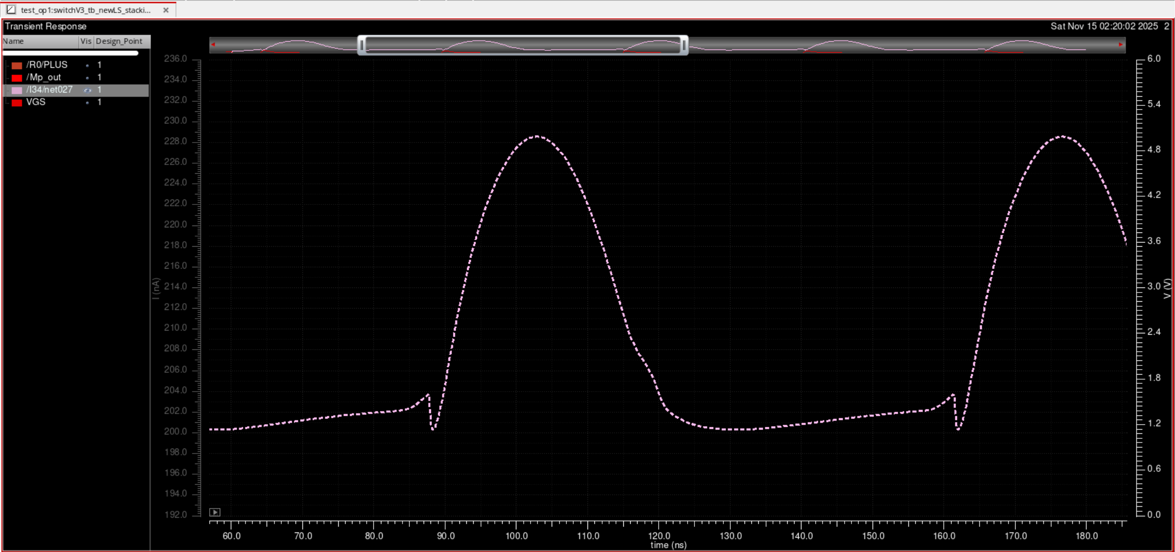
And the control signal on Mp_gate also looks relatively normal. ←
And now the stable minimum voltage value has reached 0.2uA, which is already 1% of 20uA. After reading the electrostimulation-related papers, I think this is already sufficient.

So next I'm ready to start researching other parts.
The figure below shows the Vgs after I removed the MUX. The control signal is sharper and the Vgs peak is higher. I think this should be very helpful in reducing the on-resistance of Mp
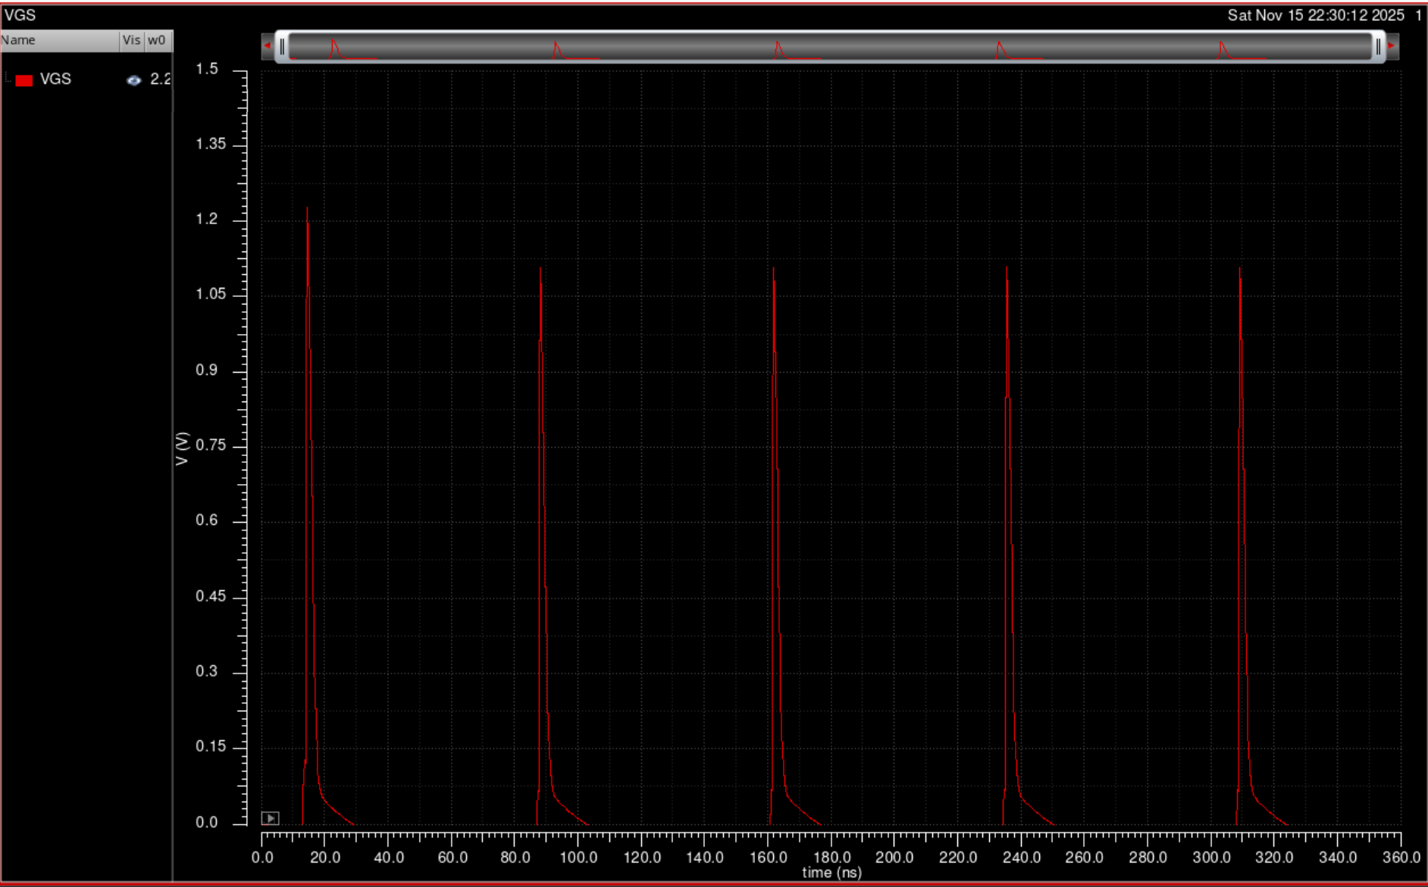
我了个去，居然MUX的影响这么大

