1：Over all
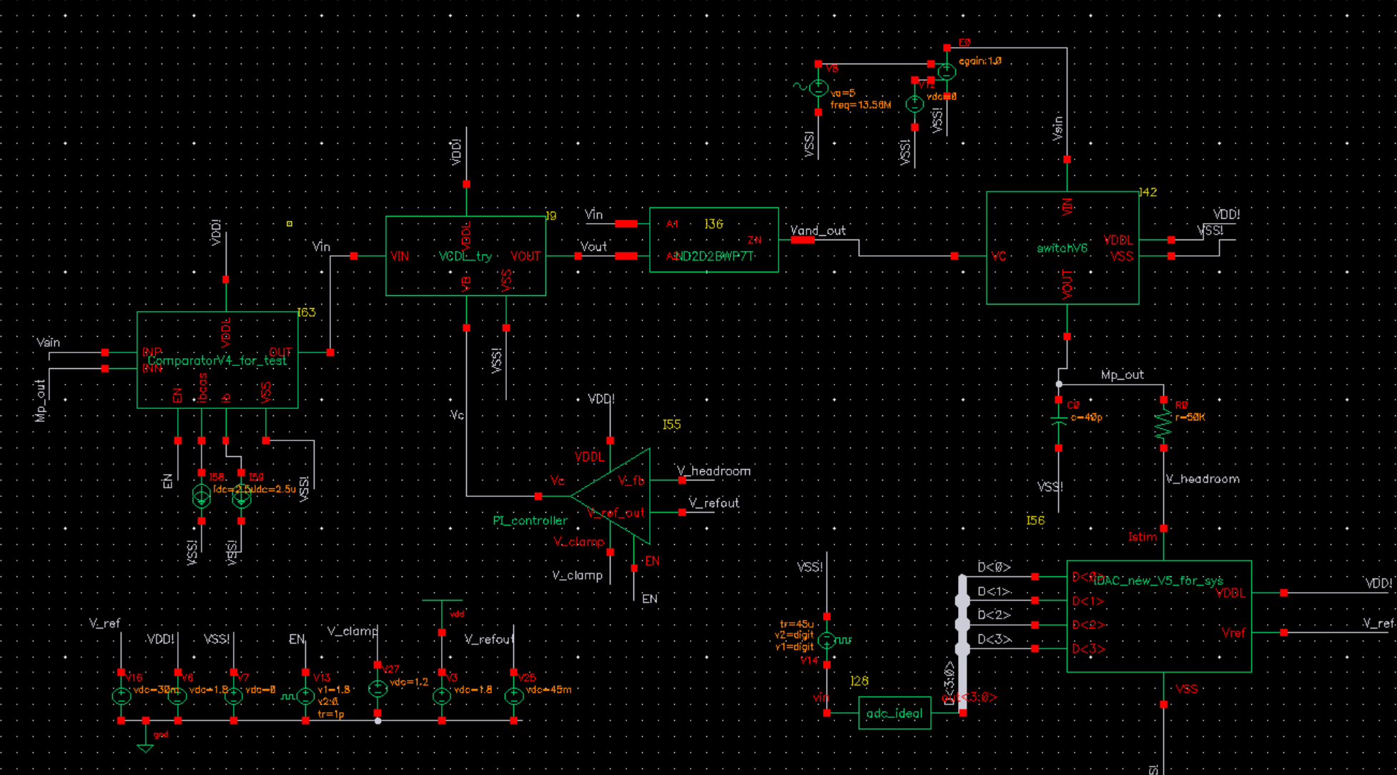
The whole system is kind of finished(kind of)
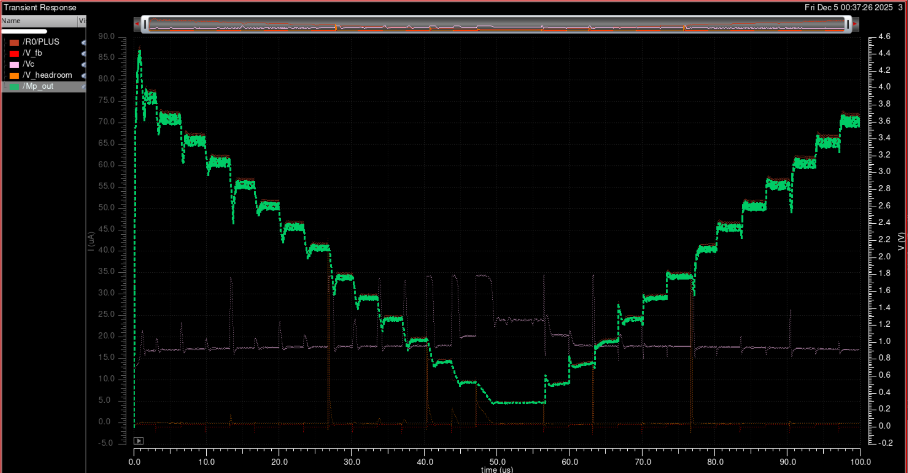
Current is accurate, Vheadroom can control at around 43mV

