David Hazall-Farrell

CSL-131

1/22/2024

Lab #3

9.

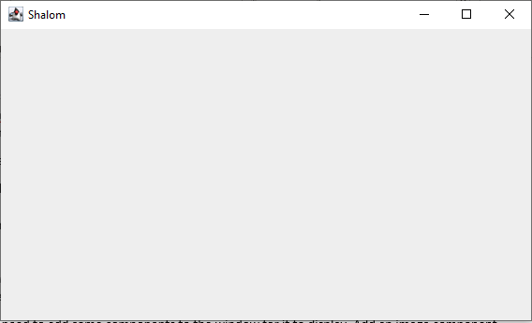

11.

Image icon is used in the middle of the program, but before the window is created.

14.

It is just the plain window with nothing else.

16.

The picture is way too big and it covers the entire screen. It forces the window to be larger as well.

18.

The size of the image is 487 x 513. After experimentation, the photo ultimately decides the size of the window.

20.

After running the program after adding more dialogue and another picture, the window became larger. It got bigger both vertically and horizontally. As a result, I had to relocate the window.

23.

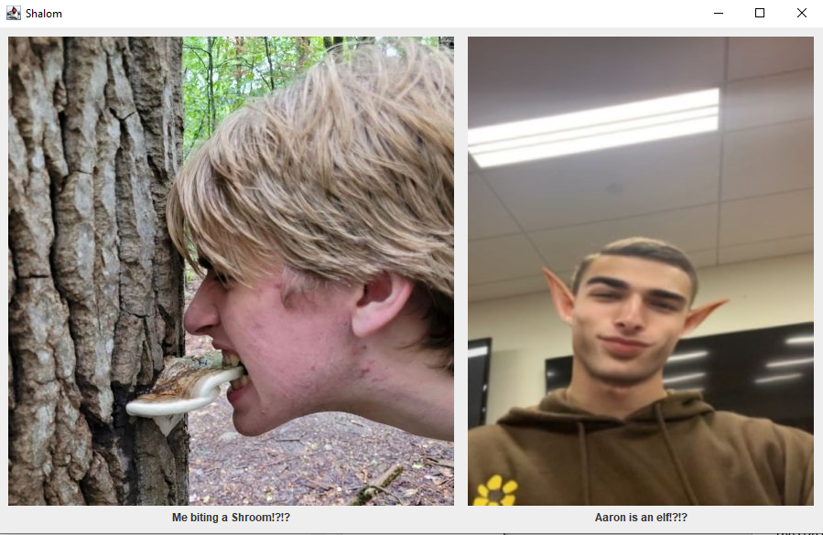

24.

**import** javax.swing.*;

**import** java.awt.*;

**public** **class** OurPictures {

**public** **static** **void** main(String[] args) {

JFrame myWindow;

myWindow = **new** JFrame();

myWindow.setDefaultCloseOperation(JFrame.***EXIT_ON_CLOSE***);

// set size of the window and make it visible

myWindow.setSize(2000, 2000);

myWindow.setLocation(400, 150);

myWindow.setTitle("Shalom");

myWindow.setVisible(**true**);

myWindow.setLayout(**new** FlowLayout());

//Set image of myself, along with text

ImageIcon imgMe = **new** ImageIcon("DJShroom.jpeg");

JLabel lblName = **new** JLabel("Me biting a Shroom!?!?", imgMe, SwingConstants.***CENTER***);

lblName.setVerticalTextPosition(SwingConstants.***BOTTOM***);

lblName.setHorizontalTextPosition(SwingConstants.***CENTER***);

//Set image of Aaron, along with text

ImageIcon imgHe = **new** ImageIcon("AaronElf.jpg");

JLabel lblHim = **new** JLabel("Aaron is an elf!?!?", imgHe, SwingConstants.***CENTER***);

lblHim.setVerticalTextPosition(SwingConstants.***BOTTOM***);

lblHim.setHorizontalTextPosition(SwingConstants.***CENTER***);

//Introduces a frame for my picture

JPanel DJShroom = **new** JPanel();

DJShroom.add(lblName);

myWindow.getContentPane().add(DJShroom);

myWindow.pack();

//Introduces a frame for Aarons picture

JPanel AaronElf = **new** JPanel();

AaronElf.add(lblHim);

myWindow.getContentPane().add(AaronElf);

myWindow.pack();

}

}