Contents

System requirements 2

Installation manual 2

User manual 3

Specification 6

Scheduling report 7

Appendix 8

System requirements

This product has been developed and tested using the following server setup:

* XAMPP version 1.8.2
* Apache 2.4.4
* MySQL 5.5.32 (Community Server)
* PHP 5.4.25

And has been tested on the following browsers:

* Google Chrome 42
* Mozilla Firefox 37
* Microsoft Internet explorer 11

Any modern browser supporting JavaScript should be capable of viewing the site without issue. Any browser incapable or unwilling to use JavaScript will be shown a message to this effect and will be unable to browse or interact with the site as JavaScript is required for essential functionalities.

**Know issues:**

Internet Explorer: After making a purchase of multiple products, some of which were purchased sucessfully but at least one not, displayed stock amounts are not updated (note: they are updated correctly in the database, only the change is not displayed).

Internet Explorer: Changing the thumbnail of a product is not possible without the developer console open. The reason for this is unknown. Functionality works correctly with console open; as a work-around, press F12 before selecting a thumbnail then.

Installation manual

To install the product, simply place the sites root directory ‘687691’ in the root folder of the server (eg. ‘htdocs’ if using XAMPP).

Upon the first visit to the site, a new database will be created to store site data. The name and login credentials for this can be found and edited in ‘687691/API/DBInterface.php’, it is highly recommended that you change the username and password or your site may be vulnerable.

Located in the same file is the option to load test data upon database creation. This is enabled by default to help you get familiar with the sites functionality, but can be easily disabled by changing the value of ‘UseTestData’ to false.

User manual

The site is designed to be as intuitive as possible and features on screen instructional text in most areas; as such this manual is written to act as a reference guide to accomplishing more complex tasks and to give an overview of how some mechanics function so you can better optimise your product catalogue.

This guide assumes the instructions in the installation manual have already been completed and that the site is now accessible; if not, contact your webmaster.

**Getting started**

Begin by navigating to the root directory (687691) in your browser. You will be presented with four options; Customer site, Content Management System, Admin controls and API. Clicking any of these links will take you to the relevant start page.

Note: you may want your webmaster to setup an automatic redirect for external visitors to automatically start them on the customer page.

1. **The Content Management System (CMS)**

This is where you add, edit and delete products and categories. The main display shows items as they would appear on the customer site. Clicking on an item will expand it (as on the customer site) but instead of ‘Add to basket’, will feature an ‘Edit’ button. Clicking this enables editing mode for the product.

* 1. **Product editing mode**

In editing mode (see above) the products details are made editable on screen. All purple text is editable. Click save to commit changes or cancel (or click away onto another tab) to discard changes. Clicking ‘Remove product listing’ will prevent the product from being listed, both on the CMS and Customer site, product information may be retained in the database if there are existing purchases of the product.

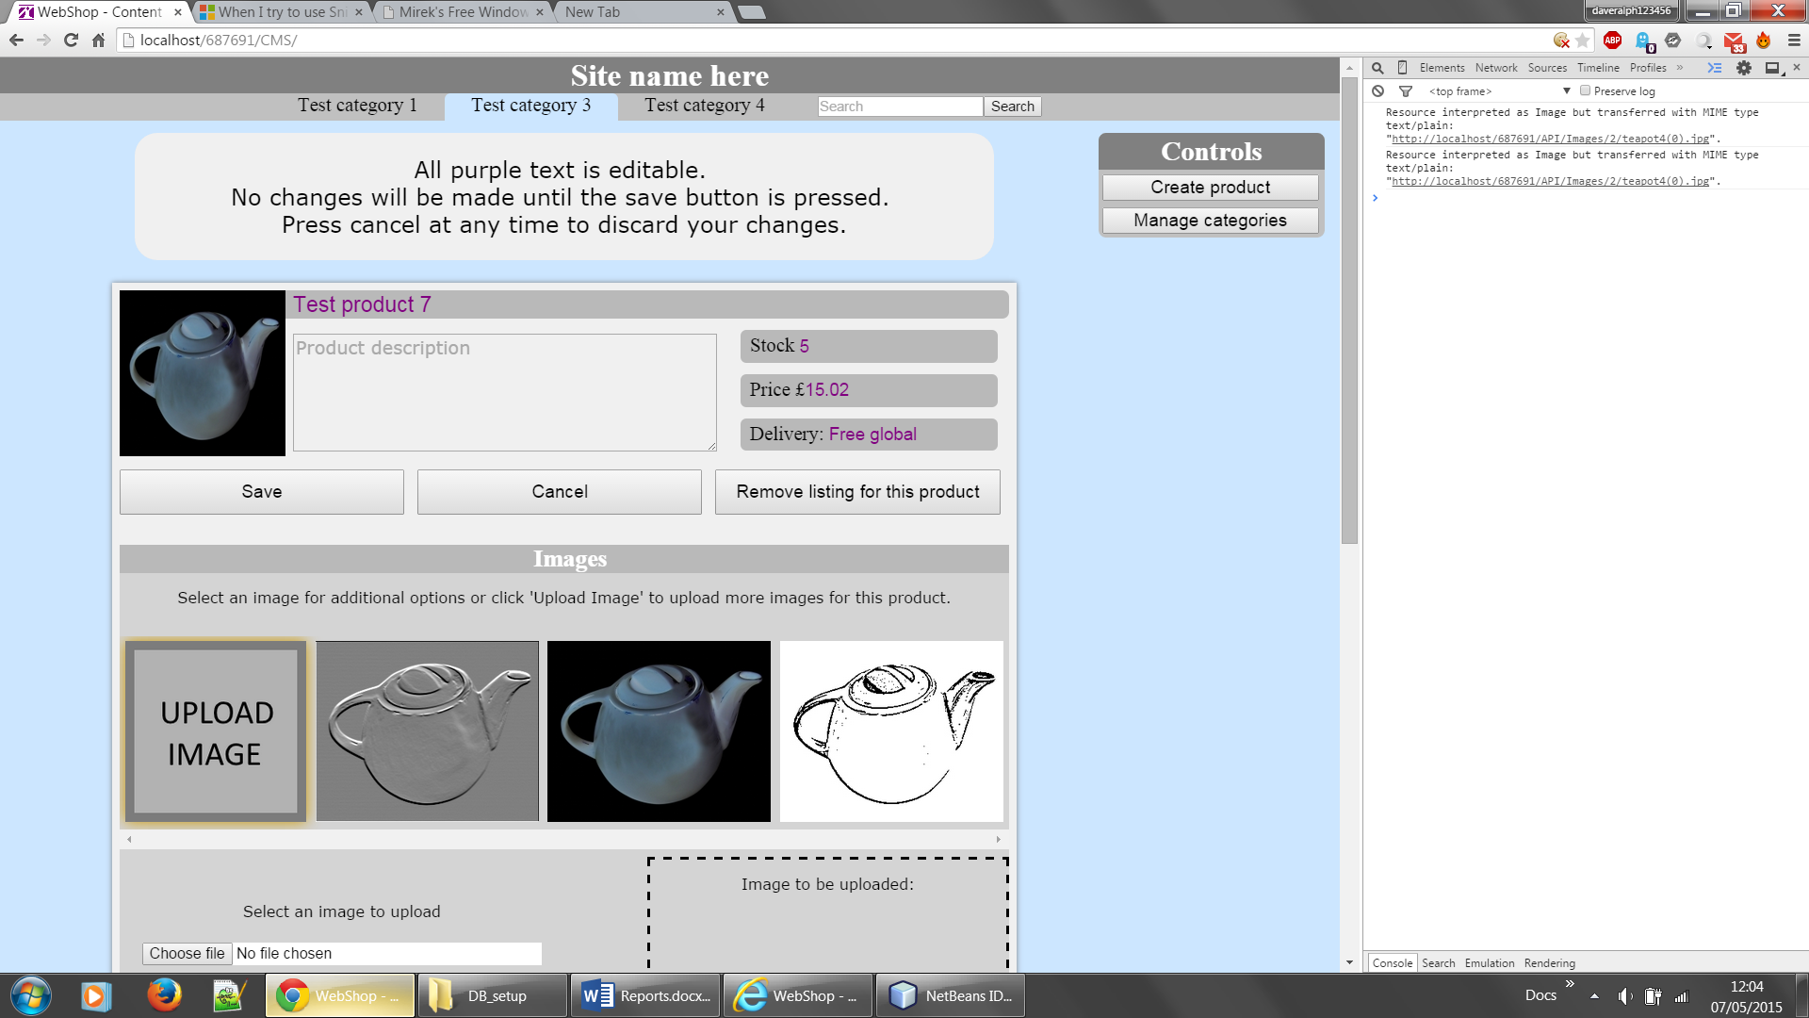

* + 1. 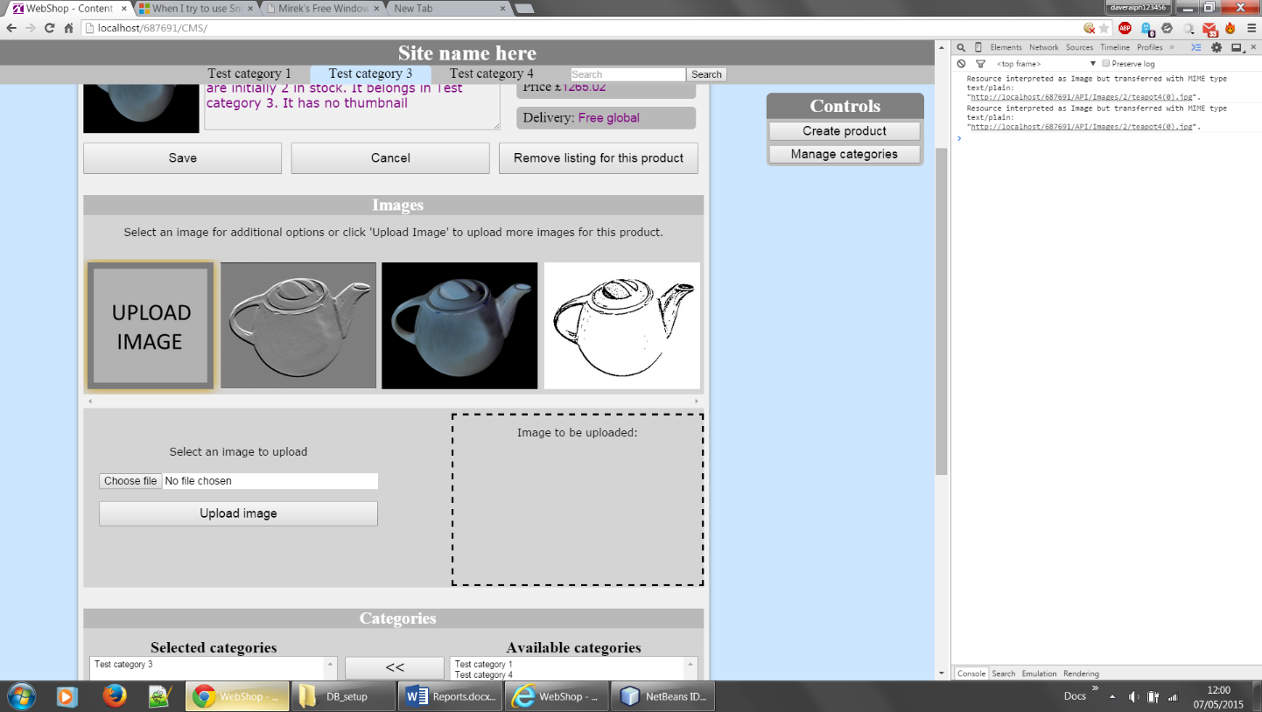**Images**

In the images section, all current images of the product are displayed. To upload a new image click the ‘UPLOAD IMAGE’ icon and select a file, a preview of the image will then be shown on the right. Click the ‘Upload Image’ button below the file selector to upload the new image.

Clicking on an existing image gives the option to ither delete the image, or use it as the products thumbnail. If you delete the image currently used as the products thumbnail, the ‘NO IMAGE’ palceholder will be used untill another is selected.

* + 1. **Category selection**

In editing mode, you also have the option of changing what categories the product will be listed in; a product can have any number of categories and will be listed under all categories show in the ‘Selected Categories’ box. To add a product to a category, select it in the ‘Avalible categories’ box and either double click it or press the ‘<<’ button, to move it into selected categories. The product can be removed from a category in the same way but by selecting it in the ‘Selected Categories’ box and using the ‘>>’ button.

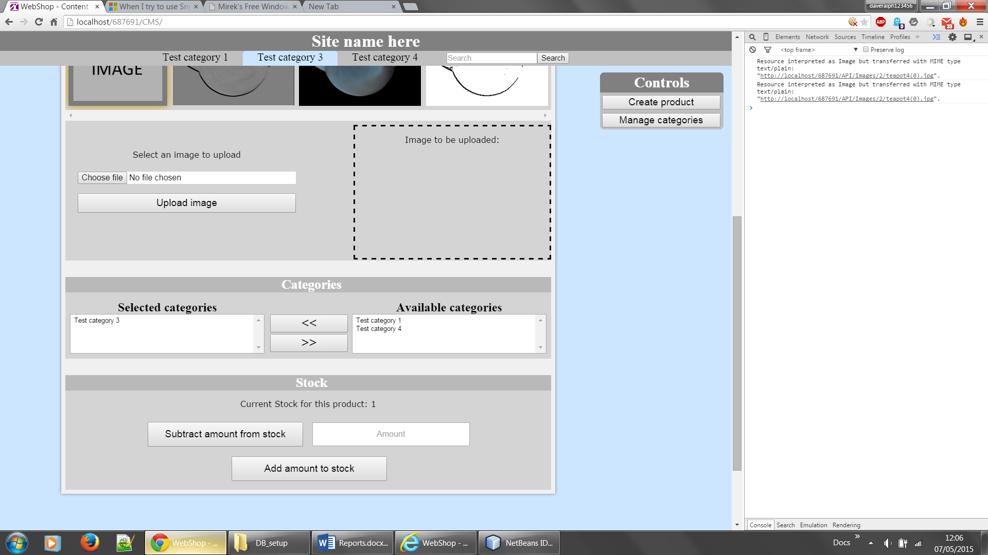

* + 1. **Stock managment**

Additionally in editing mode is the option to manage stock. As well as the option to set the stock to an exact value in the product details editor, you can add or subtract an amount from the current stock in the stock manager at the bottom of the editing form. It is highly advisable to only use the stock manager for modifying the stock of products currently on sale as new orders may have been placed during editing.

* 1. **Product creation**

Clicking the ‘Create product’ button on the control panel (only available on the Content Management System) will create and display a new blank product template in editing mode. This template can then be edited like any other product. The product will not be listed on the site until it is first saved in editing mode, so clicking away if you change your mind is no problem.

* 1. **Category management**

Clicking the ‘Manage categories’ button on the control panel (only available on the Content Management System page) will display the category manager. This displays a list of all existing categories and allows their creation and deletion. While you can have any number of categories, having too many may clutter users screens, especially if they are using devices with small screens (such as tablets or netbooks). Remember that products can be members of multiple categories and will show up in searches for all of them. Categories must have unique names. Deleting a category will not modify or delete products in it, only remove them from the category.

Create or delete categories by entering their name in the text field provided and clicking either ‘Create category’ or ‘Delete category’. Exising categories can also be selected by clicking on their name in the category manager.

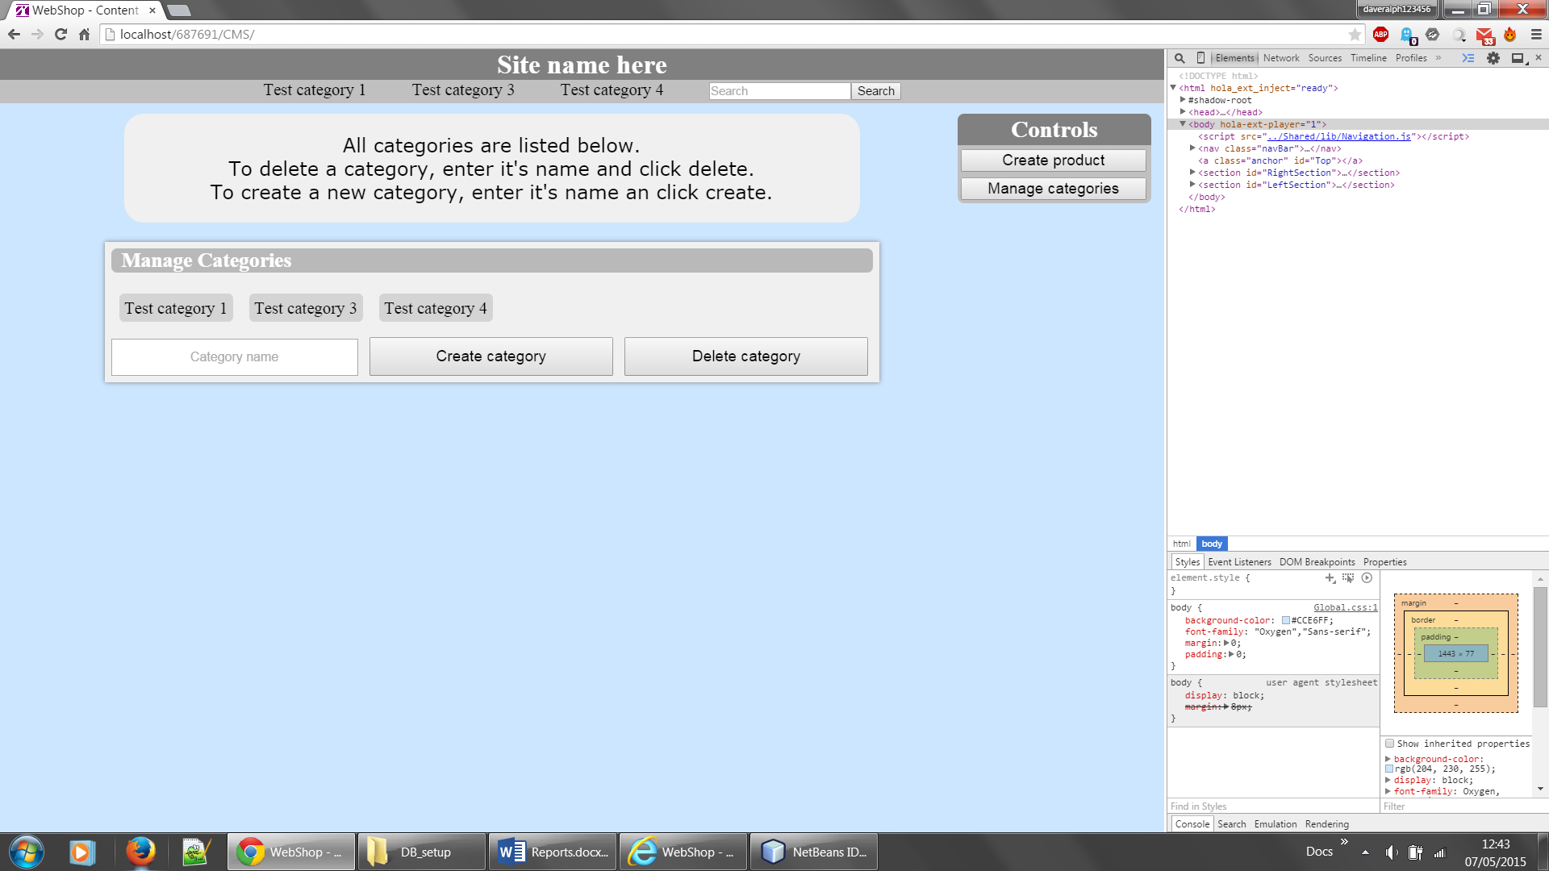

1. **The customer site**

This is where customers are able to view your product catalogue. Products can be found by category or search. Clicking on products expands the listing to show all product images and user reviews, as well as controls for adding a quantity of the item to their basket. The user also has a basket to which they can add products; clicking checkout will place an order for the respective quantities all products in the user’s basket and modify stocks accordingly. Users cannot purchase more of a product than is currently in stock.

* 1. **Searching**

The search bar allows users to easily find products based on their knowledge of the item. Searches are ranked as follows:

* Products with names containing the search term
* Products in a category whos name contains the search term
* Products with descriptions containing the search term

**3. The API**

An html table representing the site API is available on this page, this is here for reference for developers extending the site; you may want to get your web master to put some security in place to prevent the public accessing sensitive parts of this.

Specification and rational

**Expandable product listings**

Products are initially displayed in a minimised form and are expanded when clicked on, showing additional images (besides the thumbnail) and user reviews. This results in lower bandwidth usage due to rich media only being loaded for products the user has shown interest in, and also creates a cleaner, less cluttered view for the user, allowing them to have more products displayed on screen simultaneously. Multiple items can be expanded at the same time so users can easily compare product details.

**Search order**

Searches (using the search bar) are ranked first by relevant product name, then category, then description. This setup ensures more relevant items are shown earlier, however it could be improved by providing the user with options (possibly checkboxes) for which of these they wish to include in the search. It may also be useful to be able to rank results by price as well as relevancy and filter items that are out of stock.

**Three site structure**

The main site features are split into three separate pages; the Content Management System, Admin controls and Customer site. These sites have their individual resources located in separate directories (with some common elements in another directory) and finally an API directory containing server resources, this structure allows for easier implementation of security and authentication via .htaccess as well as setting read/write/execute permissions on Unix based servers (for example on the API directory, as its contents should only need to be executed by the server computer).

**RESTful API**

The site’s API is designed to follow the principles of REST. By using meaningful URIs and not depending on conversational state, the server side of the product is made greatly more scalable and maintainable. For example, load could be distributed over multiple servers (as the server would need no client identifying information). RESTful design also benefits decoupling, meaning it would be easier to develop alternative clients to interface with the server (the client being any service which can communicate over HTTP). A table representing the current API can be found both on site and in the appendix.

**Image managment**

The server stores images of products in separate directories for each product (folder name is productID), all these folders are loacted in the /API/Images directory. Any images within the folder are returned as a response to GET requests, meaning that as well as using the API to upload image files, they can be added manually (potentially useful if needing to upload many images at once.). Products lacking a thumbnail are automatically assigned a default “NO IMAGE” image, this is located in /API/Images/res and could be easily replaced with a custom image by the client.

Scheduling report

Site development loosely followed a spiral lifecycle, with the core functionality of some basic systems being completed early on, while more complex features needed to be delayed until other site infrastructure was completed. Two major milestones were around the time of the interim reports; firstly the completion of the initial wireframes and database design shortly before the first interim, and the first working interaction with server side content in early January (just before the second interim). Both interim reports are included in the appendix; they also each contain a Gantt chart reflecting progress made and projected at the time of writing.

As detailed in the second interim, a naive approach to the spiral lifecycle model lead to a lack of detailed site-wide design; this caused a number of issues that required (mostly minor) redesigns later on. Refactoring of code contributed to a large portion of each cycle and occasionally some code would be made obsolete; having focused more on component interaction design (for example making UML diagrams) early on could have potentially resulted in large time savings.

By the second interim, the project was roughly on track (roughly in that some amount of rescheduling took place due to changed perception of needs) with the basic server side functionality beginning to be implemented. However following this, due lack of confidence with PHP, I focused work on client side features, leaving all server side development for later. While this seemed a sensible development strategy, given that in class learning focused on PHP later in the year, getting caught up in client side development without a clear plan of server side facilities resulted in otherwise unnecessary amounts of refactoring and code depreciation later on.

Another effect of this was by leaving unknowns till later, accurate projection of task duration proved difficult and my original plans did not allow enough time for learning technologies, causing delays in the later stages of the project. The result of this is that some aspects of the project we’re not fully completed and polish is missing in some areas.

The main lessons learnt from this project can be summarised as:

* Detailed program-wide design (such as UML) is essential in developing large programs.
* If possible, engage unknowns and unfamiliar technologies early to avoid unexpected delays later when it may be too late.
* Distribute more slack towards the end of large projects as the compound effect of minor delays thought the project can prove hard to recover from without planned

A final Gantt chart showing actual progress made can be found in the appendix.