ECE1387
Project 2

Analytical Placement with Heterogeneous Cell Types,Spreading, Snapping/Legalizing to Grid





Stu:Dongxu Ren

Major Routines
In this assignment, I learned from the previous project and changed my programming habit from procedure oriented to object oriented and the whole project was consisted of the following classed:create_matrix.cpp-calculate the Q matrix and B matrix for calculation, block.cpp calculate the properties of each block(both fixed and moveable), net.cpp- calculate properties for each net, solver.cpp-modified fron suitesparse’s sample program to solve linear function,spread.cpp-spread strategies for question 2 and 3, extract.cpp-extract useful information from circuit file.

Part 1:Clique Model Placement
As we know that in clique model each two blocks are connected, thus makes the weight of each net 2/p (P is the total block numbers in that net), and the bounding block wire length can re aquired by calculating the subtract value of the Xmax-Xmin and Ymax-Ymin.
From the suitesparse outcome and easygl plot proved that my algorithm worked, however, I deed met some unexpected situations, when I finished testing the circuit one and ran the program to test circuit 2, at the first time, it took me 3 hours to run the cct2, which means it was impossible to implement the algorithm for question 2,3,4 under such slow run-time. Thus, I modified my algorithm by adding some extern variables and alter the algotithm of the critical path. After modification, from my estimation the run-time was eight hundred times faster than the first time. However, when I tried to run test for cct3 and cct4 the run-time increased again, due to the limit of time I did not have the chance to improve it again, but it did reminded me to care about the run-time issue when designing a big program.
 | Cct1 | Cct2 | Cct3
Run-time on visual studio(upper row is the run-time before modification) | 3 minutes | Around 40hours
 | 10s | 20s
Run-time on ecf linux machine(upper row is the run-time before modification | 10s | 3hours
 | Less than 1s | 5s | 6mins
Table1:run-time report
The circuit cct4 take significantly more time to run that cct3, thus I did not have a chance to test it, but my algotithm is well proved to correct based on cct1,2 and 3, below is the wire length calculated in HPWL algorithm.
 | Cct1 | Cct2 | Cct3
BBWL | 16.0589 | 153.807 | 463.487
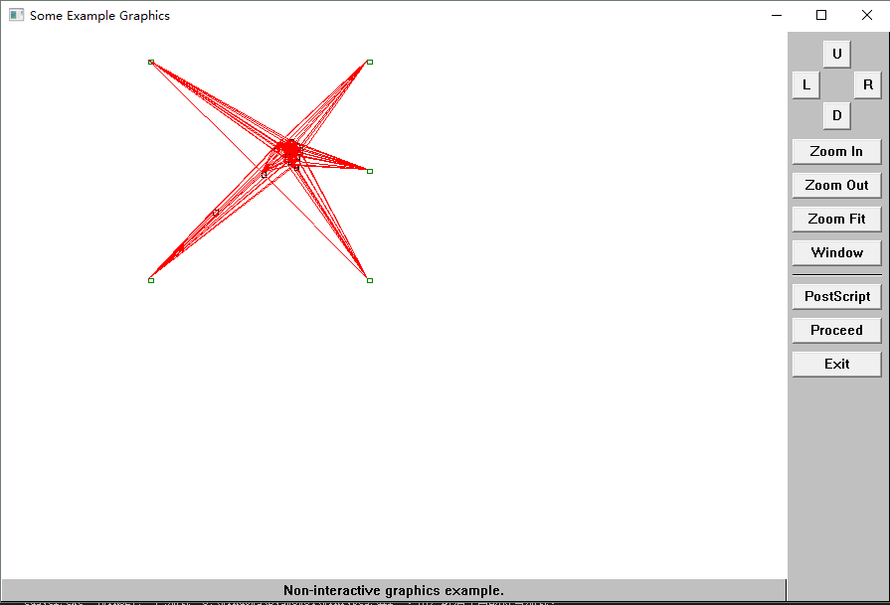
Fig 1.CCT1

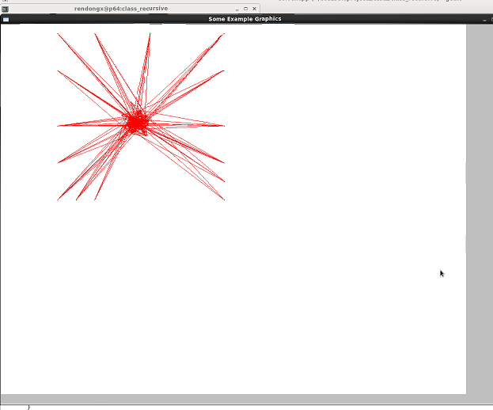
Fig2. cct2
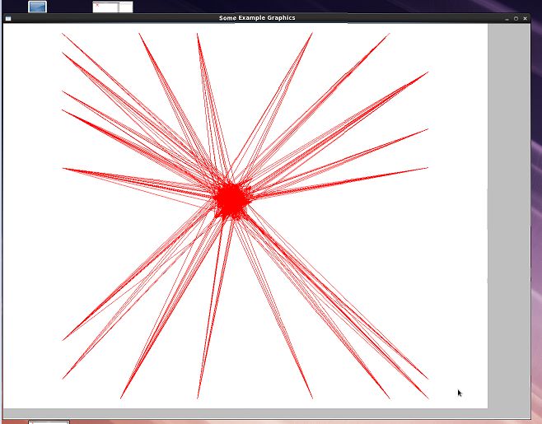
Fig3.cct3
Part 2: Introduce new fixed block in each qudrant
In this part, I came up with two possible solutions, the first one is to add the new fixed blocks to the fixed block vector and the second one is two calculate the effects that these new fixed blocks had on the calculation of matrix Q and B. Due to the reason that changing the fixed blocks would affect the other parts of the program, I decided to use the second solution. According to the formation of Q and B, only the on-diag elements of Q will be affected by introducing new fixed blocks, and each one of vector B will have to add a new value to the original one. That part is implement by class “spread”. However, when I using easygl to plot the graph, the result was a little different from my expection, that is the blocks did spread a little but most of the blocks are moved to the upper-left section, I suppose this is because most of the coordinates that we solved in part one is located at the upper-left quadrant and after spreading they are still located in that qudrant, to improve the spread effect maybe I should develop another algorithm to seperatet the blocks, so that they can be divided more equally, below is the BBWL for the test circuits
.
 | Cct2 | Cct3
BBWL | 161.304 | 507.642
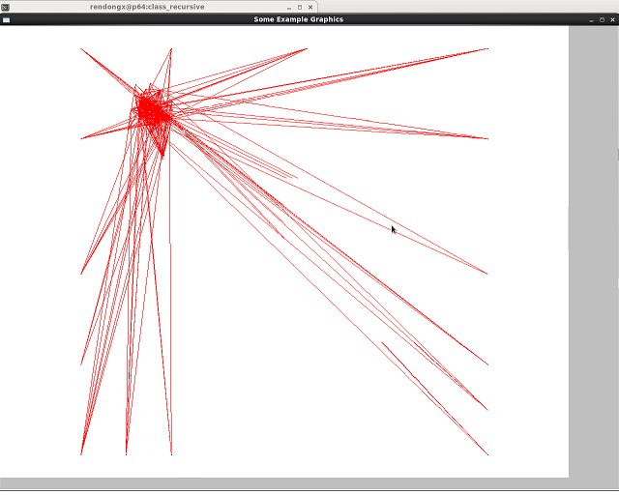
Fig 4. cct2 spread
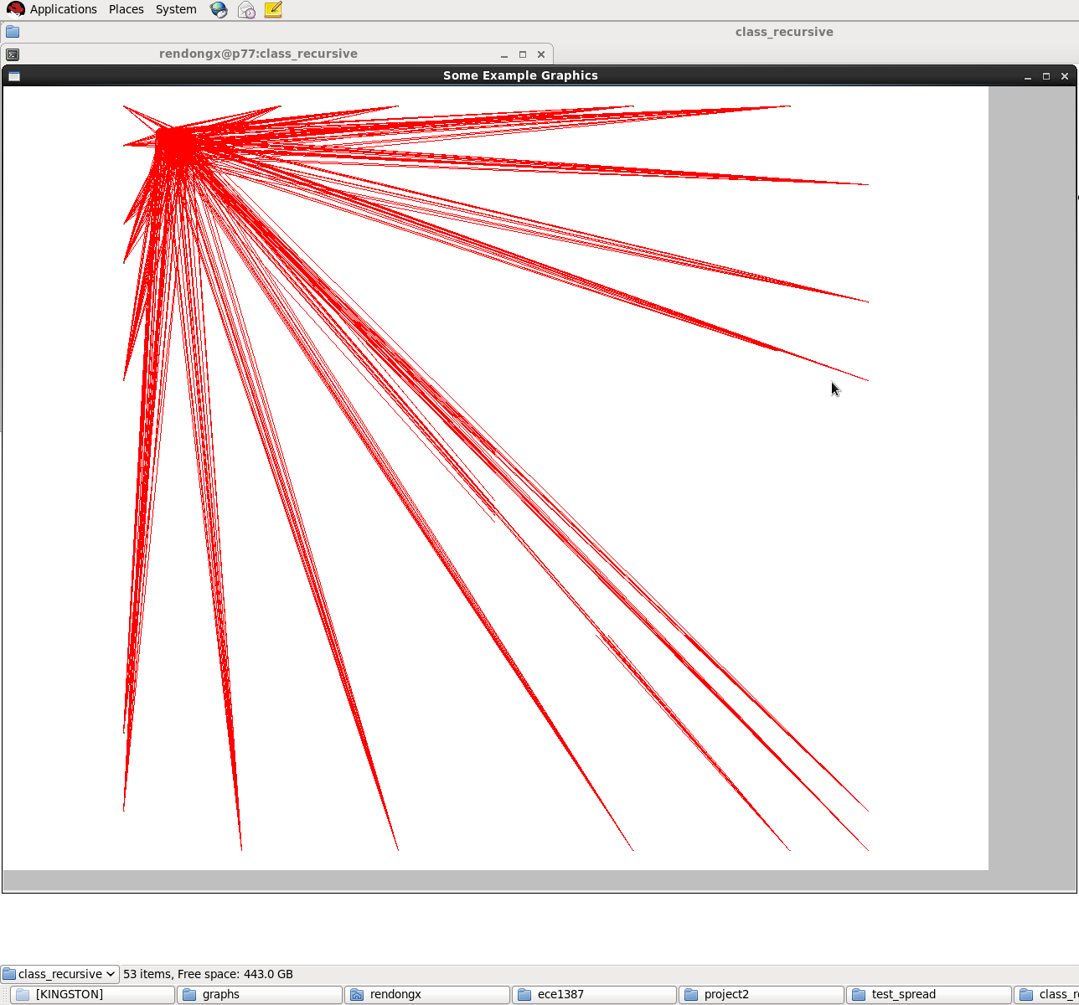
Fig5.cct3 spread
Part 3:
This part request us to develop an algorithm to recursively spread the circuit introducing new fixed blocks and keep dividing the graph until the overlap rate is satisfied. This can be done in two ways, we can either write a recursive function or using a for loop, I did some research on recursive function in c++ application, however, I found it not a good solution for solving this case, because recursive functions takes up more storage and generally slower than for loops, especially for this program, the run-time may be big, and recursive functions should be designed to return the function itself, but I suppose in addition to return itself, the formate of its return value should have some other adjustions to its return function, such as modify its parameters. Thus, the procedure to solve this question can be divided into following steps:1st make the coordinates into int types- 2nd design a function calculating overlap rate- 3rd seperate the area- 4th spread the circuit until it meets the stop condition.
Due to the design process to calculate vector B request an user input(telling the solver that we are calculating coordinates for x or y, later I found this design is meaningless and very unconvenient for other functions to call but I did not have time to fixed this problem because some lower hierarchy functions already implemented this design), I need to input the value to tell the program we are calculating for x or y, thus I changed the stop conditiono to let the area to be spreaded for ten times and from the graph I found the blocks are spreaded much better than the first time, but it does not spread much after a several times, below is the graph and table of BBWL for the test circuits(it would take extremely long time to run cct3 and cct4, thus I ran cct2 as an example of the spreading effect).

 | Cct2 | Cct3
BBWL | 164 | 706.335

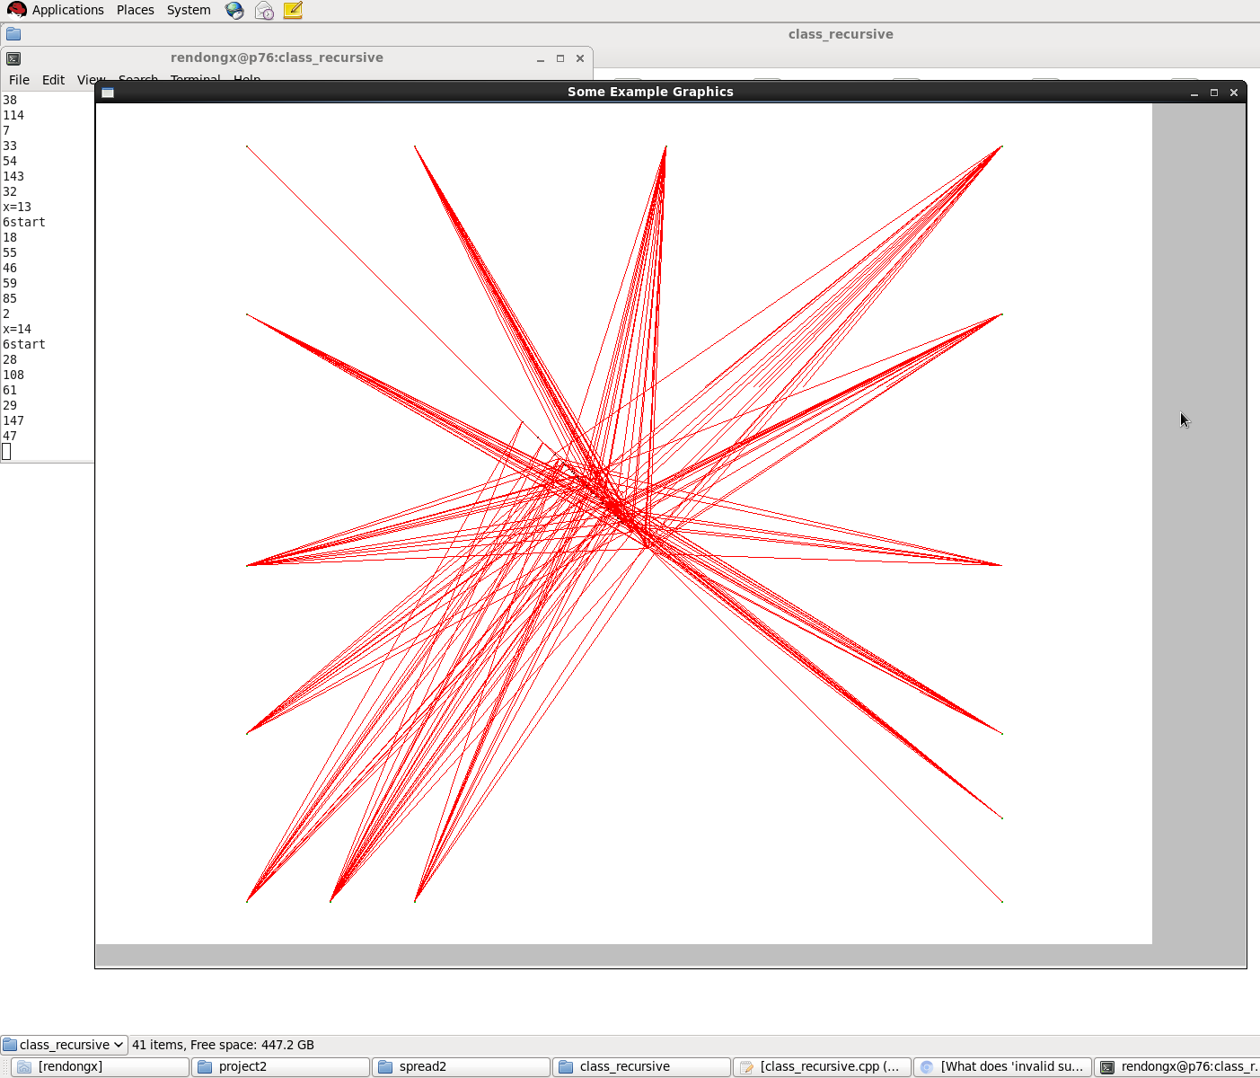
Fig.cct2 after recursive spreading

Part 4:
In this part, we need to seperate the blocks into two types, the type one and type zero, and type one can be only placed at columns that is times by five, here is the procedure of implement: 1st, make the coordinate from double to int-2nd place the blocks at the nearest slot and give them different color(Yellow for type zero, Blue for type one) and during the ploting procedure, I found that some blocks of the same type are located into the same slot which may still cause overlap.Below is the graph and BBWL.
 | Cct2 | Cct3
BBWL | 166 | 726
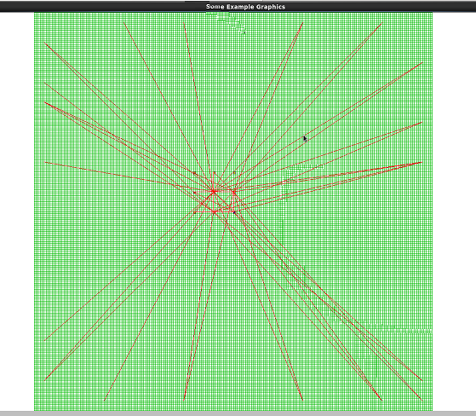
Fig6.cct3

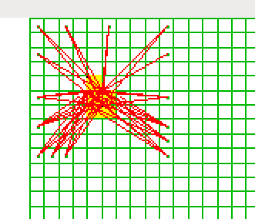
Fig7.cct2

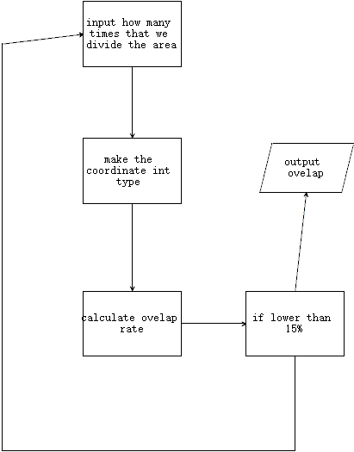
Fig 8.flow diagram for part2
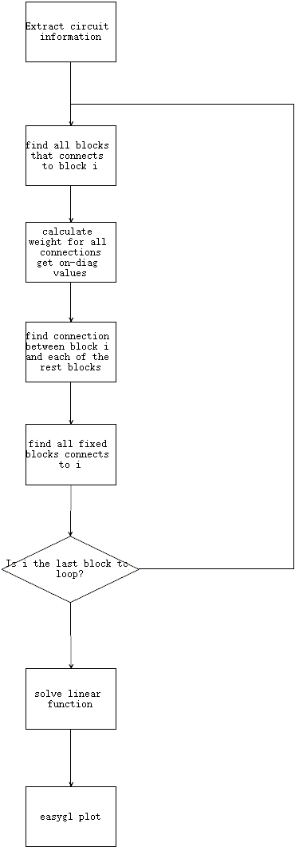
Fig9.flow diagram for part one
In the end, I met a very confusing problem in the class that use to solve linear function using the interface provided by suitesparse, as I know the interface of suitesparse request the input parameters to take the type of int and pointer, thus at first I replaced all the five arrays(Ap,Ai,Ax...) with array pointers then a strange thing happened, the value of array Ap changed before it was sent to the interface as parameter, at first I thought the reason maybe that the storage space was released and the value stored in those stock was lost, so I added delete at the end of the function, but that did not help at all, that is something that I had never met before and I could not fix it, thus I had to assign the length to each of five arraies and that worked. That is something that I discovered in this project, and I found that wire length increased as we spread the design and snap by zero and one provides the biggest wire length.

