Project 1 Router Design
ECE 1387 Student name: Dongxu Ren
- Plot of router outcome
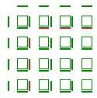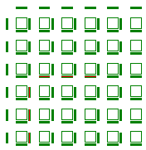
Circuit one circuit two

Circuit 3

Circuit four
The four figures above are the route plot for c1,c2,c3 and c4. When plotting the figure, firstly I tried to plot an interactive image using easygl, however, I cannot send parameters to easygl’s drawscreen function. I tried to modify its parameter and related functions but did not work, thus I plotted all my figures in non-interactive format. And that caused a problem that if I run the whole file in one time then all the wires will be shown in one hierarchy and wires will be overlapping among each other. So I plot one wire at a time and the figures above route from logic block (0,0) to (3,3), but this plotting strategy did bring a problem to calculate the routing segment number, because there are many segments that are used more than once in each four circuit. In order to count the number I have to develop another marking method to mark the segments that are used, but I haven’t figured out a workable solution the label the segment twice on the same block.
- Minimal tracks/channel value
C1 | 4
C2 | 4
C3 | 4
C4 | 4
From my understanding, the minimal W value means the number of tracks used in a design. And I wrote a program to calculate the number of tracks used in each of four designs and I found the track number that are used are 1,2,3,4 and the code to calculate the W is w.cpp in the compressed file.
- Parallel Router
I read some files about parallel computing but I am not sure what exactly to do on the code. From the definition, I think my router algorithm is a deterministic type and it should give the same result every time it runs. In addition, I read some programs in openmp, I suppose to parallel a program, we should add some #pragma lines to the original design and the program will be run in multiple cores.
- Main flow and logic explanation and data structure
Software logic flow:
Use the following logic to find the target.
if (pin on the left)?
If(the pin on the left is target)?
Yes-mark the path and return the coordinate
And start trace back
No-mark the path and go to next direction
Add the coordinate to expansion list
/
During each loop we count the number of pins added to expansion list and in each loop we also count the number of pins checked. In addition, add the length of path label number every time we finish looping all the nodes around the source pin.
/
After we find the target, the nodes that have been labeled has a value bigger than 1 and we can use the value on each node to find the original source. During the trace back process as long as the path label is smaller than current label value we can use the node to run next iteration.

Take the input file and get the data from it
Use the data of logic block number N to build a 2*N+1 matrix
Fill the matrix with number 1(paths) and number 0(logic block and switches) then mark the source and the target with different unique number
Data structure: We use the value in matrix to label the different pins to find target and trace back to find the source meanwhile mark the path in red color. The reason that I chose matrix is that the path and logic blocks can be easily represented by matrix, and I made the matrix 2*N+1 because that way we can include all the path, logic blocks, and switches and the value in each matrix can be used to mark the path length just like the lee-moore algorithm. In the coding phase, I did met some problems, one of them is the available range of variables. Especially for the expansion list, the definition of the list require it to be size changeable and after each loop its former data must be able to pass to the next loop. At first, I tried to solve this problem with static variables but it seems that static arrays cannot be redefined and then I tried to use recursion but soon I found it does not work, then finally I use the return value of the function to return a structure when we allocate the function and use the return value as the parameter for the next time.
Has a pin on left?
yes
no
Is it the target?
yes
no
finish
Go to next pin
Assume there are n(n<=4)pins near the source
Add n pins to the expansion list
Length+1 when all n pins have been checked
Return the expansion list, n, total length of expansion list ,path length for next iteration
Keep iterating until target is found
Drawing the graphic with easygl:
I used the coordinate and for loops to draw the outline for the logic blocks and path wires and when marking the path, we simply give use the coordinate to give the wire on the path a different color.
We store the data extracted from the file in a array num as shown below, by adjusting the number of parameter, we can route different source and target.
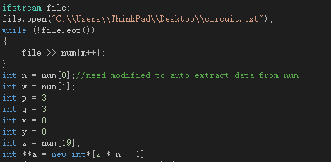
After extending the original circuit into 2*N+1 matrix, we need to give the logic blocks and all the routing and switching segments a new coordinate. Let’s suppose a block on the 2*N+1 matrix has a coordinate of a[x][y], the if both x,y are even numbers then that block should be a switching segment, if x is a even number while y is an odd number, then it should be a connection wire.If x is an odd number and y is even then it is also a place for connection wires. Otherwise it is a place for logic blocks. We give the places for logic blocks and switches a value of zero, because we cannot make connection upon them and we give the path block a number of one.
Outcome result explanation:
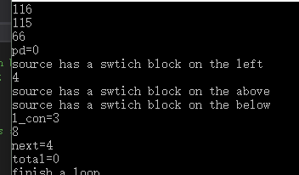
116 and 115 stands for the letter s and t in asc code and we search for these two unique value among all the logic blocks(all other logic blocks are zero), firstly we need to find if the source has other switch blocks around it, if it has then it will output “source has a block on its...side” and “next=”is another key information which marks where to add the length+1 on the expansion list. That means when we run to that coordinate value on the expansion list, we need to add the value(length)+1 because we have just finished checking all the points around the source.The photo below demonstrate this algorithm.
Conclusion:I tested the router using different sizes and different source and target, it could successfully find the shortest path between source and target based on the algorithm and data structure described above, and through marking the paths we can draw the lines from target back to the source.
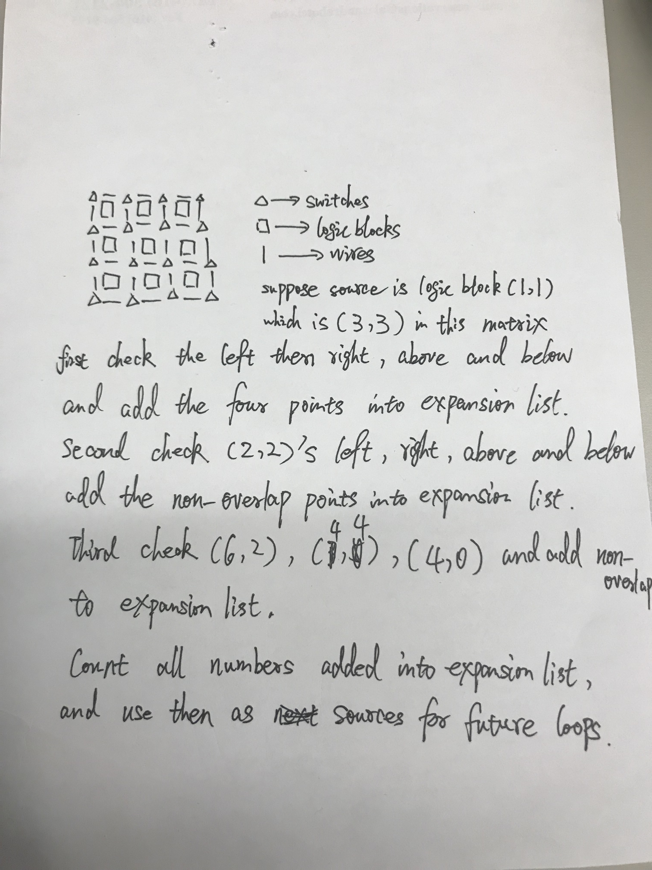
Trace back:
Get the target coordinate from file
Get the last labeled path length
If the pins near the target is the source
yes
no
Mark the path
break
Search the pins near the target, find any path that has a smaller label number
Length=length-1
Use the new coordinate as target

