UNIVERSITY “POLITEHNICA” of BUCHAREST
Faculty of Electronics, Telecommunications and Information Technology

CAD Project
Solar-Powered Plant Alarm

Dorca Victor
Simionescu David-Daniel
Coordinator: Prof. Dr. Ing. Pantazică Mihaela
Group 424Ga

CONTENTS

I. Initial design data................................................................................................................. 1
II. Description of the design schematic functionality.......................................................... 2
III. Electrical schematic............................................................................................................ 3
IV. Design Rules check (DRC).................................................................................................. 4
V. Cross Reference (CR)........................................................................................................... 5
VI. Bill of materials (BOM)....................................................................................................... 6
VII. Wirelist (WR)....................................................................................................................... 7
VIII. Nets verification............................................................................................................... 9
IX. Layer Copper TOP............................................................................................................. 10
X. Layer Copper BOTTOM...................................................................................................... 11
XI. Layer Solder Mask TOP.................................................................................................... 12
XII. Layer Solder Mask BOTTOM.......................................................................................... 13
XIII. Layer silk screen TOP..................................................................................................... 14
XIV. Layer Assembly Drawing TOP....................................................................................... 15
XV. Layer Fabrication............................................................................................................. 16
XVI. Conclusions..................................................................................................................... 17
XVII. Bibliography................................................................................................................... 18
XVIII. ANEXES.......................................................................................................................... 19

SOLAR POWERED PLANT ALARM

Initial Design Data
The primary objective of this project is to develop a PCB design for a solar-powered soil moisture warning system that operates entirely without the need for external batteries. This electronic device is specifically designed to monitor the electrical resistance of the soil through two metal probes and to activate an acoustic alarm whenever the moisture level drops below a certain threshold. The system is powered by a solar cell that provides a nominal voltage of 6V which is sufficient to drive the entire circuit during daylight hours. For visual confirmation of the power status, the design incorporates two LEDs connected in series which serve as an indicator that the solar panel is generating at least 4V to ensure proper operation. The circuit utilizes NPN transistors such as the BC547 and 2N2222 to handle signal amplification and logic inversion while a 6V piezoelectric buzzer is used as the final output for the audible alert. Precision in detection is achieved through a 50kΩ or 100kΩ potentiometer that allows the user to calibrate the sensitivity of the sensors according to the specific needs of the plant or the type of soil used.

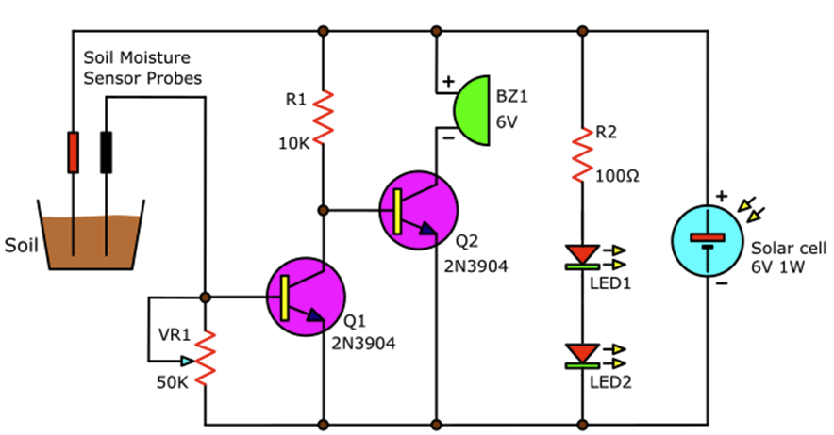

Description of the Designed Schematic Functionality
The functionality of the schematic is based on the interaction between a moisture sensor and a transistor-based logic gate that triggers an alarm under dry conditions. The two metal probes inserted into the ground act as a variable resistor whose value changes significantly depending on the water content of the soil. When the solar cell is exposed to light the current flows through a current-limiting resistor and the two series LEDs to provide a visual status of the power supply. If the soil is sufficiently wet the low resistance between the probes allows current to flow directly to the base of the first transistor which turns it on and effectively pulls the base of the second transistor to ground. In this state the second transistor remains off and the buzzer is silent because the path to the negative terminal is disconnected. However, when the soil dries out the resistance between the probes increases to a point where the first transistor can no longer stay active. This change causes the signal to be inverted through the common-emitter configuration which then allows the second transistor to turn on and complete the circuit for the piezoelectric buzzer. The specific threshold for this activation is determined by the setting of the potentiometer which modifies the voltage divider ratio and ensures that the alarm only sounds when the moisture level is truly inadequate.

Electrical Schematic

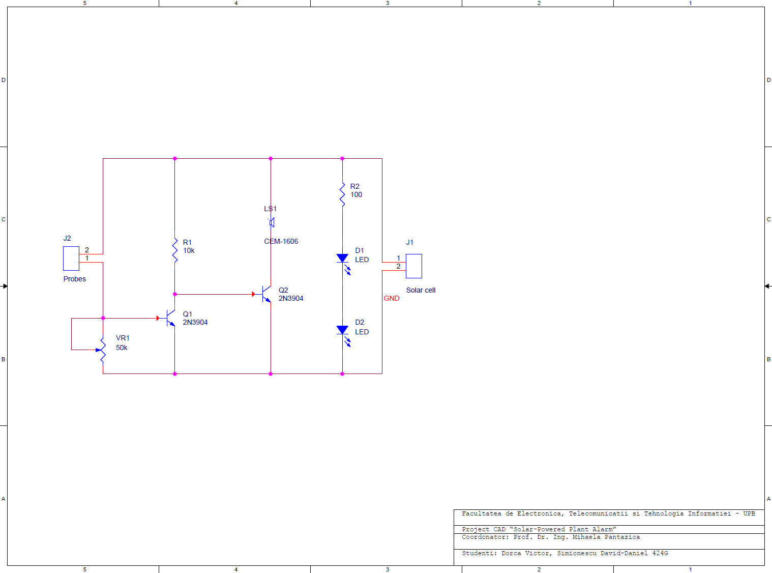

Design Rules Check (DRC)

--------------------------------------------------
Checking Schematic: SCHEMATIC1
--------------------------------------------------
Checking Electrical Rules

Checking For Single Node Nets

Checking For Unconnected Bus Nets

Cross Reference (CR)

Cross Reference Page1

Item Part Reference SchematicName Sheet Library
____________________________________________________________________________

1 2N3904 Q1 SCHEMATIC1/PAGE1 1 D:\TCAD\TOOLS\CAPTURE\LIBRARY\TRANSISTOR.OLB
2 2N3904 Q2 SCHEMATIC1/PAGE1 1 D:\TCAD\TOOLS\CAPTURE\LIBRARY\TRANSISTOR.OLB
3 10k R1 SCHEMATIC1/PAGE1 1 D:\TCAD\TOOLS\CAPTURE\LIBRARY\DISCRETE.OLB
4 50k VR1 SCHEMATIC1/PAGE1 1 D:\TCAD\TOOLS\CAPTURE\LIBRARY\DISCRETE.OLB
5 100 R2 SCHEMATIC1/PAGE1 1 D:\TCAD\TOOLS\CAPTURE\LIBRARY\DISCRETE.OLB
6 CEM-1606 LS1 SCHEMATIC1/PAGE1 1 C:\USERS\VDORC\DOWNLOADS\CEM-1606\CEM-1606.OLB
7 LED D1 SCHEMATIC1/PAGE1 1 D:\TCAD\TOOLS\CAPTURE\LIBRARY\DISCRETE.OLB
8 LED D2 SCHEMATIC1/PAGE1 1 D:\TCAD\TOOLS\CAPTURE\LIBRARY\DISCRETE.OLB
9 Probes J2 SCHEMATIC1/PAGE1 1 D:\TCAD\TOOLS\CAPTURE\LIBRARY\CONNECTOR.OLB
10 Solar cell J1 SCHEMATIC1/PAGE1 1 D:\TCAD\TOOLS\CAPTURE\LIBRARY\CONNECTOR.OLB

Bill of Materials (BOM)

No. | Qty. | Reference | Component | Description | Mount | Capsule | Manuf. | Distributor | Code product | Price / Qty. (RON) | Min. Qty. | Order’s Price
1 | 2 | D1, D2 | LED | Single Colour LEDs Single LED 3mm Red 20mA 2VDC | THT | CAP196 | EAO | ro.mouser.com | 123-10-2601.3172S | 35,31 | 1 | 70,62
2 | 1 | J1 | Solar cell | Solar Panels & Solar Cells Monocrystalline Solar Cell, 100mA, 3.6V | THT | JUMPER2 | OSEPP  Electronics | ro.mouser.com | 375-SC10036 | 33,25 | 1 | 33,25
3 | 1 | J2 | Probes | Sensor: humidity; for soil,capacitive; analogic; 3,3÷5VDC | THT | JUMPER2 | RFROBOT | www.TME.EU | DF-SEN0114 | 21,93 | 1 | 21,93
4 | 1 | LS1 | CEM-1606 | Buzzers & Audio Indicators - Board Mount Buzzers | THT | CUI_CEM-1606 | Same Sky | ro.mouser.com | 490-CEM-1606 | 5,89 | 1 | 5,89
5 | 2 | Q1, Q2 | 2N3904 | Bipolar Transistors - BJT BJT, TO-92, 40V, 200mA, NPN | THT | TO92 | Diotec Semiconductors | ro.mouser.com | 637-2N3904 | 0,52 | 1 | 1,04
6 | 1 | R1 | 10k | Carbon Film Resistors - Through Hole 1 kOhms 250 mW 5% -350/ +500 PPM / C | THT | RES400 | YAGEO | ro.mouser.com | 603-CFR-25JT-52-1K | 0,43 | 1 | 0,43
7 | 1 | R2 | 100 | Carbon Film Resistors - Through Hole 100ohm 1/4W 5% | THT | RES401 | YAGEO | ro.mouser.com | 603-CFR-25JR-52100R | 0,43 | 1 | 0,43
8 | 1 | VR1 | 50k | 1/4inch square potentiometer, Side or top adjustment with lead screw, Resistance value ranges from 20 ohm to 2Mohm | THT | VRES58 | BOURNS | ro.farnell.com | 9354387 | 4,2 | 1 | 4,2

Wirelist (WR)

Wire List

<<< Component List >>>
LED D1 CAP196
LED D2 CAP196
Solar cell J1 JUMPER2
Probes J2 JUMPER2
CEM-1606 LS1 CUI_CEM-1606
2N3904 Q1 TO92
2N3904 Q2 TO92
10k R1 RES400
100 R2 RES400
50k VR1 VRES58

<<< Wire List >>>

NODE REFERENCE PIN # PIN NAME PIN TYPE PART VALUE

[00001] GND
VR1 1 A Passive 50k
Q1 1 EMITTER Passive 2N3904
D2 2 CATHODE Passive LED
J1 2 2 Passive Solar cell
Q2 1 EMITTER Passive 2N3904

[00002] N00346
D1 1 ANODE Passive LED
R2 2 2 Passive 100

[00003] N00350
D1 2 CATHODE Passive LED
D2 1 ANODE Passive LED

[00004] N00431
Q1 3 COLLECTOR Passive 2N3904
R1 2 2 Passive 10k
Q2 2 BASE Input 2N3904

[00005] N00435
R2 1 1 Passive 100
J1 1 1 Passive Solar cell
J2 2 2 Passive Probes
R1 1 1 Passive 10k
LS1 P P Passive CEM-1606

[00006] N00515
LS1 N N Passive CEM-1606
Q2 3 COLLECTOR Passive 2N3904

[00007] N01959
VR1 3 B Passive 50k
VR1 2 WIPER Passive 50k
Q1 2 BASE Input 2N3904
J2 1 1 Passive Probes
Nets Verification

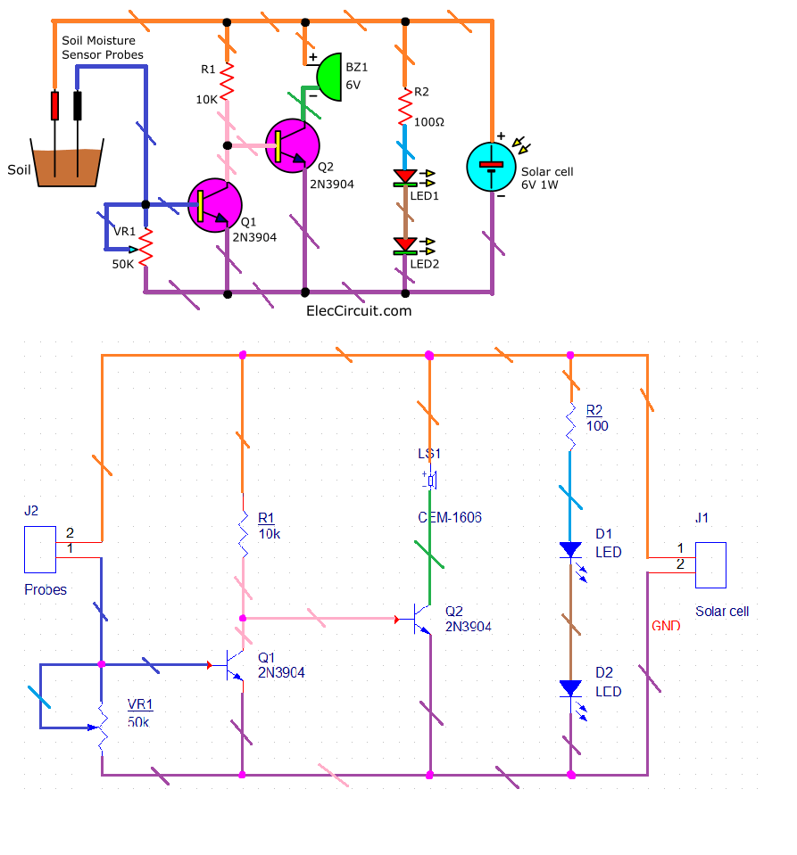

Layer Copper Top
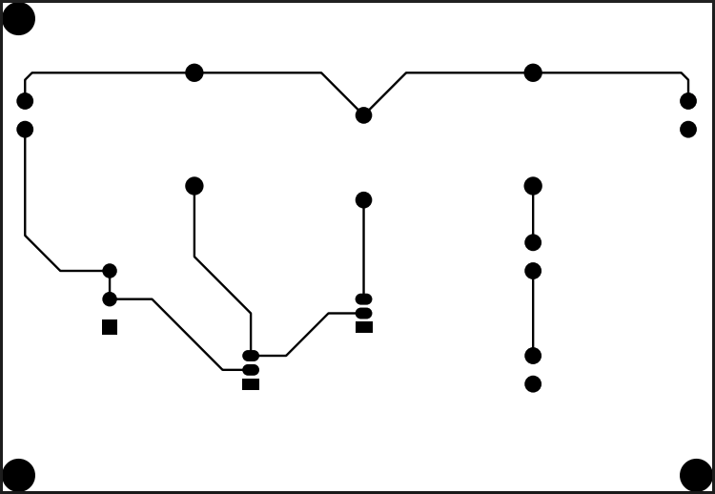

Facultatea de Electronica, Telecomunicatii si Tehnologia Informatiei - UPB
Proiect CAD “Solar-Powered Plant Alarm”
Coordonator: Prof. Dr. Ing. Mihaela Pantazica
Studenti: Dorca Victor, Simionescu David-Daniel 424G
Layer Copper Bottom
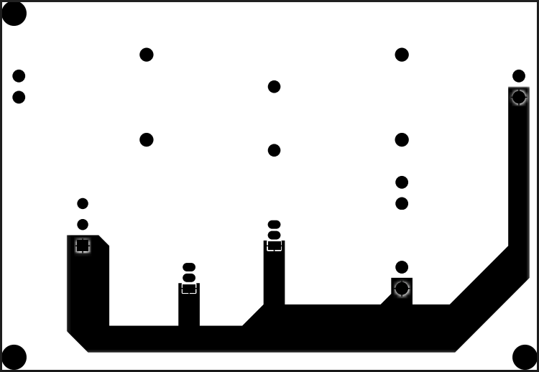

Facultatea de Electronica, Telecomunicatii si Tehnologia Informatiei - UPB
Proiect CAD “Solar-Powered Plant Alarm”
Coordonator: Prof. Dr. Ing. Mihaela Pantazica
Studenti: Dorca Victor, Simionescu David-Daniel 424G
Layer Solder Mask Top

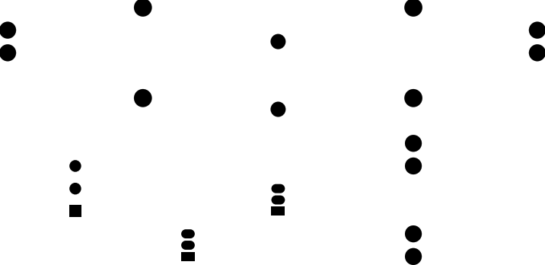

Facultatea de Electronica, Telecomunicatii si Tehnologia Informatiei - UPB
Proiect CAD “Solar-Powered Plant Alarm”
Coordonator: Prof. Dr. Ing. Mihaela Pantazica
Studenti: Dorca Victor, Simionescu David-Daniel 424G
Layer Solder Mask Bottom



Facultatea de Electronica, Telecomunicatii si Tehnologia Informatiei - UPB
Proiect CAD “Solar-Powered Plant Alarm”
Coordonator: Prof. Dr. Ing. Mihaela Pantazica
Studenti: Dorca Victor, Simionescu David-Daniel 424G
Layer Silkscreen

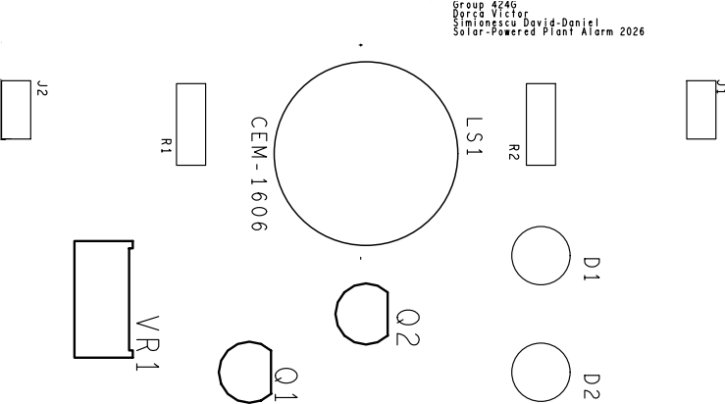

Facultatea de Electronica, Telecomunicatii si Tehnologia Informatiei - UPB
Proiect CAD “Solar-Powered Plant Alarm”
Coordonator: Prof. Dr. Ing. Mihaela Pantazica
Studenti: Dorca Victor, Simionescu David-Daniel 424G
Layer Assembly Drawing
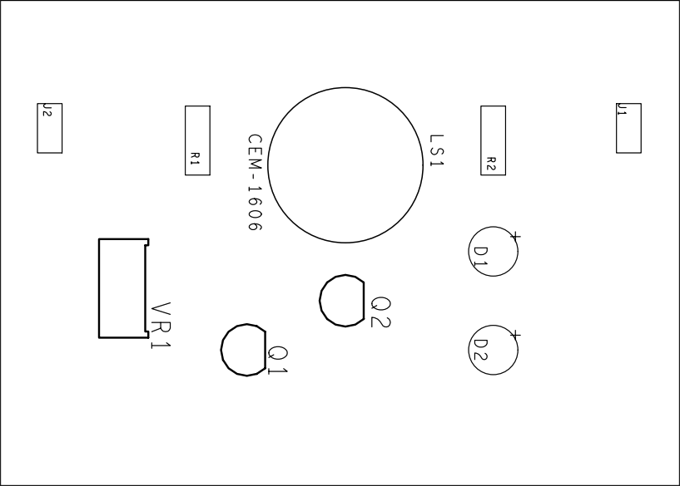

Facultatea de Electronica, Telecomunicatii si Tehnologia Informatiei - UPB
Proiect CAD “Solar-Powered Plant Alarm”
Coordonator: Prof. Dr. Ing. Mihaela Pantazica
Studenti: Dorca Victor, Simionescu David-Daniel 424G
Layer Fabrication
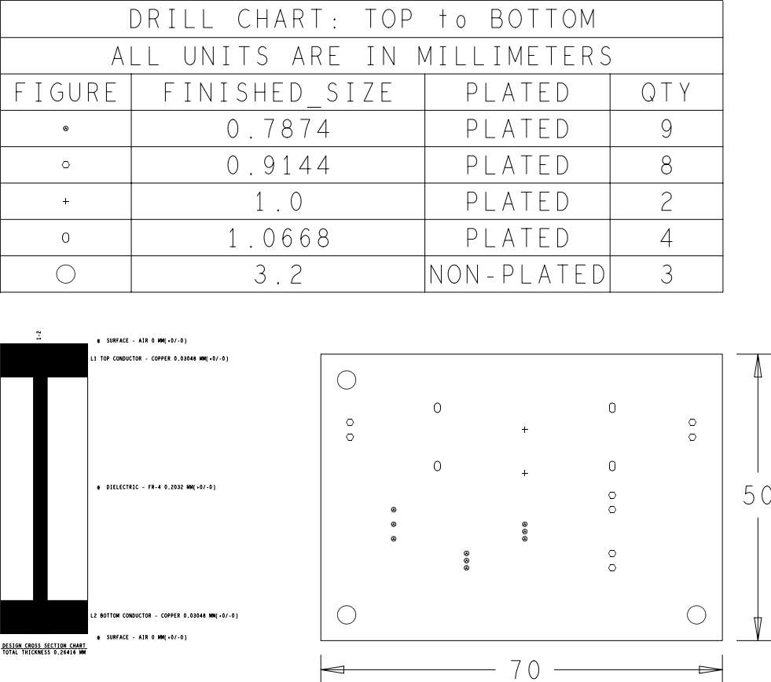

Facultatea de Electronica, Telecomunicatii si Tehnologia Informatiei - UPB
Proiect CAD “Solar-Powered Plant Alarm”
Coordonator: Prof. Dr. Ing. Mihaela Pantazica
Studenti: Dorca Victor, Simionescu David-Daniel 424G
Conclusions

The development of the Solar Plant Watering Alarm project illustrates a successful integration of simple electronic principles to solve a practical everyday problem in a sustainable manner. By utilizing solar energy, the design eliminates the ongoing costs and environmental waste associated with disposable batteries while maintaining a high degree of reliability during the day. The use of basic components like transistors and resistors to create a logic inverter proves that complex integrated circuits are not always necessary to achieve effective automation in gardening applications.
This project not only provides a functional tool for plant maintenance but also serves as a lesson for understanding how sensors and renewable energy sources can be combined into a robust PCB design. Ultimately the clarity and simplicity of this circuit ensure that it can be easily manufactured and adjusted to suit a wide variety of environmental conditions and user requirements.

Bibliography/ Webography

- https://www.cadence.com/en_US/home/tools/pcb-design-and-analysis/orcad.html
- https://pcbsync.com/how-to-generate-gerber-files-from-cadence-allegro/
- https://tracespace.io/view/
- https://ro.mouser.com/
- https://www.tme.eu/ro/
- https://www.youtube.com/user/kirschmackey/videos

ANNEX 1

Solar-powered Plant watering alarm circuit
This solar plant watering alarm circuit will sound an alarm when your plants are drying out, letting you know when to water them. It is self-sustainable because it is powered by a solar cell.
I always teach my children how to plant a tree, which typically begins with a vegetable in small pots. Even if we used the best fertilizer, if we forgot to water the plants, they would have died in no time.
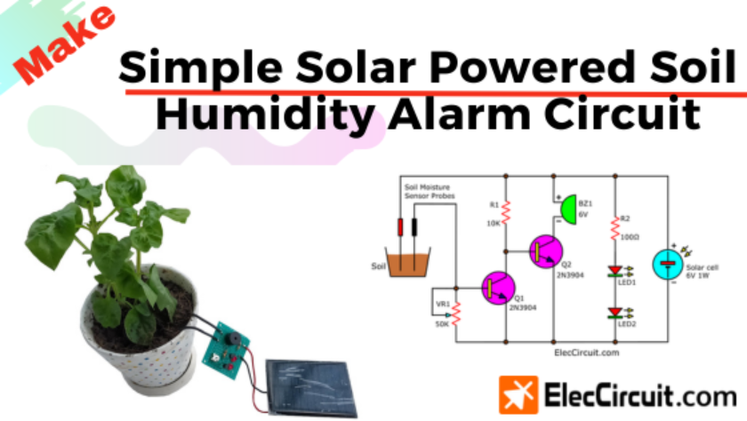
On the other hand, if we water the plants too much, it may cause their roots to rot or cause other diseases. Thus, maintaining the soil’s humidity is very important for our plants.
That’s why we are building this solar plant watering alarm circuit, or soil humidity alarm circuit, with the following features:
1. A buzzer alarms when the soil’s humidity decreases.
2. Be as energy-efficient as possible.
3. Only sounds an alarm during the day; if it sounds at night, it can be disruptive to our neighbor.
4. Uses low-cost and basic components.
5. A simple circuit that is suitable for learning basic electronics.

ANNEX 2

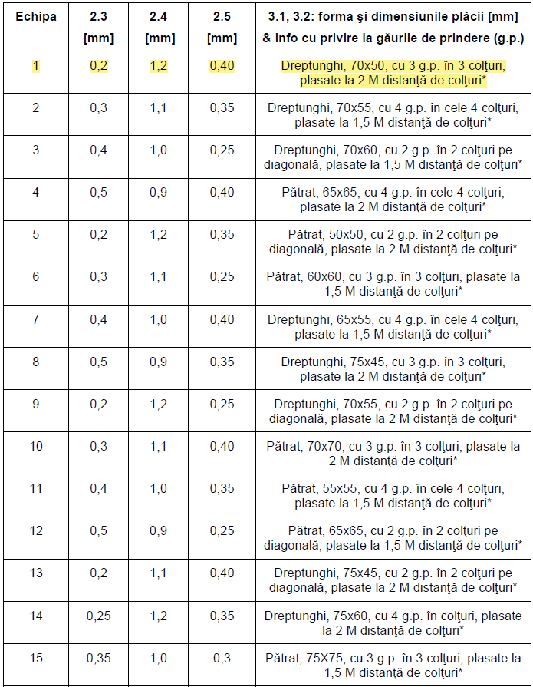

ANNEX 3
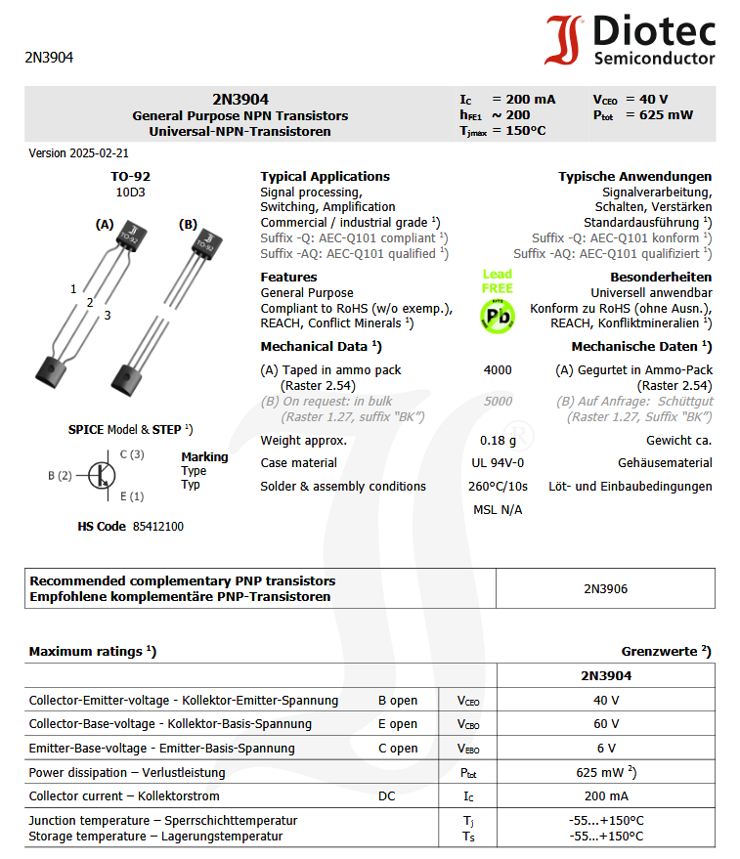

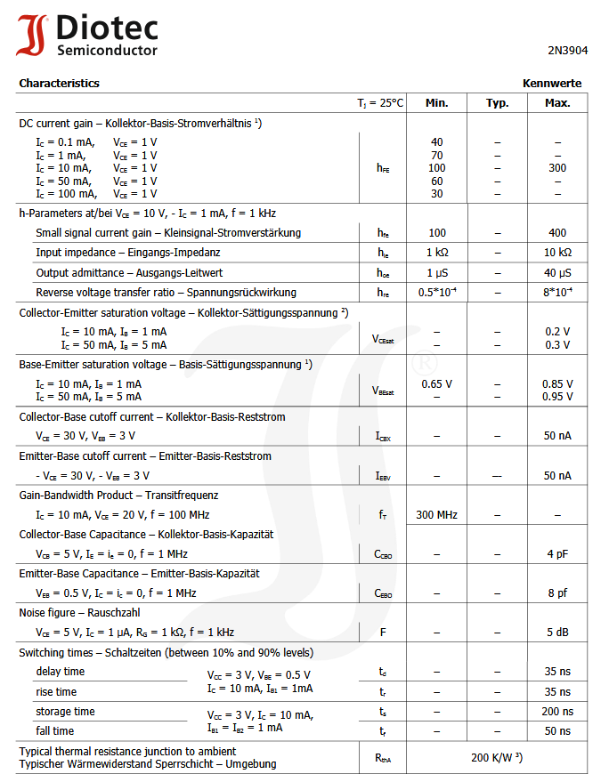

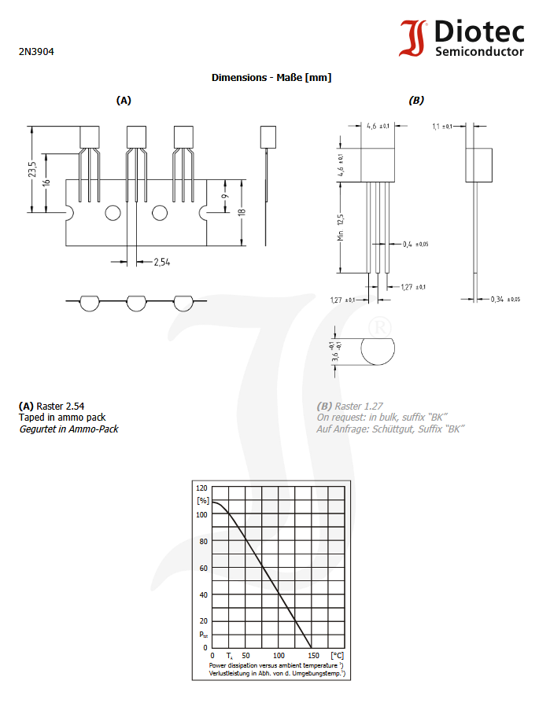

ANNEX 4

