**Scurta descriere**

Proiectul va consta intr-un website care va servi si drept reclama unei firme de constructii.

Site-ul va contine o pagina principala, introductiva, pe care vor fi prezente o serie de butoane (care vor redirectiona utilizatorul catre o alta pagina) precum:

* Contact
* Adresa
* Imagini lucrari
* Proiecte
* Utilaje
* De vanzare
* Login – singura varianta prin care cineva va putea vedea angajatii si eventuale detalii pentru un public mai restrans, autorizat

1. **Baza de date construita in Microsoft SQL**

Popularea tabelelor si ordonarea lor:

Angajati

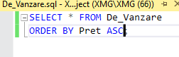Proiecte

Salarii

Salariile Angajatilor cu INNER JOIN

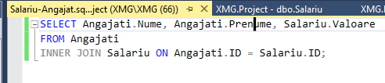

Utilaje

WEB Page:

Main page :

Login functionality:

Pagina dedicata anunturilor (vanzari):

-cu link spre un website oficial de anunturi

Date de contact (reale):

Pagina cu angajatii listati:

Pagina dedicata persoanelor interesate in aplicarea la unul dintre departamente:

Bibliography:

<https://www.w3schools.com/howto/howto_css_login_form.asp>

* I took some code examples for login window

/// <https://getbootstrap.com/docs/5.2/getting-started/introduction/#cdn-links>

<https://getcssscan.com/css-buttons-examples> - button ideea

<https://materializecss.com/getting-started.html> - CDN CSS