Contents
Contents 1
1 Introduction 2
2 Methods: Optimisation Tool 3
2.1 General description 3
2.2 Technical parameters 4
2.3 Costing calculations 4
2.4 Results 5
2.4.1 Optimization: Minimisation of LCOH 5
2.4.2 Technical parameters 9
2.4.3 Cost distribution 11
2.4.4 Sensitivity analysis 13
2.4.5 Annual performance 15
2.5 Conclusion 17

Optimizing a Modular Beam-Down Concentrated Solar Power Concept.
David Saldivia, Jose Bilbao, Anna Bruce, Robert A. Taylor

Introduction
What should go here?
- Something about transition to 100% renewable and the need for storage.
- CSP and modular designs.
- What have been done with BDR, solid particles.
- Something about markets, storage value and the kind.

Methods

Introduction

Optimization Tool

Optical and Thermal models

The present paper is a final report xxxxxxxxx
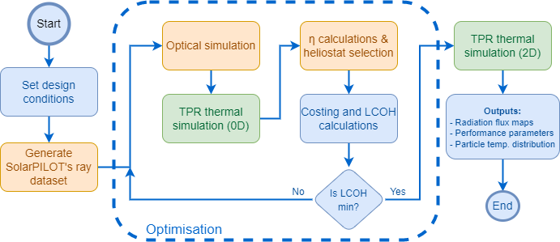
Figure 6.1. Optimisation algorithm flow-chart. In blue the components developed specifically for the opimisation. In yellow the functions from the optical simulation and in green the functions from the receiver simulation.
Write three paragraphs:
- One about the different modules that were written. Refer the reader to the Appendix.
- One about the independent variables. Refer the reader to the Appendix.
- One about the detailed discussion of the optimization. Refer the redear to the Appendix.

Power Block and Dispatch Model

Costings
The costing module was built using project assessment metrics and a combination of conventional values frequently used in CSP financial assessments in combination with specific cost estimations for BDRs and particle-based systems. The Levelized Cost of Heat was calculated using the well-known formula for future constant payments:
$LCOH=\frac{C_{C}\left(1+C_{O\&M}TPF\right)}{TPF P_{yr}}$ | (6.3)
$$TPF=\frac{1}{DR}\left(1-\frac{1}{{\left(1+DR\right)}^{N}}\right)$$ | (6.4)
Where $C_{C}$ is the capital cost, including land, heliostat, BDR mirrors, tower, receiver, storage, engineering, and contingency costs. $C_{O\&M}$ is the annual operation and maintenance costs. $P_{yr}$ is the annual heat generation and $TPF$ is the total payment factor for a given discount rate ($DR$), and plant lifespan ($N$).
The capital costs are divided into two categories: conventional and specific parameters. The conventional parameters are those that are independent of the type of CSP plant, and therefore, common values in the literature are used. The specific parameters are those specific to solid particle-based systems with beam-down optics. For some of these, literature values were available, while for others some estimations were made.
Write one or two paragraphs to refer the reader to the Supplementary Documents
Present a Summary Table

Market Data

Results
The results are divided into two sections. First, the main results from the optimisation are presented. For this, the LCOH minimisation follows an iterative process, obtaining a range of design parameter at the end. Then, for a selected case, additional detailed results are presented, which exemplify the extension of detailed analysis that is possible to carry on with the modules developed through this Thesis. This includes technical and economic results. Finally, a sensitivity analysis and annual performance for the selected case are presented.

Minimisation of LCOH
The results for the solar thermal subsystem optimisation are shown in Figure 6.10, with Figure 6.10 a) presenting the LCOH as a function of the receiver power for different tower heights (20 m to 75 m). The minimum value for each tower height is presented as a blue line. The same min LCOH line is shown in Figure 6.10 b) plus the corresponding receiver power (red squares). In these two subplots, an average radiation flux of 1.0 MW_{th}/m² was used. The results for 0.5 MW_{th}/m² and 1.5 MW_{th}/m² are presented in subplots c) and d), respectively. In both cases, it was observed that a minimum LCOH lower than 24 USD/MW_{th} was obtained for a tower height above 35 m. This indicates that initially, there are benefits to increasing tower height; however, the benefits diminish until a plateaued zone (above 65 m), where there are practically no benefits to increase tower height. The main reasons for this are the increased tower costs and lower BDR optical efficiency for taller towers.
On the other hand, the average radiation flux has a limited influence over the LCOH. For example, for a 50 m tower, increasing the radiation flux from 0.5 to 1.5 MW_{th}/m² reduces the LCOH from 26 USD/MWh to 23 MW/m². However, the average radiation flux affects the optimal receiver power. For the same height, the optimal power increases from ~12 MW_{th} to ~18 MW_{th} if the radiation flux increases from 0.5 to 1.5 MW_{th}/m². Therefore, the influence of average radiation flux is analysed in more detail.
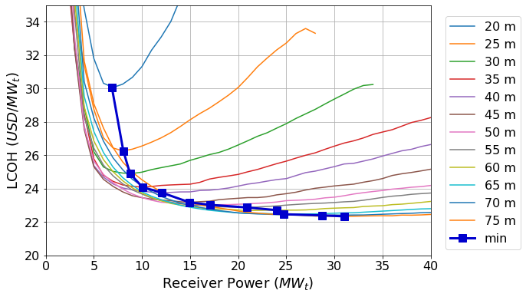 | 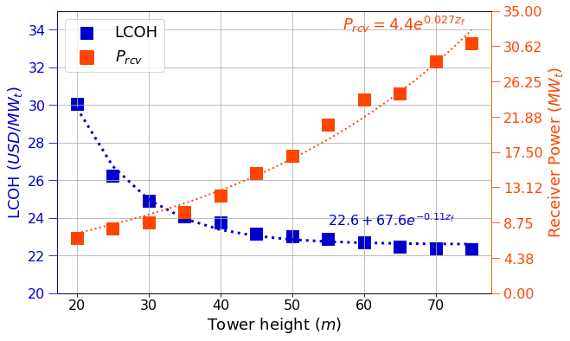
- Results for different receiver powers and tower heights (Q_{avg}=1MW/m²) | - LCOH curve with selected conditions from a).
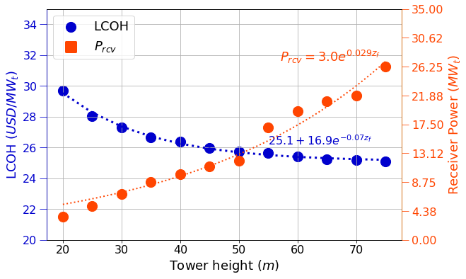 | 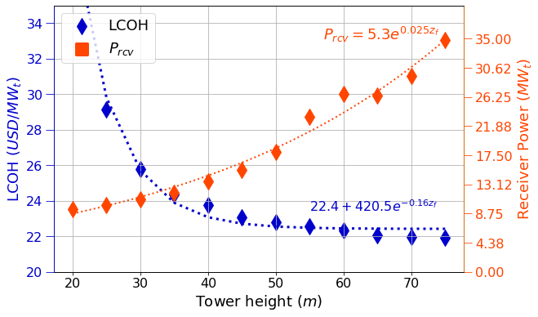
- LCOH curve for Q_{avg}=0.5MW/m² | - LCOH curve for Q_{avg}=1.5MW/m²
Figure 6.10. Result of LCOH minimisation for different receiver power, tower height, and radiation fluxes.
For each tower height, the same procedure is repeated for different average radiation flux values ranging from 0.5 to 2.0 MW_{th}/m². The result from this process is presented in Figure 6.11 for four different heights: a) 30 m, b) 40 m, c) 50 m, and d) 60 m. In each case, a minimum exists for a combination of radiation flux and receiver power, which is indicated with a red star in each subplot. Both, the optimal receiver power, and the radiation flux increase with tower height. For a 30 m tower it is around 9 MWth and 1.0 MW_{th}/m², while for a 60 m tower it is around 26 MW_{th} and 1.5 MW_{th}/m². The radiation flux is optimal for all the tower heights in the range of 1.0 to 1.5 MW_{th}/m². For short towers there is a single optimal point, but for towers above 50 m, the bottom part of the ‘U-shaped’ curve is relatively flat, so there is a wide range of possible combinations. For example, in a 50 m tower, receiver power between 12 and 25 MW_{th} with radiation fluxes between 1.25 and 1.5 MW_{th}/m² have a similar LCOH of ~23 USD/MW_{th.}
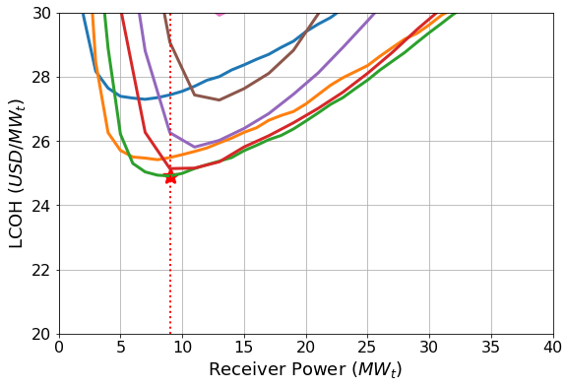  - $z_{f}=30m$ | 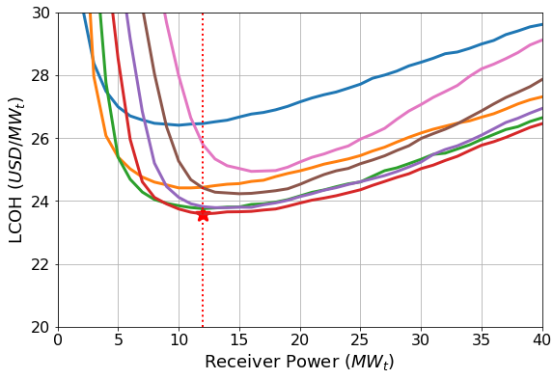  - $z_{f}=40m$ | 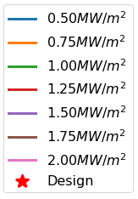
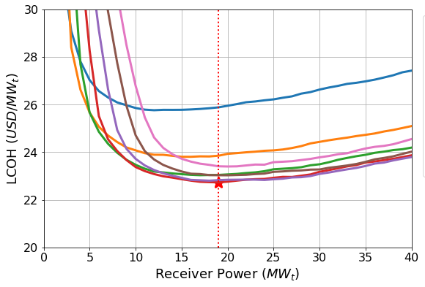  - $z_{f}=50m$ | 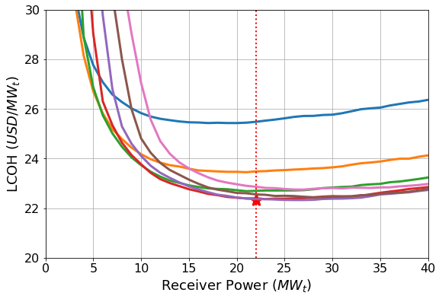  - $z_{f}=60m$
Figure 6.11. LCOH as a function of receiver power for different radiation fluxes and tower heights. In each case the minimum optimal value is presented with a red star.
If the minimum LCOH points for different towers are presented together, then a design curve for Beam-Down Tilted-Particle Receivers (BD-TPR) is generated. Figure 6.12 a) presents these results for towers between 20 m and 75 m. This final curve presents the results once the four independent variables are optimised. For a given tower height, the optimal receiver power is shown in red squares and the minimum expected LCOH (in USD/MW_{th}) is presented in blue circles. The optimal $Q_{avg}$ and $f_{zv}$ as function of tower height are also presented in Figure 6.12 b) and c), respectively.
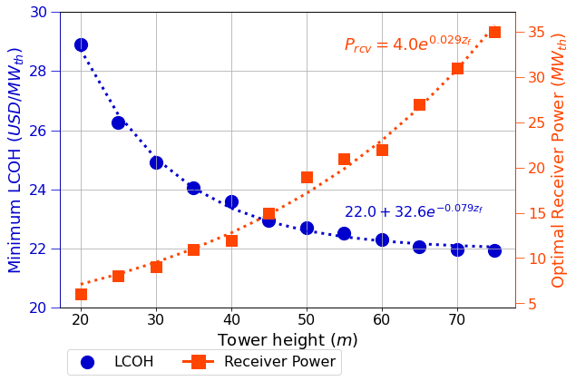  - $LCOH$ and $P_{rcv}$ | 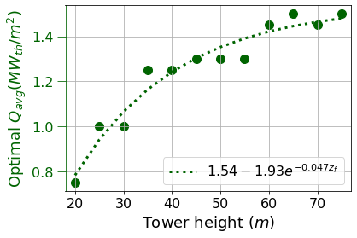  b) $Q_{avg}$
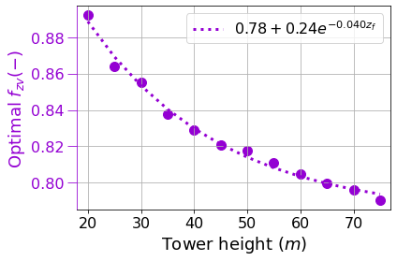
c) $f_{zv}$
Figure 6.12. Final function for minimum LCOH as function of tower height. a) minimum LCOH and optimal receiver power, b) optimal average radiation flux, c) optimal vertex ratio.
Curve fittings were performed over these relationships, which constitutes correlations to design a BD-TPR plant. For a given tower height, the optimal receiver power (Equation(6.26)), radiation flux (Equation (6.27)), vertex ratio (Equation (6.28)) and an expected LCOH (Equation (6.29)) can be calculated.
$$P_{rcv}=4.0e^{0.029 z_{f}}$$ | (6.26)
$$Q_{avg}=1.54-1.93e^{-0.047 z_{f}}$$ | (6.27)
$$f_{zv}=0.78+0.24e^{-0.040 z_{f}}$$ | (6.28)
$$LCOH=22.0+32.6e^{-0.079 z_{f}}$$ | (6.29)
Considering that this design is intended for power generation, where larger power blocks are significantly more cost-effective, a minimum receiver power of 10 MW_{th} was considered. On other hand, although the results presented are considering towers up to 75 m, taller towers pose additional issues. For example, large hyperboloid mirrors (e.g., 20 m radius) could start facing wind and structural issues. For taller towers, the alignment errors become more important and, therefore, the optical efficiencies probably will be lower than the one presented here. For these reasons, the recommended design range for BD-TPR presented here is for towers between 35 m to 50 m, with receiver capacities of 10 MW_{th} and 20 MW_{th}, respectively. In summary, a tower height of $z_{f}=50 m$, with a receiver power of $P_{rcv}=19 MW_{th}$ and a radiation flux of $Q_{avg}=1.25{MW_{th}}/{m^{2}}$ was found to obtain a $min\left(LCOH\right)=23.01 USD/MWh$. Now that the overall efficiency is presented and the main relationships between the independent variables and the LCOH were stated, a detailed analysis for the selected design parameters is presented in the next subsection.

Technical parameters
Detailed results for the final selected case are presented in this Subsection to illustrate the capabilities of the module developed so far. As this is the final selected case and one of the main recommendations from this thesis, the main components of the whole plant are presented, covering results from most of the previous Chapters. Figure 6.13 shows the final results for the most important components in a BD-TPR design. Figure 6.13 a) presents the final heliostat field of 4570 heliostats with a design point optical efficiency of 64.1%. Due to the latitude (-25°) the solar field has a slightly polar configuration, which highlights one of the advantages of BDR optics. That is, it can utilise a compact surround tower with a solar field extended angle of 360°, even for a cavity receiver. The heliostats range up to 150 m north of the receiver location and 300 m south of it. The solar field is symmetrical in its E-W axis, with 300 m extent in each direction. Figure 6.13 b) shows the hyperboloid radiation flux. A maximum value of around 60 kW/m² is found. The inner and outer radii are 5.1 m and 20.3 m, with a total 1316 m². The vertex ratio is 0.8181, and the hyperboloid mirror ranges between 43 m and 50 m heights.
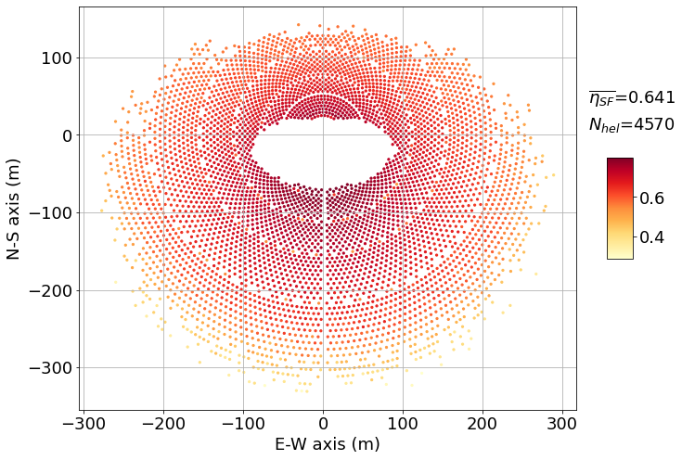  - Heliostat field | 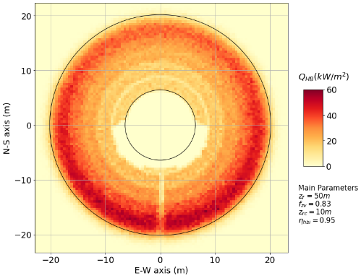  - Radiation flux in hyperboloid mirror
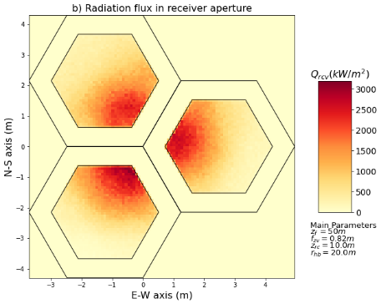  - Radiation flux on receiver aperture | 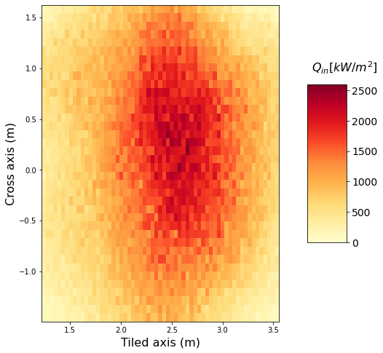  - Radiation flux on tilted surface
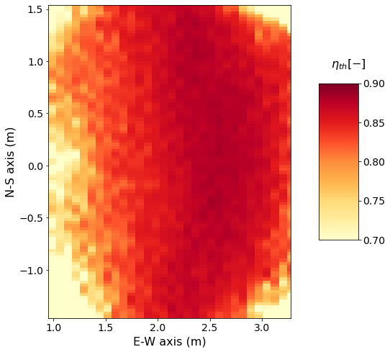  - Specific efficiency | 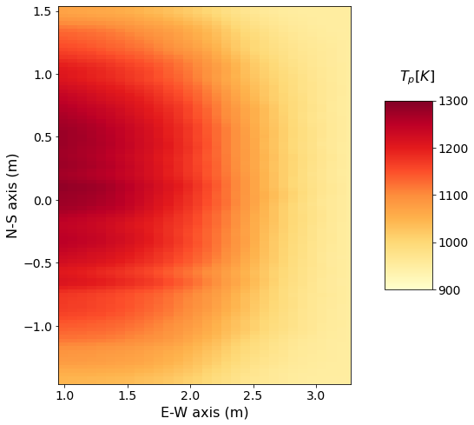  - Particles temperature
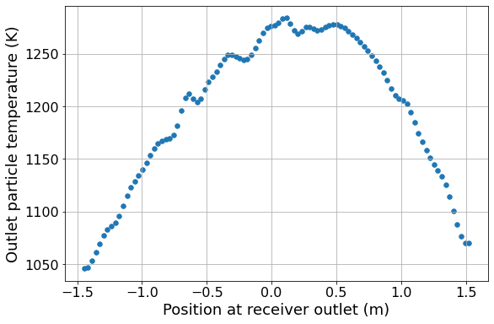  - Outlet particles temperature profile | 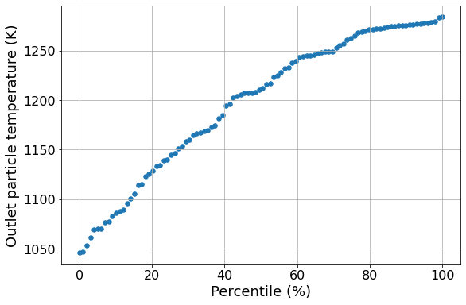  - Outlet temperature distribution
Figure 6.13. Detailed results for the selected design. a) heliostat field, b) radiation flux over hyperboloid mirror, c) radiation flux profile on receiver aperture, d) radiation flux on the tilted surface of the receiver (only one of three receivers showed here), e) specific efficiency on receiver surface, f) particle temperature distribution on receiver surface, g) particle temperature distribution on receiver outlet, h) outlet temperature by percentile.
Figure 6.13 c) shows the radiation flux in the receiver aperture for the selected TOD mirror consisting of 3-hexagonal paraboloid mirror with a concentration ratio of 2.0. The TOD height is 1.73 m, with a mirror surface area of 60.79 m². The maximum radiation flux is up to 3 MW_{th}/m²; however, it hits the virtual aperture surface defined by the outlet of the TOD. The radiation flux is spread inside the receiver’s cavity and is redistributed. Figure 6.13 d) shows the radiation flux in the final tilted particle receiver (only one of the three receivers is shown, and the tilted plane is presented). The maximum radiation flux is 2.55 MW_{th}/m², which is still within the maximum radiation flux acceptable for ceramics (~3MW_{th}/m²). Figure 6.13 e) and f) show the specific efficiency and particle temperature map on the tilted surface. An overall 83.3% efficiency is found, which is in the range of expected values for particle receivers (50-90%) [20]. Finally, Figure 6.13 g) and h) show the final distribution at the outlet of the receiver. Subplot g) shows the temperature distribution at a cross-section in the receiver's outlet. In contrast, subplot h) shows the same information in increasing order, showing a relatively linear distribution of temperature among the particles. The particle distribution ranges between 1039 K to 1285 K, which is explained by the uneven radiation flux on the receiver (as shown in Figure 6.13 d). This undesired result could be improved with a heliostat control strategy to obtain more homogeneous radiation flux, as was discussed in Chapter 5. Finally, Table 6.5 presents additional detailed information for the selected case.
Table 6.5. Detailed results for the optimised BD-TPR design. Bold values are the independent variables that were optimised.
Parameter | Value | Parameter | Value
Tower height, $z_{f}$ | $$50 m$$ | Receiver efficiency | $$83.1\%$$
Receiver thermal power, $P_{rcv}$ | $$19 MW_{th}$$ | Solar field efficiency | $$63.4\%$$
Receiver mean radiation flux, $Q_{avg}$ | $$1.25 MW/m^{2}$$ | Geometric concentration ratio | $$2105(-)$$
Vertex ratio, $f_{zv}$ | $$0.818(-)$$ | Receiver max radiation flux | $$2.56 MW/m^{2}$$
Receiver area | $$18.06 m^{2}$$ | Particle temp. range | $$1039-1285 K$$
Number of heliostats | $$4456(-)$$ | Mass flow rate | $$59.32 kg/s$$
HB mirror radius | $$20.13 m$$ | Mean residence time | $$27.69 s$$
HB mirror surface | $$1316.5 m^{2}$$ | Storage volume | $$471.8m^{3}$$
SF mirror surface | $$38010.6 m^{2}$$ | Capacity Factor | $$23.13\%$$
TOD mirror surface | $$60.79 m^{2}$$ | Land productivity | $$0.98 MW_{th}/ha$$
TOD height | $$1.73 m$$ | LCOH | $$23.01 USD/MW_{th}$$
Total mirror surface | $$39387.9 m^{2}$$ | LCOH (AUD) | $$32.21 AUD/MW_{th}$$

Cost distribution
For the selected case, the capital cost distribution is presented in Figure 6.14 a). To put this number in context, a conventional case is also presented using the default conditions given by SolarPILOT for a large plant (195 m tower and 670 MW_{th} for solar field). The comparison is done with a conventional plant with large capacity, because the default costs for tower and receiver would have generated unrealistic high values for short towers/small receivers. The only component that SolarPILOT does not calculate is the storage cost, so the same BD plant cost estimation was used (see Section 6.3.3). Finally, the heliostat cost is set at 100 USD/m², instead of the default 140 USD/m², to reflect the expected cost reductions discussed in Section 6.3.2. Financial parameters (discount rate, lifetime, EPC costs, etc) are kept the same in both cases.
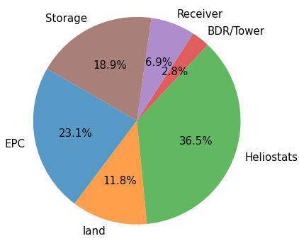  - BD-TPR plant (LCOH=23.01 USD/MWh) | 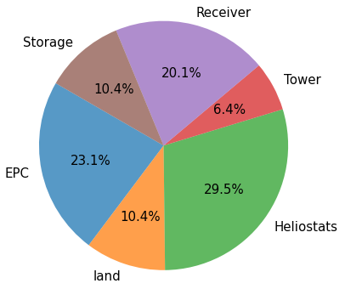  b) conventional (LCOH=26.53 USD/MWh)
Figure 6.14. Capital Costs Distributions. a) BD-TPR plant, b) conventional plant.
The heliostat field corresponds to around 36.5% of the total cost and for more than half of the equipment costs (this is, excluding land and EPC costs), which is higher share than the conventional case (29.5%). Engineering and contingency (EPC) costs represent 23%, and the storage cost is around 19%. The receiver cost (6.9% for BDR, 20.1% for conventional) is the main difference between both cases, which is actually one of the main uncertainties in the BDR cost estimation, because the estimation for a free-falling design was used. A detailed design and cost estimation for tilted-particle Receiver (BD-TPR) is then a question that this research has open. The land is the 11.8% remaining, which means that the costs associated with the solar field are roughly half of the total installing cost. The tower and BDR mirrors have a minimal impact on the total cost (~2.8% combined), reflecting the benefits of the BDR concept, simplifying the tower structure and costs. Finally, the novel design shows a 13% reduction in resulting LCOH (23.01 USD/MWh) compared with the conventional base case (26.53 USD/MWh) which suggest that the proposed design offer improvements in deployment costs.
These results have to be taken carefully and further refinement in these calculations are required. Some factors can modify positively or negatively these results. A factor not considered here is the financial costs. No loans, debts, incentives, and taxes are included in either case. In addition, the risk (represented by the discount rate) is kept the same in both cases (5%). Thus, the positive associated aspects of a modular design are not reflected in the models. For example, the expected reduction in construction times is not included. On other hand, the proposed design is only ~20 MW_{th}, which is small for competitive power generation, due to the economy of scale in power blocks. Several towers would be required to drive one single power block, and the integration costs associated are also not included. However, a multi-tower configuration would bring other benefits, as it is the partial operation during the construction process, like it has been reported in the commercial Chinese plant reported in the Literature Review (Section 2.3.4) that started its operation with only three of the 15 tower built [21].

Sensitivity analysis
An additional sensitivity analysis is performed over the main economic parameters to analyse how they might change under different assumptions or cost trends. The parameters are split in two groups, those specifically related to the BD-TPR design (HB cost, TOD cost, receiver cost, storage cost, tower cost, solar multiple, and storage capacity), and those that are general for any CSP (heliostat costs, land costs, O&M costs, discount rate, lifetime, and EPC costs). Each of these parameters is changed between an expected range and the impact over the base LCOH is calculated. The main results are shown in Figure 6.15.
It is observed that among those parameters specific of BD-TPR (Figure 6.15 a), the solar multiple is the factor that affects the most the LCOH, followed by the storage capacity. A reduction of 50% in solar multiple increases the LCOH by 20%, while duplicating the storage capacity has also a 20% impact in the final LCOH. The storage and receiver costs have a similar impact over the LCOH. Doubling the cost increases the LCOH around 10%. The tower and BDR mirror (HB and TOD) have almost no influence on the final cost, because they represent a small fraction in the cost distribution, as it was discussed in the previous section.
Among the general costs (Figure 6.15 b), the capacity factor (solar field) ($CF_{sf}$) has the highest impact over the LCOH. The relationship is inversely proportional: doubling the capacity factor reduces the LCOH by half. The main factor that affects the capacity factor is the solar resource, which explains why CSP feasibility depends so much on the specific plant location. The engineering and contingency costs is the second most influential parameter, which depends directly on the maturity of the technology, as it was discussed in Section (2.1.2). Solar tower’s EPC costs are higher than PTC’s as the deployment knowledge is still progressing. It is expected that a technology like BD-TPR would have a similar trend, with high initial EPC costs, that should reduce once more plants are installed. The heliostat cost and the discount rate are the next most influential factors. A reduction in 50% of heliostat field costs would mean a 15% reduction in LCOH. Plant lifetime and operation & maintenance costs have a significant influence too. It is clear from the comparison between both plots in Figure 6.15 that the BDR-specific costs are less influential than the general CSP costs, therefore, general trends observed in solar tower technologies, should apply to BD-TPR plants too.
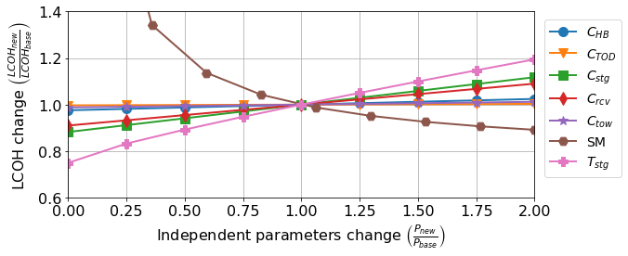
a) BD-TPR parameters
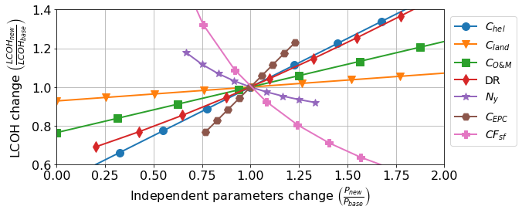
b) General CSP parameters
Figure 6.15. Sensitivity Analysis results. a) BD-TPR specific parameters, b) General parameters.
A probabilistic analysis was performed with these 14 parameters using a Monte Carlo simulation with a total of 10⁶ runs. In each run, each variable was assigned a random value between 0x and 2x the default value, which corresponds with the range presented in Figure 6.15. A uniform distribution was chosen for each variable (all values in the range are equally probable). It is important to note that, due to computational time limitations, these runs were performed only on the costing module (and not in the whole optimisation loop) using the selected case shown in Section 6.4.2 as baseline. A LCOH probabilistic distribution is obtained from this dataset and is presented in Figure 6.16.
The blue line corresponds to the probabilistic of non-exceedance, which shows the probability to not exceed a given value of LCOH (X-axis). The base case value is shown in grey, while P50 and P90 are shown in red. P50 means that there is 50% of probability that the LCOH would be equals or lower than 22.7 USD/MWh, while the P90 line indicates that there is a 90% of probability that the LCOH would be equal or lower than 49.9 USD/MWh. These results are useful inputs for decision makers in order to improve the risk analysis of the technology.

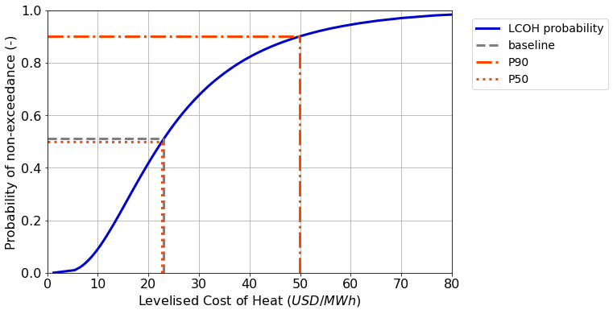
Figure 6.16. Probability of non-exceedance for LCOH. Probability curve in blue, baseline in grey, P50 and P90 in red.

Annual performance
The expected performance through the year is explored in this section. The overall efficiency considers the contribution of both the solar field and receiver. The solar field optical efficiency depends mostly on the sun position, which is usually represented by two main angles: altitude ($α$, also known as elevation) and azimuth ($z$). A set of datasets for different elevation and azimuth is generated and the selected design is simulated with these sets.
(Write something about optical and thermal efficiencies through the year)
Using these two results for optical efficiency and receiver efficiency, it is possible to analyse the performance of the system through the year using the TMY file for the selected location (Alice Springs, Australia). Figure 6. shows the annual performance grouped by month. The whole bar indicates the total incident energy in the system, blue are the losses in heliostat field, orange are the losses in the BDR, and green the losses in the receiver. The stored useful energy is shown in red. Subplot a) shows the absolute values for the 19MW_{th} plant, while the subplot b) shows the relative values, representing then the component efficiencies. It can be seen that the overall efficiency is relatively constant through the year with an average of 47%. The total annual generation is 44243 MWh, which corresponds to a 26.6% of capacity factor. The monthly average generation is 3686.9 MWh/month with a variation in the range of $\left(-17.5\%,9.97\%\right)$.
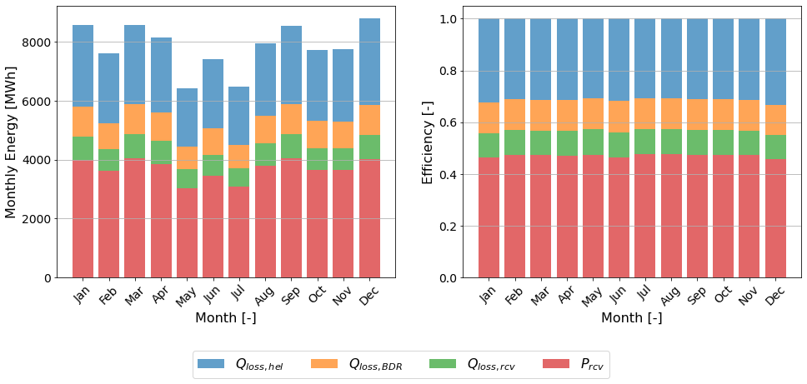
Figure 6.19. Annual performance of the selected BD-TPR plant in Alice Spring, Australia. Useful stored energy (red), heliostat losses (blue), BDR losses (orange), and receiver losses (green). a) Absolute energy, b) relative fraction (efficiencies).
Table 6.6 shows the annual performance values and are compared with the conventional plant and the BD-TPR plant values in the design point. In the case of the design point values, the annual production and capacity factor are calculated assuming the overall efficiency is constant through the year. It is observed a reduction of around ~10% in annual production (and therefore capacity factor) due to variations in different efficiencies. This justifies the factor of 0.9 applied in the capacity factor, explained in Subsection 6.3.7, therefore, the final LCOH is not affected. It has to be noted that most of the change in efficiencies is due to heliostat efficiency (68.5% annual versus 74.2% design point). The overall efficiency of a conventional plant is higher than the BD-TPR by more than 10%. However, most of this difference is due to the receiver efficiency, that is around 90% for the conventional plant. If only the optic efficiencies are considered, the difference is around 5% (62.22% for conventional plant versus 68.5% x 82.7% = 56.6%).
Table 6.6. Results from annual performance compared with design point average and conventional plant.
 | BD-TPR annual | BD-TPR design point | Conventional plant
Nominal Capacity | 19 MW_{th} | 19 MW_{th} | 670 MW_{th}
Annual Production | 44243 MWh | 49484 MWh | 12668 GWh
Capacity Factor | 26.5% | 29.7% | 21.6%
Heliostats Efficiency | 68.5% | 74.2% | 62.2%
BDR efficiency | 82.7% | 85.4% | -
Receiver Efficiency | 83.1% | 83.1% | 90.0%
Overall Efficiency | 47.07% | 52.65% | 58.5%

Conclusion
An optimisation tool is presented to find optimal parameters for a BD-TPR plant. The optimisation tool put together the BDR optical analysis developed in Chapter 3, the TPR thermal analysis developed in Chapter 5, and the detailed costing estimations specifically for BDR plants described here. All these separate modules are combined with an in-house optimisation tool, which allows working with different objective functions, including the minimisation of LCOH, which was used here. This novel innovative tool together with the BD-TPR costing calculations cover one of the research gaps found in the literature, regarding the lack of knowledge about BDR economics and an economic-based design for this technology.
The results show that for a given tower height, it is possible to find optimal values of vertex ratio, receiver power, and average radiation flux to minimise the LCOH. It was found that for a tower height range between 35-50m, it is possible to obtain LCOH of ~24 USD/MW_{th} for receiver powers between 10 - 20 MW_{th}. Specifically, for a 50 m tower, it was found that a range of possible configurations generates a similar LOCH. In particular, a 19 MW_{th} with 1.25 MW_{th}/m² was selected. These results are compared with a base case from the literature (LCOH = 26 USD/MW_{th}) and a 13% reduction in the LCOH was found. A correlation for the expected LCOH for a given tower height was presented, as well as the expected receiver power.
The detailed analysis on the selected design shows that it meets most of the additional constraints of these plants, such as, limited size of hyperboloid and TOD mirrors, adequate cooling requirement for BDR mirrors, maximum radiation flux incident on the particles, reasonable temperature distribution of the particles in the receiver outlet and expected solar field and receiver efficiencies. The cost distribution confirms the advantages of a beam-down configuration, reducing the tower- and receiver-associated costs significantly, from ~27% in the conventional case to ~10% of the total capital cost. On other hand, this increases the share of the heliostat field, which by itself is more than half of the total component costs. A sensitivity analysis over the main economic parameters shows that the capacity factor, solar multiple, and heliostat costs are the most sensible parameter, together with the plant lifetime and the EPC costs. A probability distribution using Monte Carlo simulation was also presented. A P90 value of 49.9 USD/MWh and a P50 value of 23.0 USD/MWh were obtained.
The annual performance was also explored and compared with a conventional case. A chart for the optical efficiency as function of the sun position was developed with values between 50% and 64% (from a design point efficiency of 63%). The sun’s position has higher influence over the heliostats than the BDR mirror, mostly due to cosine efficiency. The receiver efficiency is almost not affected by the sun’s position because the radiation flux remains relatively the same regardless the elevation and azimuth. These different factors affect the annual performance, with an 8% reduction compared with the design point case. The overall efficiency of a BD-TPR is lower than the conventional one (47% vs. 58%), then the reduction in LCOH comes from higher capacity factor (27% vs. 22%) and lower specific costs.
These findings suggest that BDRs coupled with solid particles as heat transfer medium could be a viable alternative for modular CST plants to drive small power generation plants or industrial heat applications. The performance of such system in real conditions is the next step in the analysis, to be covered in Chapter 7.

(The following reference list is the references from this Chapter. It is included here only for consultation purposes. The final draft will have only one consolidated reference list at the end)
[1] D. Saldivia and R. A. Taylor, “Optical and Thermal Analysis of a Horizontal-Flow Particle Receiver,” in Proceedings of the Asia Pacific Solar Research Conference 2021, Sydney, Australia, Dec. 2021.
[2] D. Saldivia, A. Bruce, and R. A. Taylor, “Design Optimization of a Horizontal Particle Receiver for a Modular Beam Down Receiver CSP,” in Proceedings of the SolarPaces Conference, Albuquerque, USA, 2022.
[3] M. J. Wagner and T. Wendelin, “SolarPILOT: A power tower solar field layout and characterization tool,” Solar Energy, vol. 171, pp. 185–196, Sep. 2018, doi: 10.1016/j.solener.2018.06.063.
[4] D. Saldivia, J. Bilbao, and R. A. Taylor, “Optical analysis and optimization of a beam-down receiver for advanced cycle concentrating solar thermal plants,” Applied Thermal Engineering, vol. 197, p. 117405, Oct. 2021, doi: 10.1016/j.applthermaleng.2021.117405.
[5] “EnergyPlus.” https://energyplus.net/weather-region/southwest_pacific_wmo_region_5/AUS (accessed Jan. 06, 2023).
[6] D. Saldivia, W. Saw, A. Chinnici, P. Ingenhoven, and R. A. Taylor, “Optical Optimization of Beam Down Receiver Geometry for High Temperature Heat Processes using the MCRT Method,” in Proceedings of the SolarPaces Conference, online, 2021.
[7] D. Potter et al., “Optimisation of ‘Beam-Up’ Configurations for the Solar Expanding-Vortex Receiver,” in ‘Proceedings of the Asia Pacific Solar Research Conference 2021, Sydney, Dec. 2021.
[8] J. M. Freeman et al., “System Advisor Model (SAM) General Description (Version 2017.9.5),” NREL/TP--6A20-70414, 1440404, May 2018. doi: 10.2172/1440404.
[9] A. Pfahl et al., “Progress in heliostat development,” Solar Energy, vol. 152, pp. 3–37, Aug. 2017, doi: 10.1016/j.solener.2017.03.029.
[10] P. Kurup, S. Akar, S. Glynn, C. Augustine, and P. Davenport, “Cost Update: Commercial and Advanced Heliostat Collectors,” NREL/TP-7A40-80482, 1847876, MainId:42685, Feb. 2022. doi: 10.2172/1847876.
[11] “Spatial algorithms and data structures (scipy.spatial) — SciPy v1.10.0 Manual.” https://docs.scipy.org/doc/scipy/reference/spatial.html (accessed Feb. 04, 2023).
[12] “CARBOBEAD high-performance ceramic media.” https://carboceramics.com:443/products/drilling-beads/carbobead/carbobead-product-detail (accessed Nov. 14, 2022).
[13] K. J. Albrecht, M. L. Bauer, and C. K. Ho, “Parametric Analysis of Particle CSP System Performance and Cost to Intrinsic Particle Properties and Operating Conditions,” presented at the ASME 2019 13th International Conference on Energy Sustainability collocated with the ASME 2019 Heat Transfer Summer Conference, Dec. 2019. doi: 10.1115/ES2019-3893.
[14] L. F. González-Portillo, K. Albrecht, and C. K. Ho, “Improvements in the techno-economic analysis of particle CSP systems,” AIP Conference Proceedings, vol. 2445, no. 1, p. 030010, May 2022, doi: 10.1063/5.0085873.
[15] R. Buck and S. Giuliano, “Impact of Solar Tower Design Parameters on xCO2-based Solar Tower Plants,” presented at the 2nd European sCO2 Conference 2018, Essen, Germany, Aug. 2018. doi: 10.17185/duepublico/46098.
[16] J. D. Holmes, Wind Loading of Structures, 2nd ed. London: CRC Press, 2007. doi: 10.4324/9780203964286.
[17] A. C. Caputo, P. M. Pelagagge, and P. Salini, “Heat exchanger design based on economic optimisation,” Applied Thermal Engineering, vol. 28, no. 10, pp. 1151–1159, Jul. 2008, doi: 10.1016/j.applthermaleng.2007.08.010.
[18] J. E. Rea et al., “Performance modeling and techno-economic analysis of a modular concentrated solar power tower with latent heat storage,” Applied Energy, vol. 217, pp. 143–152, May 2018, doi: 10.1016/j.apenergy.2018.02.067.
[19] K. K. D. Repole and S. M. Jeter, “Design and Analysis of a High Temperature Particulate Hoist for Proposed Particle Heating Concentrator Solar Power Systems,” presented at the ASME 2016 10th International Conference on Energy Sustainability collocated with the ASME 2016 Power Conference and the ASME 2016 14th International Conference on Fuel Cell Science, Engineering and Technology, Nov. 2016. doi: 10.1115/ES2016-59619.
[20] F. Nie, F. Bai, Z. Wang, X. Li, and R. Yang, “Solid particle solar receivers in the next-generation concentrated solar power plant,” EcoMat, vol. 4, no. 5, p. e12207, 2022, doi: 10.1002/eom2.12207.
[21] K. Chamberlain, “China beam-down Concentrated Solar Power pioneer predicts 30% cost reduction,” HELIOSCSP, 2018. http://helioscsp.com/china-beam-down-concentrated-solar-power-pioneer-predicts-30-cost-reduction/ (accessed Nov. 25, 2020).

