

**Web Development**

**“Website”**

ESTG Undergraduate in Games and Multimedia

David Fonseca Santos - 2202226

Inês Costa Pombinho - 2202242

Leiria, November 2021

Contents

**No table of contents entries found.**

# Introduction

For this project it was given us the opportunity to create a website of our choosing, so we decided to create one based on our studio from the 1st year project.

# Common Code

To start, we decided to create a header and a footer that would be the base of every page.

Seems simple in the html because most of the work is on the .css file.

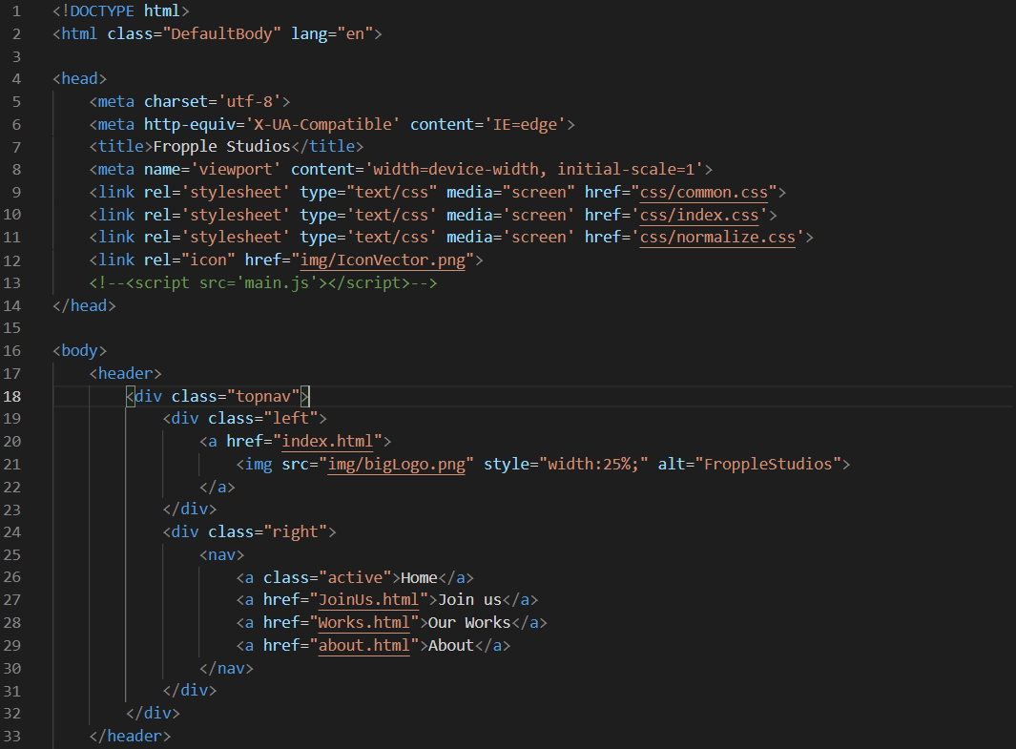

It was created a common.css

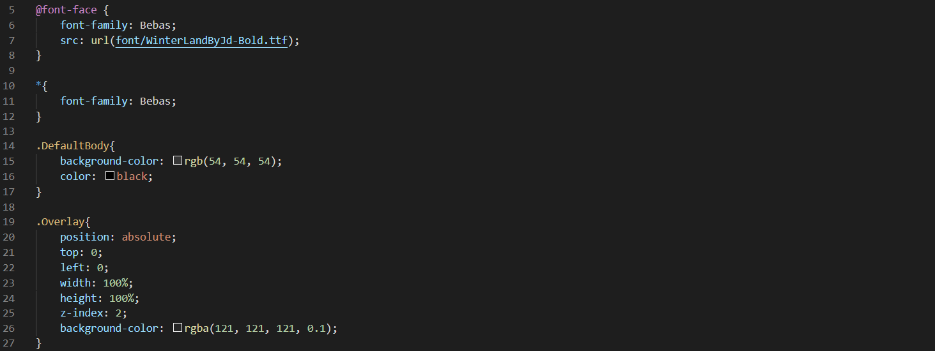

This is an example of what the common.css contains, mostly code that is re-used throughout all the pages, like the background color and font used. The overlay is used to put over images and gives them a sense opacity.

Of course, if necessary, this can be overwritten.

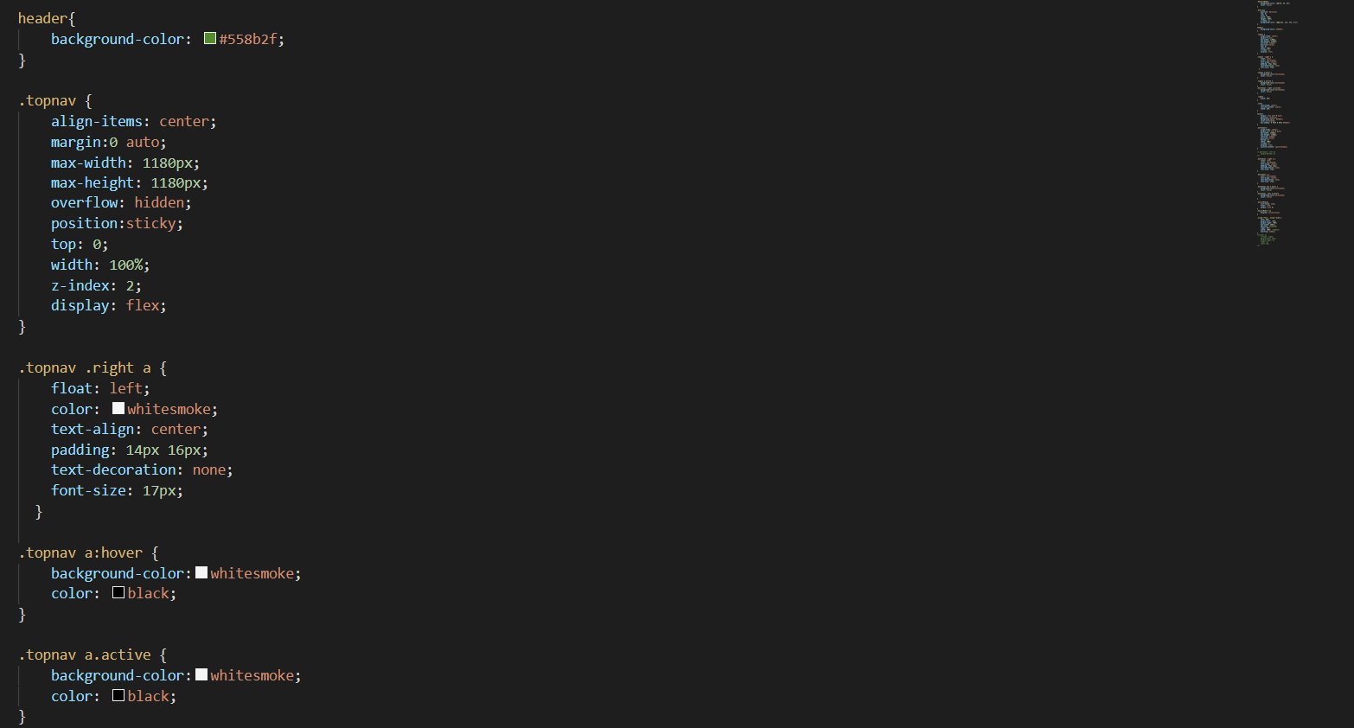

A small example of the code used for the top menu,