David Schirduan CSCI360
Answering Machine deliverable 3/13/11

Operation Contracts

Contract C01: settingMessage()
Operation: settingMessage()
Cross References: UC1: Setting Message
Preconditions: answering machine is plugged in.
Postconditions: answering message was changed to the new message

Contract C02: checkingMessage()
Operation: checkMessages()
Cross References: UC3 User checks messages, UC4 User saves message
Preconditions: answering machine has messages on it
Postconditions: messages have been checked, and either saved or deleted

Contract C03: leavingMessage()
Operation: leavesMessage()
Cross References: UC2 Caller leaves message
Preconditions: answering machine is working correctly, and has an answering message
Postconditions: answering machine has a new message that is ready for hearing

Class Diagrams

AnsweringMachine | Time | Clock | Message
- numMessages: int  -greeting: Message  -clock : Clock  -callerNum: int  -phoneNum: int | hour: int  //24hr clock  min: int  sec: int | time: Time | messageTime: Time  callerNum: int  messageDuration: int  //in seconds  messageContent: String
+playMessages()  +recordGreeting()  +recordMessage()  +playGreeting()  +keepMessage()  +deleteMessage() | +keepTime() | +recordTime() | +assignTime()  +recordDuration()  +saveMessage()  +playMessage()

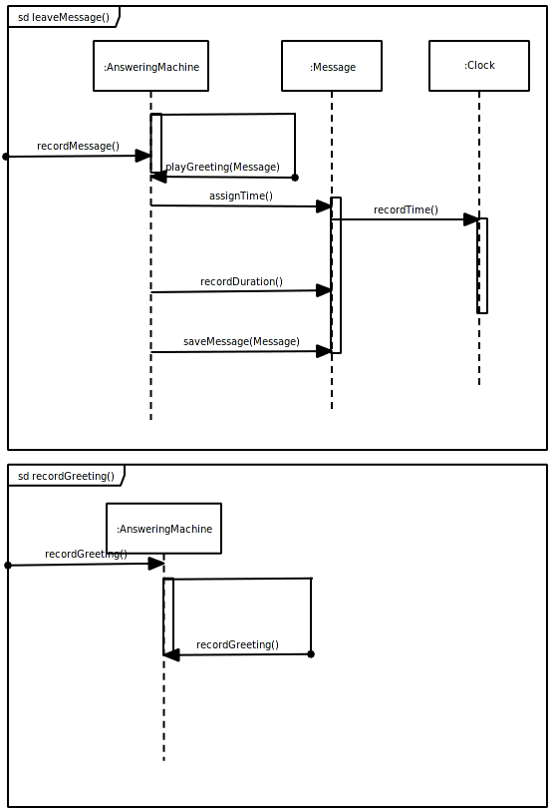
Sequence Diagrams

