A. The Chili Algorithm; it’s simple once you know the answer, but complex otherwise.

C. Inputs: 3,5,7

Process: Add 3, 5, and 7. Divide answer by 3.

Output: 5

Input: Phone

Process: Go to the Phone app. Hit Contacts. Select one of them.

Output: You have their information.

D. 1.

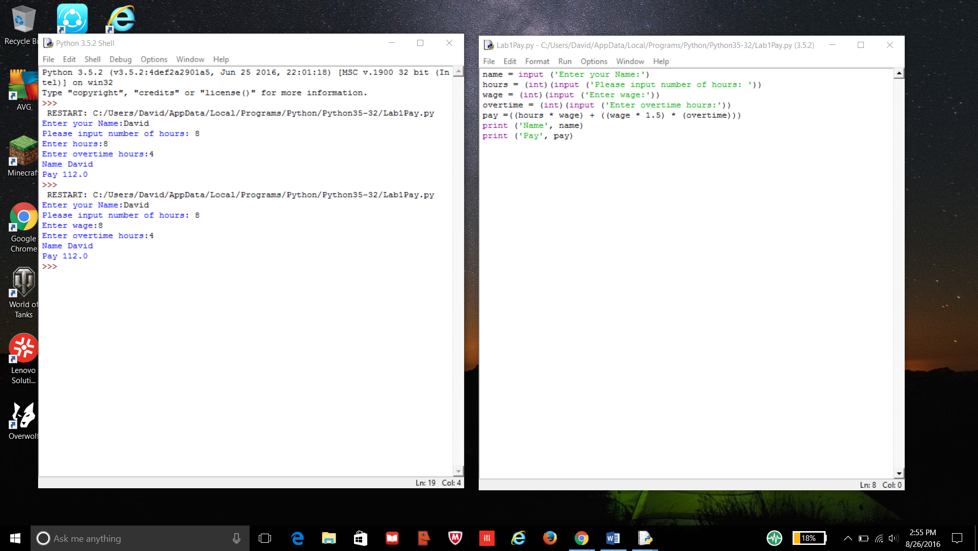

2.



3. 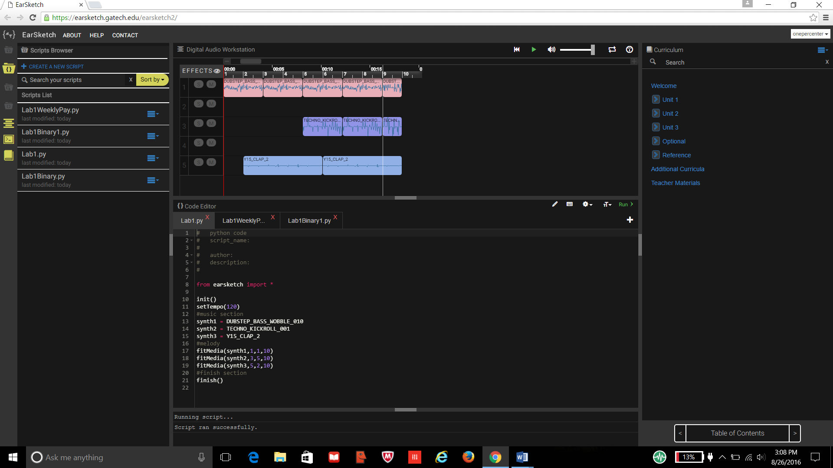

https://earsketch.gatech.edu/earsketch2/#?sharing=vevT9N3xRNCCuTj5zKxB3g

B.

