A.

a. Koan 7. It’s amazing how fast bits can move around.

b. To say that anybody can choose to use it for good or bad. Guns.

D. https://earsketch.gatech.edu/earsketch2/#?sharing=vevT9N3xRNCCuTj5zKxB3g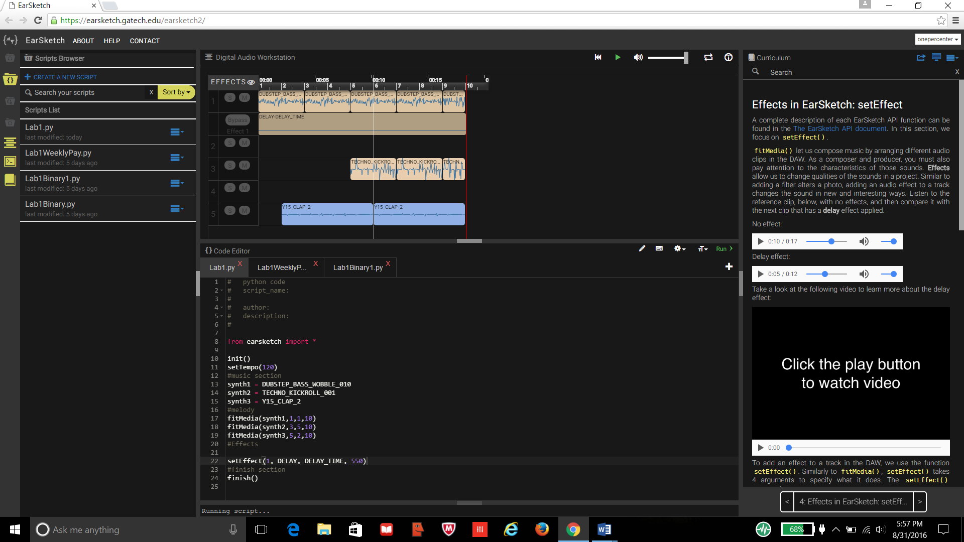

C. 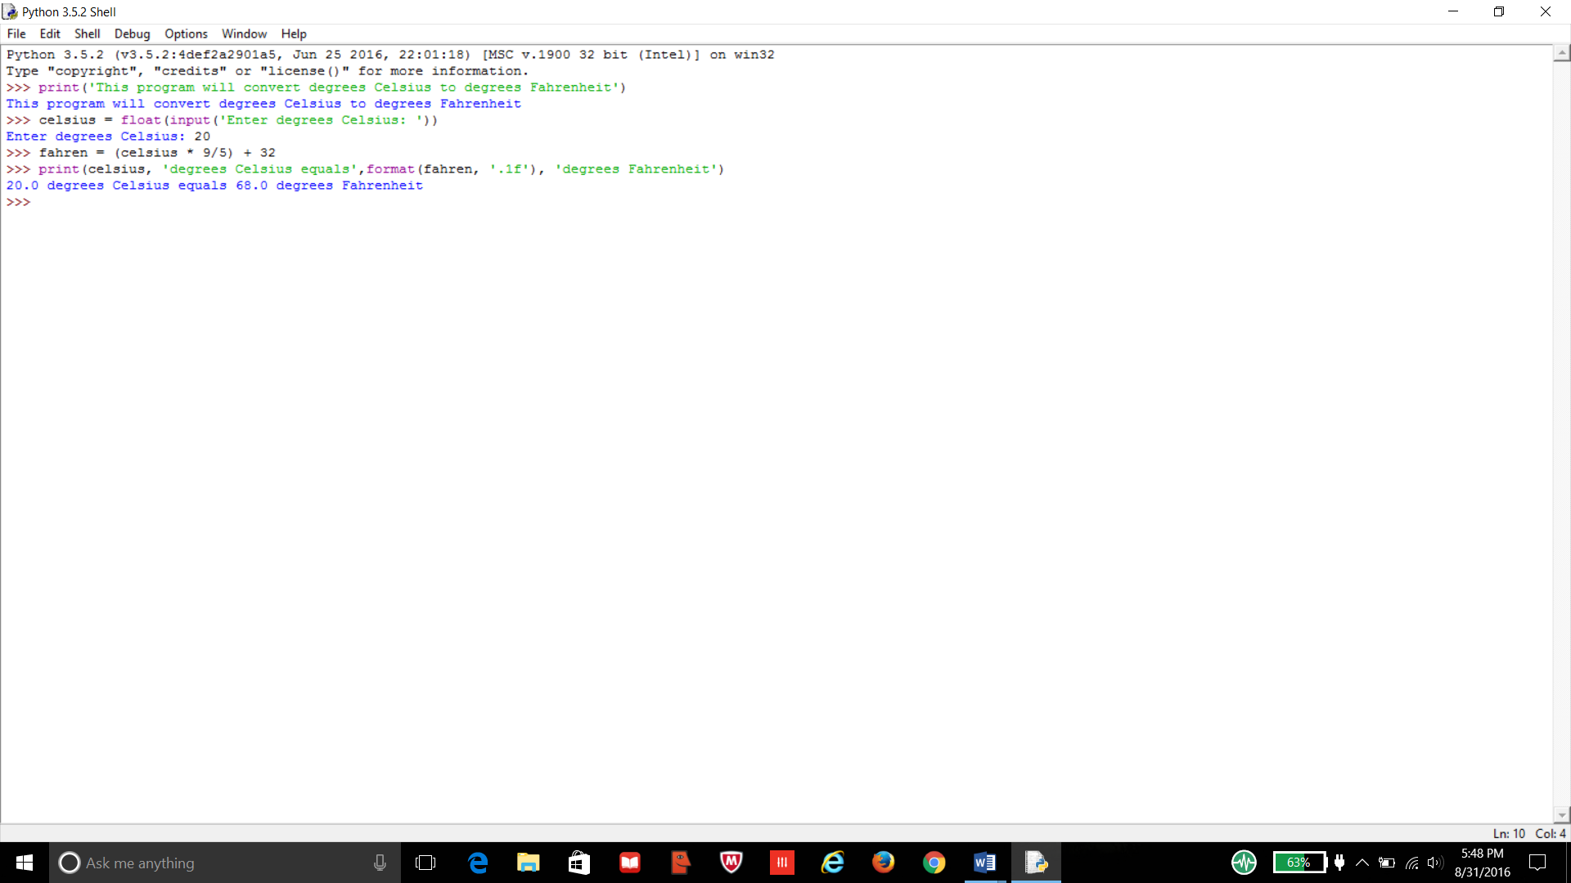

B. 