3.

https://earsketch.gatech.edu/earsketch2/#?sharing=vevT9N3xRNCCuTj5zKxB3g

2.

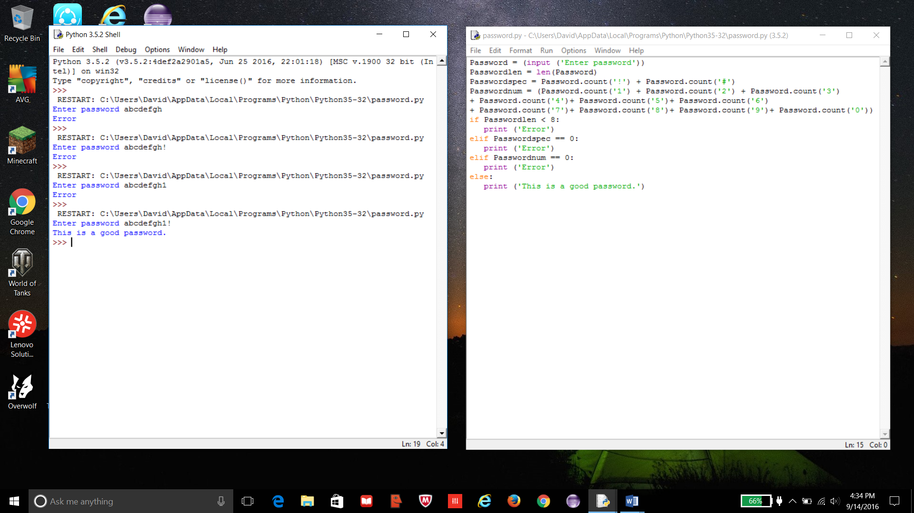

1.

