A. 5. the_turtle = turtle.getturtle ()

the_turtle.setposition (200, 0)

the_turtle.setposition (200, 200)

the_turtle.setposition (0, 200)

the_turtle.setposition (0, 0)

6. a. The exact center.

b. 100 pixels left of the center.

c. 50 pixels left of the center.

d. 50 pixels down from the center.

7. It is a rectangle.

8. A maroon line.

9. It is a dashed line.

B. P1. 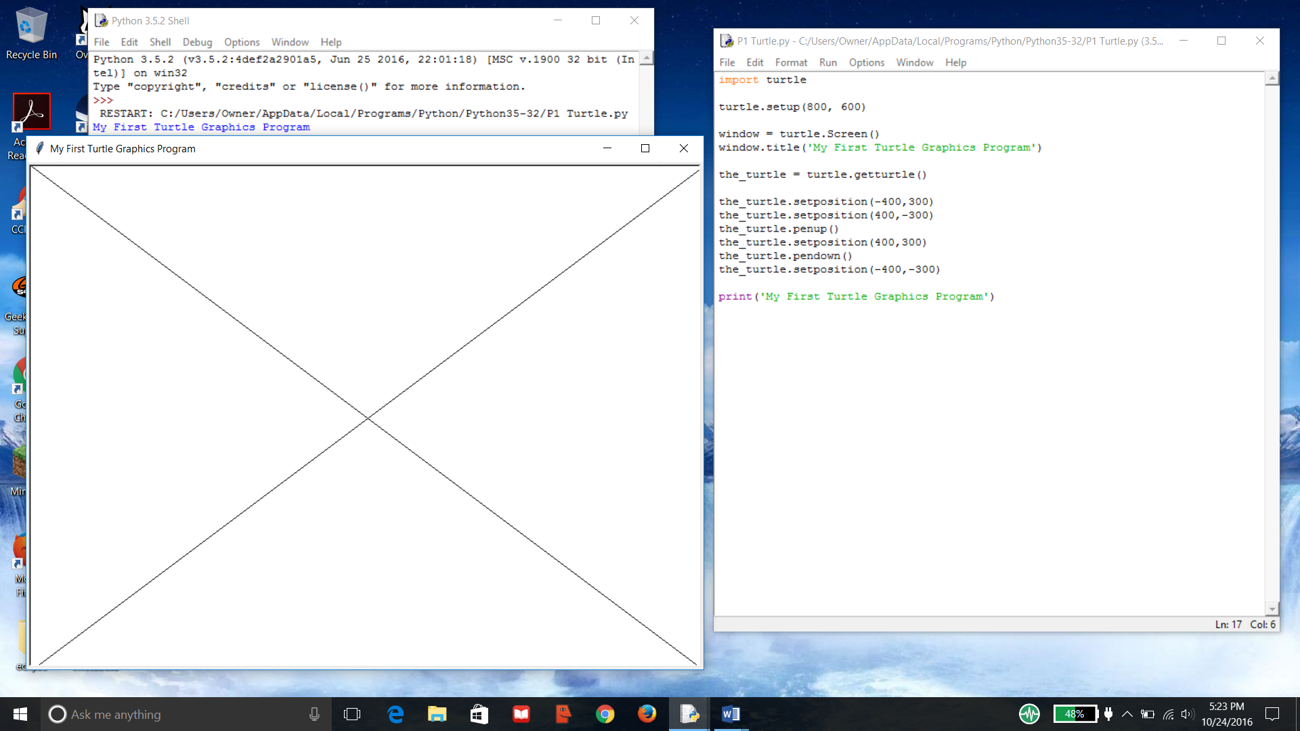

P7.

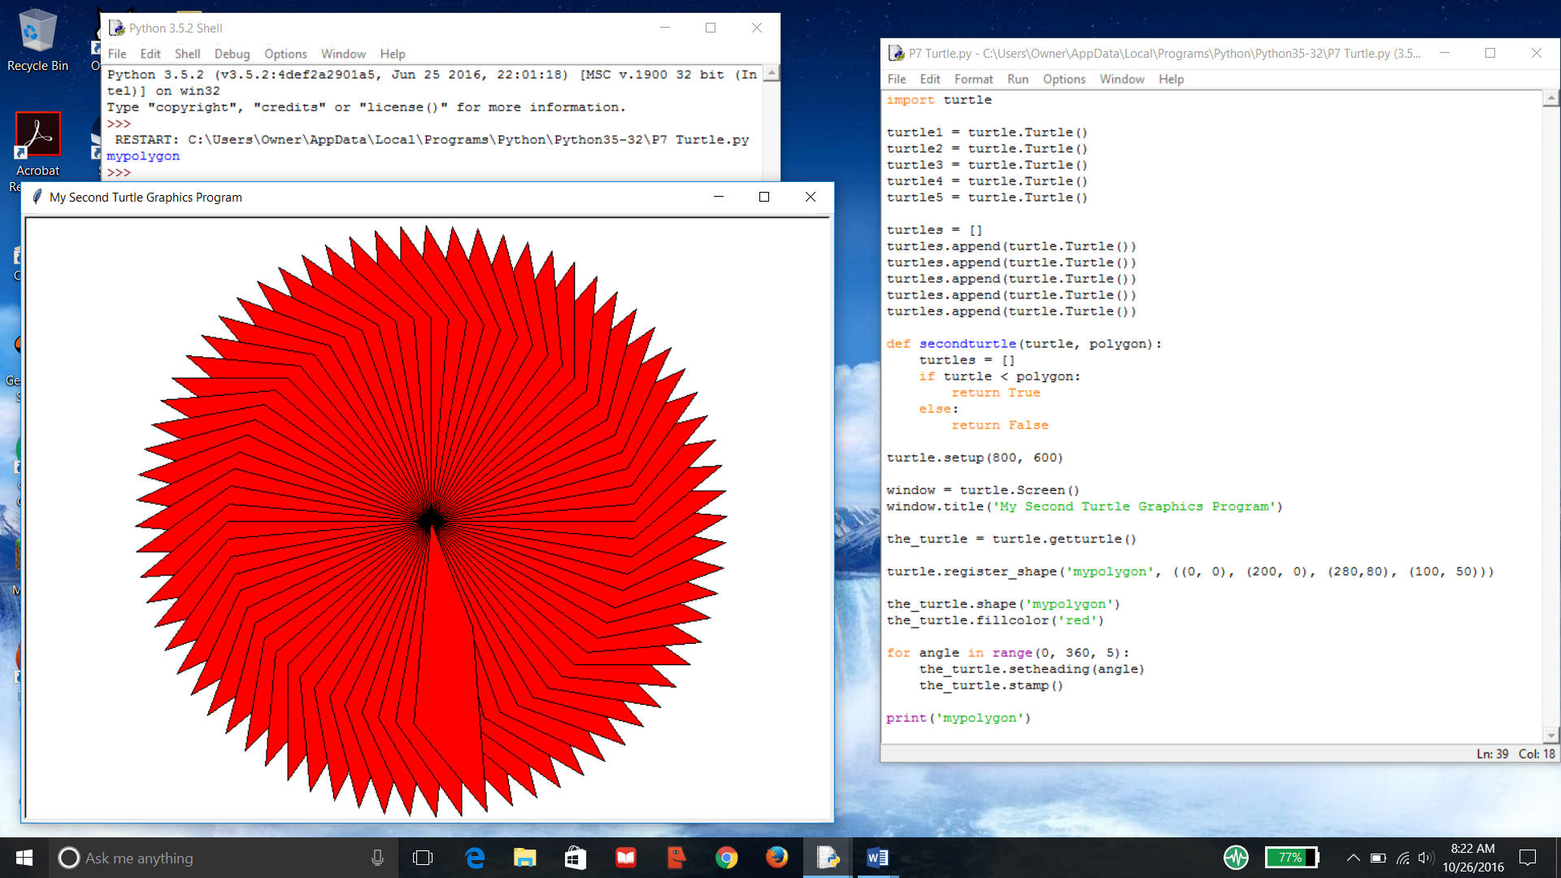

C. 