Situation Report

HZI Analysis, Output and Research

12 August, 2021

# 1 Introduction

Lorem ipsum dolor sit amet, consetetur sadipscing elitr, sed diam nonumy eirmod tempor invidunt ut labore et dolore magna aliquyam erat, sed diam voluptua. At vero eos et accusam et justo duo dolores et ea rebum. Stet clita kasd gubergren, no sea takimata sanctus est Lorem ipsum dolor sit amet. Lorem ipsum dolor sit amet, consetetur sadipscing elitr, sed diam nonumy eirmod tempor invidunt ut labore et dolore magna aliquyam erat, sed diam voluptua 10000. At vero eos et accusam et justo duo dolores et ea rebum. Stet clita kasd gubergren, no sea takimata sanctus est Lorem ipsum dolor sit amet. Lorem ipsum dolor sit amet, consetetur sadipscing elitr, sed diam nonumy eirmod tempor invidunt ut labore et dolore magna aliquyam erat, sed diam voluptua. At vero eos et accusam et justo duo dolores et ea rebum. Stet clita kasd gubergren, no sea takimata sanctus est Lorem ipsum dolor sit amet. Duis autem vel eum iriure dolor in hendrerit in vulputate velit esse molestie consequat, vel illum dolore eu feugiat nulla facilisis at vero eros et accumsan 0.43 et iusto odio dignissim qui blandit praesent luptatum zzril delenit augue duis dolore te feugait nulla facilisi. Lorem ipsum dolor sit amet, consectetuer adipiscing elit, sed diam nonummy -0.08 nibh euismod tincidunt ut laoreet dolore magna aliquam erat volutpat. Figure 1.1

## 1.1 Overview

Ut wisi enim ad minim veniam, quis nostrud exerci tation ullamcorper suscipit lobortis nisl ut aliquip ex ea commodo consequat 0. Duis autem vel eum iriure dolor in hendrerit in vulputate velit esse molestie consequat, vel illum dolore eu feugiat nulla facilisis at vero eros et accumsan et iusto odio dignissim qui blandit praesent luptatum zzril delenit augue duis dolore te feugait nulla facilisi:

Table 1.1: Overview Table

| **Total cases** | **New cases** | **Total hospitalizations** | **New hospitalizations** | **Total deaths** | **New deaths** | **7 Day Incidence** | **Change in 7 day incidence since yesterday** |
| --- | --- | --- | --- | --- | --- | --- | --- |
| 10 000 | 31 | 753 | 2 | 35 | 0 | 0.43 | -0.08 |

# 2 Epidemic Dynamic

At vero eos et accusam et justo duo dolores et ea rebum. Stet clita kasd gubergren, no sea takimata sanctus est Lorem ipsum dolor sit amet. Lorem ipsum dolor sit amet, consetetur sadipscing elitr, sed diam nonumy eirmod tempor invidunt ut labore et dolore magna aliquyam erat, sed diam voluptua. At vero eos et accusam et justo duo dolores et ea rebum. Stet clita kasd gubergren, no sea takimata sanctus est Lorem ipsum dolor sit amet. Lorem ipsum dolor sit amet, consetetur sadipscing elitr, At accusam aliquyam diam diam dolore dolores duo eirmod eos erat, et nonumy sed tempor et et invidunt justo labore Stet clita ea et gubergren, kasd magna no rebum. sanctus sea sed takimata ut vero voluptua. est Lorem ipsum dolor sit amet. Lorem ipsum dolor sit amet, consetetur.

## 2.1 Time series data

Lorem ipsum dolor sit amet, consetetur sadipscing elitr, sed diam nonumy eirmod tempor invidunt ut labore et dolore magna aliquyam erat, sed diam voluptua. At vero eos et accusam et justo duo dolores et ea rebum. Stet clita kasd gubergren, no sea takimata sanctus est Lorem ipsum dolor sit amet. Lorem ipsum dolor sit amet, consetetur sadipscing elitr, sed diam nonumy eirmod tempor invidunt ut labore et dolore:

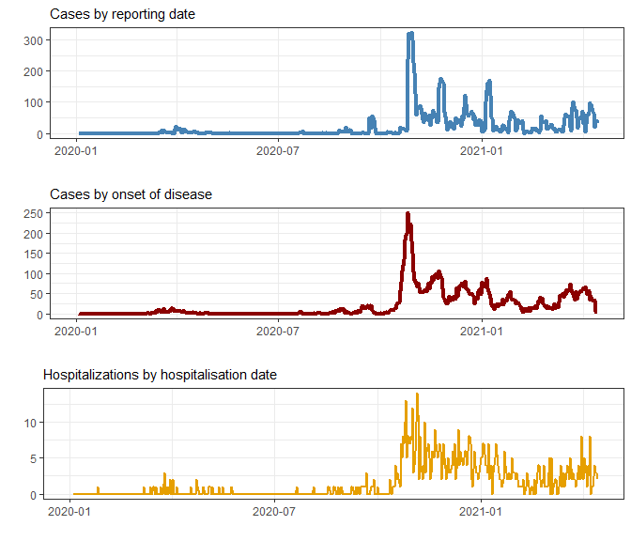

Figure 2.1: Time series data

## 2.2 Death incidences by age groups

Lorem ipsum dolor sit amet, consetetur sadipscing elitr, sed diam nonumy eirmod tempor invidunt ut labore et dolore magna aliquyam erat, sed diam voluptua. At vero eos et accusam et justo duo dolores et ea rebum. Stet clita kasd gubergren, no sea takimata sanctus est Lorem ipsum dolor sit amet. Lorem ipsum dolor sit amet, consetetur sadipscing elitr, sed diam nonumy eirmod tempor invidunt ut labore et dolore magna aliquyam erat, sed diam voluptua. At vero:

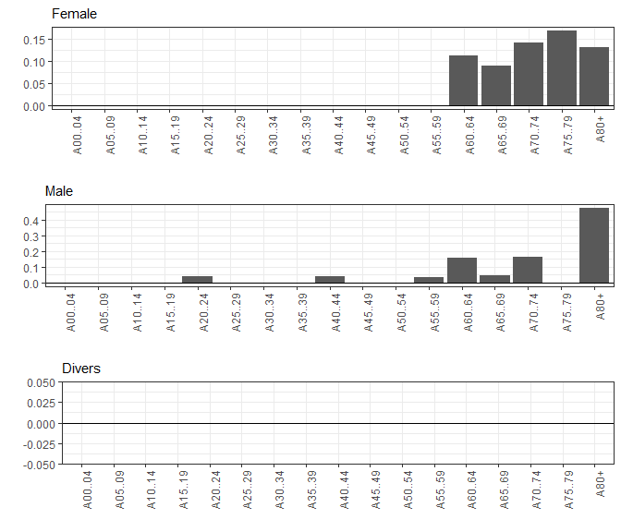

Figure 2.2: Death Incidences Distribution

# 3 Regional Situation

Lorem ipsum dolor sit amet, consetetur sadipscing elitr, sed diam nonumy eirmod tempor invidunt ut labore et dolore magna aliquyam erat, sed diam voluptua. At vero eos et accusam et justo duo dolores et ea rebum. Stet clita kasd gubergren, no sea takimata sanctus est Lorem ipsum dolor sit amet. Lorem ipsum dolor sit labore et dolore magna aliquyam erat, sed diam voluptua. At vero eos et accusam et justo duo dolores et ea rebum.

## 3.1 State level table

Lorem ipsum dolor sit amet, consetetur sadipscing elitr, sed diam nonumy eirmod tempor invidunt. Lorem ipsum dolor sit amet, consetetur sadipscing elitr, sed diam nonumy eirmod tempor invidunt ut labore et dolore magna aliquyam erat, sed diam voluptua. At vero eos et accusam et justo duo dolores et ea rebum. Stet clita kasd:

Table 3.1: State Level Table

| **State** | **Total cases** | **New cases** | **Total hospitalizations** | **New hospitalizations** | **Total deaths** | **New deaths** | **7 Day Incidence** | **Change in 7 day incidence since yesterday** |
| --- | --- | --- | --- | --- | --- | --- | --- | --- |
| Baden-WÃ¼rttemberg | 948 | 0 | 64 | 0 | 2 | 0 | 1.13 | -0.44 |
| Bayern | 1 886 | 1 | 145 | 1 | 8 | 0 | 0.48 | -0.20 |
| Berlin | 1 | 0 | 0 | 0 | 0 | 0 | 0.00 | 0.00 |
| Brandenburg | 499 | 0 | 41 | 0 | 7 | 0 | 0.00 | 0.00 |
| Bremen | 15 | 1 | 0 | 0 | 0 | 0 | 0.30 | 0.15 |
| Hamburg | 1 | 0 | 0 | 0 | 0 | 0 | 0.00 | 0.00 |
| Hessen | 1 600 | 0 | 128 | 0 | 1 | 0 | 0.02 | -0.01 |
| Mecklenburg-Vorpommern | 193 | 0 | 15 | 0 | 0 | 0 | 0.00 | 0.00 |
| Niedersachsen | 1 179 | 1 | 93 | 0 | 2 | 0 | 0.20 | -0.15 |
| Nordrhein-Westfalen | 1 886 | 14 | 127 | 0 | 7 | 0 | 0.30 | 0.07 |
| Rheinland-Pfalz | 691 | 5 | 66 | 0 | 3 | 0 | 0.69 | 0.10 |
| Saarland | 45 | 2 | 2 | 0 | 2 | 0 | 0.30 | 0.20 |
| Sachsen | 122 | 0 | 6 | 0 | 0 | 0 | 0.56 | -0.05 |
| Sachsen-Anhalt | 185 | 1 | 15 | 1 | 1 | 0 | 0.04 | 0.04 |
| Schleswig-Holstein | 390 | 0 | 24 | 0 | 1 | 0 | 0.38 | -0.18 |
| ThÃ¼ringen | 359 | 6 | 27 | 0 | 1 | 0 | 1.38 | 0.27 |

## 3.2 County level map

Lorem ipsum dolor sit amet, consetetur sadipscing elitr, sed diam nonumy eirmod tempor invidunt ut labore et dolore magna aliquyam erat, sed diam voluptua. At vero eos et accusam et justo duo dolores et ea rebum. Stet clita kasd gubergren, no sea takimata sanctus est Lorem ipsum dolor sit amet. Lorem ipsum dolor sit amet, consetetur sadipscing elitr, sed diam nonumy eirmod tempor invidunt ut labore et dolore magna aliquyam erat, sed diam voluptua. At vero eos et accusam et:

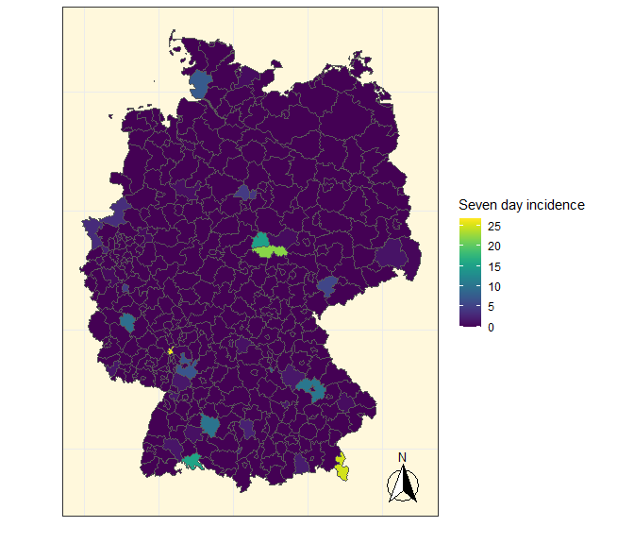

Figure 3.1: County level map

# 4 Remarks

Lorem ipsum dolor sit amet, consetetur sadipscing elitr, sed diam nonumy eirmod tempor invidunt ut labore et dolore magna aliquyam erat, sed diam voluptua. At vero eos et accusam et justo duo dolores et ea rebum. Stet clita kasd gubergren, no sea takimata sanctus est Lorem ipsum dolor sit amet. Lorem ipsum dolor sit amet, consetetur sadipscing elitr, sed diam nonumy eirmod tempor invidunt ut labore et dolore magna aliquyam erat, sed diam voluptua. At vero eos et accusam et justo duo dolores et ea rebum. Stet clita kasd gubergren, no sea takimata sanctus est Lorem ipsum dolor sit amet. Lorem ipsum dolor sit amet, consetetur sadipscing elitr, sed diam nonumy eirmod tempor invidunt ut labore et dolore magna aliquyam erat, sed diam voluptua. At vero eos et accusam et justo duo dolores et ea rebum. Stet clita kasd gubergren, no sea takimata sanctus est Lorem ipsum dolor sit amet.  
Duis autem vel eum iriure dolor in hendrerit in vulputate velit esse molestie consequat, vel illum dolore eu feugiat nulla facilisis at vero eros et accumsan et iusto odio dignissim qui blandit praesent luptatum zzril delenit augue duis dolore te feugait nulla facilisi. Lorem ipsum dolor sit amet, consectetuer adipiscing elit, sed diam nonummy nibh euismod tincidunt ut laoreet dolore magna aliquam erat volutpat.  
Nam liber tempor cum soluta nobis eleifend option congue nihil imperdiet doming id quod mazim placerat facer possim assum. Lorem ipsum dolor sit amet, consectetuer adipiscing elit, sed diam nonummy nibh euismod tincidunt ut laoreet dolore magna aliquam erat volutpat.

As illustrated in Figure 2.1 there was a spike in all three time series in the third quarter of 2020.

Table 3.1 and Table 1.1 show summary statistics.

(Lang, Nöhrbaß, and Stahl 1997)

(Wickham et al. 2021)

# 5 References

Lang, Oliver, Karl-Heinz Nöhrbaß, and Konrad Stahl. 1997. “On Income Tax Avoidance: The Case of Germany.” *Journal of Public Economics* 66 (2): 327–47.

Wickham, Hadley, Romain François, Lionel Henry, and Kirill Müller. 2021. *Dplyr: A Grammar of Data Manipulation*. <https://CRAN.R-project.org/package=dplyr>.