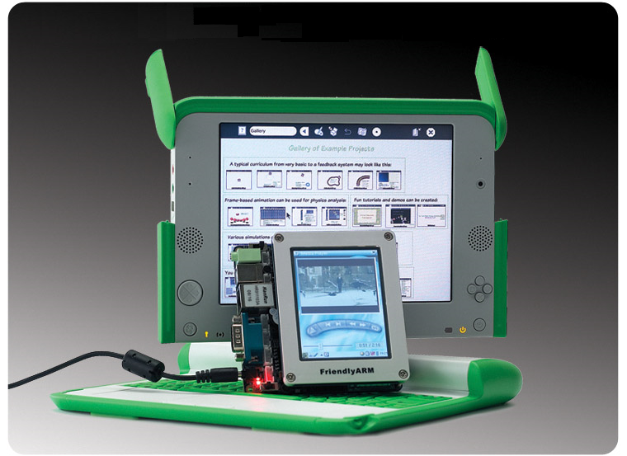

Mini-2440 Development Report

installation configuration & analysis

Sam | WDS-serials | 2017.March

Table of Contents

Section 1. Environment setup 2

§Chapter 1. Hardware information 2

§Chapter 2. Software setup 4

Section 2. Device Driver Labs 6

§Chapter 1. GPIO interface 6

§Chapter 2. Block Devices 6

§Chapter 3. LCD & Touch Screen Devices 6

§Chapter 4. BUS protocol Devices 6

§Chapter 5. I2C and SPI Devices 6

§Chapter 6. Network Devices 6

Section 3. System Porting Labs & Debugging 7

§Chapter 1. Porting U-boot 7

§Chapter 2. Porting Linux Kernel 7

§Chapter 3. Porting Rootfs 7

§Chapter 4. Linux kernel debugging 7

Section 4. Appendix Issues 7

§Chapter 1. Common Commands 7

§Chapter 2. Architecture Diagram 7

§Chapter 3. C/C++ Questions 7

# Section 1. Environment setup

So important to make sure the development path may work properly, People prefer different development tools: Fedora+arm-cross-compiler by FriendlyARM; Ubuntu by WDS and by Enjoylinux (国嵌). All of them was based on S3C2440 MCU.

### §Chapter 1. Hardware information

Based on my mini2440 Development board, the hardware information is as bellows:

**FriendlyARM Mini2440 | S3C2440 ARM9 Board**

Mini 2440 SBC (Single Board Computer) with 400MHz Samsung S3C2440 ARM9 processor.

Specification

* **Dimension:** 100 x 100 mm
* **CPU:** 400 MHz Samsung S3C2440 ARM926T (max freq. 533 MHz)
* **RAM:** 64 MB, 32 bit Bus
* **Flash:** 256 MB NAND Flash
* **EEPROM:** 256 Byte (I2C)
* **Ext. Memory:** SD-Card socket
* **Serial Ports:** 1x DB9 connector (RS232), total: 3x serial port connectors
* **USB:** 1x USB-A Host 1.1, 1x USB-B Device 1.1
* **Audio Output:** 3.5 mm stereo jack
* **Audio Input:** Connector + Condenser microphone
* **Ethernet:** RJ-45 10/100M (DM9000)
* **RTC:** Real Time Clock with battery (CR1220)
* **Beeper:** PWM buzzer
* **Camera:** 20 pin (2.0 mm) Camera interface
* **LCD Interface:** 41 pin connector for FriendlyARM Displays and VGA Board
* **User Inputs:** 6x push buttons and 1x A/D pot
* **User Outputs:** 4x LEDs
* **Expansion:** 40 pin System Bus, 34 pin GPIO, 10 pin Buttons (2.0 mm)
* **Debug:** 10 pin JTAG (2.0 mm)
* **Power:** regulated 5V (DC-Plug: 1.35mm inner x 3.5mm outer diameter)
* **Power Consumption:** Mini2440: 0.3 A, Mini2440 + 3.5" LCD: 0.6 A
* **OS Support**

Windows CE 5 and 6

Linux

[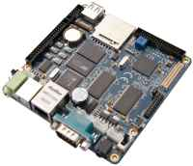](http://www.friendlyarm.net/sites/products/mini2440_2.jpg)[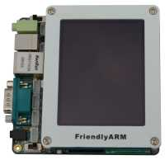](http://www.friendlyarm.net/sites/products/mini2440-35.jpg) [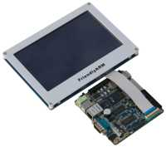](http://www.friendlyarm.net/sites/products/mini2440-70.jpg)

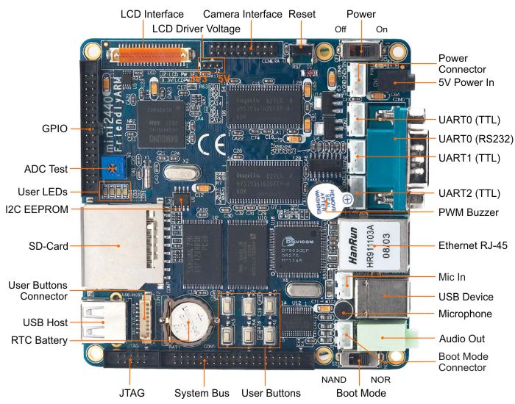

http://www.friendlyarm.net/sites/products/mini2440_3.jpg

Some useful documents (user manual and schematic diagram) can be found in bellow attached files:

 

### §Chapter 2. Software setup

There are 2 parts involved, the upper/ lower machine or host/ target machine:

Part 1. Host PC environment setup

Due to the high popularity of Linux distribution - Ubuntu was adopted as development environment, we installed Ubuntu9.10/ 10.04/ 14.04 with VMware Workstation under Windows 7.

1. Virtual Machine

Virtual machine version: VMware® Workstation 12 Pro (version# 12.5.2 build-4638234) Download original version from official website, (<https://my.vmware.com/en/web/vmware/info/slug/desktop_end_user_computing/vmware_workstation_pro/12_0>) serial number can be found from web.

* Existed VMware Ubuntu image can be used directly under VMWare workstation by “Open exist VM-machine” (WDS Ubuntu version 9.10 with all pkgs pre-copied)
* Use “new virtual machine wizard” to create a new Ubuntu system, make sure to install Ubuntu later:

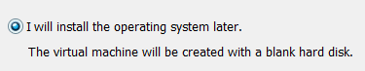

* After setup an empty Ubuntu machine, make sure locate correctly the iso image for Ubuntu installation:
* Choose “bridged” network connection and “shared folder” enabled (function works after VMWare Tools be installed)
* For VMWare Tools installation, make sure virtual CD/DVD using correct iso. Soon after the iso was selected (in my case-> D:\Program Files\VMware\VMware Workstation\linux.iso ), you can do installation from CD-ROM after reboot. 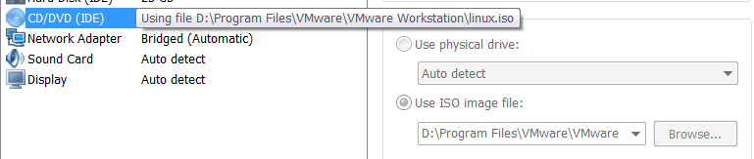
* The “shared folder” (/mnt/hgfs/xxx/) and “resolution” are functioned after VMware tools’ installation.

2. Ubuntu OS

For new installed Ubuntu, something need to configure to make your development easier.

With example of Ubuntu 9.10/ 10.04/ 14.04 (desktop-i386.iso Avoid choosing 64bit version!!)

* Add repo for Ubuntu 9.10 and 10.04(no longer support auto update problem)

In order to use old releases for 10.04, you can access them using address:

[http://old-releases.ubuntu.com](http://old-releases.ubuntu.com/)

To enable this, open the /etc/apt/sources.list file with a text editor, and wherever you see “archive.ubuntu.com” (the source of releases actively supported), change it to “old-releases.ubuntu.com” (you can use the find & replace option to speed it up).

If after replacement done, it alert again “Failed to fetch <http://ca.old-xxx/dists/xxx/>”：

Copy old sources.list from previous Ubuntu10.04:

cp /mnt/hgfs/BBT104/sources.list /etc/apt/sources.list

* Use “root” super user to login:

Set root password: [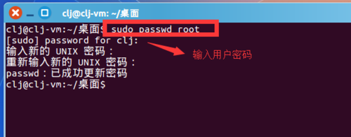](http://jingyan.baidu.com/album/4dc40848babed6c8d946f12f.html?picindex=3)

Switch to root-user:

[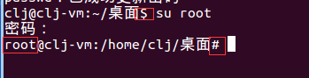](http://jingyan.baidu.com/album/4dc40848babed6c8d946f12f.html?picindex=4)

Setup login UI with root enable:

Edit under directory /usr/share/lightdm/lightdm.conf.d/50-ubuntu.conf

If it is not exist, create it: /usr/share/lightdm/lightdm.conf.d/50-ubuntu.conf

edit 50-ubuntu.conf as following：

[SeatDefaults]

user-session=Ubuntu

#autologin-user=root    #Automatically login as root, skipped the menu, don’t do that!

greeter-session=unity-greete

greeter-show-manual-login=true  #enter user name and pw manually

allow-guest=false            #disable guest

Need reboot to bring it into force；

* Change hostname under /etc/hostname
* Install and start nfs & tftp services

Install tftp server -> sudo apt-get install tftpd tftp openbsd-inetd

start nfs server -> sudo /etc/init.d/nfs-kernel-server restart

#start tftp server -> sudo /etc/init.d/openbsd-inetd start

# Section 2. Device Driver Labs

### §Chapter 1. GPIO interface

Based on my mini2440 Development board,

### §Chapter 2. Block Devices

Based on my mini2440 Development board,

### §Chapter 3. LCD & Touch Screen Devices

Based on my mini2440 Development board,

### §Chapter 4. BUS protocol Devices

Based on my mini2440 Development board,

### §Chapter 5. I2C and SPI Devices

Based on my mini2440 Development board,

### §Chapter 6. Network Devices

# Section 3. System Porting Labs & Debugging

All of them was based on S3C2440 MCU.

### §Chapter 1. Porting U-boot

All of them was based on S3C2440 MCU.

### §Chapter 2. Porting Linux Kernel

All of them was based on S3C2440 MCU.

### §Chapter 3. Porting Rootfs

All of them was based on S3C2440 MCU.

### §Chapter 4. Linux kernel debugging

All of them was based on S3C2440 MCU.

# Section 4. Appendix Issues

All of them was based on S3C2440 MCU.

### §Chapter 1. Common Commands

Based on my mini2440 Development board,

### §Chapter 2. Architecture Diagram

Based on my mini2440 Development board,

### §Chapter 3. C/C++ Questions

Based on my mini2440 Development board,