COMP8505
Assignment 2

Steganography in Python w/ PIL

David Wang
A00670230
Table of Contents
Introduction 3
About 3
Tools 3
Usage 3
Design 3
Testing 4
Improvements 6

Introduction

About
The objective of this project is to understand how to implement Steganography by hiding data of files inside images using the Least Significant Bit (LSB) of each color band (RGB) within each pixel in the image.

Tools
This program is developed in Python 2.7, and is not supported for Python 3. Please confirm the python version in your environment before executing this project. This program requires an external dependency named “Pillow”, which is a fork of the Python Imaging Library (PIL) that is widely used after PIL became outdated. Pillow can be installed with pip with the following:
pip install Pillow
Pillow is also available in certain distro repositories under “python-pillow”.

Usage
pystego.py [-h] (-e image file | -d image) [-o OUTPUT]
-h, --help show this help message and exit
-e image file, --encode image file
Encode a file into the image
-d image, --decode image
Decode the image into a file
-o OUTPUT, --output OUTPUT
Optional output filename
One of -e or -d arguments must be supplied. -o or –output is optional.
Input file must be a valid image type of the following: JPG, PNG, BMP
Output stego file must be one of either PNG or BMP

Design
The program is split into three files:
pystego.py - The main entrance for users, and processes user inputs and validations before passing the information on for processing
pyimage.py - Contains functions used for processing and manipulating images and files used for stego
pyutils.py - Contains the main “encode” and “decode” functions

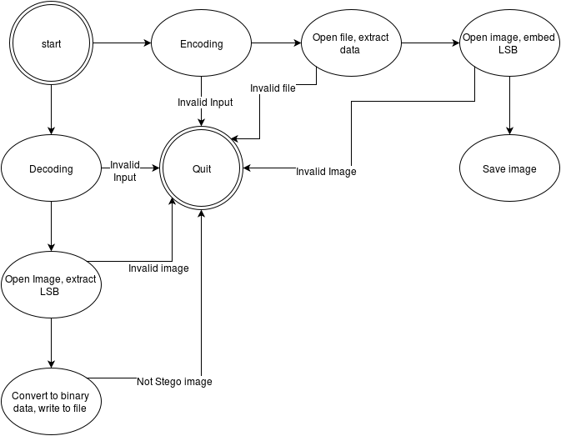

Testing
1. Encode an image - file in PNG
python pystego.py -e bird.png kappa.jpg -o stegobird.bmp
Expected: Success message
Result: True
2. Encode an image - file in BMP
python pystego.py -e stegobird.bmp sniper.jpg -o stegobird2.bmp
Expected: Success message
Result: True
3. Encode an image - file in JPG
python pystego.py -e jpvader.JPG darthvader.pdf -o stegovader.png
Expected: Success message
Result: True
4. Encode an image - Unsupported format
python pystego.py -e darthvader.pdf kappa.jpg
Expected: Failure message
Result: True
5. Encode an image - Unsupported output
python pystego.py -e bird.png kappa.jpg -o stegobird.gif
Expected: Failure message
Result: True
6. Encode an image - Filesize too large
python pystego.py -e kappa.jpg darthvader.pdf
Expected: Failure message
Result: True
7. Decode an image - BMP
python pystego.py -d stegobird.bmp -o decode_bird.jpg
Expected: Success message
Result: True
8. Decode an image - PNG
python pystego.py -d stegovader.png -o decode_vader.pdf
Expected: Success message
Result: True
9. Decode an image - Get original filename
python pystego.py -d stegobird2.bmp
Expected: Success message
Result: True
10. Decode an image - Not stego image
python pystego.py -d bird.png
Expected: Failure message
Result: True
Test files are provided in the “Testing” folder under “Test Files”. Due to the nature of the outputs, the images and terminal outputs are provided in the “Testing” folder found along with this document instead of copied in this document.

Improvements
Currently the program only supports JPG, PNG and BMP inputs and PNG, BMP outputs. Future versions should improve on support for different types of image formats such as GIF. In addition, the program currently strips alpha channels if the image is RGBA instead of RGB.
The method to use LSB encoding is also easily detectable if images used have a space of similar colours. For example, if there is a notable area of white, then there is no reason for colors in that area to have mixed values of 254 and 255. As well, if the total LSB value of the whole image is roughly 0.5, then the image becomes suspicious for steganography.

