My name is Ian from the Philippines. My comment on Stability AI on page 15, Microsoft on page 3, and last is Meta on page 10:

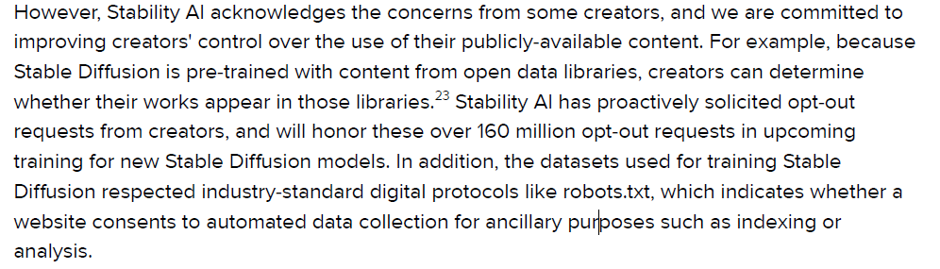

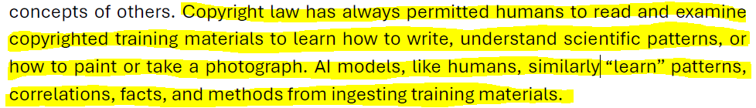

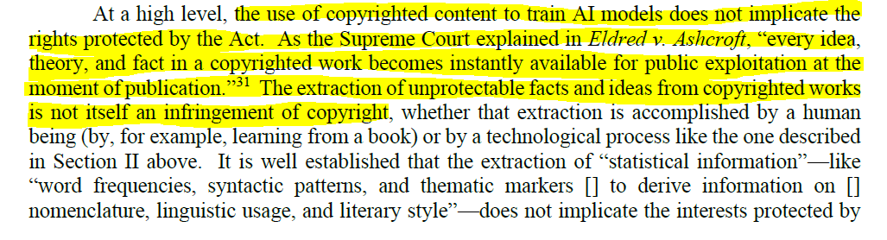

Stability AI, Microsoft, Meta, etc. have scrapped millions, if not, billions, of content in the internet without the creator's permission and without consent. Their opt-out system is useless and it is a lie as this researcher have found it: <https://twitter.com/alexjc/status/1684295440269824006>. We don't need to opt-out manually our contents in their dataset as we've never agreed to any of their Terms of Services. A lot of companies have used the creators’ content, and most of the companies who are using their models, have made it for commercial uses. Each and every companies are profiting off of their hard work and labor without compensating, consenting and crediting. Granting copyright on these companies will be a disaster and they’ll likely abuse their own ToS just to get away with it:

* Their AI models are built on stolen contents including copyrights and trademarks
* Many famous artists were used in their AI models that will create “in the style of” said artists
* When the AI learned the models that are ingested, it cannot be unlearned again
* The AI models will not function properly without those contents that they have stolen

In previous months, many artists are depressed as they’re unable to protect their works against the people who are downloading their works and feeding it on their AI, here’s an example: <https://twitter.com/Rahll/status/1730318255682646387/photo/1>. Recently, the plaintiff, Kelly McKernan, have seen an artwork that is related to her when she tried to search her name on Google: <https://twitter.com/Kelly_McKernan/status/1731216748551049698>. The artist’s didn’t made that artwork on her own, but her style has been used by the name of Thaeyne, <https://thaeyne.com/>. What is more very concerning is they also have a watermark removal so that they can remove the name of the artist of that art they’ve created: <https://twitter.com/art_magnifico/status/1625879414977224704>.

Additionally, many commissioners, who are paying for real artworks, have been victims of scams because of AI art: <https://twitter.com/DynamoSuperX/status/1701414883940618679>. Granting copyright to this kind of people can lead to bad actions because most of these people will not disclose the use of AI and that’s just the beginning. They will continue to abuse it for as long as they want to get away the money they’ve scammed, just like how crypto did.

These are my other links as to why I don’t trust AI anymore because of these:

* <https://twitter.com/NextGenPlayer/status/1729290709914497182>
* <https://twitter.com/MsJuicyGenius/status/1679299027278364674>
* <https://twitter.com/Lee_Morgan7/status/1730252820580843820>

Please do not grant copyright to these companies because the AI they’re building is unethical, and please do not grant copyright on AI artworks. **Companies and the people who defend AI wants to abolish copyright and also do not want AI regulations. They want their AI build unethical from the very start.**

Please do not grant them copyright and we needed AI to be regulated as soon as possible. Please protect the original works made by the original creators whose contents have been ingested by AI from the companies who build it. These AI models need to be disgorged if they want to build AI models ethically. Please do not allow them to have copyright and we want the government to regulate AI now.