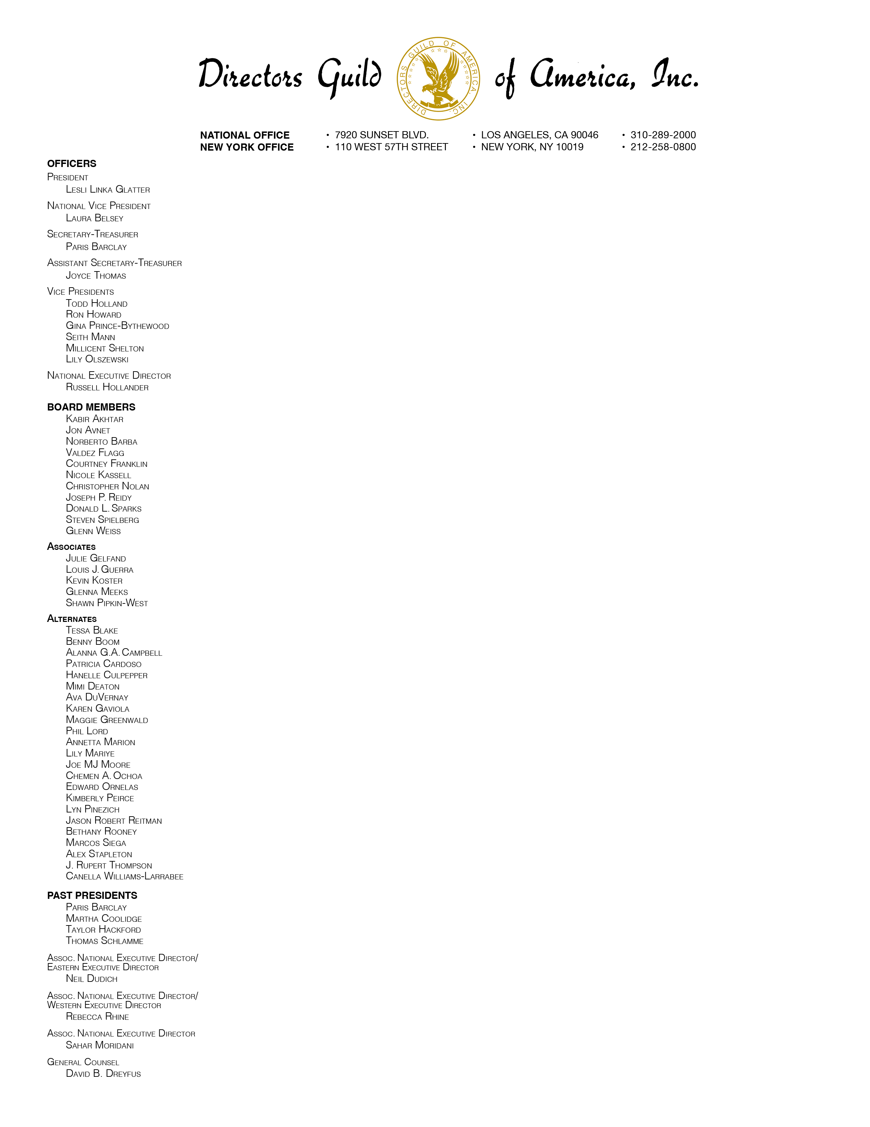Submitter: Alec French

Organization: Directors Guild of America, Inc.

December 5, 2023

Register Shira Perlmutter

U.S. Copyright Office

101 Independence Avenue, S.E.

Washington, D.C. 20559-6000

Dear Register Perlmutter:

On behalf of the Directors Guild of America (DGA), I am submitting this reply comment in response to the Copyright Office’s Notice of Inquiry. The DGA previously submitted comments to the Notice of Inquiry on October 30, 2023 and joined the comments submitted by the AFL-CIO Department of Professional Employees on that same date.

Directors oftentimes spend several years, and occasionally a decade or longer, creating the films and television programs enjoyed around the world. As a result, even successful directors regularly have long periods between projects as they go from the production and promotion of one motion picture to the pitching and development of their next project. Directors can afford these long unpaid periods of time while they work on their next project only because they share in the economic success of their prior projects through receipt of a portion of the downstream revenue in the form of residuals from the exploitation of their motion pictures in ancillary markets. Without strong copyright protection, the film and television ecosystem has the potential to quickly unravel.

The DGA acknowledges that AI, when used as a tool, may be helpful to directors and other entertainment industry professionals in their creative processes and has the potential to make film and television production more efficient. However, as with other technological advancements, when misused, AI (and specifically GAI models) pose significant economic and reputational threats to directors and other filmmakers. If appropriate safeguards are not put in place, GAI models will likely be used for content theft and mutilation, as well as copyright infringement. Consistent with our nuanced view on the use of artificial intelligence and the guardrails that should apply to it as set forth in our initial comments, there are a number of director-specific concerns we ask the Copyright Office to consider.[1]

First, the technology companies that have developed GAI products should be required to be transparent about the creative works used to train their GAI systems. Technology companies that train their systems to produce new works through the manipulation of feature films, television programs, and other motion pictures should be required: (i) to obtain prior consent[2] from the copyright holder (and where the copyright holder cannot be located, the director)[3]; and (ii) to maintain detailed records that track the content they ingest to train their models to produce the manipulated works requested by the user.[4] That information must be made available to directors upon request so they can, where appropriate, take steps to protect their work.[5]

Second, and relatedly, prompts “in the style of” a particular director should not be permitted, except with the express prior consent of the director.[6] Over time, many directors develop a unique visual style. Production companies that wish to capture that unique creative vision by producing a film “in the style of” a particular director pay a premium to hire that director for their next project. GAI models have already shown the capability to exclude prompts and concepts such that a user is unable to create a product utilizing them. For example, ChatGPT has stated it will not promote hate speech or discrimination, and it will not promote illegal activities.[7] Similarly, OpenAI’s text-to-image tool DALL-E will reject requests to display an image in the style of a living artist or depict public figures. There is no reason that similar restrictions should not apply to creators of audio-visual works. Directors should have the same right to determine whether to permit a particular GAI model to produce a manipulated product that imitates their unique creative vision.

Third, the U.S. should not adopt a compulsory license system. Compulsory licenses, where they exist (*e.g.*, the music industry), undervalue copyrighted works. We believe that technology companies seeking to build and possibly profit from their platforms using copyrighted works should negotiate with the copyright holders and pay fair value for the use of those works.[8]

Fourth, the fair use defense should not be extended beyond its current parameters.[9] Among the bases of the fair use defense is the belief that the public may use copyrighted works for commentary, criticism, or educational purposes.[10] The DGA strongly urges the Copyright Office to recommend that Congress narrow the fair use defense as it relates to AI issues.

The fair use defense should only be permitted to be employed by humans and not machines, including AI and GAI models and tools. The technology companies are not ingesting the creative works of DGA members into their GAI models to comment on them or generate a parody of a film. The technology companies should be held accountable for the unauthorized use of copyrighted works to train their models.

And, finally, as previously noted, under U.S. law directors are not afforded the creative and economic rights that exist in other countries, particularly Europe, that are also signatories to the Berne Convention for the Protection of Literary and Artistic Works. Should the Copyright Office recommend changes to U.S. law to address the growing artificial intelligence concerns, the DGA again requests that directors be afforded tailored rights of integrity and attribution to address third parties that intentionally abuse GAI technology for commercial gain.

The rights of integrity and attribution will be an important tool to be used by directors to prevent the mutilation and censorship of their works by GAI and AI technology. A third-party can change the director’s creative vision and point of view in a manner that harms the director’s reputation. There are also numerous historical uses of technology to materially alter and censor motion pictures without the involvement of the filmmaker. Examples include colorization and the creation of “family friendly” versions of films. The Copyright Office should establish guardrails that prevent the use of GAI by third parties to alter or censor a director’s creative works.

We again thank the Copyright Office for seeking public comment on these important issues and look forward to policy recommendations that will in part address the unique concerns of directors.

Sincerely,

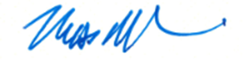

Russell Hollander

National Executive Director

Directors Guild of America

1. USCO Question No. 2
2. USCO Question No. 9
3. OpenAI’s text-to-image tool DALL-E allows artists to opt out of having their artwork train future generations of OpenAI text-to-image models. See *OpenAI Unveils DALL-E 3, Allows Artists to Opt Out of Training*, Kyle Wiggers, techcrunch.com (Sept. 20, 2023). Consent should be required from audio visual artists as well in the form of an “opt-in” system.
4. USCO Question No. 15
5. USCO Question No. 16. While directors are by and large not the copyright holder under U.S. law, these issues impact the product of a director’s years-long effort to create and release a motion picture, as well as the pension and health plans that are funded, in part, from the exploitation of those works.
6. USCO Question No. 32
7. *Here are 11 Things That ChatGPT will Refuse to Do*, Jon Martindale, digitaltrends.com (May 2, 2023).
8. USCO Question No. 10
9. USCO Question No. 27
10. Fairuse.stanford.edu/overview (Rich Stim, *Getting Permission*, 2019).