# Introduction

Per the comment response, I want to address questions 6, 7, 18 and some extras in this document. I specifically go into detail on question 18 with examples. If you are uninterested in the background and context of response, feel free to skip to the end of this document for those answers.

My work in the generative AI space is primarily around the ‘furry’ art community. This is a community has a special interest in anthropomorphic animals. While the traditional art efforts are quite large, just the AI wing of the community has gatherings of tens of thousands of individuals engaging with this kind of art and technology, either as consumers or as producers of said art. If you are a producer of AI art, we would say you are a ‘director’ – I’ll carry that terminology forward here as to distinguish an AI ‘artist’ from a traditional artist.

The interest space is of special importance. Training a model usually means providing a computer with many samples of the kind of subject matter you wish to produce, followed by describing to a computer the various elements in the image. The process of describing to a computer the elements in an image can be extremely tedious, and it must be meticulously accurate – You are attaching words (or ‘tokens’) to an image, and the computer does not interpret your meaning – it consumes it literally. This means that if you train your AI to understand a blue sky as, ‘Clear Sky’ and forget that that is the token you used to describe that property and maybe start describing it as ‘Blue Sky’, you are damaging the consistency of your model and are going to get poor results.

This is where the furry community is especially relevant. This community has spent more than a decade consolidating and tagging millions of images, hand-reviewed by the community with strict tagging standards. It is an absolute gold mine for training data, and it will be the focus of the remainder of this document.

## The Data Treasure Trove

The furry community has several sites where artists can upload their work, but the one that is of particular interest to us is e621.net (or simply ‘e6’). Before you go clicking on that, please be aware that while there is art of all kinds there, it trends toward the pornographic. There is a (mostly) sanitized, PG-13 version of the same dataset at e926.net, but it’s imperfect and caution should be taken. Still, if you are feeling adventurous, understanding the incredible value of this dataset can hopefully help one understand the implications of law around AI training. I’ll provide some examples here and I’ll be sure they are appropriate!

E6 hosts millions of images, all tagged with data that is ideal for training: It’s consistent, robust, descriptive, and repeatable. We can look at an example here to see how this is important:  
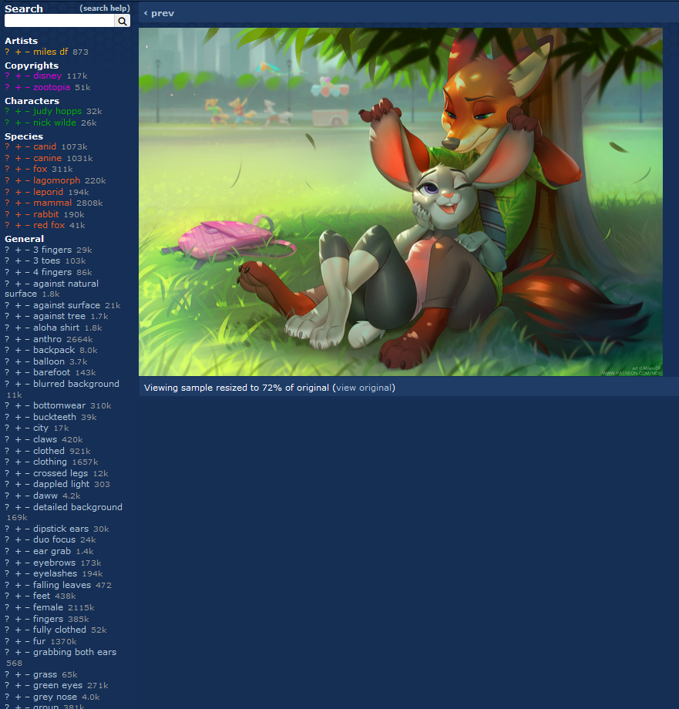

Here we have some fan art from the show Zootopia – Important for our discussion is the list of items on the left side. These are the tags that are associated with this image and include things like the character names, various features of the characters and composition, poses, etc. As mentioned before, these tags are very consistent across the entire data set of millions of images – the number to the right of each tag indicates how many times an image was tagged as such. In this case, ‘Disney’ was tagged 117,000 times. There are 2,808,000 images tagged as ‘mammal’.

Also, of note here is how detailed and robust the tagging system is. Even with this list of dozens of tags, I have cut off the number of visible tags here after the letter ‘g’.

The point I want to drive home here is how perfect this kind of dataset is for training.

From here, if I wanted to make my own model based on the e6 data set, I would just need to download all these images and make sure that the tag data can be associated with them and then go to work. This could be done relatively trivially with a bot, but someone has already made this available and many of the furry models are trained on this very dataset as a result.

## Two Birds with One Stone

Besides having very consistent tags for the sake of training, this dataset also provides a reference for would-be directors. The ‘magic’ of AI is often its ability to translate a human-readable sentence into something usable. For this particular kind of training though, that isn’t necessary (but still does work). If you understand the e6 tagging system, you can get remarkably consistent results via reasonably easy prompt crafting due to how specific the structure is – You don’t need to ‘explore’ the model and figure out how to get specific results, you have the guidebook already printed with examples at e6.

This is a powerful side effect of how furry data specifically is trained. This entire system is so powerful for model training that I expect other sites that intend to compile image data for use in models will follow suit, but that of courses introduces The Question:

## What about Copyright

Everything above I hope provides context for the answers for question 6 (at the end of this document).

While the e6 dataset is hugely robust, all these images have implicit copyright, and so few of them have been correctly licensed to be included in models that it may as well be a rounding error from zero – and for good reason. The process involved in trying to make a model ‘legit’ is overwhelming. Almost all of these artists are using an alias and many are impossible to contact. The allure of utilizing this tech is so great, and the process to try and contact every artist who ‘contributed’ to the model and work out a deal of some kind is so monumental, it is not hard to see why people have just scrapped the entire e6 dataset and started building without much of a second thought.

Even outside the furry world, I expect there to be similar stories – our current laws and processes make utilizing a mass amount of copyright material, each representing a tiny data point in a model, impossible.

I try to keep my ear to the ground on the state of AI image generation, and while thousands of models and LoRAs exist, not a one is usually material they’ve negotiated a license for.

The implications are probably obvious: AI Image Generation just doesn’t exist as a technology if it was determined that model creators needed a license for each image they added to their model. Even the smallest of ‘checkpoint’ datasets are using thousands of images, and some are using millions.

Ultimately, the copyright office must balance the realities of how models are made and the requirements thereof, with the interests of the artists. As a director of AI art, my thoughts compressed to one line are as follows:  
  
 ***“AI Models are free to use any material to generate train on. AI Art is not eligible for copyright protection.”***

I think trying to fight how AI models are trained is already a lost war. The best we can do is deal with the back-end. I feel this is an adequate balance of good and harm, and also among the most realistic approaches that can be reasonably enforced.

## Questions – Section 6

***6. What kinds of copyright-protected training materials are used to train AI models, and how are those materials collected and curated?***

In my experience, trainers are targeting resources that are already well documented and tagged by an interested community. Many image repositories exist in a variety of places, and narrowing down your model to target specific needs can inform where that information might be located and how you can acquire it.

***6.1. How or where do developers of AI models acquire the materials or datasets that their models are trained on? To what extent is training material first collected by third-party entities (such as academic researchers or private companies)?***

It is my experience that the vast majority of data is acquired via an AI-ready dataset, derived from existing collections by 3rd parties (usually for non-AI related purposes). The e6 example I give above is a perfect showing of this – One person scrapped the entire site and put together the data that was ‘easy’ for a model creator to use and many people have used that collection since.

***6.2. To what extent are copyrighted works licensed from copyright owners for use as training materials? To your knowledge, what licensing models are currently being offered and used?***

Absolutely zero. I get many of my models from Civitai, and to my knowledge, none of them are ‘properly licensed’.

***6.3. To what extent is non-copyrighted material (such as public domain works) used for AI training? Alternatively, to what extent is training material created or commissioned by developers of AI models?***

I’d imagine public domain works are used when it’s convenient, but no one is seeking it out. Likewise, I’ve never heard someone commission a work for use specifically in a model – the cost to do so would be astronomical at the scale you’d need to make a decent model.

***6.4. Are some or all training materials retained by developers of AI models after training is complete, and for what purpose(s)? Please describe any relevant storage and retention practices.***

In my community, the training data is freely available and shared as a torrent and in other places. It is extremely valuable to have well-formatted, training-ready data available and many of these ‘specialty’ communities will share training data quite freely.

## Questions – Section 7

***7. To the extent that it informs your views, please briefly describe your personal knowledge of the process by which AI models are trained. The Office is particularly interested in:***

I’ve trained my own models, created my own mixes, and built my own LoRAs (mini ‘plug-in’ like models). My views here are based on the reality that none of this work is licensed for this kind of activity, but it is all copyright-eligible. Trying to find the balance between ‘not harming the artists’ and ‘managing the reality of the situation around AI’ is paramount. Trying to create a licensing system for models is almost certainly impossible.

***7.1. How are training materials used and/or reproduced when training an AI model? Please include your understanding of the nature and duration of any reproduction of works that occur during the training process, as well as your views on the extent to which these activities implicate the exclusive rights of copyright owners.***

They aren’t so much ‘reproduced’ as they are ‘consumed’. The dataset is setup for training and while that is technically a reproduction of the work, reproduction is not the goal – the goal is to be able to associate tokens and tags with a specific image, which is made easier if you have a copy of it on your local machine.   
  
 As far as implicate the rights of copyright owners – that is wildly complex. I would probably be inclined to cite *Authors Guild vs Google* as an example where access to works was considered a public good and might try to frame this in a similar light: Models are a net good for the world and I think I’d argue for their general existence sans-licensing.

***7.2. How are inferences gained from the training process stored or represented within an AI model?***

That’s a computer science question that might require another ten pages to answer adequately.

***7.3. Is it possible for an AI model to “unlearn” inferences it gained from training on a particular piece of training material? If so, is it economically feasible? In addition to retraining a model, are there other ways to “unlearn” inferences from training?***

Can an AI technically ‘unlearn’ an inference without retraining? Yes, but it’s effectively impossible to do that. It’s the most technical ‘yes’ there can be in so far that you could in theory manipulate bits to take it out, but in practice, the answer is a resounding ‘no’. The economic feasibility follows that: Absolutely not.

What you could more feasibly do is remove token recognition. If for example an AI was designed to reproduce art in the style of a specific artist, you could ‘remove’ that artist from the model by making that model ‘blind’ to the artist token requested. What you could not do however is surgically remove the individual elements that trained that model on that artist.

***7.4. Absent access to the underlying dataset, is it possible to identify whether an AI model was trained on a particular piece of training material?***

You could probably infer it with high confidence on some elements – using our artist example again, we could generate an image with the prompt, ‘*A view of a corn field from the top of a church steeple in the style of Vincent Van Gogh*’. Van Gogh has a distinct style and it would be relatively easy to see from the output of that prompt if the model understands the token ‘Vincent Van Gogh’.

However, for more non-specific tokens, it would be substantially more challenging and situational to know if a specific work was used in the training, and generally speaking, the answer would be ‘no’.

## Question – Section 18

***18. Under copyright law, are there circumstances when a human using a generative AI system should be considered the “author” of material produced by the system? If so, what factors are relevant to that determination? For example, is selecting what material an AI model is trained on and/or providing an iterative series of text commands or prompts sufficient to claim authorship of the resulting output?***

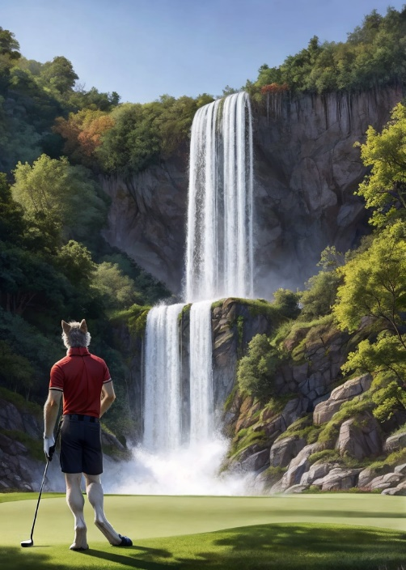A lot of people have this impression that AI generation is just a prompt and you hit ‘go’ and hope for the best. While this is certainly a lot of what’s being done, the tooling around AI image generation is substantially more robust than that would suggest. Some of the common toolsets like A1111 or ComfyAI allow you to craft massive networks of parameters to generate specific output.

I’m most familiar with A1111 so I’ll give some examples. A common example of craftsmanship would be in what is called ‘inpainting’ which is a technique you can use to refine an image with additional prompt work after it’s generated. In the example here, I’ve generated a wolf playing golf against a spectacular waterfall background. This base image was prompted for specifically, but even here there are some things I see that I don’t really like.

First, I want to fix that weird foot – I can simply ask the AI to regenerate that part of the image until a desirable result shows up – that’s easy enough.

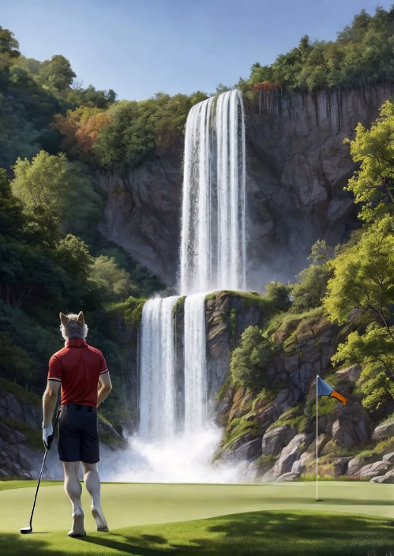The second thing I want to fix here though is an addition. I want to add a pin and flag to the scene to really sell that this is a golf course. Here, I can select a piece of the image and then re-prompt against it to get some additive results.

Base Image - No Changes

The results here are a result of maybe 30 minutes of tinkering with this single feature. The scene is a little more convincing and for the purposes of copyright, it’s a little bit more ‘mine’. I’ve injected more of a ‘human touch’ into the process.

There are many other features here too – I could use a Posing tool to get a specific pose out of my character(s) if I want. I can use other ‘img2img’ tools to use other pictures as a base. The toolset is extremely robust – make no mistake.

Inpainting – Fixing the Right foot and adding a pin and hole to the work

The critical question though is does this rise to the level of copyrightable? **I would strongly argue that the answer is ‘no’.**  I say this as someone who is at least relatively competent with these tools: This is still ultimately asking a computer to do the vast majority of the work, even when you work as a director for hours on a picture.

I would further argue that it is a legal quagmire to allow copyright on AI images generated from models that are trained on unlicensed works. Ultimately, I think copyright should not be obtainable by AI image directors.

## Questions – Others

***8. Under what circumstances would the unauthorized use of copyrighted works to train AI models constitute fair use? Please discuss any case law you believe relevant to this question.***

I am not a lawyer.

With that out of the way, I think the case I point to here is *Author’s Guild vs Google*. I think there is a ‘net good’ in allowing images to be used to training models, and I would support the idea that it should be an implicit part of the fair use clause.

***12. Is it possible or feasible to identify the degree to which a particular work contributes to a particular output from a generative AI system? Please explain.***

Not really – there is a world where you could *maybe* at least suggest the amount a specific work contributes to the final output, but as a matter of practicality, this is functionally impossible. This gets even more impossible as the dataset grows and the model becomes increasingly ‘noisy’. Achieving this would be a massive leap in computer science and I would cast doubt on anyone who claims it could be possible (Or I’d love to read the proposal for it!).