Hello and thank you for accepting public comments on AI regulation via your Notice of Inquiry. I am a writer, educator, investor, and YouTuber who creates mixed media pieces using a combination of AI diffusion, Photoshop, and Filmora. The second file attached in my NOI comment is an essay-format commentary.

***It includes:***

1. *a description of how basic AI systems and diffusion models work, including the curation and program-use of dataset information.*
2. *a discussion about specific AI-related regulatory topics that your office might find useful*

***It does not include*** (but I would like to include here) a specific thought that AI regulation should probably be tiered in some way, since larger corporate entities make use of AI art in ways that are different from small and individual creators. I am not sure if a specific framework for such a thing is feasible in your eyes, but I thought the idea was worth sharing.

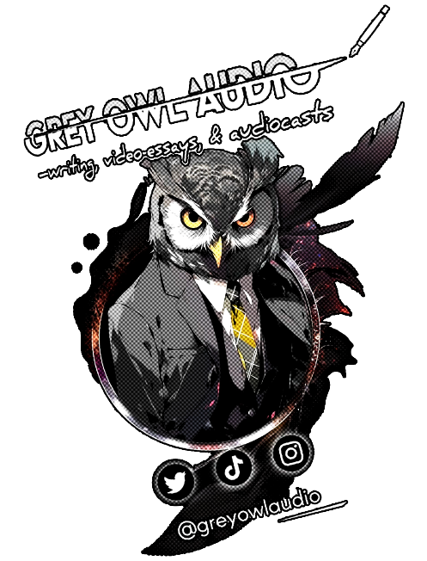

It was a pleasure sharing my thoughts during the public listening sessions that the USCO hosted earlier this year, and I hope my essay submission here will provide a more in-depth view of legal and ethical topics that concern the regulation of AI frameworks. This is the most recent version of my paper, credited to my most recent pseudonym (Thomas K. Yonge), and if the office has any follow-up questions, it is always welcome to reach out to me at my current email address.

Thank you for the work you folks do and I look forward to hearing future USCO updates!