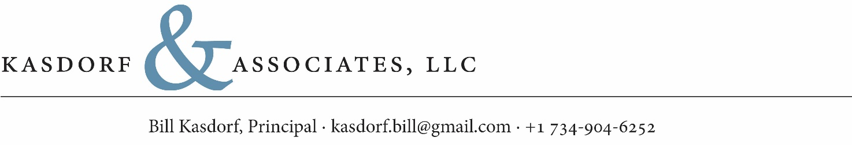

date: September 5, 2023

to: Artificial Intelligence Study Submission of Comments

re: Judge Howell’s Memorandum of Opinion in Thaler v. Perlmutter

While Judge Howell’s Opinion in Thaler v. Perlmutter is thoroughly researched and well stated, I believe it will create the impression that it is broader than what it explicitly states and may thus discourage or impede creative activity by owners of intellectual property using artificial intelligence (AI) to create new intellectual property to which they should rightly retain copyright.

I offer the following example.

An owner of a corpus of content expressed in one medium—for example, video entertainments using stories and characters that are their intellectual property—creates or causes to be created derivative works, such as books relaying the same stories, using the same characters, through the use of artificial intelligence.

While the content expressed in the books is not word-for-word identical to the content expressed in the videos because of the essential differences between dramatic content expressed in videos and narrative content expressed in books, the resulting books should also be that IP owner’s intellectual property and they should retain copyright in the derivative books.

To be clear, while humans working for the IP owner, whether as employees or under contract, would have been involved in the development and training of the artificial intelligence to produce proper saleable books corresponding to the videos, and humans would have been involved in reviewing and potentially refining the output of the artificial intelligence to result in books the IP owner deems faithful representations of the video content as books, it is entirely possible—in fact, likely—that over time that process will have been refined sufficiently to require no human involvement. Nevertheless, even those derivative works should rightly be copyrightable by that IP owner, or they will have inadvertently relinquished rights to that intellectual property which they solely should have the right to exploit for commercial gain.

I suggest that exceptions such as this should be clarified by the court. Otherwise, the decision in Thaler v. Perlmutter is likely to be interpreted—or in fact misinterpreted—as using an excessively broad brush to address the issue of whether content created by AI can be copyrighted. Instead, the nature of the AI, the parties employing it, and the specific nature of its use must be taken into account.

Respectfully submitted for consideration,

William E. Kasdorf  
Principal, Kasdorf & Associates, LLC, a publishing technology consultancy