This text is about generative AI specifically

I’m a artist and a programmer studant that started to do researchs to know more about AI generative, including damages and how affect people negatively, so I know what I’m saying

First, name it “AI generative” is wrong. The correct term should be “Artificial imitative”. That ins’t artificial intelligence, in this case the term is used just to marketing. It’s artificial, but intelligent? No.

I’ll use the term “AI imitative” to refer to “AI generative” on the text.

WHAT’S THE DATA USED ON AI? THEY ACQUIRED IT LEGALLY OR NOT?

Those programs needs a big amount of works (what developers name “data”) to give satisfactory results, so obviously those datas were acquired illegaly and they continue to acquire it illegaly, because those who can do something to stop their actions (like courts and congress) aren’t doing nothing. Do you really think it’s humanly possibly to acquire a big amount of data in such amoun of time like those companies did? It’s impossible! Even big companies like microsoft can’t do it.

Almost all of datas used on training it’s copyrighted and/or private. Developers and companies KNOW and they choose to steal billions of people to create illegal programs to profit. For know, EVERY AI IS ILLEGAL AND USES STOLEN WORKS/DATAS. If companies choose to pay for all the data, they should pay a big amount of money, considering those programs literally can destroy people’s entire careers and let them starving, due to their functions be to do works of those same people, like artists.

“But why they choose to not use works not copyrighted and on public domain?”, the result will not be as safiscatory as results that use stolen works/datas.

AI “WORKS” SHOULD HAVE COPYRIGHT?

About the copyright’s question, my answer is a big NO. Why can AI “works” have copyright, if copyright is to protect human creators? That doesn’t make any sense and it’ll harm us more than we’re already harmed. With copyright, workers are losing their jobs and clients due to AI, if copyright office allow AI “works” to have copyright it’ll be WORSE to us. Believe on me, better not allow it in any circunstance. Even if just a part of the work is AI and the rest is human, it shouldn’t be allowed.

Copyright should be just to works 100% human made, without the use of those AIs imitatives. Copyright office shouldn’t consider a copyright porcentage. The owner used AI imitative on the work? So it shouldn’t have copyright. It’s simple

HOW AI IMITATIVE IS AFFECTING PEOPLE NEGATIVELY?

People are losing their jobs due to AI. AI can do things on a mass scale on several fields and careers, it’s a big threat and causes big problems to workers, with companies using it to replace people!

And it disturbs competition, at a point that just big companies will benefit from it, and small workers’ll lose everything. Their jobs, their career... Everything

Workers will not be able to compete against companies, specially big ones. Many CEOS, like Sam Altman, openAI’s CEO, says it’s good to replace normal people and let them lose their jobs. Those people are terribly dangerous

Some big companies using it to replace workers:

1. Microsoft
2. Adobe
3. Twitter/X
4. Google
5. Tencent (Epic Games, Artstation...)
6. Blizzard
7. Riot Games
8. Amazon
9. Netflix
10. Getty Images
11. Meta
12. Warner Bros
13. Paramount
14. Zoom
15. Universal Music Studio
16. Envato
17. Activision (COD/Call of Duty)
18. COD
19. Disney
20. Japan government
21. Apple
22. Nintendo
23. SEGA
24. Etsy
25. Patreon
26. Kickstarter
27. Unity
28. Unreal
29. Reddit
30. GitHub

SUSPICIOUS COMPANIES

1. Oracle corporation/Opera

Some persons are even harassed and cyberbullined by pro-AI people. I see many times pro-AI persons, for example, incentiving artists to kill themselves if they don’t accept AI imitative. No, I’m not exagerating. Do a quick search and you’ll see terrible things they say against those victms

A person mentally affected can do something to harm their own life if they lose control because of those people. That’s much problematic

Those AIs use many ambiental resources to works, at a bizarre rate. The amount of water is colossal. Consider this and servers from several websites full of such “content” uploaded, servers will need more resources than before to maintain everything on the internet

POSSIBLE MEASURES

I suggest two possible measures against AI imitative.

1. Ban it entirely on a global scale

Let’s be real. AIs imitatives DON’T NEED TO EXIST. Sure, some AIs are useful, like AIs used on search algoritms, but... That ins’t the case. They were created to replace workers and let people starving.

And when I say “ban it”, it’s on a global scale. It should be banned on all countries, not just US. I’ll explain: ban it just on a X or Y country’ll not resolve anything. Somebody or a company could just use a VPN and bypass it. In Italy, the government banned chatGPT, yet many citizens used VPNs and other things to bypass and use it ilegally. It needs to be banned at a GLOBAL SCALE

1. Ban it partialy and limit AIs imitatives allowed to exist just if it’s limited

In case the ban is unsucessful, some AIs imitates should be banned completely. Some examples: deepfakes AIs, chatboxs AIs.

Some allowed to exist, but limited. Like, MUCH LIMITED. The quantity of works/data used on training is limited on a small quantity, not allowed datasets that have millions or billions of works/data, even if it’s on public domain. The limit can’t be ultrapassed

The dataset needs to be public, so people can know if their work/data is used without consent or not

Also, some functions that AIs have should be prohibited. Let’s see:

1. Don’t allow to upload of other images that aren’t on the AI dataset. Other works/data can be uploaded without consent, if the function is not removed
2. Don’t allow the use of the person’s work/data created using the AI. I know this sounds strange, but hear me: what if the work/data actually is mimic from other work/data of other people? For example, some artists and writers can mimic other styles from other authors, so... Better just use what’s on the AI dataset already and not let something upload or creat using it
3. Watermark to show it’s AI, not human made. Some AIs can remove trademarks and other watermarks (that’s a crime) and maybe it’sn not much effective, but it could be implemented someway

And remember...

'There is no ethical way to use the major AI image generators.  All of them are trained on stolen images, and all of them are built for the purpose of deskilling, disempowering, and replacing real, human artists.'
- Molly Crabapple
artist and activist

ARTICLES TO KNOW MORE ABOUT AI AND DAMAGES

https://gizmodo.com/apple-cancels-jon-stewarts-the-problem-1850944488 - Jon Stewarts is canceled by Apple after they want to start to talk against AI

https://www.nytimes.com/2021/03/15/technology/artificial-intelligence-google-bias.html - IA algorithm by google giving racists results

https://www.rollingstone.com/culture/culture-features/ai-explicit-material-twitter-big-tech-1234855484/

https://www.washingtonpost.com/opinions/2023/10/19/ai-large-language-writers-stealing/

<https://twitter.com/venturetwins/status/1715161818199674923> - A IA influencer that possibly works to adobe incentives the use of deepfakes

<https://twitter.com/Adobe/status/1711793740120293563> - Adobe announces a new feature to generate deepfake. People warns that it’ll be used on scams, but adobe doesn’t care

https://gizmodo.com/github-copilot-ai-microsoft-openai-chatgpt-1850915549

<https://www.bbc.com/news/world-europe-66877718> - More deepfake scandals

<https://twitter.com/NexusBen/status/1705582423721828589> - More deepfake

<https://futurism.com/critics-microsoft-water-train-ai-drought> - AI needs much ambiental resources to works, it can give big ambiental problems, but companies doesn’t care

<https://twitter.com/OpenAI/status/1707077710047216095> - OpenAI says chatGPT can browser the internet. Everybody knows they stole data and works to put on chatGPT, that’s clearly another try on stolen other people again

<https://futurism.com/sam-altman-replace-normal-people-ai> - Sam Altman, openAI CEO, says he intends to replace normal people with AI

<https://twitter.com/StabilityAI_JP/status/1707976060737077594> - StabilityAI Japan incentives deepfakes, using even copyrighted works

<https://twitter.com/agoraitconsulti/status/1708110480860917801> - A japanese shares a deepfake of Zelensky, president of Ucraine

<https://techcrunch.com/2023/09/30/how-much-can-artists-make-from-generative-ai-vendors-wont-say/> - Companies don’t give even a pennie to artists whose works are used on AI imitative

<https://twitter.com/kenklippenstein/status/1701658625280704599> - Gurner CEO says many things against workers

<https://kotaku.com/pokemon-go-adventures-abound-art-ai-artificial-niantic-1850793819> - A example of company firing off their workers to use AI to replace them

<https://www.disconnect.blog/p/generative-ai-closes-off-a-better> - The future is in dager because of AI imitative

<https://www.theverge.com/2023/8/30/23852652/call-of-duty-activision-modulate-toxmod-artificial-intelligence-voice-moderation> - A example of company using AI to moderation. This it’ll lead to moderators fired off

<https://apnews.com/article/chatgpt-gpt4-iowa-ai-water-consumption-microsoft-f551fde98083d17a7e8d904f8be822c4> - ChatGPT needs a amount of water to works

<https://www.forbes.com/advisor/investing/cryptocurrency/what-is-worldcoin/> - OpenAI wants biometrical data to their coin worldcoin

<https://www.vice.com/en/article/dy3vmx/an-ai-scraping-tool-is-overwhelming-websites-with-traffic> - AI scrappings websites and causes much excessive traffic

https://www.wired.com/story/amazons-new-robots-automation-revolution/

<https://www.npr.org/2023/08/02/1190605685/movie-extras-worry-theyll-be-replaced-by-ai-hollywood-is-already-doing-body-scan> - Hollywood background actors had their image scanned by AI without any warning

https://www.economist.com/biometrics-pod

https://www.wsj.com/articles/ai-medical-diagnosis-nurses-f881b0fe

https://www.theverge.com/features/23764584/ai-artificial-intelligence-data-notation-labor-scale-surge-remotasks-openai-chatbots

Pro-AI person saying what they think about AI doing harms to other people. This opinion is the same as from other pro-AI people

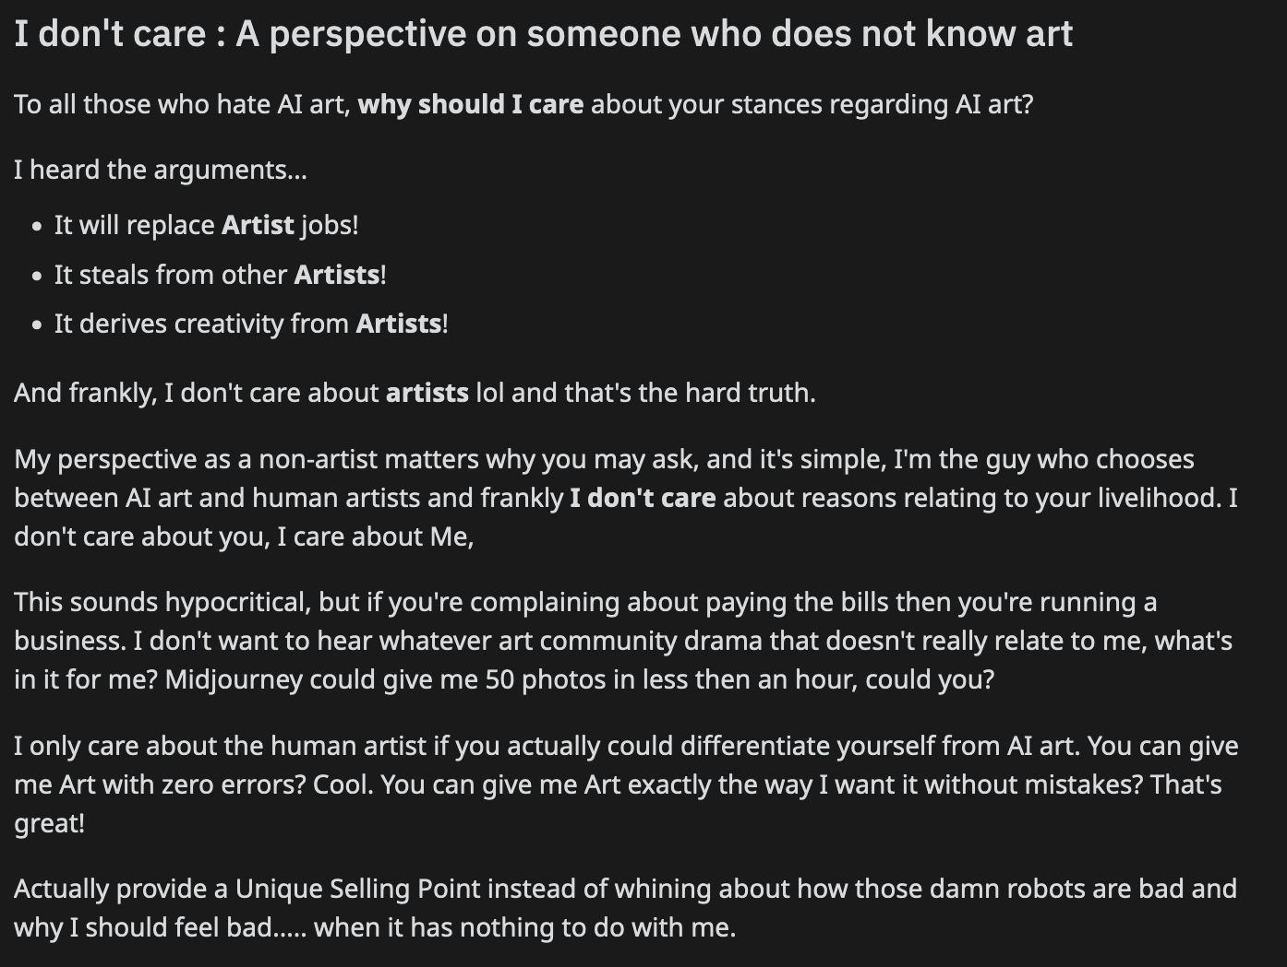

AI scams on facebook

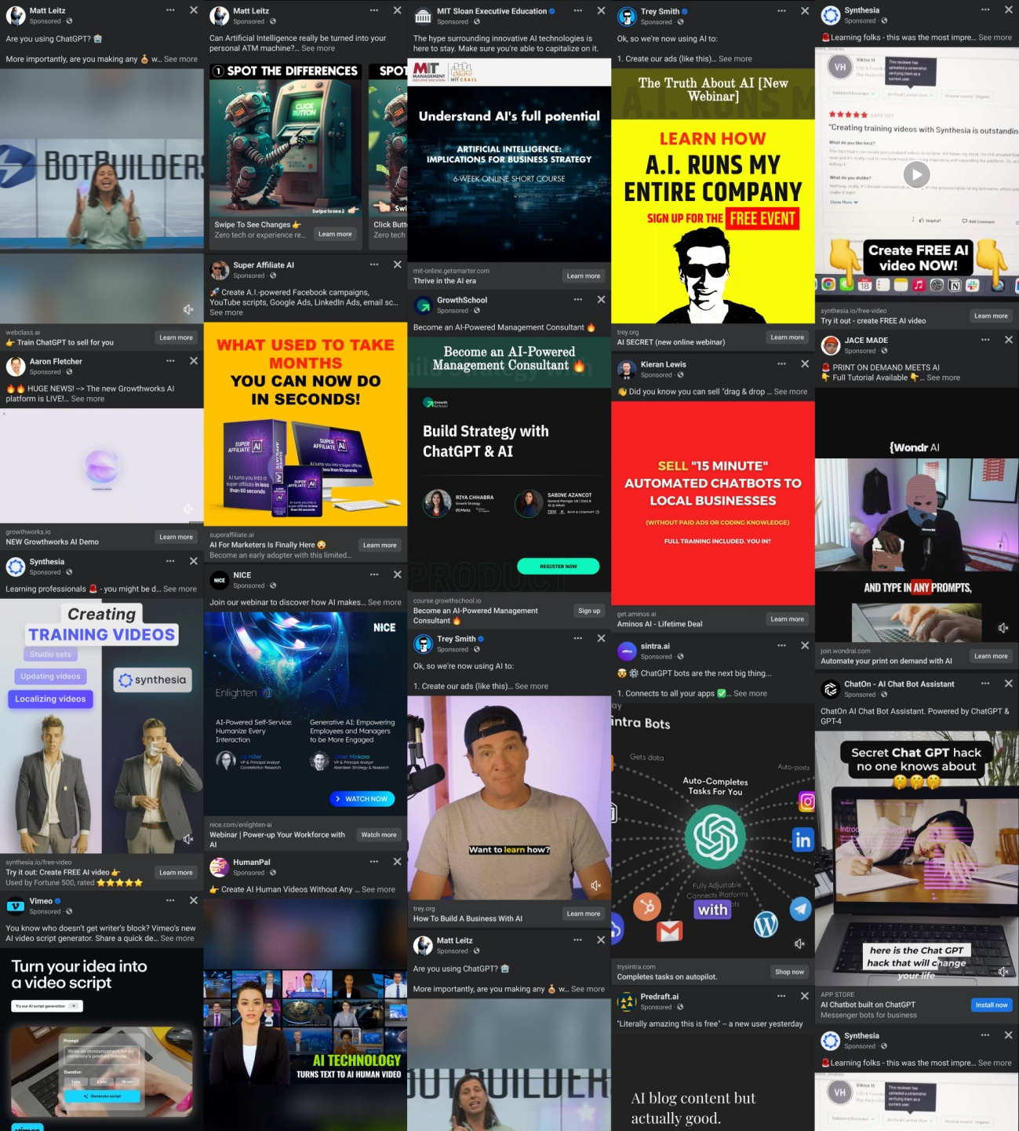

A person claims a photo was taken on 1930s when it’s clearly a deepfake. They fooled many people

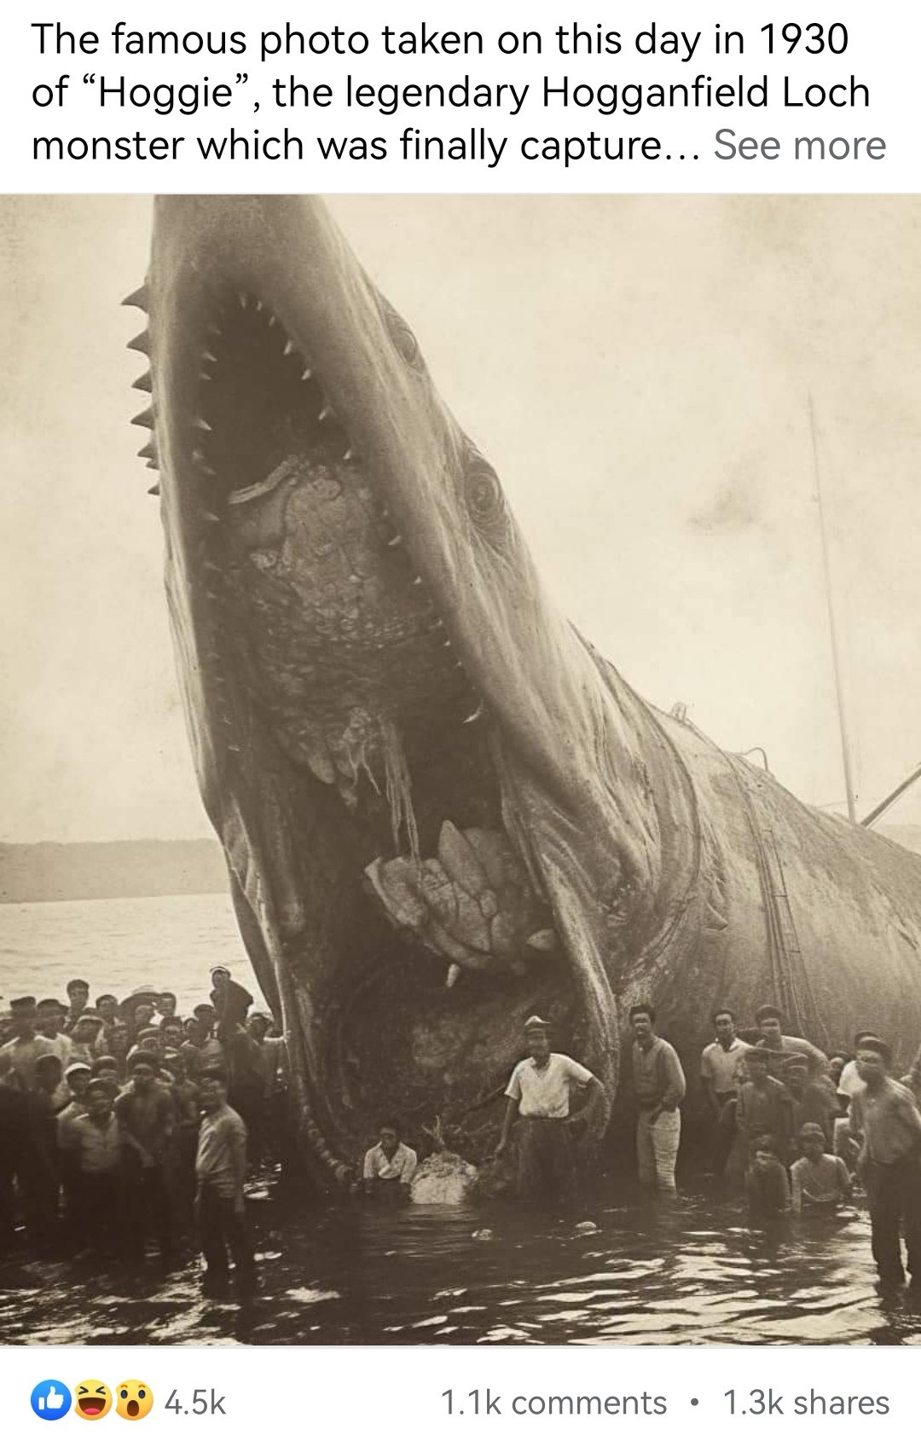

Adobe has many AI “works” on adobe stock, like this AI image of Emma Watson. Notice they used Greg Rutkowski’s names, a artist that have their name used without consent more than 400.000 times

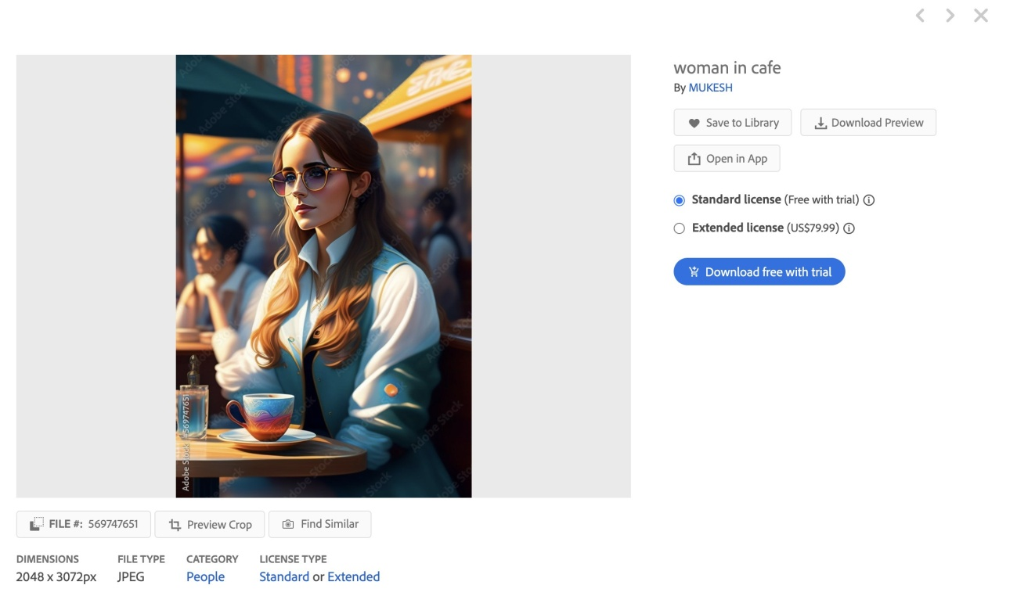

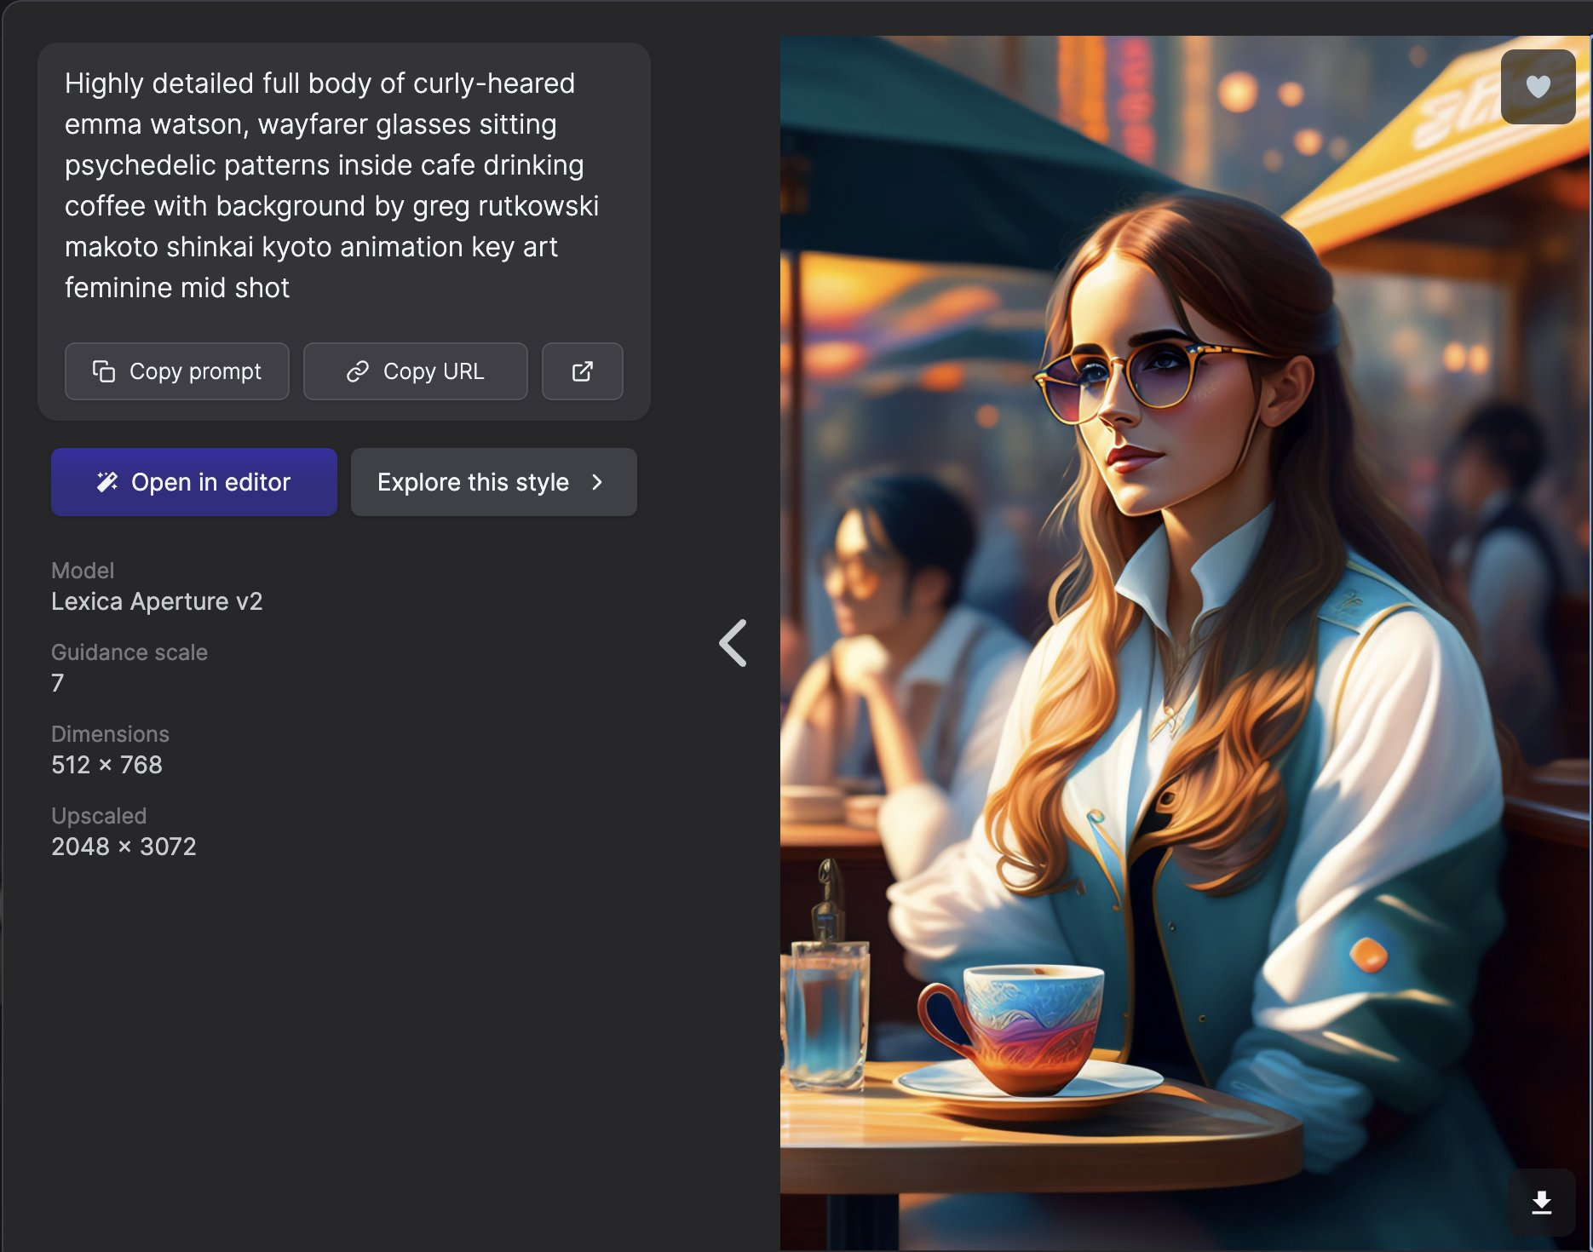

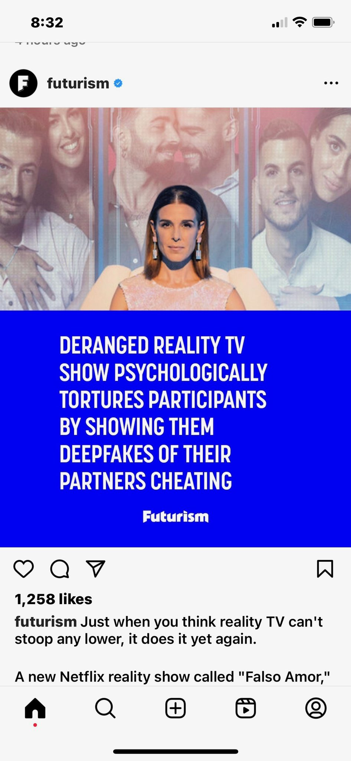

Where does Meta get training information for generative AI?
Because it takes such a large amount of data to teach effective models, a combination of sources are used for training. These sources include information that is publicly available online and licensed information, as well as information from Meta's products and services. There are more details on how we use information from Meta's products and services in our .
When we collect public information from the Internet or licence data from other providers to train our models, it may include personal information. For example, if we collect a public blog post, it may include the author's name and contact information. When we do get personal information as part of this public and licensed data that we use to train our models, we don't specifically link this data to any Meta account.

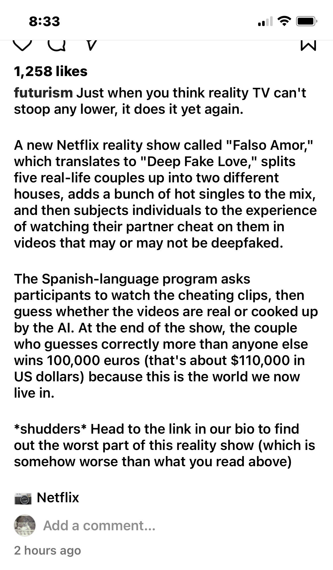

'There is no ethical way to use the major AI image generators.  All of them are trained on stolen images, and all of them are built for the purpose of deskilling, disempowering, and replacing real, human artists.'
- Molly Crabapple
artist and activist

Ron DeSanti’s campaign team uses AI images

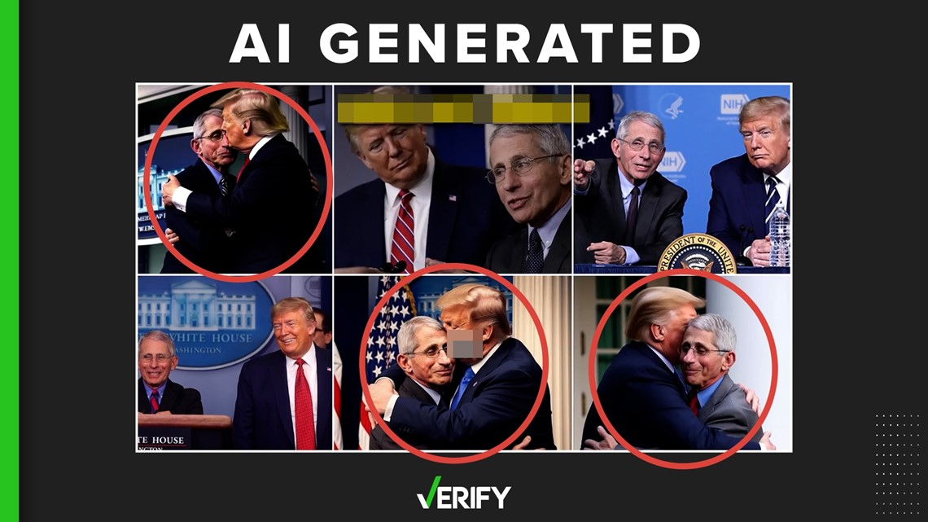

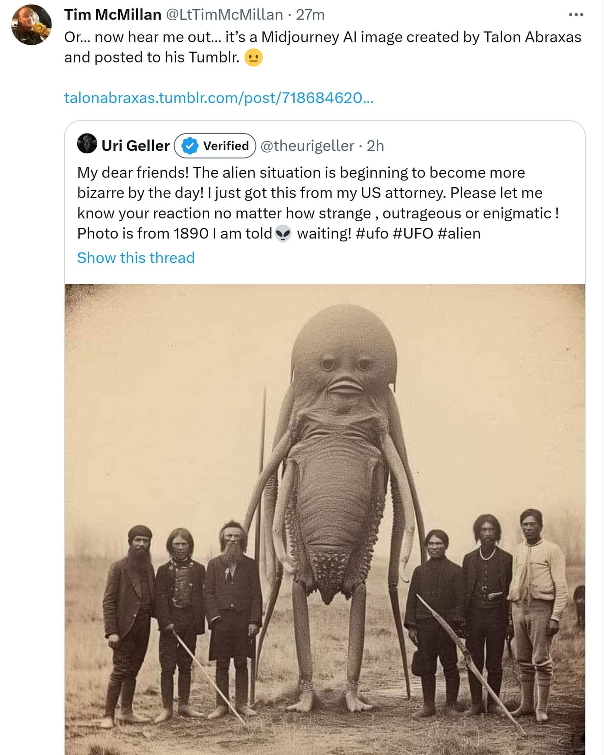

And remember that those people thinks about workers

