
Grammar
Past simple

 Complete the dialogues with the correct past simple form of the verbs in the box.You need to use some of the verbs more than once.
do earn go have make meet spend take

1 A: Yesterdayl three hours doing those physics exercises for homework.
B:I. … … … … … … … … … … .me a long time,too.
………… you …………………………the maths problems? A:No,|………………………………………(not)time.
2 A: My sister… a music degree at university and now she plays in an orchestra.
B: … … … … … .she … … … … … … … … … … a lot of money when she started?
A: No, but she………………………fun.

3 A: ……………………… to a summer camp last July. B:………… you………………………many friends?
A: Yes, … … … … … … … … … … … people from lots of different countries.
4 A: (not)very well in the exam last week.I know … … … ….a lot of mistakes.
B:That's because you……………………………………(not)much time revising.
A:I know. I thought……………………………a good memory, but I was wrong!


Past simple,past continuous and used to Choose the correct option in italics.
1 I used to enjoy/was enjoying history when I was in primary school but now it's very difficult.
2 He gave/was giving a presentation in the
communication skills class when the computer stopped/was stopping working.
3 Did you spend/Were you spending a lot of money when you were on holiday last year?
4 It was raining/used to rain when we left the house but later the sun came/was coming out.
5 I played /was playing on my phone when I received/ was receiving a text.
6 My parents didn't use to let/weren't letting me go out on school days.
7 The children made/were making so much noise in the playground that they didn't hear/weren't hearing the bell.
8 We decided /were deciding to have a cup of coffee while we used to shop/ were shopping in the city centre.

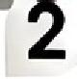
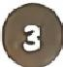 Complete the text with the past simple or past
continuous form of the verbs in brackets.

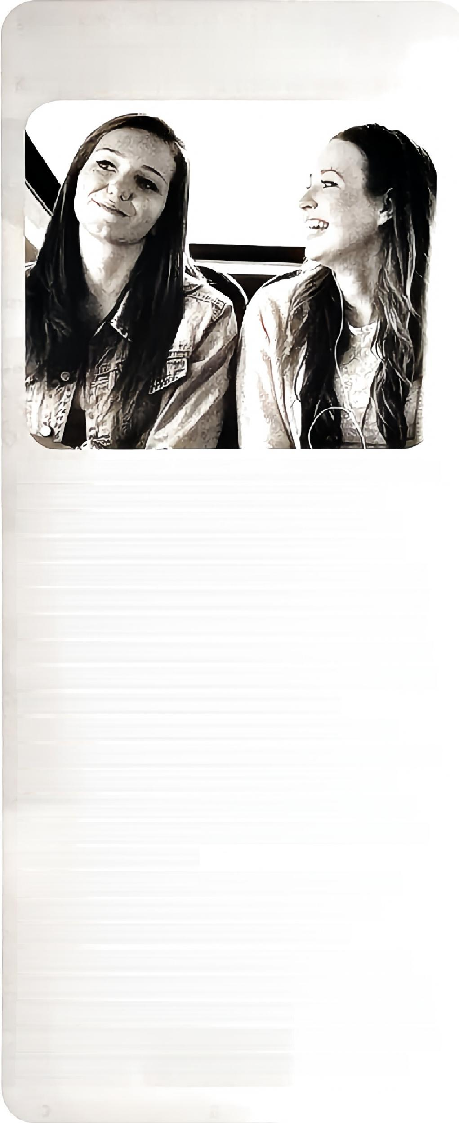
A terrible trip!

On the day of the school trip I(1)……………………………………… (wake up)as usual at 8 o'clock to go to school.
I(2)……………………………………… (leave)the house when
I realisedI(3) …………… …………………………(not have)my
sandwiches,soI(4) … … … … … … … …………………(run)back inside. I(5)… …………………………… (set off)again and I
(6) ……………………………………(walk)along the road when suddenly it(7)…………………………………………(start)to rain.At that moment,my friend Alice (8)………………………………………… (come)past in her mother's car and they
(9) … …………………………………(stop)to pick me up.The
excursion (10) …………………………………………(be)to the wildlife park about 15 minutes from our town.When we
(11)……………………………………………… (arrive)at school, the bus was waiting outside,so we (12) …… ………………………… (get on)and sat down.
Alice andI(13) … … … … … … … … … … … … … … (talk),so we
(14)……… …………………………(not notice)the other students on the bus.Half an hour later we
(15) …………………………………………(look)out of the window.
We(16) ………………………………………(be)at the museum,not in the park! We looked at the other people around us and we (17) ………………………………… (see)they were from another class.It(18)……………………………………………(be)the
wrong bus!

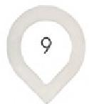
2 At school

