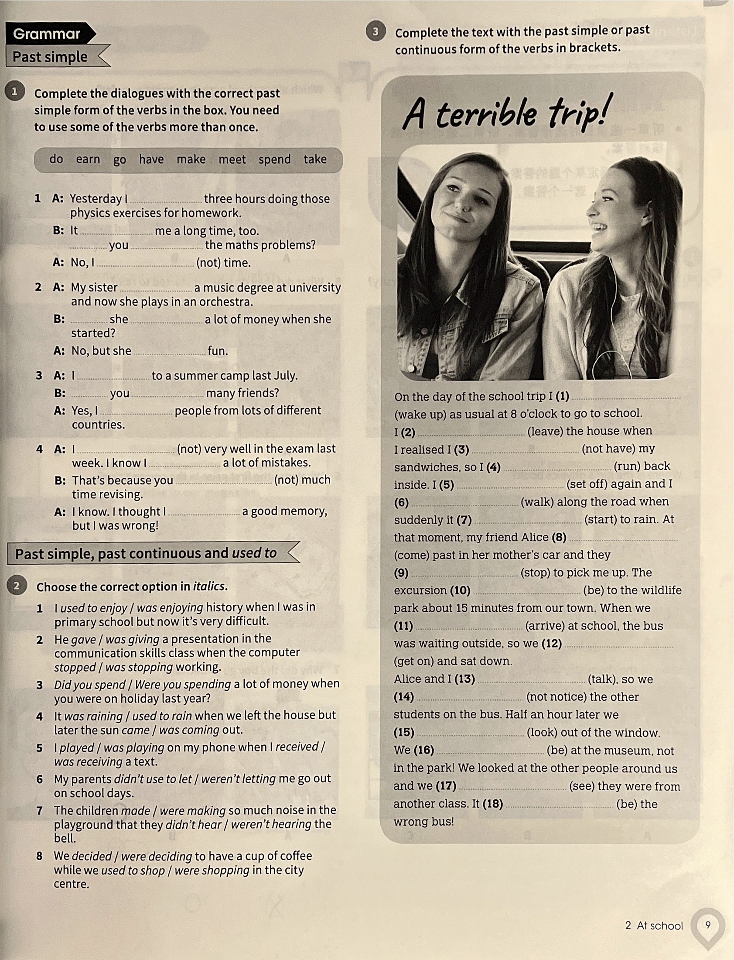

Grammar

Past simple
Complete the dialogues with the correct past
simple form of the verbs in the box. You need
to use some of the verbs more than once.
do earn go have make meet spend take
1 A: Yesterday l three hours doing those
physics exercises for homework.
B: It me a long time, too.
you the maths problems?
A: No, I (not) time.
2 A: My sister a music degree at university
and now she plays in an orchestra.
B: she a lot of money when she
started?
A: No, but she fun.
3 A: l to a summer camp last July.
B: you many friends?
A: Yes, I people from lots of different
countries.
4 A: 1 (not) very well in the exam last
week. I know I. a lot of mistakes.
B: That's because you (not) much
time revising.
A: I know. I thought l a good memory,
but I was wrong!
Past simple, past continuous and used to
Choose the correct option in italics.
1 lused to enjoy / was enjoying history when I was in
primary school but now it's very difficult.
2 He gave / was giving a presentation in the
communication skills class when the computer
stopped / was stopping working.
3 Did you spend / Were you spending a lot of money when
you were on holiday last year?
4 It was raining / used to rain when we left the house but
later the sun came / was coming out.
5 I played / was playing on my phone when I received /
was receiving a text.
6 My parents didn't use to let / weren't letting me go out
on school days.
7 The children made / were making so much noise in the
playground that they didn't hear / weren't hearing the
bell.
8 We decided / were deciding to have a cup of coffee
while we used to shop/ were shopping in the city
centre.
Complete the text with the past simple or past
continuous form of the verbs in brackets.
A terrible trip!
On the day of the school trip I (1)
(wake up) as usual at 8 o'clock to go to school.
I (2) (leave) the house when
I realised I (3) (not have) my
sandwiches, so I (4) (run) back
inside. I(5) (set off) again and I
(6) (walk) along the road when
suddenly it (7) (start) to rain. At
that moment, my friend Alice (8)
2 At school
(9) | (stop) to pick me up. The
excursion (10) | (be to the wildlife
 | park about 15 minutes from our town. When we
(11) | (arrive) at school, the bus
was waiting outside, so we (12)
(get on) and sat down.
Alice and I (13) | (talk), so we
(14) | (not notice) the other
students on the bus. Half an hour later we
(15) | (look) out of the window.
We (16) | (be at the museum, not
 | in the park! We looked at the other people around us
and we (17) | (see) they were from
another class. It (18) | (be the

